Analyzing America’s Race to Zero Carbon

#### 1. Abstract:

According to a 2018 report by the United Nations’ Intergovernmental Panel on Climate Change (IPCC), Earth will reach the crucial threshold of 1.5 degrees Celsius (the “tipping point”) by as early as 2030 (IPCC, 2018). To mitigate this crisis, many countries like the United States have adopted new greenhouse gas reduction plans. Under President Biden’s plan, one of the goals is to establish a carbon emissions-free power sector by 2035. Our project has scrutinized this plan by determining where the power sector as a whole stands in this current decarbonization race based on the variation of dependence on different renewable and non-renewable energy sources temporally (over the past 20 years) and spatially, and some of the drastic initiatives the power industry must take to reach zero carbon by 2035.The project intends to be a reminder of the bleak reality that the world is facing when it comes to climate change and how any half-hearted measures will fall far short of the needed impact.

#### 2. Introduction:

Based on the U.S. Environmental Protection Agency (EPA) annual reporting, the “electric power” sector accounted for 25 percent of all greenhouse gas emissions in 2019. Carbon dioxide (C02) makes up most of the greenhouse gases emissions from the sector. This gas is released during the combustion of fossil fuels, such as coal, oil, and natural gas, to produce electricity. Power plants using fossil fuels accounted for 61.5 percent of electricity generated in the United States in 2019, with the rest generated from nuclear and renewable sources (US EPA, 2021).

On April 22, 2021, President Biden announced a new target for the U.S. to achieve a “50 percent reduction from 2005 levels in greenhouse gas pollution in 2030” (Office of the Press Secretary, 2021). However, the focus of our project is the plan’s complete elimination of the power sector’s dependence on fossil fuels by 2035. This plan thus informs the basis of our methodology.

#### 3. Literature review:

## 3.1 Energy sector status:

The transition to low-emitting carbon energy has been underway for decades, with nuclear and later natural gas providing early contributions. Since roughly 2010, major renewable deployment has been taken on by federal investment programs, tax subsidies, and regulatory initiatives. Also, through state policies, research and development, and market trends. More than 546 coal-fired power plant units were decommissioned between 2010 and 2019. This includes 102 gigawatts (GWs) of capacity, with another 17 GWs slated for retirement by 2025 (Department of Energy, 2019).

## 3.2 Future predictions on USA Strategy to net-zero emissions:

Electricity provides a wide range of services to all areas of the economy in the United States. In recent years, the shift to a sustainable electrical grid has accelerated due to falling costs for solar and wind technologies, as well as due to federal/state laws and customer demand. Building on this success, the US has set a goal of achieving 100 percent renewable electricity by 2035, laying the groundwork for net-zero emissions by 2050 (IPCC, 2021).

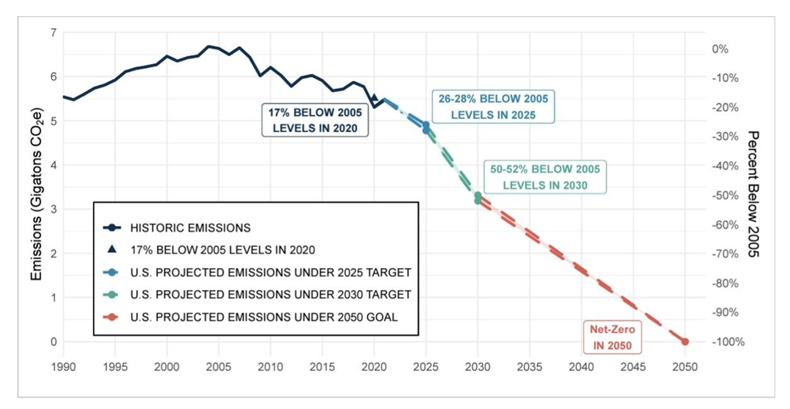

*Fig. 1.1: Historical and predicted emissions in the United States under the net-zero goal of 2050 (IPCC, 2021).*

The above graph depicts the historical trend of net GHG emissions in the US from 1990 to 2019, as well as the expected route to the 2030 nationally determined contributions (NDC) of 50-52 percent below 2005 levels and the 2050 goal of net-zero emissions. The US also set a goal of 100 percent clean electricity by 2035 (Congress, 2021).

## 3.3 Predictions in the transition of energy to achieve net-zero emissions:

Renewable capacities have been quickly increasing over the last decade and are getting closer to the levels required to maintain the overall decarbonization trend in energy needed to meet the 2050 zero-carbon goal displayed below in Fig. 1.2 (left). According to a sample pathway (center), the deployment of overall zero-carbon technology is estimated to be on the order of 60-70 GWs each year. Various scenarios in this research indicate a variety of possible paths to net-zero energy (right). Note: Historical data comes from the Environmental Information Agency (EIA) Monthly Energy Reviews, while predictions are from long-term strategy scenarios run by the Global Change Assessment Model (GCAM). Other possibilities, which are not included in the graph, feature cumulative nuclear capacity increases of up to 90-100 GWs by 2050 (EIA, 2001-2021).

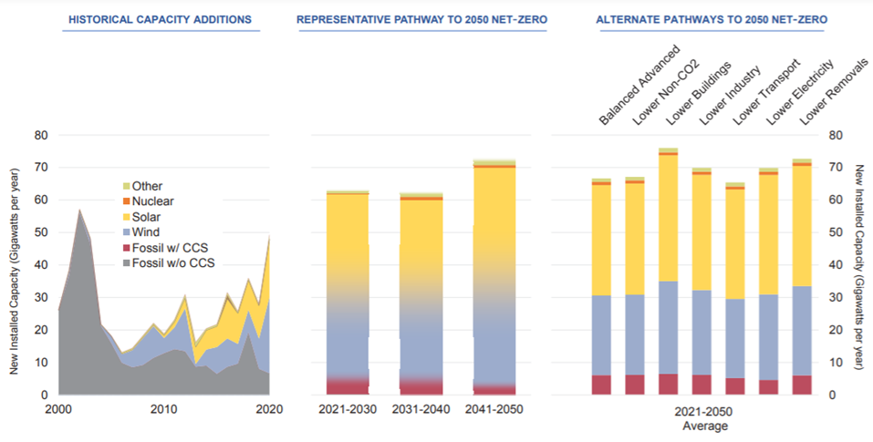

*Fig. 1.2: Transition to renewable energy as predicted by the US EIA and GCAM reports.*

As a result, energy sources in the United States have shifted, with power being generated through renewable fuel types now accounting for more than coal. This study analyzes whether the pace of change is sufficient to reach the goal of decarbonization, and clusters the states by their energy profiles to understand the transitions that need to be made.

#### 4. Data:

## 4.1 Monthly GHG emissions from 2001 to 2021:

The US Energy Information Administration and the US Environmental Protection Agency provided monthly data on CO2 and other GHG emissions.

## 4.2 Yearly energy generation from 2001 to 2021:

The US Environmental Protection Agency provided data at a unit level with geo location and energy production for that year.

## 4.3 United States cartographic boundary:

The US Census Bureau’s geographic database provided the boundary shapefiles for geospatial data at the state level.

#### 5. Methodology:

## 5.1 K-means clustering:

In order to detect patterns in our data, K-means clustering was used to group states by their fuel type and the amount of power generated from each type. Distinguishing states based on similar fuel-type profiles give an overall picture of which states are lagging or progressing in their efforts to shift from non-renewable to renewable sources of energy.

The K-means clustering analysis was based on yearly data by the US Energy Information Administration and focused on four separate years: 2005, 2010, 2015, and 2020. For each year, the power generated from every renewable and non-renewable energy source was found in each state and normalized for each state by their total energy output to get their size-independent fuel type profile. After applying clustering to the states by their profile, the number of clusters (k) was determined by calculating the silhouette coefficient. Finally, the clustered states can be visualized along with the categorical fuel-type profile of each cluster.

The same clustering analysis was performed by looking at power companies instead of states in order to analyze how the fuel-type profiles are clustered at the company level.

## 5.2 Temporal Prediction - Business-as-usual scenario:

Historical trends in carbon emissions data sourced from EPA were analyzed and an Auto-Arima time-series forecasting model was applied to predict progression by 2025 without any additional commitments from energy companies to reduce emissions. The main question being, if efforts to decarbonize are not taken seriously and do not materialize, then what will our future carbon levels look like?

The data was taken from EPA for each generation facility at a monthly level from January 2005 to September 2021. The data was then grouped at the owner company level and visualized temporally. The Auto - Arima Univariate Time Series model was used to predict monthly data for the period of October 2021 to December 2025. For the purposes of the result visualization, the sum of CO2 emissions at the yearly level was calculated, where for 2021, the sum was from actual data till September and predicted data for the last three months. The result was visualized as a line graph along with other scenarios discussed further in this section.

The scenario assumptions are predicted based on the values by using the AAA version of the Exponential Smoothing (ETS) algorithm using yearly coal composition in the total energy generation.

## 5.4 Emission calculator:

In order to convert energy consumption to its GHG emission, the conversion matrix given by EPA was referred to convert net energy requirement by year 2025 and based on fuel type usage. As mentioned in the matrix, for per million kWh of electricity generated by each fuel type, pounds per kWh of Co2 emission was calculated.

#### 6. Results

## 6.1 K-means Clustering:

Most US regions in 2005 outputted their energy using non-renewable fuels such as coal and natural gas, as shown in the bar plot, below in the red line (appendix: Fig. 3.1). The states are clustered together based on their categorical fuel type profile. Only clustering label ‘1’, located in the Northwest region, has a profile that includes a high proportion of renewable energy. The clustering of states by their fuel profile remains almost the same for 2010. The only slight change is a slight increase in renewable energy as shown in the bar plot above the red line (appendix: Fig. 3.2).​ In 2015, a greater proportion of output in renewable energy was seen for clustering labels ‘0’ and ‘2’, which includes the Midwest and Northwest regions of the United States (Appendix: Fig. 3.3). Electricity generated using coal has dropped in favor of natural gas, which is technically cleaner than coal but still a carbon-emitting fuel source.​ In 2020, power generation in the US came from more renewable sources as shown below in Fig. 3.4. For instance, the clustering label ‘0’ is made up of mostly hydroelectricity, and now includes not only the Pacific Northwest but states like Montana, Maine, and Vermont. States in purple, generally in the Central regions, have shifted towards wind energy production. Although progress has been made since 2005, those same states as well as the ones in blue still generated mostly from non-renewable sources in 2020. States in purple, in particular, need to push for green policies that move away from coal and promote the generation of power from renewable sources.​

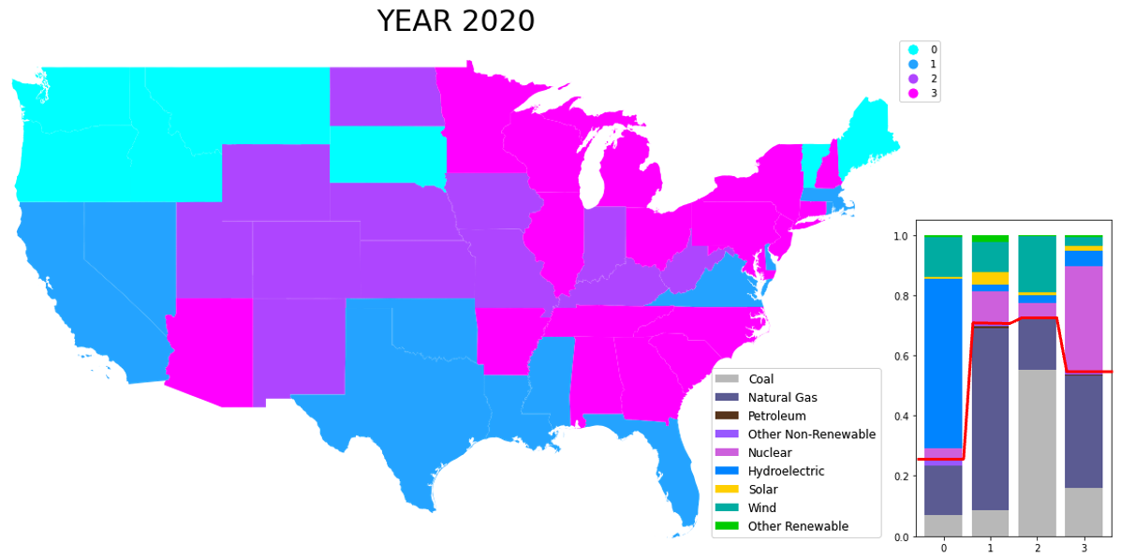

*Fig. 3.4: K-means clustering of states based on power generated from all fuel types for 2020.*

The following K-means clustering analysis groups power companies instead of states by their fuel profile. For 2005, power companies seemed to focus on using only one type of non-renewable fuel, except for hydroelectricity (appendix: Fig. 3.5). This is almost the same for 2010, except for a clustering of companies investing in both coal and nuclear, and another cluster generating wind energy (appendix: Fig. 3.6). Year ​2015 started to include a stronger clustering of companies focused on mostly non-renewable energy, such as wind, solar, and hydroelectricity (appendix: Fig. 3.7).​ For 2020, the clustering again mostly focused on a single fuel source as shown below in Fig. 3.8, but those sources are now almost all renewable. Based on this analysis, the companies clustered in labels ‘0’ and ‘2’ should shift from non-renewable to renewable energy sources in order to meet Biden’s 2030 goal.

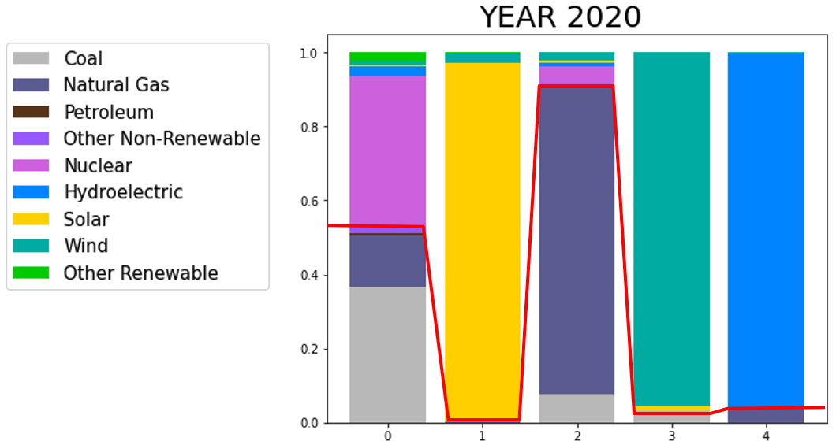

*Fig. 3.8: K-means clustering of energy companies based on power generated from all fuel types for 2020.*

## 6.2 Temporal prediction - Different Scenarios:

The temporal prediction of emission levels in 2025 gave a comparison of multiple levels of effort from the power sector to reduce its emissions:

1. If the power sector decides to take no extra action than already being planned or happening naturally, it will manage to reduce only 40% of the CO2 emissions from 2005 levels and only 10% from 2021 levels.
2. Coal currently contributes to ~40% of the energy generation in the US and is the most polluting energy source based on direct CO2 emissions. Many firms have a key focus on weaning off of coal in the near future. We built and analyzed multiple scenarios of coal dependence reduction and their impact on CO2 emissions:
   1. Reducing dependence on coal by 50% and replacing it with natural gas: Previous trends show that many electricity providers are shifting their focus from coal to natural gas. Noticeable reasons can be the reliability of fuel to generate electricity and its affordability compared to other fuel types. According to the above projections, if the power sector shifts 50% of its coal dependency to natural gas, it will contribute to a 42.9% reduction in CO2 emissions from the 2005 level, and 11.6% from the 2021 emission level. Which is not very different if we continue with the usual business scenario.
   2. Reducing dependence on coal by 100% and replacing it with natural gas: This scenario is taken into consideration because shifting from coal to natural gas in a short period seems easy to cut CO2 emissions from coal by 2025. This is because it does not require additional infrastructure to be built or any new electricity production or distribution system to be laid. Usage of natural gas to produce electricity is already in the pipeline and for the same reason its comparatively possible to scale up the production in a shorter period. But, the concerning part about the usage of natural gas is it cannot lead us to net-zero emissions anytime in the future. According to the projections, this scenario can contribute to a 51.5% reduction in CO2 emissions from the 2005 level, and 26.2% from the 2021 emission level.
   3. Reducing dependence on coal by 100% and replacing it with renewable energy sources like nuclear, solar, wind etc. (sources without direct CO2 emission contribution): Renewable energy sources like nuclear, solar, wind etc. do not have any direct emissions. This scenario is built with the consideration that decarbonization is taken seriously putting all the efforts and resources. This will need a considerable amount of infrastructure and financial investment. According to the projections, this scenario can bring up to a 64.8% reduction in CO2 emissions from the 2005 level, and 46.4% from the 2021 emission level.

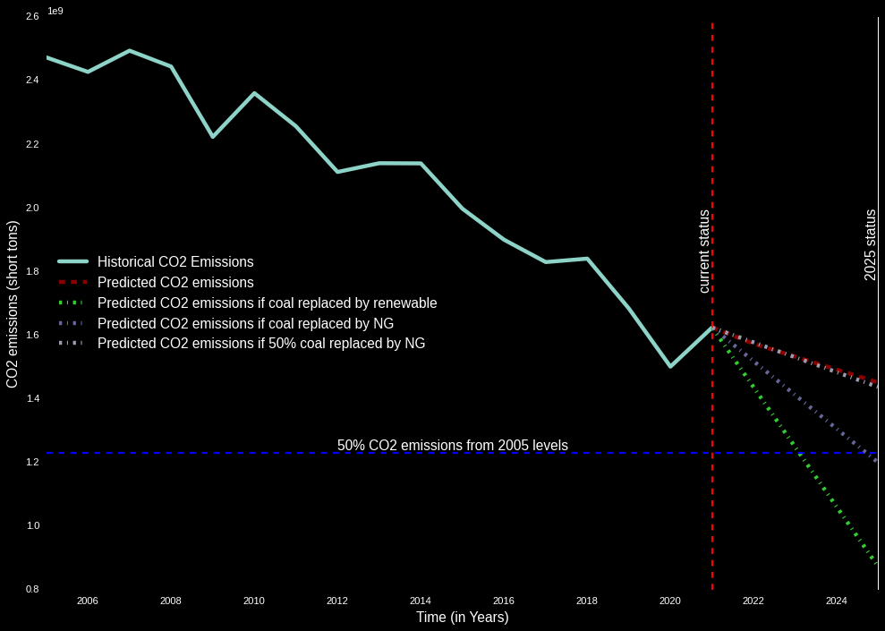

*Fig. 4.1: Temporal progression of direct CO2 emissions from 2005 to 2025 for the US Energy sector*

#### 7. Conclusion

The study gives us hope that slowly but steadily, the power sector has been moving in the right direction for the past 15 years. Though some states have a clear advantage over others and have moved ahead in adopting renewable energy sources, a clear shift from coal and natural gas to nuclear and other renewable sources is observed across the board. The study also shows that Biden's recently stated 2030 goal for a carbon free power sector, while ambitious, is not practically feasible unless improbable and drastic measures are taken by the industry. Even for reaching 50% levels of CO2 emissions from 2005, the United States will very certainly require a considerable departure from business as usual, which will be a difficult and expensive effort.

*8. Appendix*

## 8.1 K-means clustering

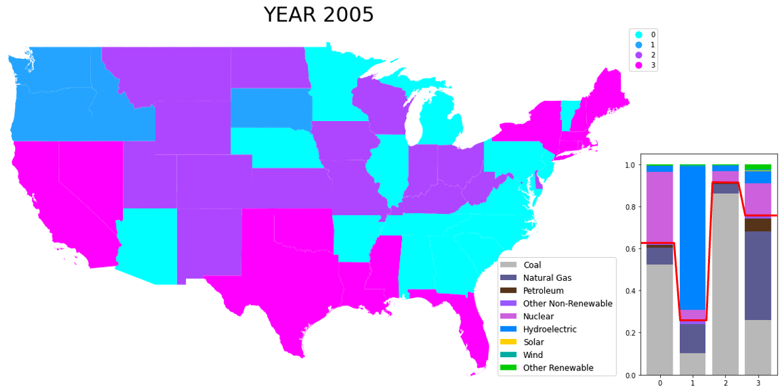

*Fig. 3.1: K-means clustering at the state level based on energy output for all fuel types for 2005.*

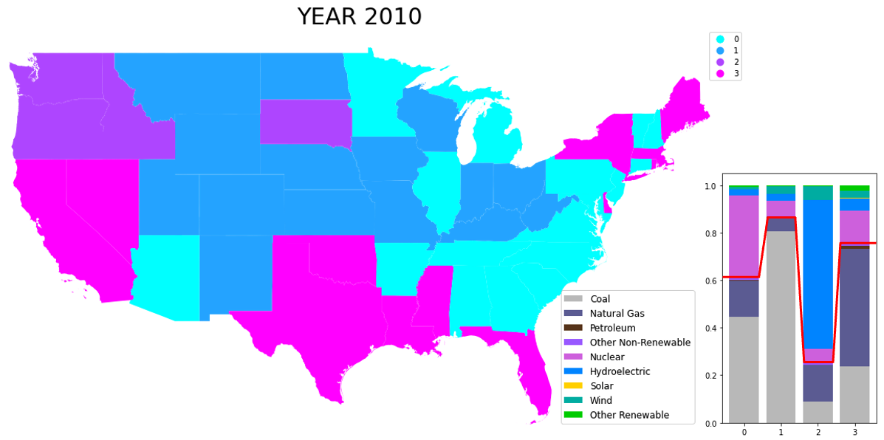

*Fig. 3.2: K-means clustering at the state level based on energy output for all fuel types for 2010.*

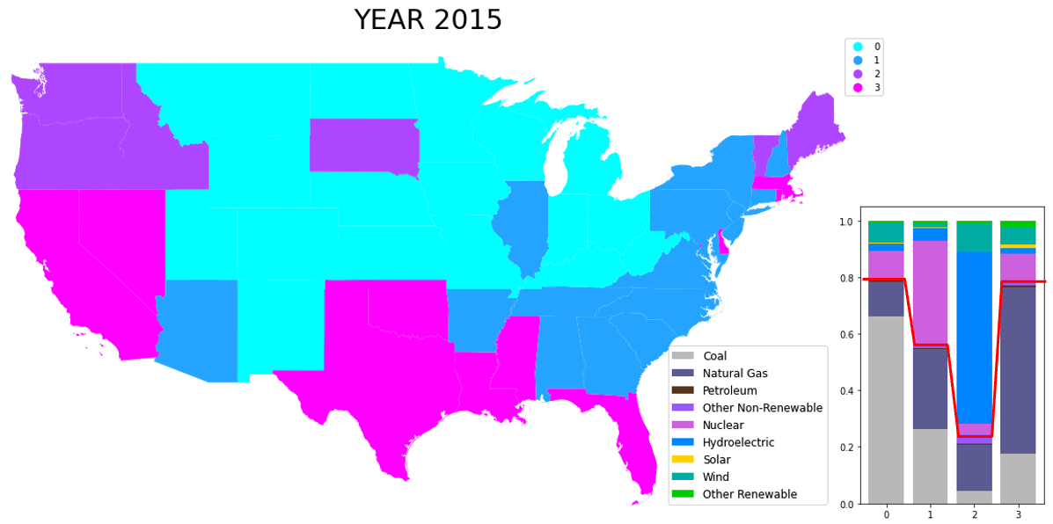

*Fig. 3.3: K-means clustering at the state level based on energy output for all fuel types for 2015.*

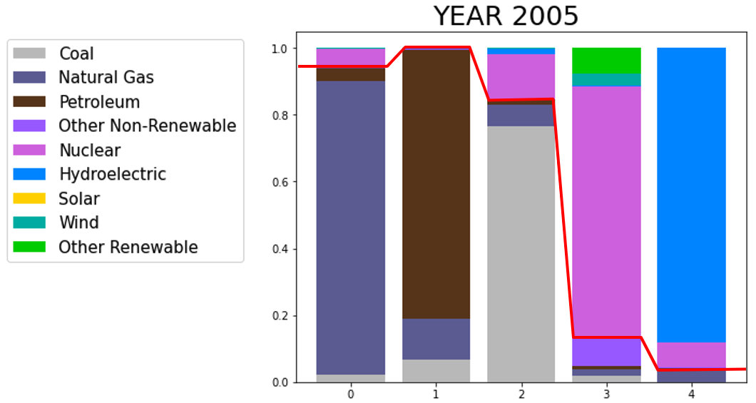

*Fig. 3.5: K-means clustering of energy companies based on power generated from all fuel types for 2005.*

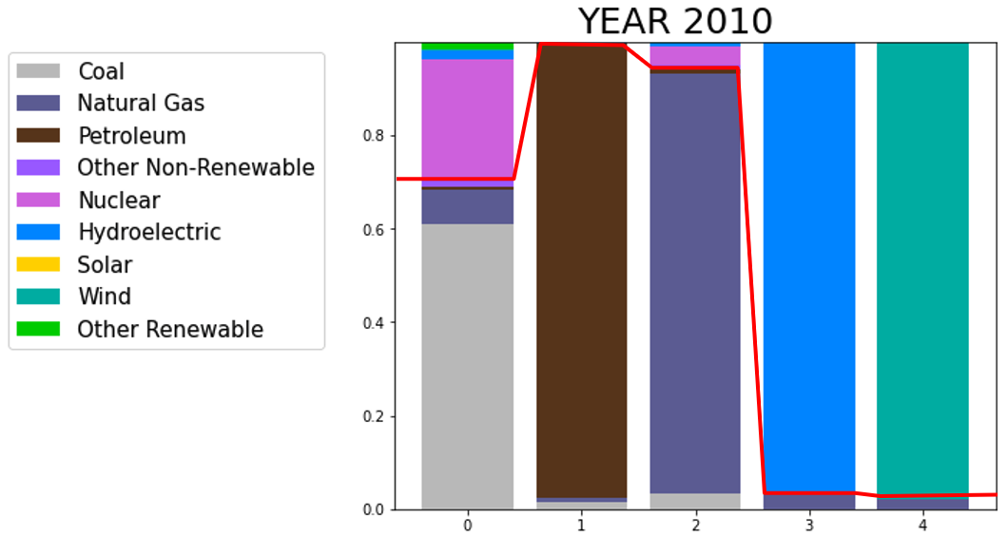

*Fig. 3.6: K-means clustering of energy companies based on power generated from all fuel types for 2010.*

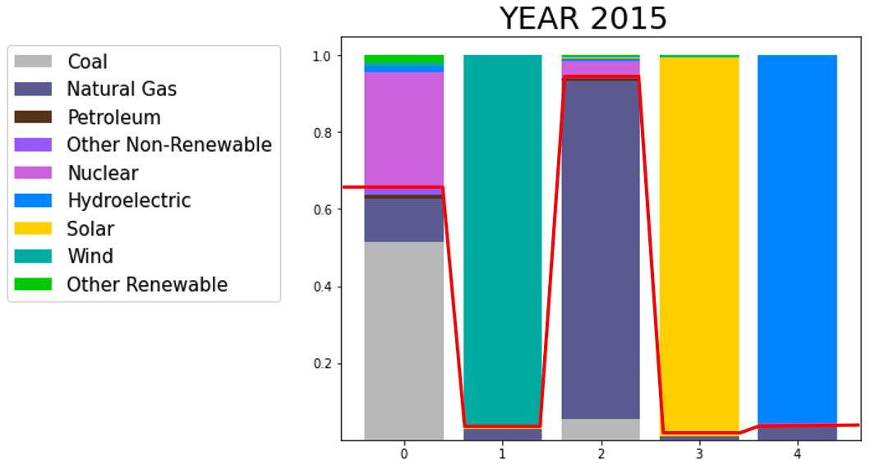

*Fig. 3.7: K-means clustering of energy companies based on power generated from all fuel types for 2015.*

8.2 Emission conversion matrix by EPA:

| Fuel Type | Electricity generation million kWh | Co2 emissions million metric tons | Million short tons | Pounds per kWh |
| --- | --- | --- | --- | --- |
| Coal | 757,763 | 767 | 845 | 2.23 |
| Natural Gas | 1402438 | 576 | 635 | 0.91 |
| Petroleum | 13665 | 13 | 15 | 2.13 |

## Individual Roles and Contributions:

| Project Components | Sub Components | *Brian Song* | *Charan Kukunoor* | *Vaishnavi Muthukrishnan* | *Vishakha Hedau* |
| --- | --- | --- | --- | --- | --- |
| Coding | Data cleaning | *X* | *X* | *X* | *X* |
| Clustering analysis | X |  |  |  |
| Current scenario analysis |  | X |  |  |
| Scenario Predictions |  |  | X | X |
| Report | Introduction |  |  | X |  |
| Literature Review |  | X |  |  |
| Clustering Analysis | X |  |  |  |
| Scenario Analysis |  |  | X | X |
| Conclusion |  | X | X |  |
| Appendix |  |  |  | X |
| References | X | X |  |  |
| Data Collection |  | X | X |  |  |
| Presentation |  | *X* | *X* | X | X |

#### 9. Reference

1. IPCC. “Global Warming of 1.5°C.” [Masson-Delmotte, V., P. Zhai, H.-O. Pörtner, (eds.)]. World Meteorological Organization, 2018. 32pp. <https://www.ipcc.ch/sr15/>.
2. US EPA. “Inventory of U.S. Greenhouse Gas Emissions and Sinks.” EPA 430-R-21-005, Apr. 2021.
3. Office of the Press Secretary, US. “President Biden Sets 2030 Target [Fact sheet].” The White House, Apr. 2021.
4. Department of Energy, Energy Information Administration. "More U.S. coal-fired power plants are decommissioning as retirements continue." Washington DC, 2019. <https://www.eia.gov/todayinenergy/detail.php?id=40212>.
5. IPCC. "Climate Change 2021: The Physical Science Basis. Contribution of Working Group I to the Sixth Assessment Report of the Intergovernmental Panel on Climate Change." Cambridge University Press. Cambridge UK, 2021.<https://www.ipcc.ch/report/ar6/wg1/>.
6. Congress, US. The United States Executive Office of the President. *The Long-Term Strategy of the United States: Pathways to Net-Zero Greenhouse Gas Emissions by 2050*. The United States Department of State, 2021. pp. 13–29.
7. EIA. Annual Energy Outlook 2014 with projections to 2040 (Vol. April 2014): U. S. Energy Information Administration (EIA), 2014.
8. EIA. Energy Consumption by Sector Retrieved December 12, 2014, from US Energy Information Administration (EIA), 2014. <http://www.eia.gov>.
9. EIA. Monthly Energy Review (Vol. Dec 2001): US Energy Information Administration (EIA), 2001.
10. EIA. Monthly Energy Review (Vol. Dec 2002): US Energy Information Administration (EIA), 2002.
11. EIA. Monthly Energy Review (Vol. Dec 2003): US Energy Information Administration (EIA), 2003.
12. EIA. Monthly Energy Review (Vol. Dec 2004): US Energy Information Administration (EIA), 2004.
13. EIA. Monthly Energy Review (Vol. Dec 2005): US Energy Information Administration (EIA), 2005.
14. EIA. Monthly Energy Review (Vol. Dec 2006): US Energy Information Administration (EIA), 2006.
15. EIA. Monthly Energy Review (Vol. Dec 2007): US Energy Information Administration (EIA), 2007.
16. EIA. Monthly Energy Review (Vol. Dec 2008): US Energy Information Administration (EIA), 2008.
17. EIA. Monthly Energy Review (Vol. Dec 2009): US Energy Information Administration (EIA), 2009.
18. EIA. Monthly Energy Review (Vol. Dec 2010): US Energy Information Administration (EIA), 2010.
19. EIA. Monthly Energy Review (Vol. Dec 2011): US Energy Information Administration (EIA), 2011.
20. EIA. Monthly Energy Review (Vol. Dec 2012): US Energy Information Administration (EIA), 2012.
21. EIA. Monthly Energy Review (Vol. Dec 2013): US Energy Information Administration (EIA), 2013.
22. EIA. Monthly Energy Review (Vol. Dec 2014): US Energy Information Administration (EIA), 2014.
23. EIA. Monthly Energy Review (Vol. Dec 2015): US Energy Information Administration (EIA), 2015.
24. EIA. Monthly Energy Review (Vol. Dec 2016): US Energy Information Administration (EIA), 2016.
25. EIA. Monthly Energy Review (Vol. Dec 2017): US Energy Information Administration (EIA), 2017.
26. EIA. Monthly Energy Review (Vol. Dec 2018): US Energy Information Administration (EIA), 2018.
27. EIA. Monthly Energy Review (Vol. Dec 2019): US Energy Information Administration (EIA), 2019.
28. EIA. Monthly Energy Review (Vol. Dec 2020): US Energy Information Administration (EIA), 2020.
29. EIA. Monthly Energy Review (Vol. Nov 2021): US Energy Information Administration (EIA), 2021.