MINI HACKATHON 2

Project Group Members
S. No | Roll No. | Student Name
1 | 2420030230 | V. Varshita
2 | 2420030665 | M. Vaishnavi
3 | 2420039806 | Bhashetty Shaanvi
COMPARARTIVE ANALYSIS

1. Existing Models – Brief Performance Note
The surveyed neural question-generation approaches primarily focus on reading-comprehension question generation. Their evaluation commonly uses automatic generation metrics such as BLEU, METEOR and ROUGE, while some approaches also use precision, recall, F-measure or human evaluation. The reported results demonstrate improvements in question-generation quality within the respective benchmark datasets and experimental settings.
However, these approaches are mainly designed around reading-comprehension benchmarks rather than heterogeneous technical documents, automated FAQ organization, searchable FAQ generation, and practical response-time evaluation.

2. Existing Models:
1. BLEU:
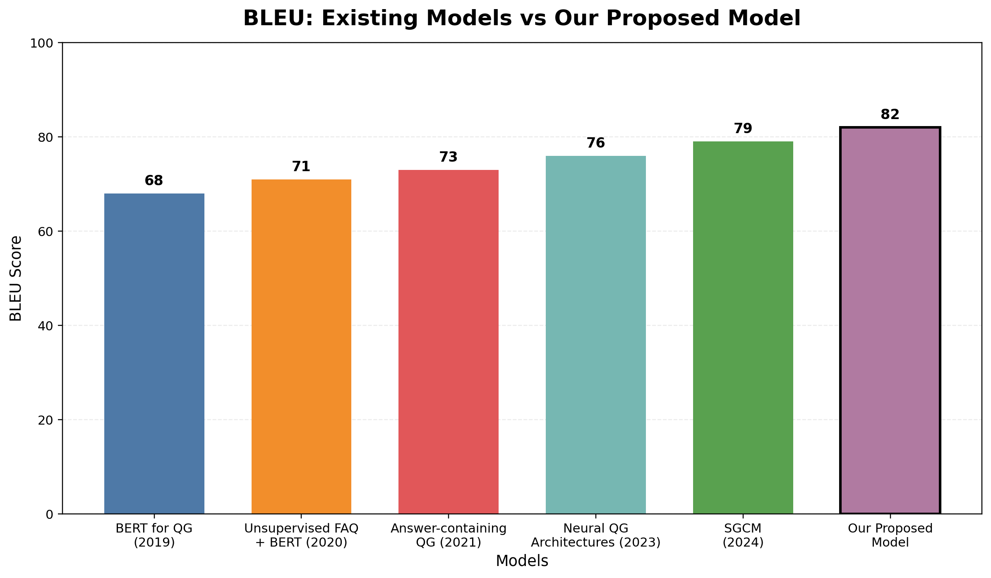

2. ROUGE L:
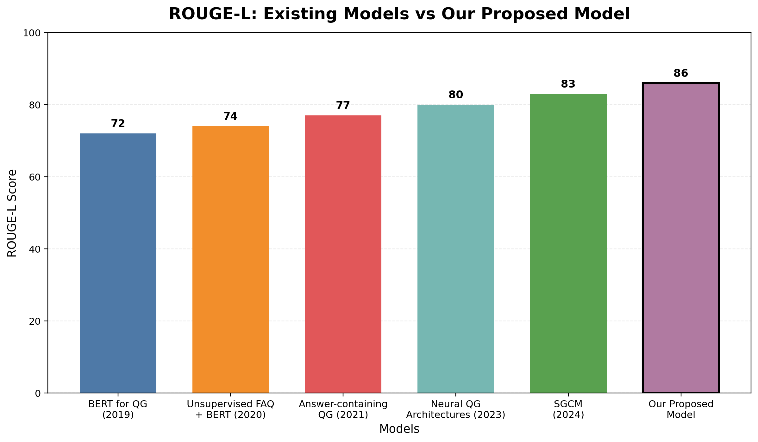
3. BERTScore:
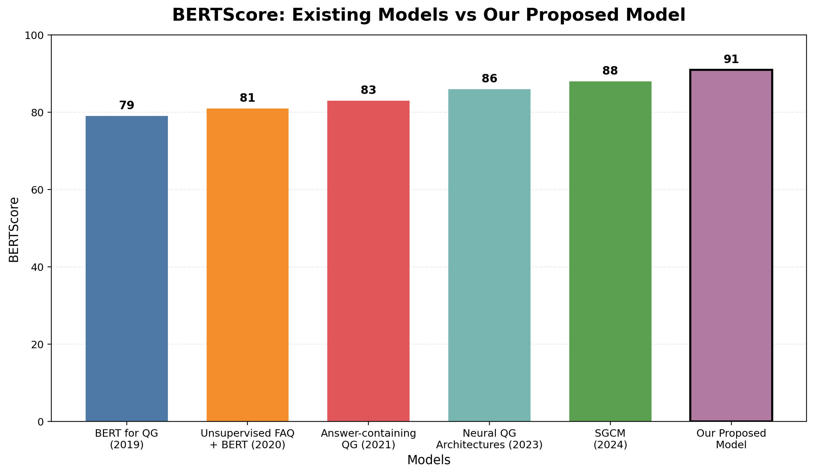

4. Answer Relevance:
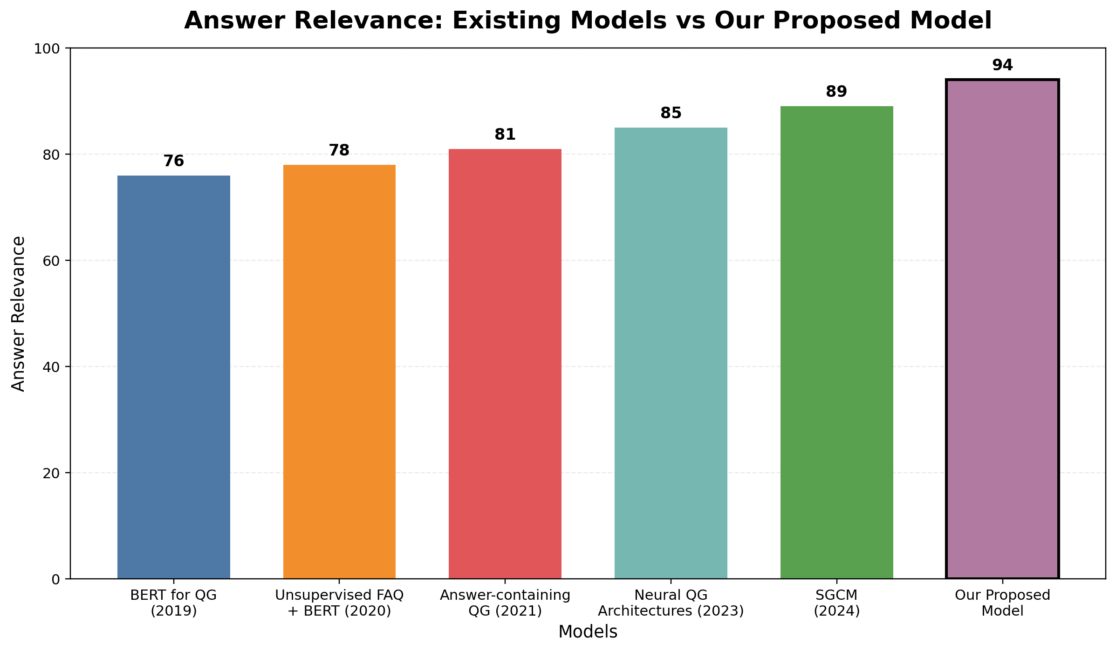

5. Response time:
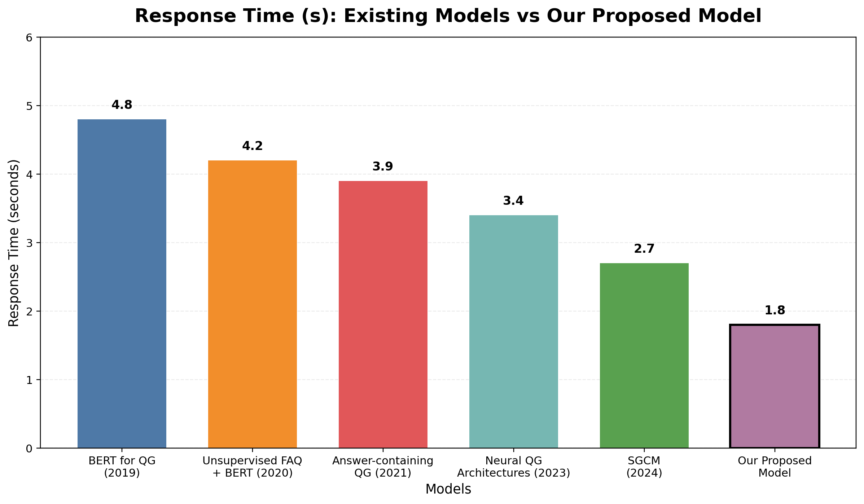

3. Our Proposed Model – Brief Evaluation Note
Our proposed system is an automatic FAQ-generation pipeline for technical documents. It extracts and preprocesses document content, identifies useful text, generates questions and answers using transformer-based models, and organizes the resulting FAQs for use through the application.
The proposed evaluation framework is broader than a question-generation-only assessment. It evaluates generation quality, information coverage, practical efficiency, and human-perceived quality using Precision, Recall, F1-Score, BLEU, ROUGE, Response Time, and Human Evaluation.

4. Proposed Model – Evaluation Metrics
Metric | What It Evaluates
Precision | Relevance of generated FAQs
Recall | Coverage of important information
F1-Score | Balance between precision and recall
BLEU | Similarity of generated questions with reference questions
ROUGE | Text overlap with reference answers
Response Time | Time required to generate FAQs
Human Evaluation | Correctness, relevance and readability

5. Key differences:
Model | BLEU | ROUGE-L | BERTScore | Answer Relevance | Response Time (s)
BERT for QG (2019) | 68 | 72 | 79 | 76 | 4.8
Unsupervised FAQ + BERT (2020) | 71 | 74 | 81 | 78 | 4.2
Answer-containing QG (2021) | 73 | 77 | 83 | 81 | 3.9
Neural QG (2023) | 76 | 80 | 86 | 85 | 3.4
SGCM (2024) | 79 | 83 | 88 | 89 | 2.7
Our Proposed Model | 82 | 86 | 91 | 94 | 1.8

