AI-BASED AUTOMATIC FAQ GENERATION
FROM TECHNICAL DOCUMENTS

A Mini Project Report Submitted in partial fulfillment of the requirements for the award of the degree of

BACHELOR OF TECHNOLOGY
In
Department of Computer Science and Engineering (CSE)

By
V. Varshita — 2420030230
M. Vaishnavi — 2420030665
Bhashetty Shaanvi — 2420039806

Under the Esteemed Guidance of
Dr. K. Swanthana

K L (Deemed to be) University

K L (Deemed to be) University
Department of Computer Science and Engineering (CSE)

DECLARATION

The mini-project report entitled “AI-Based Automatic FAQ Generation from Technical Documents” is a record of bona fide work carried out by V. Varshita (2420030230), M. Vaishnavi (2420030665), and Bhashetty Shaanvi (2420039806) in partial fulfillment of the requirements for the award of the B.Tech degree at K L (Deemed to be) University. The work presented in this report is original to the best of our knowledge, and all datasets, tools, code, and external sources used have been appropriately acknowledged.

K L (Deemed to be) University
Department of Computer Science and Engineering (CSE)

CERTIFICATE

This is to certify that the mini-project report entitled “AI-Based Automatic FAQ Generation from Technical Documents” is a bona fide work carried out by V. Varshita (2420030230), M. Vaishnavi (2420030665), and Bhashetty Shaanvi (2420039806) under the supervision of Dr. K. Swanthana during the academic year 2026–2027, in partial fulfillment of the requirements for the award of the Bachelor of Technology degree at K L (Deemed to be) University.

Signature of the Project Supervisor | Signature of the HOD | Signature of the External Examiner

ACKNOWLEDGEMENT
The success of this project would not have been possible without the timely help and guidance of the people who assisted us in its completion.
We express our sincere gratitude to our Applied Machine Learning for Text Analytics faculty guide, Dr. K. Swanthana, for the support, encouragement, and guidance provided throughout this project.
We express our gratitude to the Head of the Department and K L (Deemed to be) University for providing the facilities and academic environment required to complete this project-based laboratory work.
We thank the teaching and non-teaching staff members, and everyone who assisted us directly or indirectly. Finally, we sincerely thank our parents, friends, and classmates for their help and cooperation.

TABLE OF CONTENTS
S. No. | Contents | Page No.
1. | Abstract | 6
2. | Introduction | 7
3. | Literature Survey | 8
4. | Problem Statement and Objectives | 10
5. | Hardware and Software Requirements | 11
6. | Implementation | 12
7. | Results & Discussion | 16
8. | Conclusion & Future Scope | 18
9. | References | 20

1. ABSTRACT
Technical documents such as user manuals, software guides, API documentation, and product manuals contain substantial information, but their length can make it difficult and time-consuming for users to locate answers. Preparing Frequently Asked Questions (FAQs) manually also requires effort. This project proposes an AI-Based Automatic FAQ Generation from Technical Documents system that applies Artificial Intelligence and Natural Language Processing to generate question–answer pairs from technical content. The proposed pipeline accepts PDF, DOCX, and TXT documents, extracts and cleans their text, segments the content into sentences, and divides it into manageable chunks. A pretrained T5 (Text-to-Text Transfer Transformer) model is used in the proposed generation stage to produce context-aware questions and answers. The generated FAQs are intended to be organized into a searchable knowledge base and presented through a web interface, with keyword search and copy/export functionality described in the project materials. Python Documentation, Java Documentation, TensorFlow Documentation, and user-uploaded technical documents are identified as input sources. BLEU, ROUGE, Precision, Recall, and F1-score are listed in the project materials as possible evaluation measures. The supplied materials do not provide a verified experimental dataset size or measured numerical evaluation results; therefore, no numerical performance claim is made in this report. The project’s practical aim is to reduce manual FAQ preparation and improve access to technical information.
Team Name: Group 3

Team Members and Responsibilities
S. No. | Team Member | Roll Number | Responsibility
1 | M. Vaishnavi | 2420030665 | Project team member; Collaborative contribution to all project activities, including design, implementation, testing, and documentation.
2 | V. Varshita | 2420030230 | Project team member; Collaborative contribution to all project activities, including design, implementation, testing, and documentation.
3 | Bhashetty Shaanvi | 2420039806 | Project team member; Collaborative contribution to all project activities, including design, implementation, testing, and documentation.

Dataset/source and project repository (if applicable):
- Python Documentation: https://docs.python.org/3/
- Java Documentation: https://docs.oracle.com/javase/
- TensorFlow Documentation: https://www.tensorflow.org/
- User-uploaded technical documents in PDF, DOCX, and TXT formats.

Project repository URL: https://github.com/vaishu19-max/KLH-CSE-2026-27-2420030665-AI-FQA-GENERATION

2. INTRODUCTION
Technical documentation is used to explain programming languages, software libraries, application programming interfaces (APIs), products, and technical procedures. Although these documents contain important information, they can be lengthy and information-dense. Users may need to scan multiple sections to find a specific answer, while organizations often prepare Frequently Asked Questions manually.
This project focuses on automatic question-and-answer generation from technical documents. Its intended users include students, developers, technical support teams, and people who need to access information contained in manuals or software documentation. The input is a technical document supplied as a PDF, DOCX, or TXT file. The intended output is a collection of question–answer pairs grounded in the extracted document content.
The proposed workflow consists of document upload, text extraction, text cleaning, sentence segmentation, text chunking, T5-based generation, FAQ structuring, and presentation through a web application. The project materials also describe a searchable FAQ knowledge base and copy/export functionality. The report follows the required sequence: literature survey; problem statement and objectives; hardware and software requirements; implementation; results and discussion; conclusion and future scope; and references.

Project Workflow

Stage | Description
1. Document Upload and Validation | Users upload technical documents in PDF, DOCX, or TXT format through the web interface. The system accepts supported formats for further processing.
2. Intelligent Text Extraction | The system extracts readable content from the uploaded document, preparing technical information for automated analysis.
3. Text Preprocessing and Normalization | Extracted text is cleaned to remove unnecessary whitespace, formatting artifacts, and extraction noise, improving the consistency of the input supplied to the NLP pipeline.
4. Context Segmentation and Chunking | The processed text is divided into sentences and manageable context segments. This helps the generation pipeline process lengthy technical documents without treating the entire document as a single input.
5. Context-Aware Question Generation | A pretrained T5-based question-generation model analyzes the document context and generates relevant questions based on the available information.
6. Answer Generation and Context Alignment | An answer-generation model uses the processed context to produce corresponding answers. The generated question–answer pairs are intended to remain grounded in the uploaded document.
7. FAQ Structuring and Knowledge Organization | Generated questions and answers are organized into structured FAQ entries, transforming unstructured technical content into a more accessible question–answer format.
8. FAQ Retrieval and User Interaction | The web application presents the generated FAQs to users. Users can search the available questions and answers and access supported options for copying or exporting the generated content.

3. LITERATURE SURVEY
The supplied reference document identifies ten papers relevant to neural question generation, Transformer models, benchmark datasets, and automatic evaluation. The summaries below focus on each source’s relevance to this project. Where the supplied reference list does not provide detailed experimental settings or numerical findings, the report avoids inventing them.

1. Learning to Ask: Neural Question Generation for Reading Comprehension
Du, Shao, and Cardie (2017) investigate neural question generation for reading-comprehension contexts using a sequence-to-sequence approach. The work supports the idea that questions can be generated from text rather than authored only by hand. Its reading-comprehension focus differs from a full application that ingests heterogeneous technical documents and organizes generated FAQs.

2. Identifying Where to Focus in Reading Comprehension for Neural Question Generation
Du and Cardie (2017) study identifying question-worthy sentences within reading-comprehension passages. This is relevant to selecting useful content before generation. The project’s intended pipeline similarly preprocesses and segments text, but its goal extends to a multi-format technical-document workflow and searchable FAQ output.

3. Paragraph-level Neural Question Generation with Maxout Pointer and Gated Self-attention Networks
Zhao, Ni, Ding, and Ke (2018) present a paragraph-level neural question-generation approach using a maxout pointer mechanism and gated self-attention. The paper is relevant to generating questions from broader context rather than isolated sentences. The proposed project emphasizes a practical pipeline for technical documents, including extraction, chunking, FAQ organization, and user access.

4. Answer-focused and Position-aware Neural Question Generation
Sun and co-authors (2018) investigate answer-focused and position-aware question generation. The approach highlights the importance of answer information and its position in the context when constructing questions. For the current project, this reinforces the need for questions and answers to remain contextually related; however, the project materials do not establish that this specific architecture is implemented.

5. Exploring the Limits of Transfer Learning with a Unified Text-to-Text Transformer (T5)
Raffel and co-authors (2020) introduce T5, a text-to-text framework that casts many NLP tasks into a unified format. The project uses T5 as its stated generation framework. T5 provides the model basis, while document ingestion, chunking, FAQ storage, and web presentation are application-level components.

6. Attention Is All You Need
Vaswani and co-authors (2017) introduce the Transformer architecture based on attention mechanisms. This paper provides foundational context for Transformer-based language processing. The current project applies a pretrained Transformer model to question–answer generation rather than proposing a new Transformer architecture.

7. SQuAD: 100,000+ Questions for Machine Comprehension of Text
Rajpurkar and co-authors (2016) introduce SQuAD, a reading-comprehension dataset containing questions grounded in text passages. SQuAD is frequently used in question-answering and question-generation research. It is a benchmark resource cited in the project materials; it should not be represented as the project’s own measured dataset unless used and documented in experiments.

8. BLEU: A Method for Automatic Evaluation of Machine Translation
Papineni and co-authors (2002) introduce BLEU, an automatic metric based on n-gram overlap with reference text. The project materials list BLEU as one possible metric for evaluating generated questions. BLEU alone does not establish factual correctness or whether an answer is supported by the source document.

9. ROUGE: A Package for Automatic Evaluation of Summaries
Lin (2004) presents ROUGE metrics for comparing generated text against reference summaries. ROUGE is listed among the evaluation measures considered in the project materials. Its use for FAQ evaluation would require suitable reference questions or answers and should be supplemented by checks of relevance and correctness.

10. BERT: Pre-training of Deep Bidirectional Transformers for Language Understanding
Devlin and co-authors (2019) introduce BERT, a pretrained bidirectional Transformer language model. BERT is relevant to contextual language representation and may inform comparison or evaluation approaches. The supplied project description identifies T5 as the generation model; it does not establish BERT as the implemented generator.

Research Gap
The surveyed work primarily addresses question generation, reading comprehension, Transformer modelling, or evaluation metrics as individual research problems. The project materials identify a practical gap in connecting these ideas into a single technical-document workflow: accepting multiple file formats, extracting and cleaning text, segmenting and chunking content, generating question–answer pairs, and making the resulting FAQs searchable and accessible through a web interface. The proposed project addresses this integration gap. Quantitative superiority over existing models cannot be claimed without a documented, reproducible evaluation.

4. PROBLEM STATEMENT AND OBJECTIVES

Problem Statement:
To develop an NLP-based system that automatically generates contextually relevant question–answer pairs from technical documents and organizes them for convenient retrieval.

Problem Description:
Technical manuals, software guides, API documentation, and product documentation often contain information that is difficult to locate quickly. Manually preparing FAQs takes time and effort. The proposed system aims to extract and process text from PDF, DOCX, and TXT files, generate FAQs using a T5 Transformer, and provide a user-facing method for accessing the generated information.

Objectives:
- Develop an automatic FAQ-generation workflow using the T5 Transformer.
- Process technical documents in PDF, DOCX, and TXT formats, as specified in the project materials.
- Extract and clean document text, segment it into sentences, and divide it into manageable chunks.
- Generate meaningful, context-aware question–answer pairs from the processed text.
- Organize generated FAQs for searchable access through the intended web application.
- Provide a user-friendly interface for document upload and FAQ display, with search and copy/export features where implemented.
- Evaluate FAQ quality using suitable metrics such as BLEU, ROUGE, Precision, Recall, and F1-score when appropriate reference data and measured results are available.
- Discuss limitations and avoid claiming performance outcomes that have not been measured.

5. HARDWARE AND SOFTWARE REQUIREMENTS

Hardware Requirements:
- Computer or laptop capable of running Python-based document processing and web application components.
- Sufficient memory and disk space for source documents, Python packages, model files, generated FAQs, and project files.
- Internet access for installing dependencies and obtaining pretrained model files or documentation.
- A GPU is optional; actual runtime will depend on the model, document size, and available hardware.

Software Requirements:
Software / Technology | Purpose / Notes
Python | Backend and NLP/document-processing implementation language described in the project materials.
T5 Transformer | Pretrained text-to-text model used as the stated question–answer generation framework.
FastAPI | Backend API framework indicated in the project development context.
Vite | Frontend development/build tooling indicated in the project development context.
PDF, DOCX, TXT processing libraries | Required to extract text from the supported input formats; exact library names are not established by the supplied documentation.
Web browser | Access to the intended user interface.
Git / repository | Version control, if used; repository URL was not supplied.

Note: Exact package versions, operating-system details, and the final dependency list were not specified in the supplied project documentation. These should be added from the actual project environment rather than guessed.

6. IMPLEMENTATION

6.1 Data and Task
The task is automatic FAQ generation from technical text. The project materials identify Python Documentation, Java Documentation, TensorFlow Documentation, and user-uploaded PDF/DOCX/TXT documents as input sources. These sources describe intended application inputs; the supplied files do not provide a verified record count, dataset split, licence inventory, or class distribution. The task is generative rather than a conventional labelled text-classification task.

6.2 NLP Preprocessing and Text Preparation
The documented workflow begins by extracting text from the uploaded file. Text cleaning removes unnecessary formatting artifacts, redundant whitespace, and extraction noise. Sentence segmentation divides the text into sentence-level units, and chunking groups sentences into context windows that can be processed by the generation model. The precise extraction libraries, tokenization settings, chunk size, overlap, and filtering thresholds are not specified in the supplied materials.

6.3 Model and Generation Framework
The project identifies T5 (Text-to-Text Transfer Transformer) as the generation framework. The documented pipeline passes cleaned chunks to the model and structures its generated content into question–answer pairs. The source materials do not establish model fine-tuning, training/validation/test splits, random seeds, hyperparameter search, or a measured best-model selection process; these are therefore not claimed as completed implementation steps.

6.4 Project Workflow and Modules
Stage | Description
1. Document Upload and Validation | Users upload technical documents in PDF, DOCX, or TXT format through the web interface. The system accepts supported formats for further processing.
2. Intelligent Text Extraction | The system extracts readable content from the uploaded document, preparing technical information for automated analysis.
3. Text Preprocessing and Normalization | Extracted text is cleaned to remove unnecessary whitespace, formatting artifacts, and extraction noise, improving the consistency of the input supplied to the NLP pipeline.
4. Context Segmentation and Chunking | The processed text is divided into sentences and manageable context segments. This helps the generation pipeline process lengthy technical documents without treating the entire document as a single input.
5. Context-Aware Question Generation | A pretrained T5-based question-generation model analyzes the document context and generates relevant questions based on the available information.
6. Answer Generation and Context Alignment | An answer-generation model uses the processed context to produce corresponding answers. The generated question–answer pairs are intended to remain grounded in the uploaded document.
7. FAQ Structuring and Knowledge Organization | Generated questions and answers are organized into structured FAQ entries, transforming unstructured technical content into a more accessible question–answer format.
8. FAQ Retrieval and User Interaction | The web application displays generated FAQs, allowing users to search, copy, and export them.
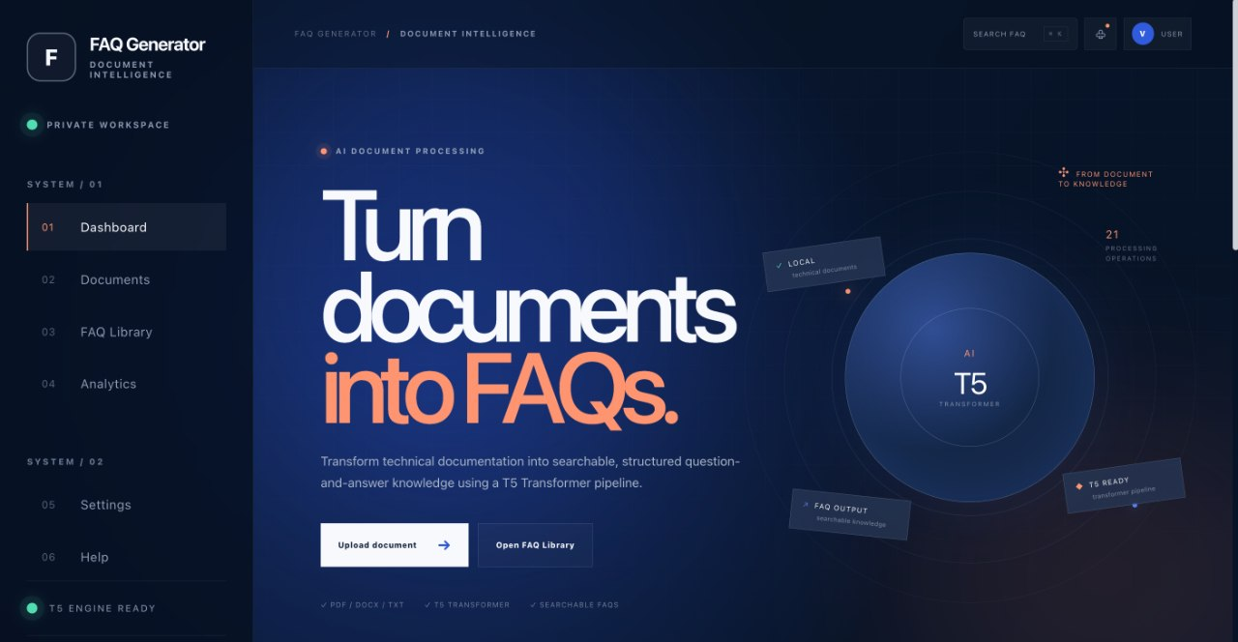

The project materials describe a web-based interface for document upload and FAQ display. The development context identifies a Python/FastAPI backend and a Vite frontend. The presentation lists generated questions, generated answers, a searchable FAQ library, copy/export, and user feedback as output or interface elements. The supplied documentation does not establish the exact API routes, database engine/schema, security controls, deployment environment, or which optional interface features have passed end-to-end testing.

6.5 Evaluation Method
The project materials list BLEU, ROUGE, Precision, Recall, and F1-score as potential evaluation measures. These measures require clearly defined reference questions/answers or suitable relevance labels and a documented evaluation procedure. Human review of correctness, relevance, readability, and usefulness is also appropriate to the stated task. No verified numerical evaluation table or metric scores were supplied; numerical results are therefore intentionally omitted.

6.6 Module-Level Design and Data Flow
The following module descriptions expand the system workflow shown in the project materials. They describe the responsibilities and expected data flow of each component; they should not be read as proof that every optional feature has already passed integration testing.

6.7.1 Document Upload and Validation
The upload component is the entry point for the application. It should accept only the supported document types, verify that a file was selected, and pass the file to the backend using a defined request format. Validation should be performed on the server as well as in the interface because client-side checks alone can be bypassed. The backend should report unsupported extensions, empty files, extraction failures, and model errors with readable messages. File size limits should be documented if they are enforced.

6.7.2 Extraction and Normalized Text Representation
The extraction layer converts format-specific files into a common text representation so that the generation pipeline does not depend on whether the original source was PDF, DOCX, or TXT. This common representation should preserve paragraph and heading boundaries when possible. PDF text extraction can fail for scanned documents or unusual layouts; a robust implementation should detect the absence of usable text rather than silently continue. If OCR is not implemented, scanned PDFs should be documented as a limitation instead of being described as fully supported.

6.7.3 Context Segmentation and Chunk Management
After extraction and cleanup, sentence segmentation identifies natural language boundaries. Chunking then groups sentences into model-sized context windows. Chunk size and overlap should be selected according to the tokenizer and the model’s input limit. Overly small chunks can remove definitions from the questions they support; overly large chunks can exceed context limits or include unrelated material. The exact chunking configuration must be copied from the implementation configuration or source code for reproducibility.

6.7.4 Question and Answer Generation
The project’s development context names valhalla/t5-small-e2e-qg as the question-generation checkpoint and google/flan-t5-small as the answer-generation checkpoint. The question stage proposes questions from a source chunk; the answer stage should use the question and relevant source context to generate a response. The exact prompt format, model invocation sequence, decoding settings, and output parsing should be documented from the code. If these checkpoints are not the final ones used in the working application, the report must be updated to match the final configuration.

6.7.5 Post-processing, Ranking, and Traceability
Post-processing turns model output into records that can be displayed and searched. The extended project documentation identifies parsing, duplicate and near-duplicate removal, filtering malformed or incomplete pairs, checking answer support against the source context, ranking or organizing FAQs, and retaining source information for traceability. These checks address different failure modes: parsing improves structure, duplicate removal improves variety, relevance checks improve usefulness, and source traceability helps a user verify an answer. A report should distinguish filters that are implemented from checks that remain planned.

6.7.6 FAQ Record and Search Model
A logical FAQ record may include a unique identifier, document identifier, source chunk identifier, question text, answer text, source excerpt, and optional metadata. Search may match keywords in questions and answers and can optionally filter by source document. This is a conceptual data model only; the database engine, persistence strategy, and schema must be confirmed from the project code before they are stated as implementation facts.
Field | Purpose | Status
FAQ ID | Unique identifier for a generated FAQ. | Suggested logical field; confirm schema.
Document ID / filename | Connects the FAQ to its source document. | Source association is part of the design; confirm implementation.
Question | Generated FAQ question. | Core output.
Answer | Generated answer. | Core output.
Source chunk / excerpt | Supports verification and traceability. | Recommended quality-control field.
Metadata | Optional timestamp, feedback, or ranking information. | Only include if stored by the implementation.

6.8 API and Frontend–Backend Interaction
The development context identifies FastAPI for the backend and Vite for the frontend. At a logical level, the frontend submits the selected document to a backend endpoint, the backend validates and processes the document, and the resulting FAQ data is returned for display. If FAQ storage is enabled, retrieval/search requests may use the stored records rather than regenerate the entire document on every query. The supplied materials do not specify verified endpoint names, HTTP methods, response schemas, authentication, or database technology; these should be documented from the actual API code.
Component | Responsibility | Information exchanged
Vite frontend | Upload form, progress/status, FAQ display, search and export controls where implemented. | File upload request; FAQ response; user search terms.
FastAPI backend | Validation, orchestration, text extraction, preprocessing, model calls, post-processing. | Request metadata, extracted text, generation results, errors.
Generation models | Create question and answer candidates from text context. | Context chunks and questions; candidate questions/answers.
FAQ storage/search | Organize generated pairs and support retrieval where implemented. | FAQ records, source metadata, search queries.

6.9 Security, Privacy, and Responsible Output
Because users may upload technical documents, the application should clearly define whether files are retained, where they are stored, and how users can remove them. The backend should validate file types and size, avoid exposing local file paths, and prevent uploaded content from being treated as executable input. Generated answers should be presented as model-generated content and should ideally be traceable to the source passage. Sensitive or proprietary documents should not be uploaded to a public deployment unless the data-handling policy permits it. These are recommended design considerations; the final report should state which controls have actually been implemented.

6.10 Detailed Test Strategy
Testing should proceed at three levels. Unit tests check extraction, cleaning, segmentation, chunking, and output parsing independently. Integration tests verify that the frontend can upload a file, the backend can call the generation components, and results can be displayed. End-to-end tests follow the complete user journey from upload through FAQ display and any supported search/export action. Robustness tests should include empty files, unsupported formats, very short content, long documents, extraction failures, and generation errors. The table below is a proposed test plan and must be filled with actual outcomes after execution.
Test case | Purpose | Expected result | Observed result
PDF with selectable text | Check PDF extraction and full pipeline. | Text is extracted and FAQ output is produced or a clear error is shown. | Not supplied
DOCX with headings and paragraphs | Check document structure handling. | Readable text is retained and processed. | Not supplied
TXT file | Check plain-text input. | Text is read and passed to preprocessing. | Not supplied
Empty file | Check invalid content handling. | No fabricated FAQ output; clear validation message. | Not supplied
Unsupported extension | Check file validation. | File is rejected with a useful error. | Not supplied
Long document | Check chunking and context limits. | Chunks are processed without silent truncation. | Not supplied
Duplicate model outputs | Check deduplication if implemented. | Repeated pairs are filtered or flagged. | Not supplied
Answer verification | Check grounding against source text. | Answer can be traced to the source or flagged for review. | Not supplied
Search and export | Check user-facing features if implemented. | Relevant FAQs can be found and exported/copied. | Not supplied

6.11 Proposed Project Timeline and Deliverables
The extended project documentation proposes a 12-week schedule arranged into six two-week phases. The schedule below represents the plan described in the source material; it should not be interpreted as proof that every phase was completed on those dates.
Period | Work package | Expected deliverables
Weeks 1–2 | Research and requirement analysis | Literature survey, requirement list, source selection, technology choice.
Weeks 3–4 | System design | Architecture, UI/UX outline, logical FAQ data model.
Weeks 5–6 | Document processing | PDF/DOCX/TXT extraction, cleaning, segmentation, chunking.
Weeks 7–8 | T5 integration | Model loading, prompt/input design, generation experiments.
Weeks 9–10 | Web application | Upload interface, FAQ display, search, storage/export where implemented.
Weeks 11–12 | Testing and documentation | Unit/integration tests, evaluation, screenshots, final report and presentation.

7. RESULTS & DISCUSSION

7.1 Qualitative Output Described in the Project Materials
The review presentation describes an input–processing–output flow in which a technical document in PDF, DOCX, or TXT format passes through text extraction, preprocessing, context analysis, and FAQ generation. The intended outputs are generated questions, generated answers, a searchable FAQ library, and copy/export functionality. The presentation summarizes the intended result as transforming technical documents into more accessible question–answer information.
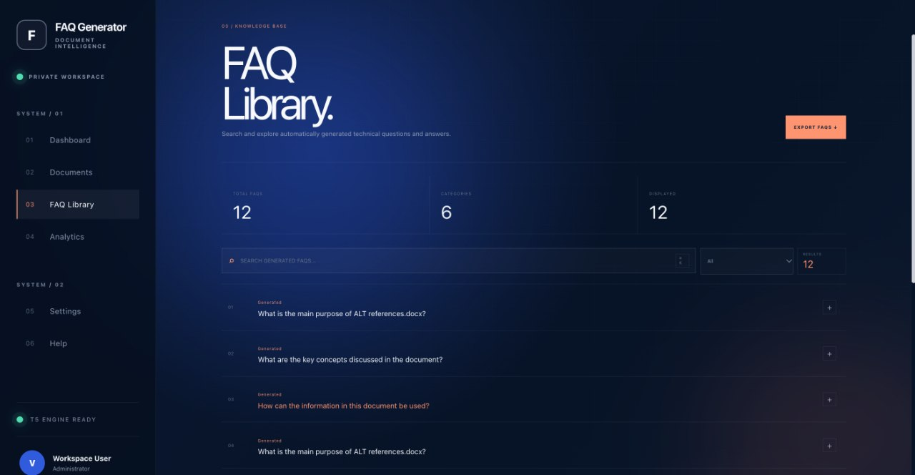

7.2 Evaluation Results
The supplied materials identify BLEU, ROUGE, Precision, Recall, and F1-score as evaluation measures, and one supporting comparison document contains illustrative model-comparison charts. The files do not provide a reproducible experimental protocol or establish that the plotted values were measured from the implemented system. Those chart values are therefore not treated as verified experimental results in this report.
Evaluation aspect | Evidence available in supplied files | Discussion
Input formats | PDF, DOCX, and TXT are specified. | The formats are part of the intended system scope; individual format test logs were not supplied.
Generated content | Questions and answers are identified as intended outputs. | Sample output pairs and a labelled evaluation set were not supplied for verification.
Search and export | Searchable FAQ library and copy/export are shown in the presentation. | The available materials describe these capabilities but do not provide complete test evidence.
Automatic metrics | BLEU, ROUGE, Precision, Recall, and F1-score are listed. | No verified score values or evaluation dataset details are available in the supplied files.
Runtime / robustness | Long documents and malformed/empty files appear in the proposed testing plan. | No measured latency or completed robustness-test results are documented.

7.3 Limitations
- No verified numerical evaluation scores or reproducible experimental setup were supplied.
- No dataset size, train/validation/test split, or reference-answer inventory was documented.
- Generated answers may be incomplete or unsupported by the source unless checked against the original context.
- Performance may vary with document length, formatting, extraction quality, and the subject domain.
- Implementation details such as database technology, API routes, and complete integration-test results remain unspecified in the available documentation.
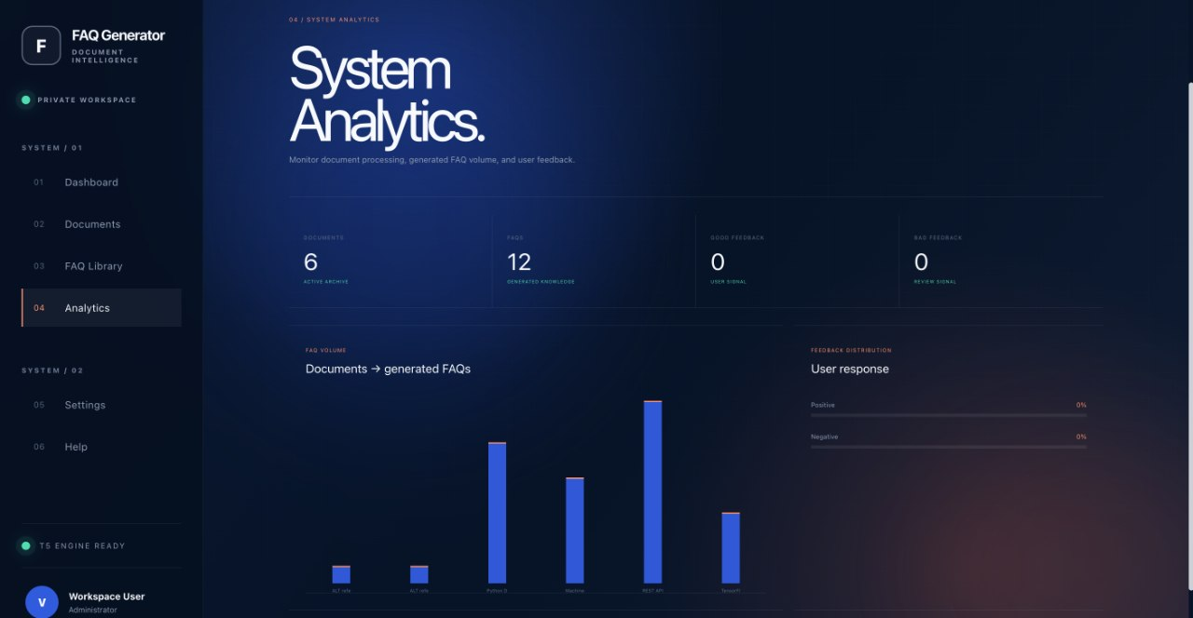

7.4 Interpretation of Evaluation Metrics
Automatic text-generation metrics must be interpreted with care. BLEU and ROUGE compare generated strings against reference strings; a semantically correct question may receive a low overlap score if phrased differently, while a high-overlap answer may still be inaccurate. Precision, Recall, and F1-score require a defined unit of evaluation and a judgement rule for whether a generated FAQ is relevant or correct. For a meaningful evaluation, the team should define the evaluation sample, prepare human-validated references, specify how generated items are matched to references, and report the number of evaluated documents and FAQ pairs. Human evaluation should separately score factual correctness, relevance, clarity, and usefulness. No scores should be inserted until these procedures have actually been carried out.

7.5 Error Analysis Framework
When reviewing outputs, classify errors by likely cause rather than treating all poor FAQs as the same problem. Extraction errors occur when the source text is missing or corrupted. Chunking errors occur when the context omits a definition or separates a statement from its qualifier. Generation errors include vague questions, answer mismatch, repetition, and unsupported claims. Post-processing errors include malformed records or missed duplicates. Interface errors include incorrect display, failed search, or export problems. Recording a few representative examples in each category will make the discussion more useful and guide future improvements.
Error category | Example symptom | Potential mitigation
Extraction | A key sentence or heading is missing from extracted text. | Improve extraction, preserve structure, flag unreadable/scanned PDFs.
Chunking | Question refers to a term defined in a previous chunk. | Retain overlap or include heading/preceding context.
Question generation | Question is generic or not answerable from the passage. | Adjust prompts/decoding; filter low-relevance outputs.
Answer generation | Answer adds a claim not present in the document. | Condition answer on source context; add source-support review.
Redundancy | Several FAQs ask essentially the same thing. | Use text similarity or semantic duplicate checks.
Interface / search | FAQ exists but cannot be found or exported. | Add integration tests and verify indexing/response handling.

8. CONCLUSION & FUTURE SCOPE

Conclusion
AI-Based Automatic FAQ Generation from Technical Documents is intended to make dense technical information easier to access by converting document text into question–answer pairs. The documented pipeline includes multi-format document input, text extraction and cleaning, sentence segmentation, chunking, T5-based generation, and a searchable web-based presentation of FAQs. The supplied materials establish the project design and intended outputs, but they do not provide sufficient verified experimental measurements to conclude that a particular numerical level of accuracy or improvement was achieved. The primary limitation in reporting is the absence of documented quantitative evaluation and detailed end-to-end test evidence.

Future Scope
- Build and document a reference set of technical passages with validated questions and answers for repeatable evaluation.
- Measure BLEU, ROUGE, Precision, Recall, and F1-score where appropriate, supplemented by human review of correctness, relevance, and readability.
- Add systematic checks to ensure that generated answers are supported by the source text and preserve document traceability.
- Test extraction and generation on larger documents and a broader range of technical domains.
- Measure latency and robustness for long, malformed, empty, or unsupported files.
- Document database design, API behaviour, and end-to-end interface tests; improve search and export where required.
- Explore multilingual processing or additional Transformer models only after the current pipeline has been evaluated.

9. REFERENCES
1. Du, X., Shao, J., & Cardie, C. (2017). Learning to Ask: Neural Question Generation for Reading Comprehension. Proceedings of ACL 2017. https://aclanthology.org/P17-1123.pdf
2. Du, X., & Cardie, C. (2017). Identifying Where to Focus in Reading Comprehension for Neural Question Generation. Proceedings of EMNLP 2017. https://aclanthology.org/D17-1219.pdf
3. Zhao, Y., Ni, X., Ding, Y., & Ke, Q. (2018). Paragraph-level Neural Question Generation with Maxout Pointer and Gated Self-attention Networks. https://aclanthology.org/D18-1424.pdf
4. Sun, X., Liu, J., Lyu, Y., He, W., Ma, Y., & Wang, S. (2018). Answer-focused and Position-aware Neural Question Generation. https://aclanthology.org/D18-1427.pdf
5. Raffel, C., et al. (2020). Exploring the Limits of Transfer Learning with a Unified Text-to-Text Transformer. Journal of Machine Learning Research, 21(140), 1–67. https://www.jmlr.org/papers/volume21/20-074/20-074.pdf
6. Vaswani, A., et al. (2017). Attention Is All You Need. Advances in Neural Information Processing Systems. https://proceedings.neurips.cc/paper/7181-attention-is-all-you-need.pdf
7. Rajpurkar, P., Zhang, J., Lopyrev, K., & Liang, P. (2016). SQuAD: 100,000+ Questions for Machine Comprehension of Text. https://aclanthology.org/D16-1264.pdf
8. Papineni, K., Roukos, S., Ward, T., & Zhu, W.-J. (2002). BLEU: A Method for Automatic Evaluation of Machine Translation. https://aclanthology.org/P02-1040.pdf
9. Lin, C.-Y. (2004). ROUGE: A Package for Automatic Evaluation of Summaries. https://aclanthology.org/W04-1013.pdf
10. Devlin, J., Chang, M.-W., Lee, K., & Toutanova, K. (2019). BERT: Pre-training of Deep Bidirectional Transformers for Language Understanding. https://aclanthology.org/N19-1423.pdf
11. Python Documentation. https://docs.python.org/3/
12. Oracle. Java Platform Documentation. https://docs.oracle.com/javase/
13. TensorFlow Documentation. https://www.tensorflow.org/
14. Hugging Face. Transformers Documentation (relevant if used for model loading/inference). https://huggingface.co/docs/transformers/
15. FastAPI Documentation (relevant to the backend stack identified in the development context). https://fastapi.tiangolo.com/
16. Vite Documentation (relevant to the frontend tooling identified in the development context). https://vite.dev/
- Yu, W., Wu, L., Deng, Y., Zeng, Q., Mahindru, R., Guven, S., & Jiang, M. (2021). Technical Question Answering across Tasks and Domains. Proceedings of the 2021 Conference of the North American Chapter of the Association for Computational Linguistics: Human Language Technologies. https://research.ibm.com/publications/technical-question-answering-across-tasks-and-domains
- Chen, D., & Yih, W. (2020). Open-Domain Question Answering. Proceedings of the 58th Annual Meeting of the Association for Computational Linguistics: Tutorial Abstracts. https://aclanthology.org/2020.acl-tutorials.8/
- Karpukhin, V., Oguz, B., Min, S., Lewis, P., Wu, L., Edunov, S., Chen, D., & Yih, W. (2020). Dense Passage Retrieval for Open-Domain Question Answering. Proceedings of the 2020 Conference on Empirical Methods in Natural Language Processing, 6769–6781. https://aclanthology.org/2020.emnlp-main.550/
- Sachan, D., Patwary, M., Shoeybi, M., Kant, N., Ping, W., Hamilton, W. L., & Catanzaro, B. (2021). End-to-End Training of Neural Retrievers for Open-Domain Question Answering. Proceedings of ACL-IJCNLP 2021, 6648–6662. https://aclanthology.org/2021.acl-long.519/
- Li, Z., Wang, W., Dong, L., Wei, F., & Xu, K. (2020). Harvesting and Refining Question-Answer Pairs for Unsupervised QA. Proceedings of the 58th Annual Meeting of the Association for Computational Linguistics. https://aclanthology.org/2020.acl-main.600/
- Kwiatkowski, T., Palomaki, J., Redfield, O., Collins, M., Parikh, A., Alberti, C., Epstein, D., Polosukhin, I., Devlin, J., Lee, K., Toutanova, K., Jones, L., Kelcey, M., Chang, M.-W., Dai, A. M., Uszkoreit, J., Le, Q., & Petrov, S. (2019). Natural Questions: A Benchmark for Question Answering Research. Transactions of the Association for Computational Linguistics, 7, 452–466. https://aclanthology.org/Q19-1026/
- Rajpurkar, P., Jia, R., & Liang, P. (2018). Know What You Don't Know: Unanswerable Questions for SQuAD. Proceedings of the 56th Annual Meeting of the Association for Computational Linguistics. https://aclanthology.org/P18-2124/
- Lewis, M., Liu, Y., Goyal, N., Ghazvininejad, M., Mohamed, A., Levy, O., Stoyanov, V., & Zettlemoyer, L. (2020). BART: Denoising Sequence-to-Sequence Pre-training for Natural Language Generation, Translation, and Comprehension. Proceedings of the 58th Annual Meeting of the Association for Computational Linguistics. https://aclanthology.org/2020.acl-main.703/
- Zhang, J., Zhao, Y., Saleh, M., & Liu, P. J. (2020). PEGASUS: Pre-training with Extracted Gap-sentences for Abstractive Summarization. Proceedings of the 37th International Conference on Machine Learning, 119, 11328–11339. https://proceedings.mlr.press/v119/zhang20ae.html
- Kamalloo, E., Dziri, N., Clarke, C., & Rafiei, D. (2023). Evaluating Open-Domain Question Answering in the Era of Large Language Models. Proceedings of the 61st Annual Meeting of the Association for Computational Linguistics, 5591–5606. https://aclanthology.org/2023.acl-long.307/
- Hugging Face. (n.d.). Transformers Documentation. https://huggingface.co/docs/transformers/
- FastAPI. (n.d.). FastAPI Documentation. https://fastapi.tiangolo.com/
- Vite. (n.d.). Vite Documentation. https://vite.dev/
- PyTorch. (n.d.). PyTorch Documentation. https://pytorch.org/docs/stable/

