**COLLEGE CODE : 3108**

**COLLEGE NAME : JEPPIAAR ENIGINEERING COLLEGE**

**DEPARTMENT : INFORMATION TECHNOLOGY**

**STUDENT NM-ID :** **91666DCE01AAD5D88724619B6A3D9ABA**

**ROLL NO : 310823205109**

**DATE : 15-05-2025**

**AUTONOMOUS VEHICLE AND ROBOTICS**

# SUBMITTED BY,

**1.VAISHNAVI. R.G.**

**2.VYSHALINI. N**

**3.SUSHMITHA.D**

**4.PADMAVATHI.S**

**5.SIJITHA.E**

**Phase 5: Project Demonstration & Documentation**

Title: AUTONOMOUS VEHICLE AND ROBOTICS

**Abstract:**

This project focuses on developing autonomous vehicles and robotics that can effectively navigate complex environments, interpret human behavior, and operate reliably in adverse weather conditions. The goal is to address the limitations of current AV technology and enable widespread adoption.

1. **Project Demonstration**

**Overview:**

The project demonstration will showcase the autonomous vehicle's ability to navigate complex environments, detect and respond to human behavior, and operate in adverse weather conditions.

**Demonstration Details:**

- The demonstration will take place in a controlled environment with simulated complex scenarios.

- The vehicle's performance will be evaluated based on its ability to detect and respond to human behavior, navigate complex environments, and operate in adverse weather conditions.

**Outcome:**

- The demonstration will provide valuable insights into the vehicle's performance and identify areas for improvement.

1. **Project Documentation**

**Overview:**

The project documentation will provide a comprehensive overview of the project's development, testing, and evaluation.

**Documentation Sections:**

1. Introduction: A brief overview of the project, including its goals, objectives, and scope.

2. System Design: A detailed description of the system's architecture, including hardware and software components, and how they interact with each other.

3. Technical Requirements: A list of technical requirements for the system, including hardware and software specifications.

4. System Components: A detailed description of each system component, including sensors, actuators, and control systems.

5. Software Development: A description of the software development process, including programming languages, frameworks, and tools used.

6. Testing and Evaluation: A description of the testing and evaluation process, including test cases, test results, and evaluation metrics.

7. Results and Discussion: A presentation of the results, including data analysis and discussion of the findings.

8. Conclusion: A summary of the project's outcomes, including lessons learned and recommendations for future development.

9. Future Work: A discussion of potential future developments and improvements to the system.

10. Appendices: Additional information that supports the project, such as code snippets, data sheets, and technical specifications.

**Outcome:**

The documentation will serve as a reference for future development and provide a detailed understanding of the project's outcomes.

1. **Feedback and Final Adjustments**

**Overview:**

The feedback and final adjustments phase will involve collecting feedback from stakeholders, refining the system, and conducting final testing.

**Steps:**

* + **Feedback Collection:** Collect feedback from stakeholders and identify areas for improvement.
  + **Refinement:**  Refine the system based on the feedback collected.
  + **Final Testing:** Conduct final testing to ensure the system meets the required standards.

**Outcome:**

The feedback and final adjustments phase will ensure that the system is refined and meets the required standards.

1. **Final Project Report Submission**

**Overview:**

The final project and report submission will involve submitting the final project report and presenting the project's outcomes.

**Report Sections:**

* + **Executive Summary:** A brief overview of the project's goals, objectives, outcomes, and key findings.
  + **Phase Breakdown:** A detailed description of the project's phases, including planning, design, development, testing, and deployment.
  + **Challenges & Solutions:** A discussion of the challenges encountered during the project, including technical, logistical, and operational challenges, and the solutions implemented to address them.
  + **Outcomes:** A summary of the system’s current capabilities and readiness for deployment.

**Outcome:**

- The final project and report submission will provide a comprehensive overview of the project's outcomes and serve as a reference for future development.

**5. Project Handover and Future Works**

**Overview:**

The project handover and future works phase will involve handing over the project to the relevant stakeholders and identifying future development opportunities.

**Handover Details:**

• **Next Steps:**

1. Future development: Identify opportunities for future development and improvement.

2. Maintenance: Ensure ongoing maintenance and support for the system.

**Outcome:**

- The project handover and future works phase will ensure that the project is successfully transitioned and provide opportunities for future development.

**Include Screenshots of source code and Working final project.**

**SOURCE CODE :**

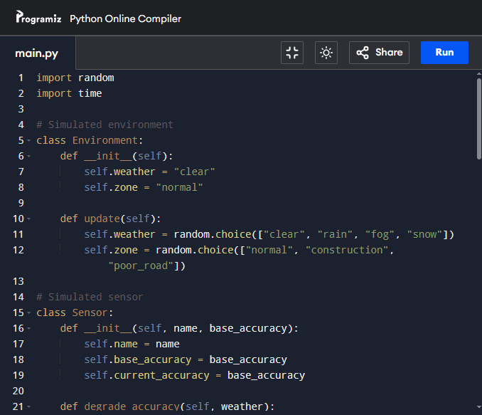

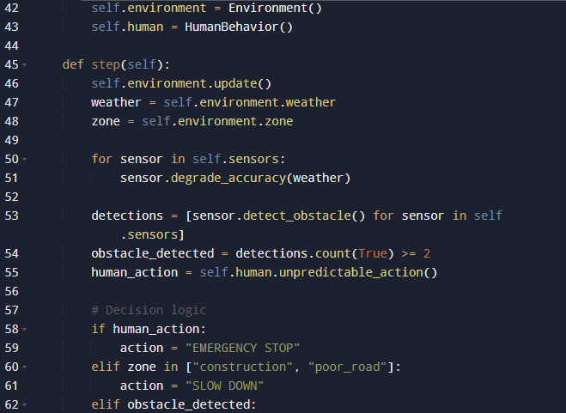

**OUTPUT:**



