**EXPERIMENT 9:**

Write the python program to implement A* algorithm

**AIM:**

The aim is to implement A* algorithm using python program.

**PROGRAM:**

import heapq

class Node:

def __init__(self, row, col, cost, heuristic):

self.row = row

self.col = col

self.cost = cost

self.heuristic = heuristic

self.parent = None

def __lt__(self, other):

return (self.cost + self.heuristic) < (other.cost + other.heuristic)

def astar(grid, start, goal):

rows, cols = len(grid), len(grid[0])

open_set = [Node(start[0], start[1], 0, heuristic(start, goal))]

closed_set = set()

while open_set:

current_node = heapq.heappop(open_set)

if (current_node.row, current_node.col) == goal:

path = []

while current_node:

path.append((current_node.row, current_node.col))

current_node = current_node.parent

return path[::-1]

closed_set.add((current_node.row, current_node.col))

for neighbor in get_neighbors(current_node.row, current_node.col, rows, cols):

if neighbor not in closed_set:

neighbor_row, neighbor_col = neighbor

cost = current_node.cost + grid[neighbor_row][neighbor_col]

heuristic_val = heuristic((neighbor_row, neighbor_col), goal)

new_node = Node(neighbor_row, neighbor_col, cost, heuristic_val)

new_node.parent = current_node

heapq.heappush(open_set, new_node)

return None

def heuristic(a, b):

return abs(a[0] - b[0]) + abs(a[1] - b[1])

def get_neighbors(row, col, max_row, max_col):

neighbors = []

if row > 0:

neighbors.append((row - 1, col))

if row < max_row - 1:

neighbors.append((row + 1, col))

if col > 0:

neighbors.append((row, col - 1))

if col < max_col - 1:

neighbors.append((row, col + 1))

return neighbors

grid = [

[1, 3, 1, 2, 4],

[2, 5, 3, 1, 2],

[1, 1, 2, 5, 3],

[3, 2, 4, 1, 4],

[2, 4, 2, 3, 3]

]

start_node = (0, 0)

goal_node = (4, 4)

result = astar(grid, start_node, goal_node)

if result:

print("Shortest path:", result)

else:

print("No path found.")

**INPUT:**

start_node = (0, 0)

goal_node = (4, 4)

**OUTPUT:**

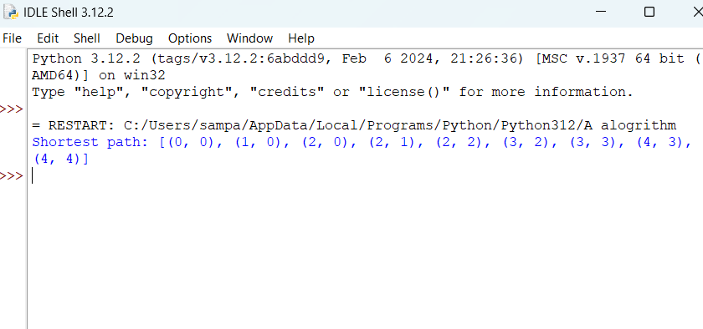

**RESULT:**

A*algorithm program executed successfully.