1. **ReactJS-HOL**

Create a new React Application with the name “myfirstreact”, Run the application to print “welcome to the first session of React” as heading of that page.

1. To create a new React app, Install Nodejs and Npm from the following link:

<https://nodejs.org/en/download/>

1. Install Create-react-app by running the following command in the command prompt:

**npm create-react-app myfirstreact**

1. To create a React Application with the name of “myfirstreact”, type the following command:

**npx create-react-app myfirstreact**

1. Once the App is created, navigate into the folder of myfirstreact by typing the following command:

**cd myfirstreact**

**code .**

**App.js**

import React from 'react';

function App() {

return (

<div>

<h1>Welcome to the first session of React</h1>

</div>

);

}

export default App;

**Run the app:**

npm start

**Output**

Compiled successfully!

You can now view myfirstreact in the browser.

Local: http://localhost:3000

On Your Network: http://10.38.85.110:3000

Note that the development build is not optimized.

To create a production build, use npm run build.

webpack compiled successfully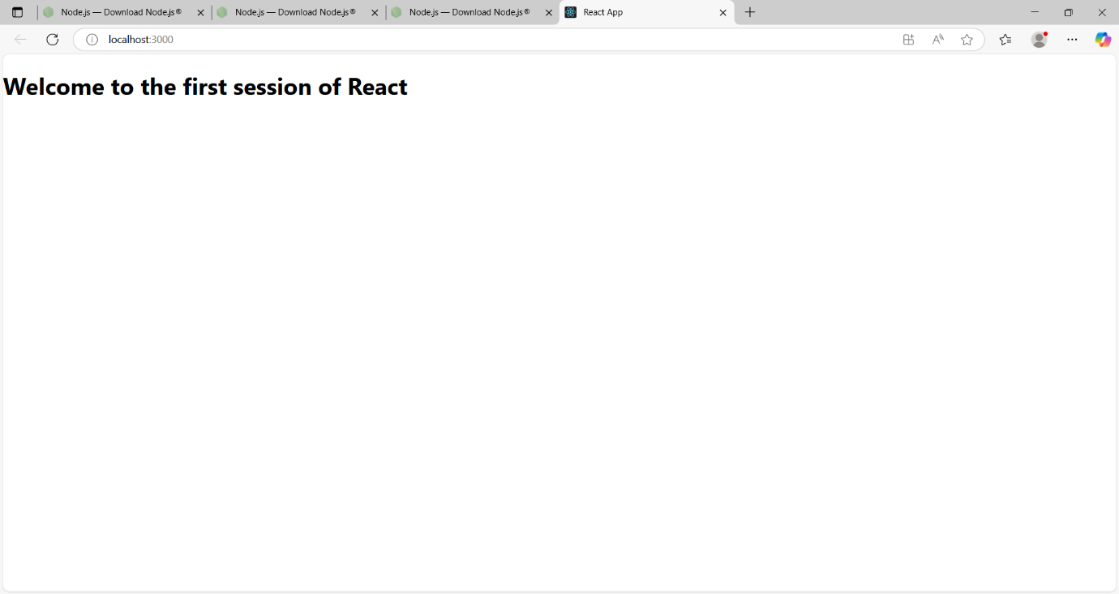

1. **ReactJS-HOL**

Create a react app for Student Management Portal named StudentApp and create a component named Home which will display the Message “Welcome to the Home page of Student Management Portal”. Create another component named About and display the Message “Welcome to the About page of the Student Management Portal”. Create a third component named Contact and display the Message “Welcome to the Contact page of the Student Management Portal”. Call all the three components.

1.Create a React project named “StudentApp” type the following command in terminal of Visual studio

npx create-react-app StudentApp

1. Create a new folder under Src folder with the name “Components”. Add a new file named “Home.js”

**Home.js**

import React from 'react';

function Home() {

return (

<div>

<h1>Welcome to the Home page of Student Management Portal</h1>

</div>

);

}

export default Home;

**About.js**

import React from 'react';

function About() {

return (

<div>

<h1>Welcome to the About page of the Student Management Portal</h1>

</div>

);

}

export default About;

**App.js**

import React from 'react';

import Home from './Components/Home';

import About from './Components/About';

import Contact from './Components/Contact';

function App() {

return (

<div className="App">

<Home />

<About />

<Contact />

</div>

);

}

export default App;

**Run the App**

npm start

**Output**

Compiled successfully!

You can now view studentapp in the browser.

Local: http://localhost:3000

On Your Network: http://10.38.85.110:3000

Note that the development build is not optimized.

To create a production build, use npm run build.

webpack compiled successfully

1. **ReactJS-HOL**

Create a react app for Student Management Portal named scorecalculatorapp and create a function component named “CalculateScore” which will accept Name, School, Total and goal in order to calculate the average score of a student and display the same.

1. Create a React project named “scorecalculatorapp” type the following command in terminal of Visual studio:

npx create-react-app scorecalculatorapp

cd scorecalculatorapp

**CalculateScore.js:**

import React from 'react';

import '../Stylesheets/mystyle.css';

function CalculateScore(props) {

const { name, school, total, goal } = props;

const average = total / goal;

return (

<div className="score-container">

<h2>Student Score Calculator</h2>

<p><strong>Name:</strong> {name}</p>

<p><strong>School:</strong> {school}</p>

<p><strong>Total Marks:</strong> {total}</p>

<p><strong>Goal (Subjects):</strong> {goal}</p>

<p><strong>Average Score:</strong> {average.toFixed(2)}</p>

</div>

);

}

export default CalculateScore;

**mystyle.css:**

.score-container {

background-color: #f0f8ff;

border: 2px solid #007bff;

border-radius: 10px;

padding: 20px;

margin: 20px auto;

width: 60%;

font-family: Arial, sans-serif;

box-shadow: 2px 2px 12px rgba(0, 0, 0, 0.1);

}

.score-container h2 {

color: #007bff;

}

.score-container p {

font-size: 16px;

margin: 8px 0;

}

**App.js**

import React from 'react';

import './App.css';

import CalculateScore from './Components/CalculateScore';

function App() {

return (

<div className="App">

<CalculateScore

name="Harini S"

school="Sunshine High School"

total={480}

goal={6}

/>

</div>

);

}

export default App;

**Run the Application**

npm start

**Output**

Compiled successfully!

You can now view scorecalculatorapp in the browser.

Local: http://localhost:3000

On Your Network: http://10.38.85.110:3000

Note that the development build is not optimized.

To create a production build, use npm run build.

webpack compiled successfully

1. **ReactJS-HOL**
2. Create a new react application using *create-react-app* tool with the name as “blogapp”
3. Open the application using VS Code

npx create-react-app blogapp

cd blogapp

code .

**Post class**

class Post {

constructor(userId, id, title, body) {

this.userId = userId;

this.id = id;

this.title = title;

this.body = body;

}

}

export default Post;

**Posts.js**

import React, { Component } from 'react';

import Post from './Post';

class Posts extends Component {

constructor(props) {

super(props);

this.state = {

posts: [],

error: null

};

}

loadPosts method

loadPosts = () => {

fetch('https://jsonplaceholder.typicode.com/posts')

.then(response => {

if (!response.ok) {

throw new Error('Failed to fetch posts');

}

return response.json();

})

.then(data => {

const postObjects = data.map(post => new Post(post.userId, post.id, post.title, post.body));

this.setState({ posts: postObjects });

})

.catch(error => {

this.setState({ error: error.message });

});

};

componentDidMount

componentDidMount() {

this.loadPosts();

}

componentDidCatch

componentDidCatch(error, info) {

alert('An error occurred: ' + error.toString());

}

render

render() {

const { posts, error } = this.state;

if (error) {

return <h2>Error: {error}</h2>;

}

return (

<div>

<h1>Blog Posts</h1>

{posts.map(post => (

<div key={post.id} style={{ marginBottom: '20px', padding: '10px', border: '1px solid #ccc' }}>

<h2>{post.title}</h2>

<p>{post.body}</p>

</div>

))}

</div>

);

}

}

export default Posts;

**App.js**

import React from 'react';

import './App.css';

import Posts from './Posts';

function App() {

return (

<div className="App">

<Posts />

</div>

);

}

export default App;

**Run the app**

npm start

**Output**

Compiled successfully!

You can now view blogapp in the browser.

Local: http://localhost:3000

On Your Network: http://10.38.85.110:3000

Note that the development build is not optimized.

To create a production build, use npm run build.

webpack compiled successfully

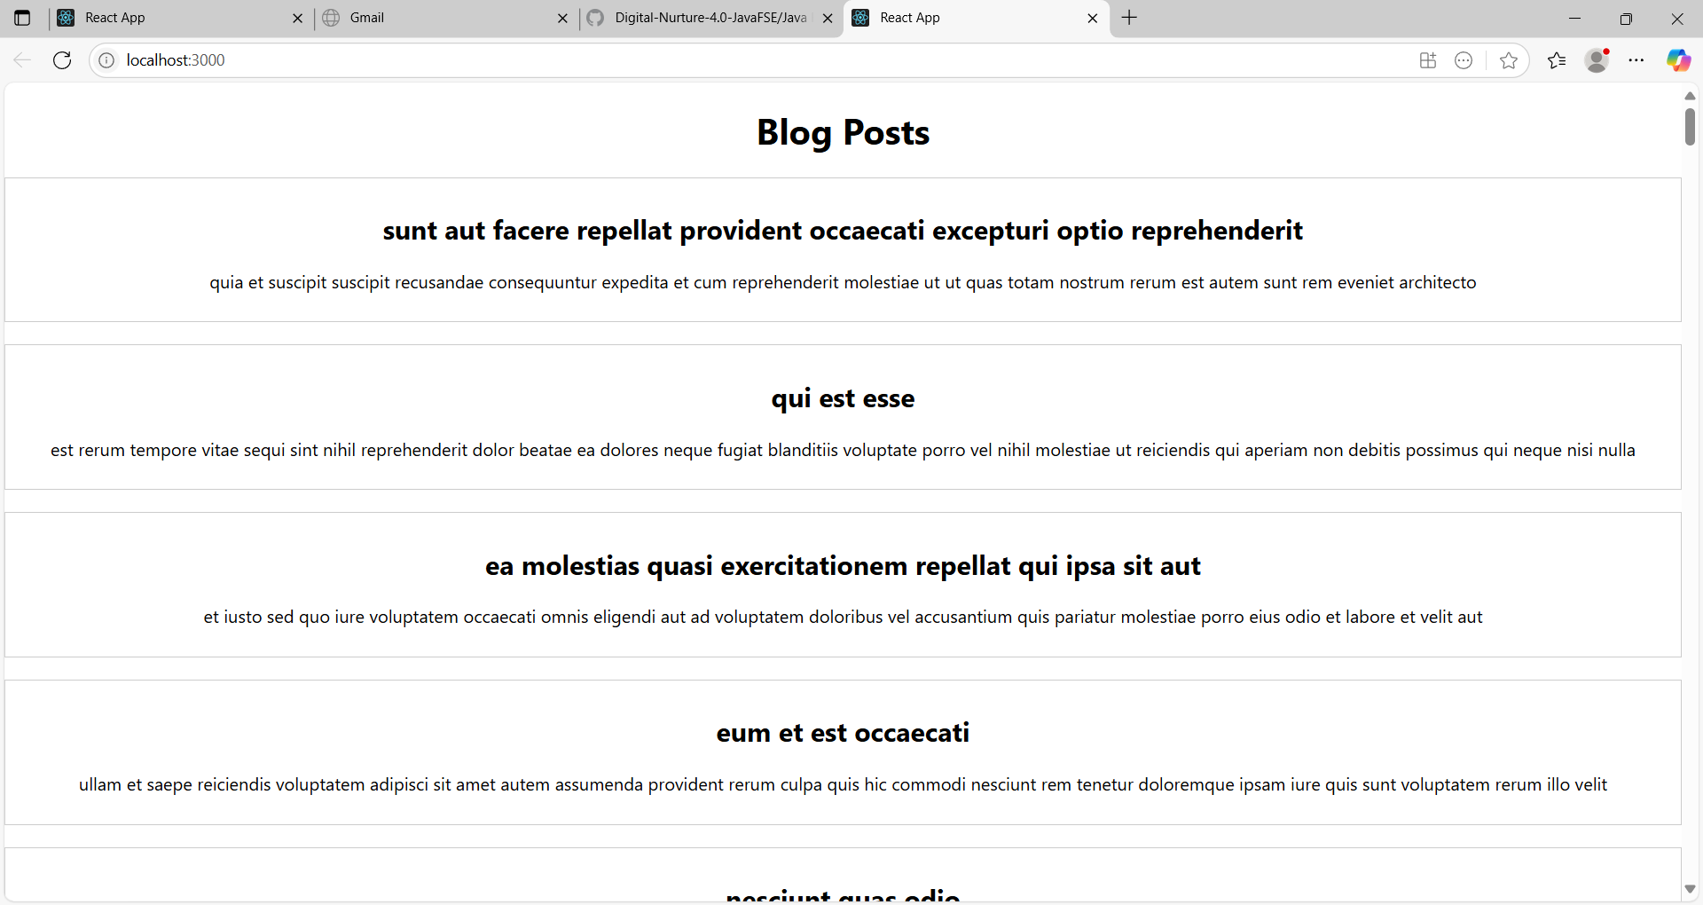

1. **ReactJS-HOL**

My Academy team at Cognizant want to create a dashboard containing the details of ongoing and completed cohorts. A react application is created which displays the detail of the cohorts using react component. You are assigned the task of styling these react components.

**Node Packages**

npm install

code **.**

**Create CSS Module File**

CohortDetails.module.css

.box {

width: 300px;

display: inline-block;

margin: 10px;

padding: 10px 20px;

border: 1px solid black;

border-radius: 10px;

}

dt {

font-weight: 500;

}

**CohortDetails.js**

function CohortDetails(props) {

return (

<div className="box">

<h3>{props.name}</h3>

<dl>

<dt>Status</dt>

<dd>{props.status}</dd>

<dt>Start Date</dt>

<dd>{props.startDate}</dd>

<dt>End Date</dt>

<dd>{props.endDate}</dd>

</dl>

</div>

);

}

**CohortDetails.js**

import React from 'react';

import styles from './CohortDetails.module.css';

function CohortDetails(props) {

const headingStyle = {

color: props.status.toLowerCase() === 'ongoing' ? 'green' : 'blue'

};

return (

<div className={styles.box}>

<h3 style={headingStyle}>{props.name}</h3>

<dl>

<dt>Status</dt>

<dd>{props.status}</dd>

<dt>Start Date</dt>

<dd>{props.startDate}</dd>

<dt>End Date</dt>

<dd>{props.endDate}</dd>

</dl>

</div>

);

}

export default CohortDetails;

**Run the App**

npm start

**Output**

Compiled successfully!

You can now view CohortDetails in the browser.

Local: http://localhost:3000

On Your Network: http://10.38.85.110:3000

Note that the development build is not optimized.

To create a production build, use npm run build.

webpack compiled successfully

