#Line

#VRML V2.0 utf8

#lineset.wrl

#Demonstrates use of a simple indexed lineset

Shape {

geometry IndexedLineSet

{

coord Coordinate

{

point

[

#base of pyramid

-2 0 0, # point 0,

2 3 0, # point 1,

] # end point

} # end coord

coordIndex

[

0, 1, -1, # join points 0 and 1

] # end coordIndex

} # end geometry

} # end shape

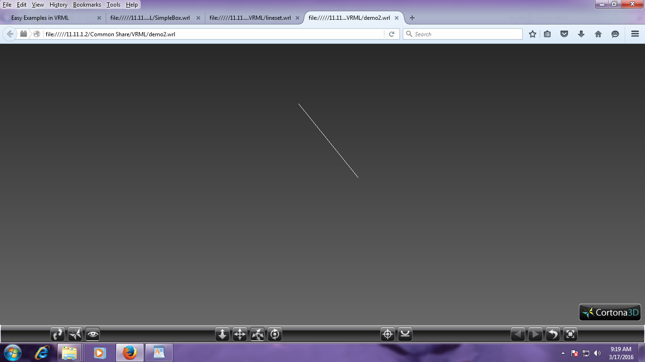

#box

#Simple box

#VRML V2.0 utf8

Shape {

appearance Appearance {

material Material {

}

}

geometry Box {

}

}

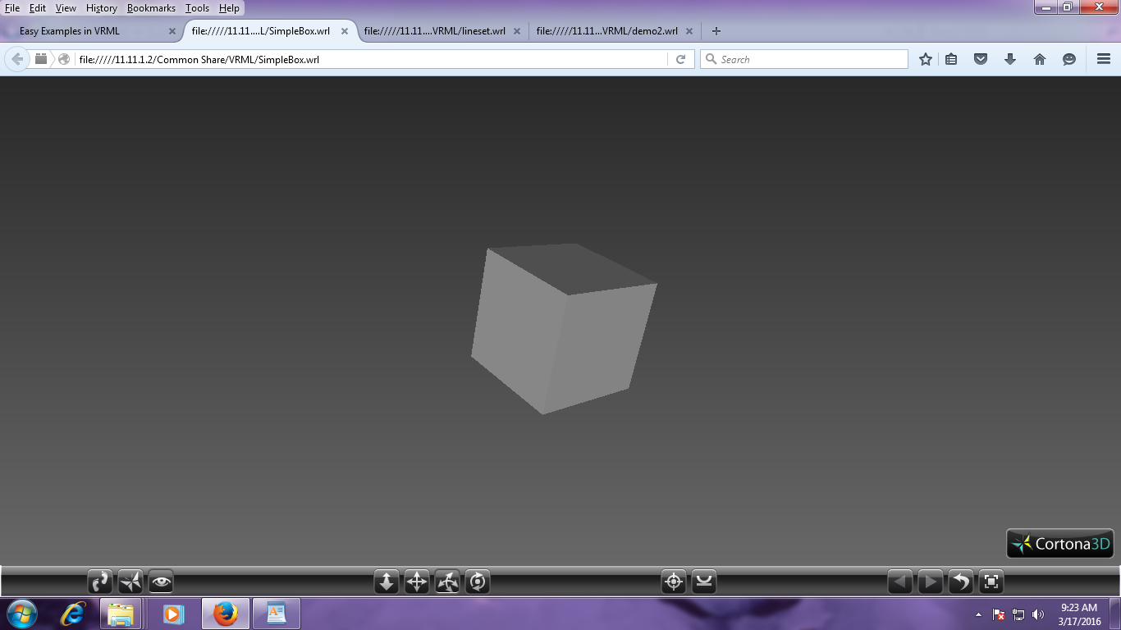

#Pyramid

#VRML V2.0 utf8

#lineset.wrl

#Demonstrates use of a simple indexed lineset

Shape {

geometry IndexedLineSet {

coord Coordinate {

point [

#base of pyramid

-2 0 2,

-2 0 -2,

2 0 -2,

2 0 2,

#point

0 2 0,

] # end point

} # end coord

coordIndex [

#base

0, 1, 2, 3, 0, -1,

#vertical edges

0, 4, -1,

1, 4, -1,

2, 4, -1,

3, 4, -1,

] # end coordIndex

} # end geometry

} # end shape

