Assignment 4: Write a C++ class for a circle drawing inheriting line class

#include<iostream.h>

#include<graphics.h>

#include<conio.h>

#include<math.h>

#include<dos.h>

class pixel

{

public:

int x,y,r;

};

class circle1:public pixel

{

public:

void drawcir(int);

void drawcir();

};

void circle1::drawcir(int r)

{

int i;

float x1,y1,x2,y2;

float start_x,start_y;

float e,val;

i=1;

do

{

val=pow(2,i);

i++;

}while(val<r);

e=1/pow(2,i);

start_x=0;

start_y=r;

x1=start_x;

y1=start_y;

do

{

x2=x1+e*y1;

y2=y1-e*x2;

putpixel(x2+100,y2+100,15);

delay(40);

x1=x2;

y1=y2;

}while((y1-start_y)<e ||(start_x-x1)>e);

}

void circle1::drawcir()

{

int i;

float x,y;

float d;

cout<<"Enter the Radius for Bresenham:";

cin>>r;

d=3-2*r;

x=0;

y=r;

do

{

putpixel(x+100,y+100,15);

putpixel(y+100,x+100,15);

putpixel(y+100,-x+100,15);

putpixel(x+100,-y+100,15);

putpixel(-x+100,-y+100,15);

putpixel(-y+100,-x+100,15);

putpixel(-y+100,x+100,15);

putpixel(-x+100,y+100,15);

delay(50);

if(d<0)

{

d=d+4*x+6;

}

else

{

d=d+4*(x-y)+10;

y=y-1;

}

x=x+1;

}while(x<y);

}

void main()

{

pixel p;

circle1 l,m;

int gd=DETECT,gm;

initgraph(&gd,&gm,"c:\\tc\\bgi");

cout<<"\n Enter the Radius for DDA :";

cin>>p.r;

m.drawcir();

l.drawcir(p.r);

getch();

closegraph();

}

**********Output*****************

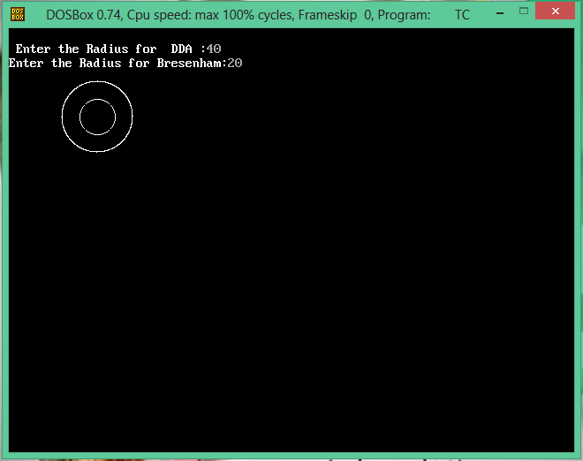

******Output*********

