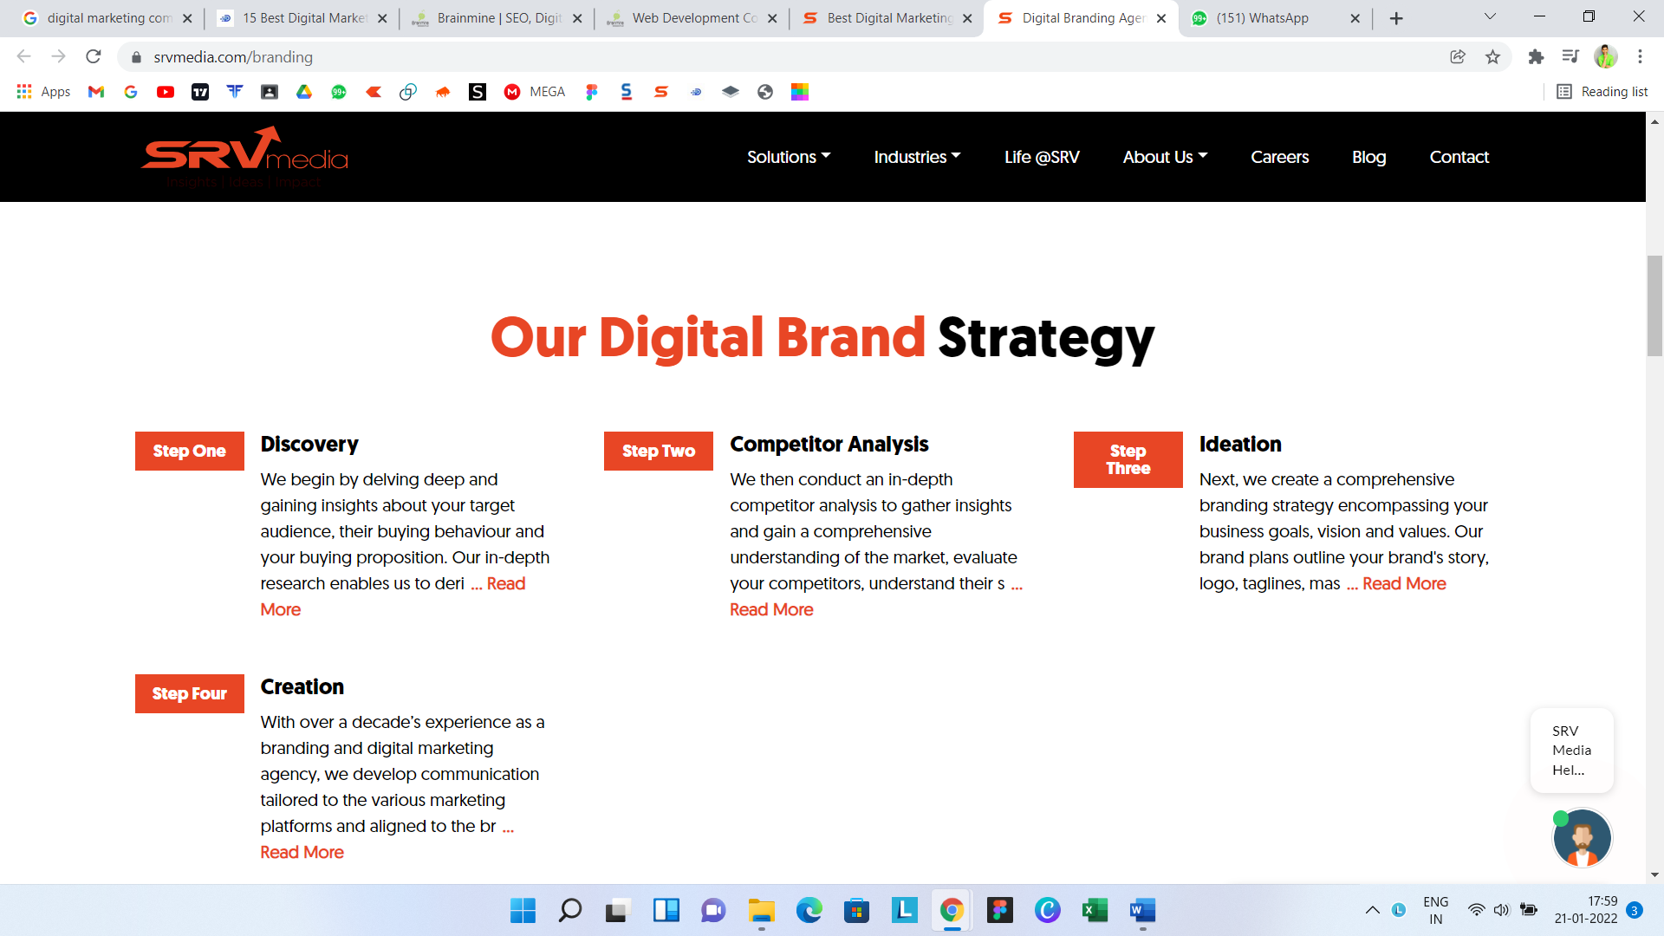

<https://www.srvmedia.com/branding>

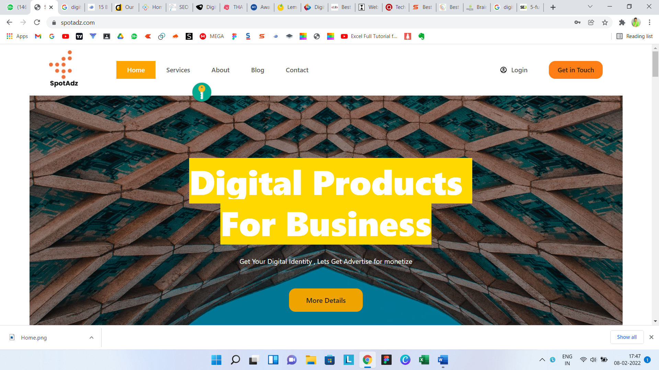

Digital product for smart business.

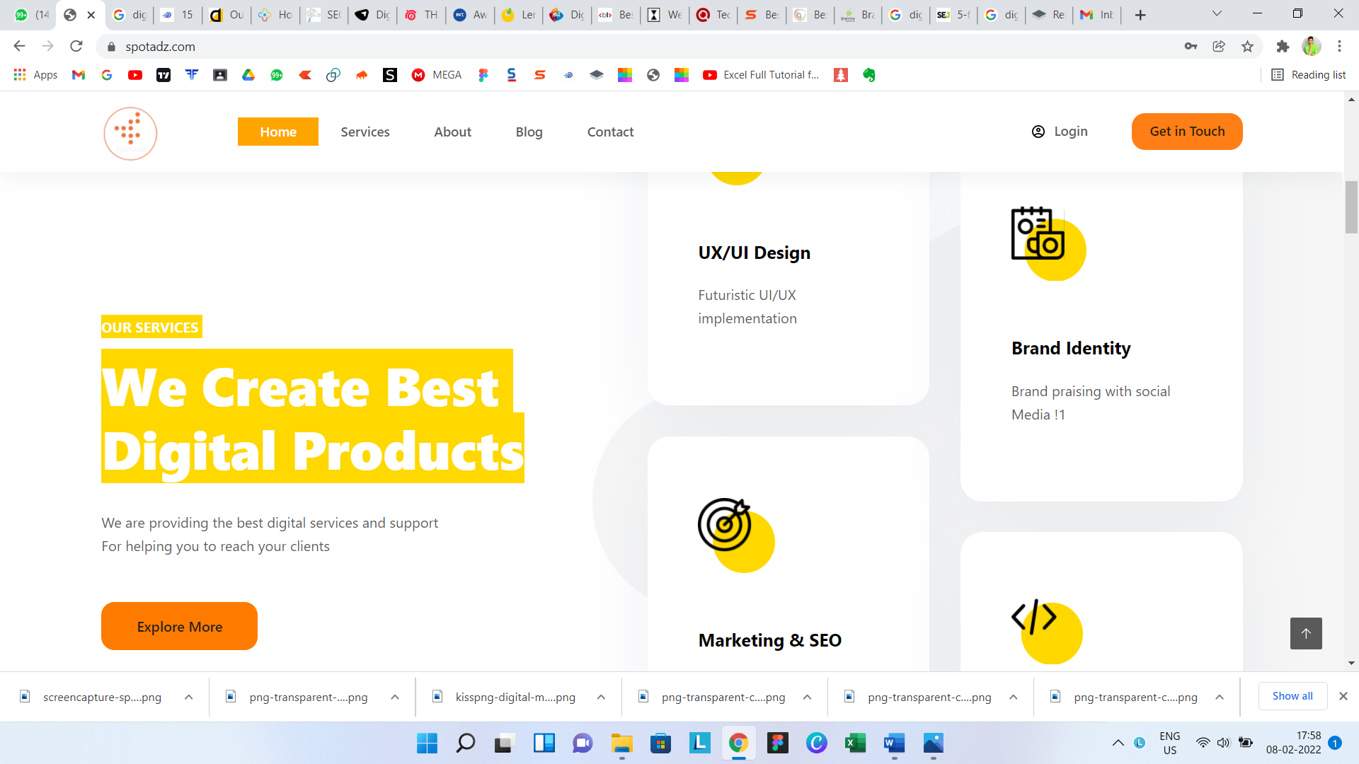

Our expertise

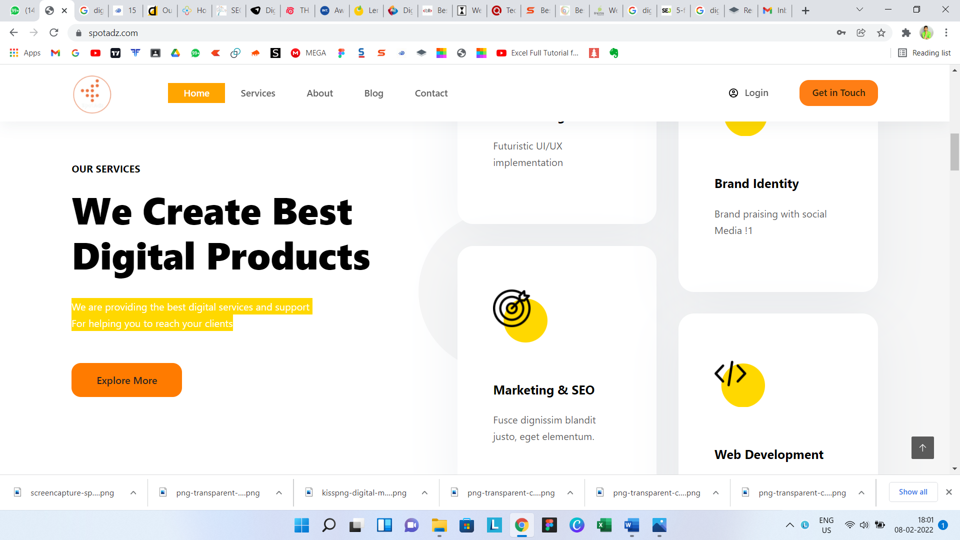

We are best at creating digital product

**Our services**

1. **Ui Ux –**

**Futuristic design, with help of professional designers**

1. **Marketing**

**Marketise your product for monetize, also creat your digital marketing**

1. **Web**

**Impressive model for designing of websits**

1. **App**

**Provide app designing as per your need**

1. **Flex**

**We design attractive flexes for marketing**

1. **Logo**

**We design attractive logo such a meaning full way**

1. **Business model**

**Provide ideal business model as per your idea.**

1. **Consulting**

**Provide consuling as per your need for your support are teem is ready for you**

1. **Seo**

**Case study kadhun tak**

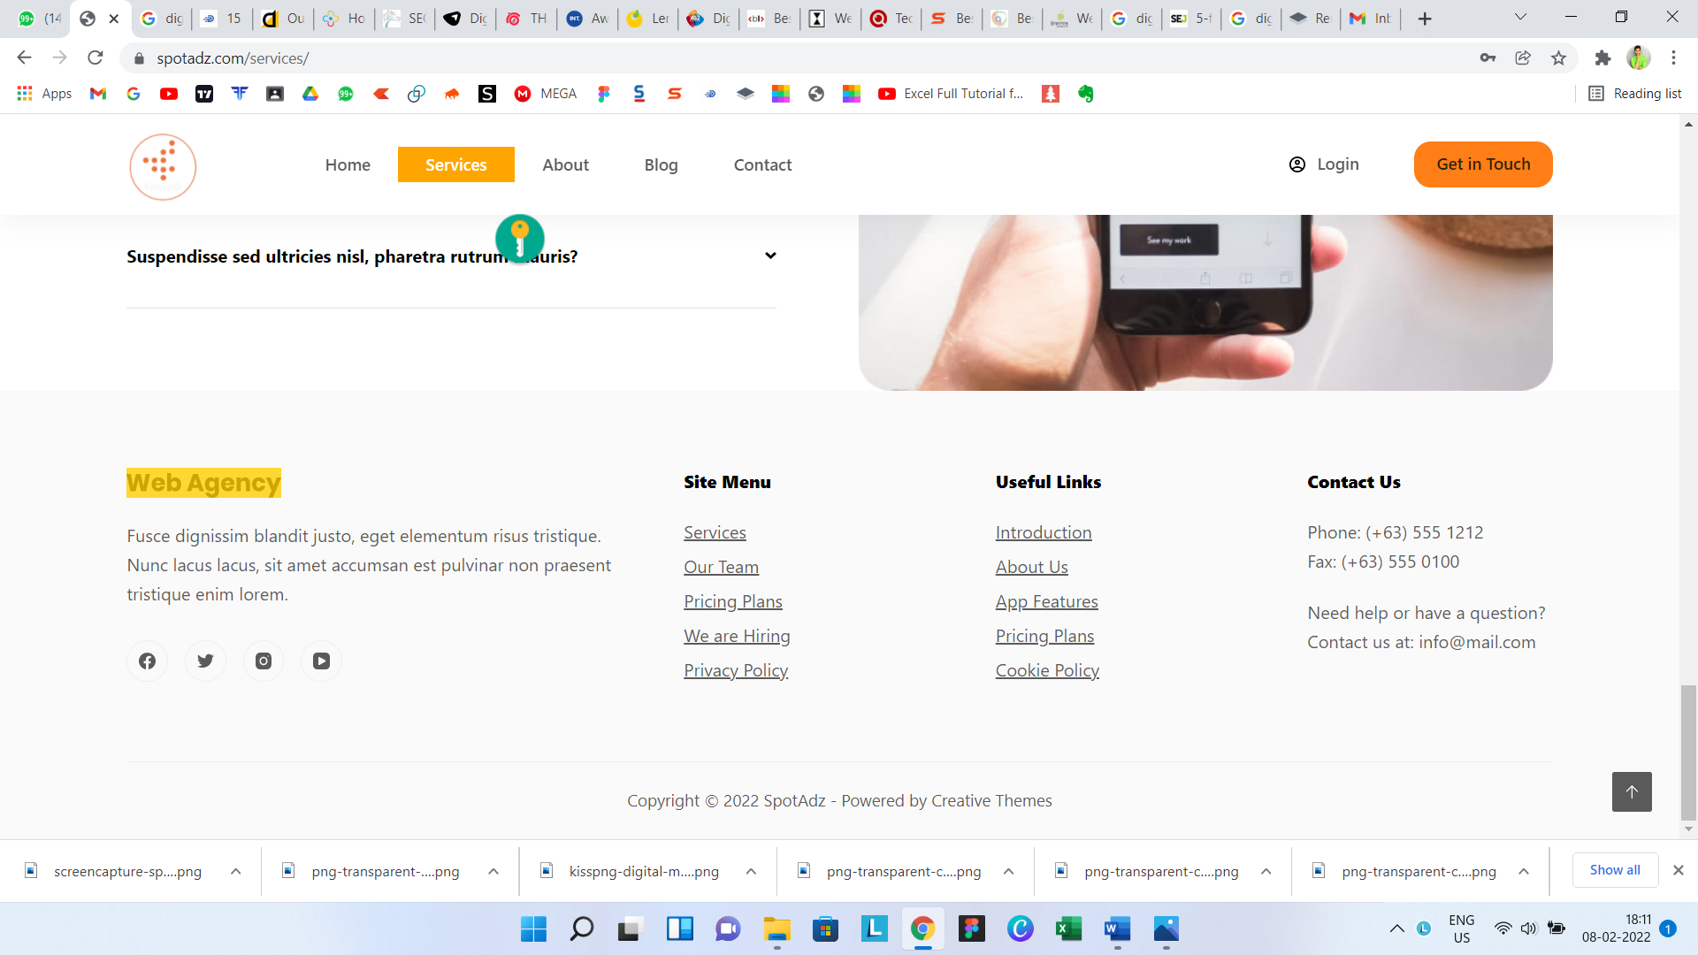

**In case of web agency –**

**Our moto –**

**We belive in futuristic goals, our priorities and responcibility are to make your product as productive.**