**Identify Optimal Delta Hedging Interval for a Structured Notes Options Portfolio**

Team Members: Vaishnavi Choppalli, Abhilash Kalapatapu, Ameya Tembhekar, Jack McManus

The project involves understanding of structured notes, which are products issued by Wealth and Asset management firm as an investment instrument for High Net Worth and Ultra High Net Worth individuals. These products form a part of their portfolios as a means of diversification and also to earn returns that beat inflation in times of muted equity returns. These products are a very useful tool for portfolio managers as well. Portfolio managers can customize these products as per the clients’ risk appetite and their return requirements thus giving them more control over the portfolio.

The derivatives portfolio underlying these products are usually of maturity ranging from 2 to 6 years. These derivatives are not liquid in the market and hence we cannot trade them directly. Thus, we recreate the payoff of the derivatives in using other derivatives, like Futures, by replicating the delta. As delta of the Futures is constant and delta of the options keeps on changing, we need to adjust the delta frequently (ideally at every instant). But, frequently adjusting the delta is not really possible because of reasons such as liquidity and transactions costs make it inefficient. Hence, in our project we test for the various interval where we adjust the delta and compare the output with the actual option payoff. The intervals we test for are 20 points, 40 points, 0.5% and 1% move in the underlying.

We first studied various products issued by firms such as Morgan Stanley, BNP Paribas etc. and tried to reverse engineer these products to arrive at the underlying options portfolio. Our major challenge was to source the tick data (trade data for every tick that is every time a trade happens) for the underlying which in our case we assumed it to be S&P Emini Futures. This data is usually maintained by the index management firms and is available for a substantial fee. We tried to utilize Bloomberg for this but we could only get the lowest tick as a minute and the data was available only for the last 6 months.

There are two options available to us. The first option is to hold a position in options that align with the product expiry on the S&P 500, which will generate the required payoff. The product's duration is three years, and in theory, we could hedge with a same-tenor option. However, in reality, three-year options are not very liquid, making it challenging to obtain them for this maturity. Additionally, we need to calculate the implied volatility to price the options, but for a three-year timeframe, we cannot accurately predict where the market will be, introducing uncertainty in price that we wish to avoid.

Since finding liquidity in three-year options is difficult, we can take a different approach by investing in short-term derivatives of E-mini S&P 500 futures. These derivatives typically mature in March, June, September, and December. If we're in April, we can start with the June expiry. However, this approach carries some risk due to market movements, which we need to adjust for. Specifically, we're interested in movements of 20 and 40 points, as well as 0.5% and 1% changes in the underlying. To replicate the payoff of the options, we calculate the delta for options underlying the structured notes and replicate the delta of the option portfolio. Whenever our pre-determined conditions are met, such as a 20, 40 point move or a 0.5% and 1% move in the underlying, we adjust our delta to the point where we observe the change. However, it's not possible to adjust our delta for every second or every tick due to transaction costs and liquidity constraints. Therefore, we aim to capture as many moves as possible while balancing cost efficiency.

The assumptions made with respect to that are as follows:

1. We are making certain assumptions for this project. Firstly, transaction costs are the fees charged by brokers for buying or selling the products. Secondly, we have selected a bull spread structure using call options with strikes ranging from 100% to 102%. This is because for a 3-year maturity, the strikes usually range from 106% to 109%, but since our project is for 1 year, we interpolated to these figures.
2. We are assuming that the underlying for all the products in this project is the E-mini S&P 500 futures index.
3. In order to obtain the highest resolution intraday data, we have chosen tick data for the E-mini S&P 500 Futures for every minute from Bloomberg. Tick data is a sequence of each executed trade or bid/ask quote aggregated from multiple exchanges.
4. We have assumed that the trading hours are from 9 am to 4:30 pm, and we have generated 10 paths for all the trading days (1 year) for each of the movements in our analysis, which are a 20-point move, 40-point move, 0.5% move, and 1% move in the underlying.

Alternatively, Monte Carlo simulations were ran to arrive at random paths. We used the historical mean and standard deviation as an input to these paths. We generated 10 paths for our project.

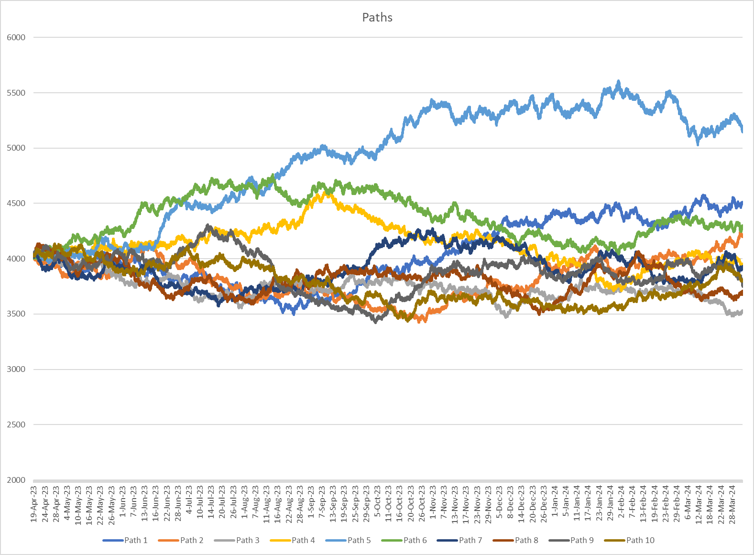

On each path we used our delta hedging methodology to generate the payoff for a sample bull spread using call options with strikes 100% and 102% of the underlying. For each path we check for a change in the underlying of the magnitude 20 points, 40 points, 0.5% and 1% to arrive at the final payoffs. We used python to optimize the process. Following are the results from our study.



From the table above we can see that the results are inconclusive. The green highlighted are the ones closest to the options payoff. To arrive at conclusive results, we believe that we need to generate more such paths, use more complex Monte Carlo methods to cover all possible scenarios. We could also use other derivatives to generate the options payoff like short term options or constituent stock futures.

We all contributed equally to the project and at every step we were did the same tasks and then discussed the results. This gave us all a hands-on experience on working with such structured products. Also, we got to learn more from each team member. We used python packages to calculate the option prices and option Greeks for the first time.