VAISHNAVI DEVARDEKAR
Software Developer
 vaishuu2397@gmail.com q https://www.linkedin.com/in/vaishuu/ q https://vaishuuportfolio.netlify.app/

SUMMARY
Passionate software developer with 1 years of experience in designing and developing scalable, user-friendly applications. Proven track record in delivering complex projects on time, focusing on AI governance, risk management, and data analytics. Eager to embrace challenging opportunities in software development and AI/ML.
EXPERIENCE
Software Developer
Passion Infotech Pvt Ltd
2023
Present

Pune, India
Passion Infotech Pvt Ltd delivers high-performance software solutions with a focus on innovation and user-centric design across multiple platforms.
- Backend Optimization Enhanced backend infrastructure using Node.js, Express.js, and PostgreSQL with Sequelize ORM for efficient relational data management and high-performance queries. Created React JS API for database integration.
- Incident Management Module Led the development of a robust incident management system, leveraging JavaScript, PostgreSQL, and a modular architecture to streamline workflows and automate critical processes. Developed Forms using React.js. HTML, CSS
- Real-Time Data Visualization Designed and developed interactive React.js dashboards, utilizing Chart.js and Redux for state management, delivering seamless real-time insights and a user-centric experience.
- API Security and Integration Built and secured RESTful APIs using JWT for authentication, tested endpoints with Postman, and implemented best practices to ensure secure and reliable data transactions across the application.

Software Developer Intern
02
/2023
08/2023

Pune, India
Elansol Technologies Pvt ltd
Elansol Technologies Pvt Ltd specializes in providing innovative IoT solutions and advanced software development services to enhance operational efficiency across various industries.
- IoT Digitalization of Blanking Press Machine Led the transformation of blanking press machines using IoT devices and sensors for real-time performance monitoring. Developed an intuitive user interface with Angular and integrated it with ThingsBoard for data visualization and management, utilizing MQTT for seamless communication between devices and gateways.
- Building Management System Development Automated building systems by creating a comprehensive UI with Angular for real-time data visualization and reporting. Implemented backend solutions using JavaScript and Node.js to process and manage data efficiently, leveraging ThingsBoard for analytics and operational insights.
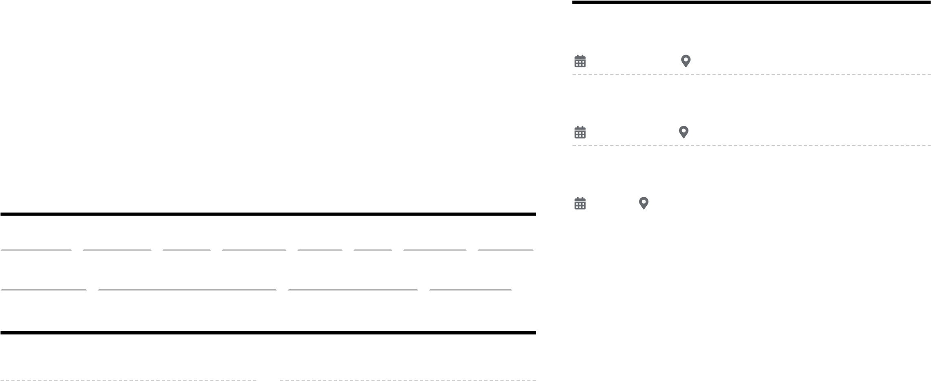
- CNC Machine Digital Transformation Spearheaded the digitalization of CNC machines by integrating IoT technology for continuous performance monitoring. Developed robust backend systems with JavaScript and connected them to ThingsBoard to visualize machine performance metrics. Applied data analytics to improve Overall Equipment Effectiveness OEE by 50%, providing actionable insights for enhanced operational efficiency.

TECHNICAL SKILLS
ReactJS NodeJS Java Python SQL Git Django UI/UX
Javascript Application Development Database System Leaderhip

CERTIFICATIONS
Data Analytics Professional Google) Full Stack Software Development QJPSPIDERS
Software Development And Martian Training And Internship
Designing DevTown Goggle- PERSISTENT SYSTEMS
Microsoft)

Python Coursera) Artificial Intelligence MyCaptain)
www.enhancv.com

PROJECTS

Capitol Tunnels.ai
12/2023 07/2024
Risk Management System Developed a comprehensive risk management system that implements advanced machine learning algorithms for proactive risk detection and analysis. Utilized the MERN stack SQL, Express.js, React.js, Node.js) to create a robust web application, enabling data-driven decision-making through real-time analytics and visualizations.
Incident Management System Designed and developed an incident management system tailored for the agro industry, facilitating efficient incident assignment and resolution. Implemented administrative functionalities to streamline task delegation, enhance operational efficiency, and improve responsiveness. This system uses Node.js for backend development and React.js for a userfriendly interface, ensuring a seamless experience for users in managing incidents. Building Management System
04/2023 06/2023
Real-Time Automation and Control Engineered a
Building Management System BMS utilizing ThingsBoard and Node-RED to automate the management of critical building components, including lighting, HVAC systems, and elevators. This integration of real-time data ensures efficient operation, promotes energy savings, and enhances occupant comfort.
Advanced Reporting and Analysis Developed detailed reporting and analytics features within the BMS to monitor building operations, energy usage, and performance metrics. This capability enables informed decision-making and continuous optimization of building management processes, leveraging JavaScript and Angular for a responsive and interactive user interface.

EDUCATION

Bachelor of Technology, Information Technology
Government College Of Engineering Amravati
2019 2023 Amravati

Higher Secondary 12th
Abeda Inamdar Junior College for Girls Pune
2017 2019 Pune, India

High School
Army Public School
2017 Pune
Powered b_{y} 

