1. **What is database?**

Database is basic collection of data.

1. **Introduction of cafeteria:**

A Cafeteria Management System (CMS) in a Database Management System (DBMS) leverages structured databases to efficiently manage cafeteria operations. It includes features like inventory tracking, menu item management, and order processing, all centralized in a database to ensure accuracy and streamline workflow. By utilizing tables for employees, orders, menu items, and payments, the CMS facilitates real-time updates, reduces manual errors, and provides comprehensive reporting. This integration helps in optimizing inventory levels, tracking sales, and managing staff, ultimately enhancing the overall efficiency and service quality of the cafeteria.

1. **Advantages and Disadvantages:**

**Advantages:**

1. Improved Efficiency: Automates and streamlines operations, reducing manual tasks and speeding up order processing.

2. Accurate Data Management: Ensures precise tracking of inventory, sales, and employee records, minimizing errors.

3. Comprehensive Reporting: Provides detailed insights and reports on sales, inventory, and performance, aiding in better decision-making.

4. Enhanced Customer Experience: Faster service and accurate order fulfillment improve overall customer satisfaction.

**Disadvantages:**

1. High Initial Costs: Requires significant investment for setup, including hardware, software, and training.

2. Complexity: Can be complex to integrate with existing systems and may require specialized knowledge to manage.

3. Maintenance Needs: Ongoing maintenance and updates are necessary to keep the system secure and functional.

4. Training Requirements: Staff need training to effectively use the system, which can be time-consuming and costly.

1. 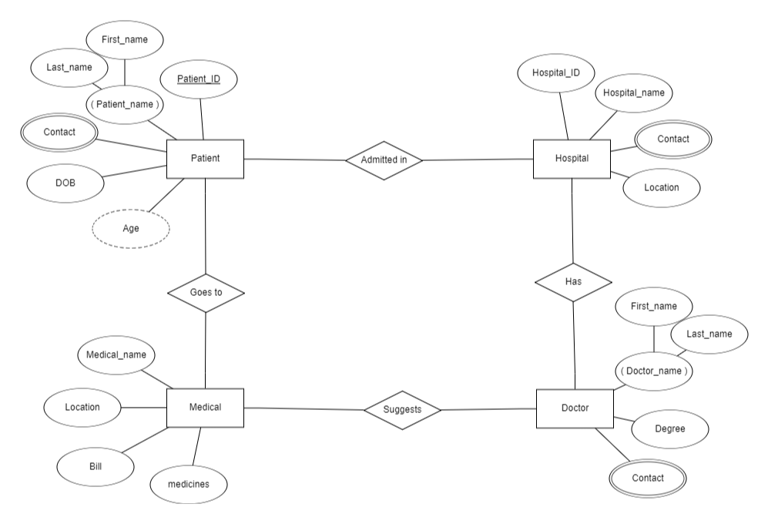**ER diagram for Cafeteria Management System:**

1. **Application of micro project.**

1. Inventory Tracking Module: Develop a streamlined system to monitor stock levels, manage reordering, and generate low-stock alerts to ensure timely inventory management.

2. Order Processing Interface: Create a simplified interface for staff to quickly enter, update, and track customer orders, improving service speed and accuracy.

3. Sales Reporting Tool: Implement a basic reporting feature to generate daily or weekly sales summaries, helping managers analyze performance and make informed decisions.

4. Employee Scheduling System: Design a small-scale module for managing employee shifts and schedules, facilitating better workforce planning and reducing scheduling conflicts.

1. **Output:**

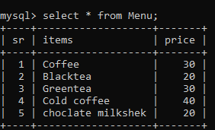

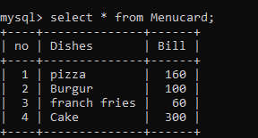

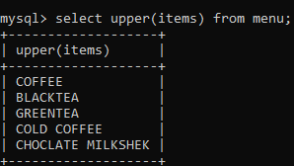

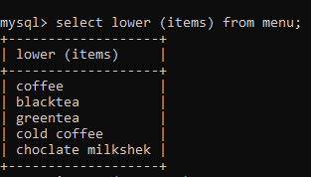

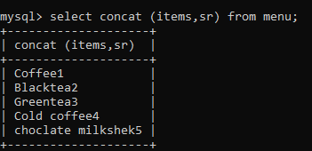

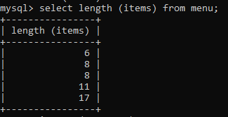

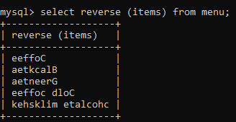

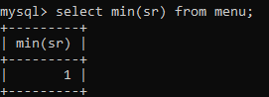

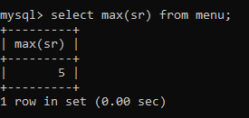

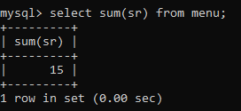

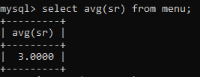

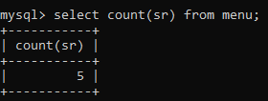

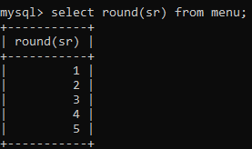

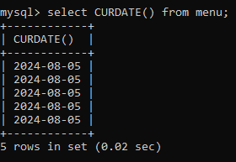

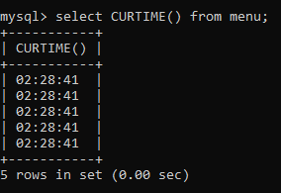

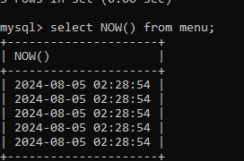

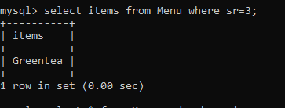

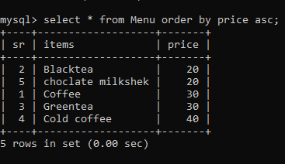

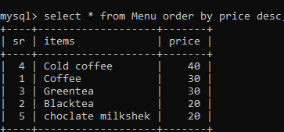

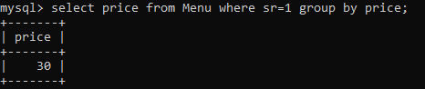

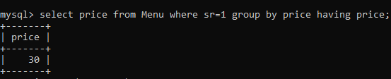

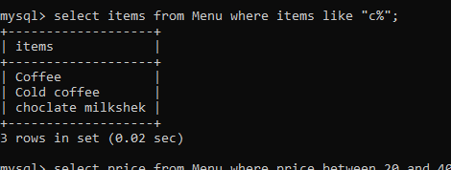

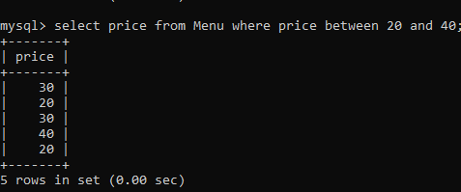

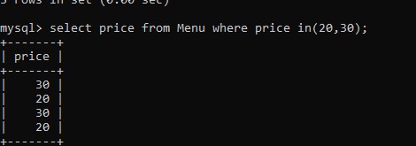

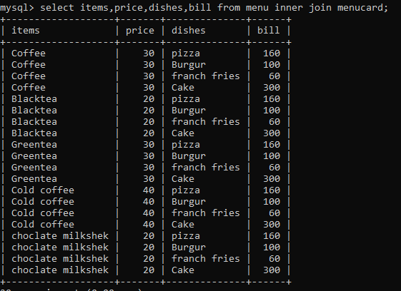

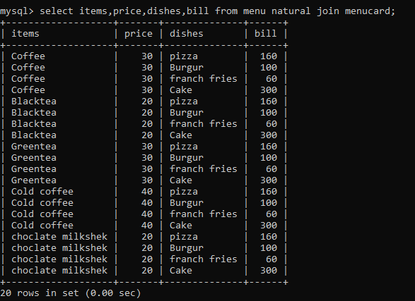

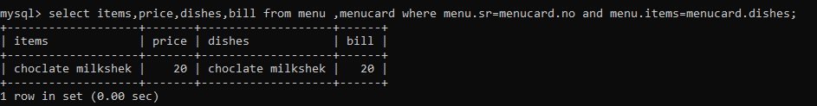

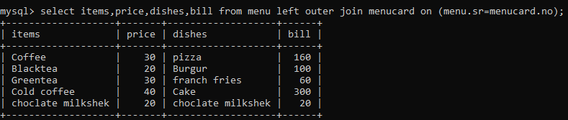

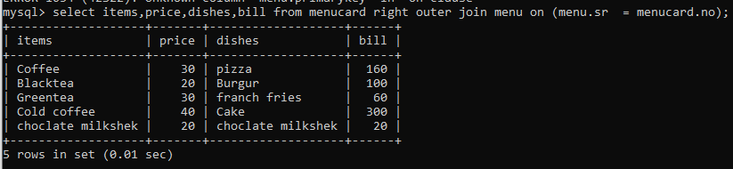

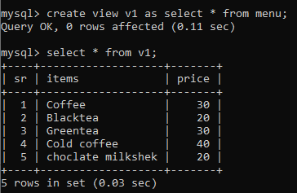

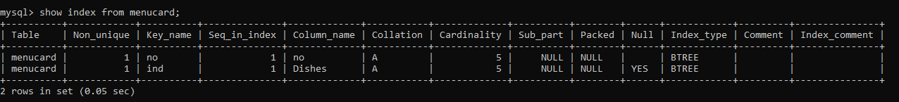

1. **Conclusion:**

The cafeteria management system using a Database Management System (DBMS) streamlines and optimizes various operational tasks such as inventory management, order processing, billing, and customer service. By integrating DBMS, the system ensures efficient data storage, quick retrieval, and reliable updates, enhancing overall functionality and accuracy. This system not only reduces manual errors and operational costs but also improves the user experience by providing real-time data access and reporting capabilities. Ultimately, it contributes to better decision-making, operational efficiency, and customer satisfaction in the cafeteria environment.

1. **References:**
2. Armstrong, E.; Ball, J.; Bodoff S.; Carson, D. B.; Evans, I.; Green, D.; Haase, K.; Jendrock, E..The J2EE 1.4 Tutorial, Sun Microsystems, 2005.
3. Raghu. Ramakrishnan, Database Management System, McGraw-Hill, 2002.
4. Sang H. Son and Jhon A. Stankovic, "Concurency control for time constrained database system" in The computer journal, 1995.
5. Shilbershatz Abraham, Korth and Sudarshan, Database System Concepts, McGraw-Hill, 2005.
6. R. Abbott, Scheduling Real-System Transactions: a Performance Evaluation, 1991.