**Restaurant Review and Online Food Ordering**

**Abstract**

This project is developed to help the food lovers in our society. Anyone can search for the restaurants near them according to their taste using this website. The main highlight is that it give true reviews of the restuarants as the feedback is given by the customers themselves. Advertisements are used for publicity and it does not show the flaws of an enterprise , but customer reviews can be relied on as it is given from their own personal experience. The other features are online food ordering and table reservation. Some restaurants provide home delivery. The list of those restaurants will also be given in this website. A customer can reserve a table for specific number of seats for a specific time .

**Existing System**

There is an existing system which provides information and reviews on restaurants including images of menus but not food ordering or table reservation.

**Disadvantages**

* The ratings of restaurants given in this site are unreliable because they never reveal how they calculate it.
* Reviews of small restaurants are not available in this system.
* Online food ordering is not available.
* Does not provide the exact location of the restaurants.

**Proposed System**

This system provides many extra features that the existing system lacks. This helps the people to find a restaurant in a specific place according to their taste.

**Advantages**

* Food can be ordered online.
* Provides the exact location of the restaurant via google map.
* Helps in promoting small restaurants which doesnot have their own website
* A customer can reserve a table for specific number of seats for a specific time.
* Customers’ suggestions will be taken into consideration.

FEASIBILITY STUDY

A feasibility analysis usually involves a thorough assessment of the operational (need), financial and technical aspects of a proposal. Feasibility study is the test of the system proposal made to identify whether the use needs may be satisfied using the current software and the hardware technologies, whether the system will be cost effective from a business point view and whether it can be developed with the given budgetary constraints. A feasibility study should be relatively cheap and done at the earliest possible time. Depending on the study, the decision is made whether to go ahead with a more detailed analysis.

When a new project is proposed, it normally goes through feasibility assessment. Feasibility study is carried out to determine whether the proposed system is possible to develop with available resources and what should be the cost consideration. Facts considered in the feasibility analysis were

* Technical feasibility
* Operational feasibility
* Economic feasibililty

TECHNICAL FEASIBILITY

The main consideration is to be given to the study of available resources of the organization where the software is to be implemented. Here the system analyst evaluates the technical merits of the system giving emphasis on the performance, Reliability, maintainability and productivity. By taking the consideration before developing the proposed system, the resources availability of the organization was studied. The organization was immense computer facilities equipped with sophisticated machines and the software hence this technically feasible.

A detailed study and analysis of the Network Backup tool was conducted. The system must be evaluated from the technical point of view. The assessments of this feasibility must be based on an outline design of the system requirement in the terms of input, output, programs, procedure and staff. Having identified an outline system, the investigation must go to suggest the type of equipment required for developing the system designed. The project should be devolved such that the necessary functions and performance are achieved within the constraints.

Technical feasibility study deals with the hardware as well as software requirements. The scope was whether the work for the project is done with current equipments, the existing software technology and available human resources. The outcome was found to be positive.

OPERATIONAL FEASIBILITY

Operational feasibility is a test of feasibility that will check whether the system will work when it is developed and installed in place of the existing system and whether the proposed system will meet the organization operational requirements. This feature of feasibility study is related to its operational aspect where the working of the hardware, the software and the human resources is to be taken in to account. So, it is checked whether the system will work if it is developed and implemented

ECONOMIC FEASIBILITY

The developing system must be justified by cost and benefit. A criterion is to ensure that effort taken on the project give to best return as the earliest. One of the factors which affect the devotement of the new system is the cost it would require. Since the system developed is part of the project work, there is manual cost to spend for the proposed system. Also all the resources are already available, giving an indication that the system is economically possible for development.

STSTEM SPECIFICATION

SOFTWARE SPECIFICATION

Operating System : Windows XP and more

Technology used : PHP

Front End : PHP

Back End : MySQL

Web Server : Apache

Documentation : MS Word

HARDWARE SPECIFICATION

Processor : Pentium IV 2.4 GHZ

Memory : 256 MB RAM

Hard disk space : 2 .5GB installation drive

Monitor : 15 inch Color Monitor

Keyboard : 105 Keys

Display Type : Super VGA (800x600)

DATA FLOW DIAGRAMS

A data flow diagram is graphical tool used to describe and analyze movement of data through a system. These are the central tool and the basis from which the other components are developed. The transformation of data from input to output, through processed, may be described logically and independently of physical components associated with the system. These are known as the logical data flow diagrams. The physical data flow diagrams show the actual implements and movement of data between people, departments and workstations. A full description of a system actually consists of a set of data flow diagrams. Using two familiar notations Yourdon, Gane and Sarson notation develops the data flow diagrams. Each component in a DFD is labeled with a descriptive name. Process is further identified with a number that will be used for identification purpose. The development of DFD’S is done in several levels. Each process in lower level diagrams can be broken down into a more detailed DFD in the next level. The lop-level diagram is often called context diagram. It consists a single process bit, which plays vital role in studying the current system. The process in the context level diagram is exploded into other process at the first level DFD.

The idea behind the explosion of a process into more process is that understanding at one level of detail is exploded into greater detail at the next level. This is done until further explosion is necessary and an adequate amount of detail is described for analyst to understand the process. Larry Constantine first developed the DFD as a way of expressing system requirements in a graphical from, this lead to the modular design.

A DFD is also known as a “bubble Chart” has the purpose of clarifying system requirements and identifying major transformations that will become programs in system design. So it is the starting point of the design to the lowest level of detail. A DFD consists of a series of bubbles joined by data flows in the system.

DFD SYMBOLS

In the DFD, there are four symbols

1. A square defines a source(originator) or destination of system data
2. An arrow identifies data flow. It is the pipeline through which the information flows
3. A circle or a bubble represents a process that transforms incoming data flow into outgoing data flows.
4. An open rectangle is a data store, data at rest or a temporary repository of data

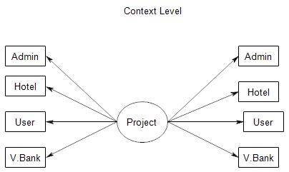

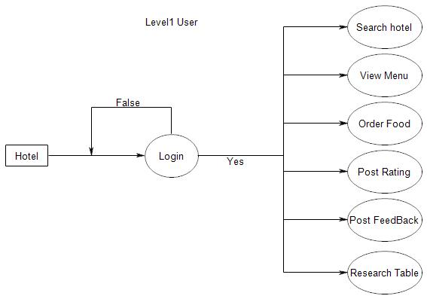

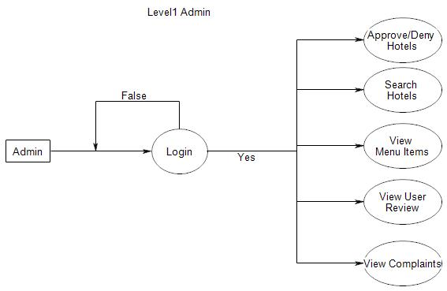

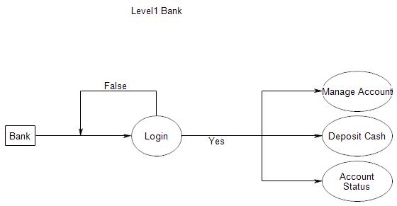

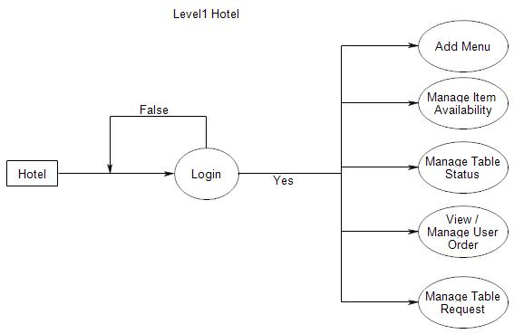

**Use case Diagram**

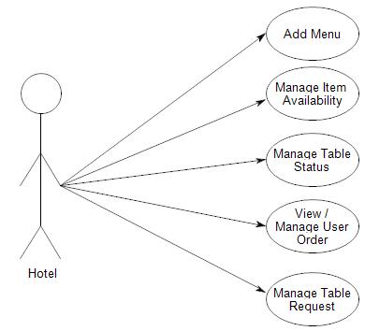

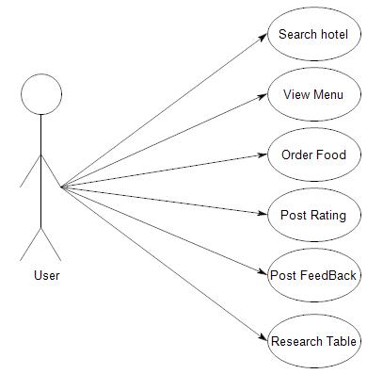

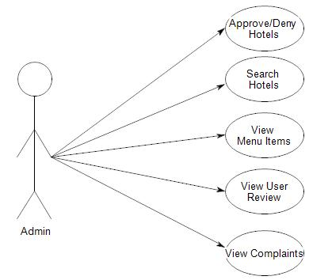

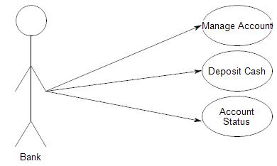

**Sequence Diagram**

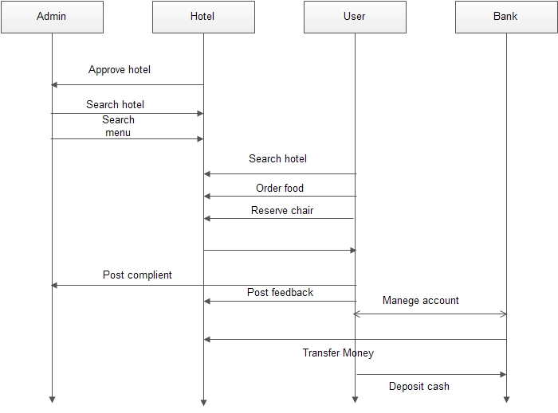

GANTT CHART

