**ASSIGNMENT**

**Name:** Vaishnavi Tajane

**Roll no:** 60

**Package name:** ShellJS

**Illustrate the need for ShellJS** **Package:**

**ShellJS:**

ShellJS is a portable (Windows/Linux/macOS) implementation of Unix shell commands on top of the Node.js API. You can use it to eliminate your shell script's dependency on Unix while still keeping its familiar and powerful commands. You can also install it globally so you can run it from outside Node projects - say goodbye to those gnarly Bash scripts! ShellJS is proudly tested on every node release since v8! Here are some reasons why you might consider using ShellJS in your Node.js projects:

**Shell-like commands:** ShellJS allows you to use familiar shell commands, such as ls, cd, rm, mkdir, and cat, directly within your JavaScript code. This makes it easier to work with the file system and execute system commands without having to spawn child processes manually.

**Cross-platform compatibility:** ShellJS is designed to be cross-platform, which means it works consistently on different operating systems, including Windows, macOS, and Linux. It abstracts away the differences in shell commands and file system operations between various platforms, allowing you to write code that works seamlessly across different environments.

**Code readability:** By using ShellJS, you can write code that closely resembles shell scripts, which can make your code more readable and maintainable, especially if you are familiar with shell scripting. It provides a higher-level API that simplifies common file system operations, eliminating the need for low-level file system interactions.

**Convenience and productivity:** ShellJS provide convenience methods for common tasks, such as copying files, moving files, searching for files, and executing shell commands. It saves you from writing boilerplate code and makes it quicker to accomplish file system-related operations.

**Integration with existing tools:** ShellJS integrates well with other tools and libraries in the Node.js ecosystem. For example, you can combine it with build tools like Gulp or Grunt to automate tasks, use it with testing frameworks for test setup and teardown, or incorporate it into deployment scripts to perform system-related actions.

However, it's worth noting that executing shell commands from a Node.js application may have security implications. Always exercise caution when executing user-supplied or untrusted commands to prevent potential vulnerabilities.

**Shell.js:**

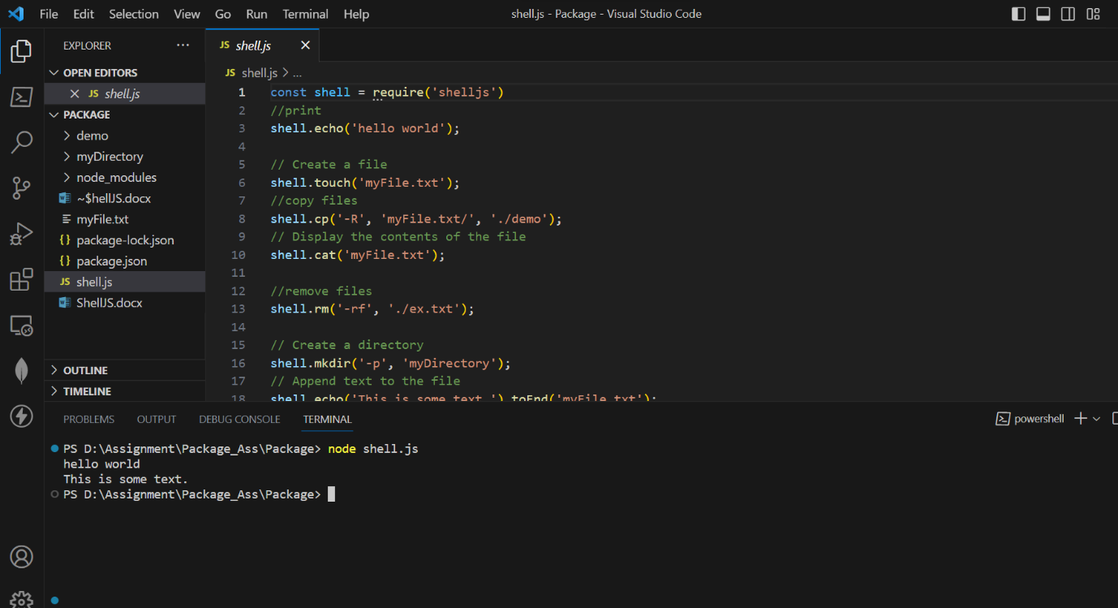

**Illustrate the need for code of ethics:**

The need for a code of ethics arises from several important considerations. Here are some key illustrations of why a code of ethics is necessary:

1. Guidance for Decision Making: A code of ethics provides individuals and organizations with a framework and principles to guide their decision-making processes. It establishes a set of standards and values that help individuals navigate ethical dilemmas and make choices aligned with ethical principles.
2. Establishing Trust and Credibility: A code of ethics helps build trust and credibility among stakeholders, including customers, clients, employees, and the general public. By adhering to a code of ethics, individuals and organizations demonstrate their commitment to ethical conduct, which enhances their reputation and fosters trust in their actions and operations.
3. Setting Expectations and Accountability: A code of ethics outlines the expected behaviour and conduct for individuals within an organization or profession. It establishes clear expectations, rules, and responsibilities, ensuring that individuals are aware of the ethical standards they are expected to uphold. This promotes accountability and provides a basis for evaluating and addressing ethical breaches.
4. Protecting Stakeholder Interests: A code of ethics helps protect the interests and well-being of various stakeholders. It ensures that individuals and organizations prioritize the rights, safety, and needs of stakeholders over personal or organizational gain. By following ethical principles, potential harm or exploitation of stakeholders can be minimized or prevented.
5. Safeguarding Integrity and Professionalism: A code of ethics upholds and preserves the integrity and professionalism of individuals and organizations. It promotes honest and transparent behaviour, discourages unethical practices, and encourages individuals to act in a manner consistent with the highest professional and moral standards.
6. Compliance with Laws and Regulations: A code of ethics often incorporates legal and regulatory requirements, ensuring that individuals and organizations operate within the boundaries of the law. It provides guidance on legal and ethical obligations, helping individuals understand and fulfil their legal responsibilities while maintaining ethical integrity.
7. Fostering a Positive Organizational Culture: A code of ethics contributes to the development of a positive organizational culture characterized by integrity, respect, and fairness. It sets the tone for ethical behaviour and serves as a unifying force, aligning individuals and teams towards a shared ethical purpose.
8. Adapting to Changing Contexts and Challenges: A code of ethics can be a dynamic document that evolves with changing social, cultural, and technological landscapes. It allows for the consideration and inclusion of emerging ethical issues and challenges, ensuring that individuals and organizations adapt and respond ethically to new circumstances