DBMS WEEKLY TASK
PAYMENT MANAGEMENT SYSTEM
1. Objectives
The main objectives of this task are:
- To create a Payment table.
- To store customer payment details.
- To manage successful and failed transactions.
- To modify payment status when required.
- To analyze the different payment methods used.
- To calculate the amount collected through each payment mode.
- To generate a payment transaction report.

2. Payment Table Structure
Column | Data Type | Constraint | Description
PAYMENT_ID | NUMBER(5) | Primary Key | Unique payment identification number
ORDER_ID | NUMBER(5) | Foreign Key | Identifies the related order
PAYMENT_DATE | DATE | NOT NULL | Date of payment
PAYMENT_MODE | VARCHAR2(20) | NOT NULL | Payment method
PAYMENT_AMOUNT | NUMBER(10,2) | NOT NULL | Amount paid
PAYMENT_STATUS | VARCHAR2(20) | NOT NULL | Status of payment

3.Create Payment Table
- The Payment table is created to store all payment-related information. The PAYMENT_ID is the primary key, and ORDER_ID is connected to the Orders table using a foreign key.

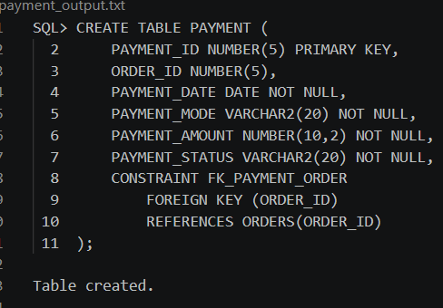

4. Insert Payment Details
Payment details are inserted into the Payment table using the INSERT command.
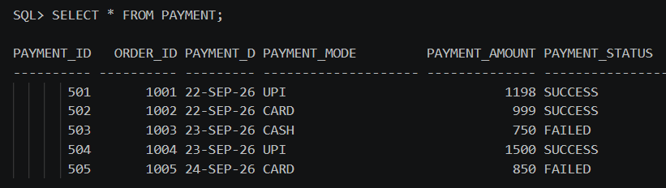

5. Display Successful Payments
Successful transactions can be displayed using the WHERE condition.
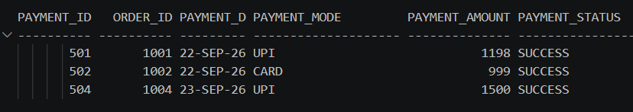

6. Display Failed Payments
Failed transactions can also be identified using the WHERE condition.
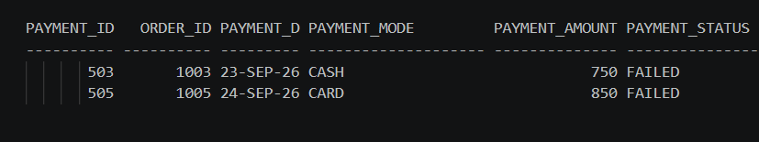

7. Modify Payment Status
The payment status can be modified when the transaction status changes.
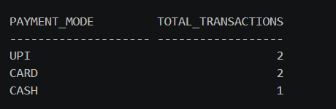

8. Analyze Payment Methods
The number of transactions made using each payment method can be calculated using GROUP BY and COUNT().
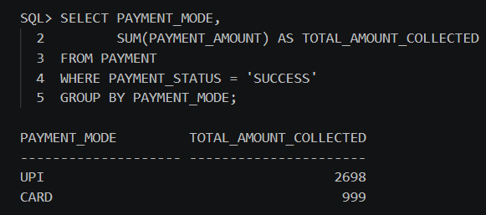

9. Payment Transaction Report
A payment transaction report can be generated by joining the Payment table with the Orders table.
