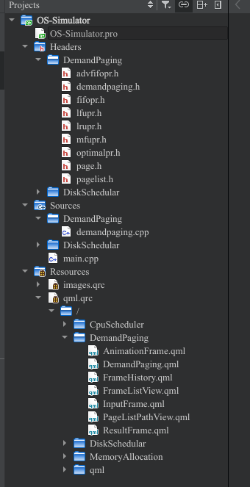
OS Mini Project
on
Demand Paging/ Page Replacement Algorithms

By
Rajiv Singh (SE Comps B 58)
Sushrut Kuchik (SE Comps B 62)
Vivek Vaishya (SE Comps B 66)

Abstract
Demand Paging is a method of virtual memory management. In a system that uses demand paging, the operating system copies a disk page into physical memory only if an attempt is made to access it and that page is not already in memory. It follows that a process begins execution with none of its pages in physical memory and many page faults will occur until most of a process's working set of pages are located in physical memory. Make a GUI application to simulate the mostly employed Page Replacement policies by Operating Systems.

Source Code Flow

}
Basic Algorithms implemented

GUI

}
GUI Design
Source Code
//demandpaging.h
#ifndef DEMANDPAGING_H
#define DEMANDPAGING_H
#include <QObject>
#include <QThread>
class DemandPaging : public QObject
{
Q_OBJECT
Q_PROPERTY(int FrameSize READ FrameSize WRITE setFrameSize NOTIFY FrameSizeChanged)
Q_PROPERTY(QList<QObject*> FrameList READ FrameList NOTIFY FrameListChanged)
Q_PROPERTY(QList<QObject*> PageList READ PageList NOTIFY PageListChanged)
Q_PROPERTY(QList<QObject*> FrameHistory READ FrameHistory NOTIFY FrameHistoryChanged)
Q_PROPERTY(QObject* FirstPage READ FirstPage NOTIFY FirstPageChanged)
Q_PROPERTY(int PageFaults READ PageFaults NOTIFY PageFaultsChanged)
Q_PROPERTY(int PageHits READ PageHits NOTIFY PageHitsChanged)
Q_PROPERTY(int TotalPages READ TotalPages NOTIFY TotalPagesChanged)
Q_PROPERTY(QString ExtraTip READ ExtraTip NOTIFY ExtraTipChanged)
public:
explicit DemandPaging(QObject *parent = nullptr);
int FrameSize() const{ return frameSize;}
void setFrameSize(const int FrameSize);
QList<QObject*> FrameList() const{ return frameList;}
QList<QObject*> PageList() const{ return pageList;}
QObject* FirstPage() const{ return pageList.first();}
QList<QObject*> FrameHistory() const{ return frameHistory;}
int PageFaults() const{ return pageFaults;}
int PageHits() const{ return pageHits;}
int TotalPages() const{ return totalPages;}
QString ExtraTip() const{ return extraTip;}
signals:
void FrameSizeChanged();
void FrameListChanged();
void PageListChanged();
void FirstPageChanged();
void FrameHistoryChanged();
void startThreadCalc();
void moveNextPage(int frameIndex);
void PageFaultsChanged();
void PageHitsChanged();
void TotalPagesChanged();
void ExtraTipChanged();
public slots:
void addPage(int page);
void startCalculation(int typeOfAlgorithm);
void reset();
void updatePageList(int changedFrameNo);
void updateFrameList(int changedFrameNo, int changedValue);
void updateResult(int faults, int hits);
private:
int frameSize;
QList<QObject*> frameList;
QList<QObject*> pageList;
QList<QObject*> frameHistory;
QThread calcThread;
int pageFaults;
int pageHits;
int totalPages;
QString extraTip;
};
#endif // DEMANDPAGING_H

//fifopr.h
#ifndef FIFOPR_H
#define FIFOPR_H
#include <QThread>
#include "page.h"
class FifoThread: public QObject{
Q_OBJECT
public:
FifoThread(QList<QObject*> PageList, int FrameSize, QObject *parent = nullptr)
:QObject (parent){
pageList.append(PageList);
frameSize = FrameSize;
}
void calculate(){
int faults = 0, hits = 0;
for(int i = 0; i < frameSize; i++)
frameList.append(new Page(-1));
int counter = 0;
while(!pageList.isEmpty()){
auto firstPage = qobject_cast<Page*>(pageList.takeFirst());
emit updatePageList(counter);
QThread::msleep(500);
if(contains(firstPage)){
hits++;
emit updateFrameList(-1, firstPage->Id());
}
else{
frameList.replace(counter, firstPage);
emit updateFrameList(counter, firstPage->Id());
counter = (counter + 1)%frameSize;
faults++;
}
emit updateResult(faults, hits);
QThread::msleep(250);
}
}
bool contains(Page *page){
foreach(QObject *obj, frameList){
auto frame = qobject_cast<Page*>(obj);
if(frame->Id() == page->Id())
return true;
}
return false;
}
signals:
void updatePageList(int changedFrameNo);
void updateFrameList(int changedFrameNo, int changedValue);
void updateResult(int faults, int hits);
private:
int frameSize;
QList<QObject*> frameList;
QList<QObject*> pageList;
};
#endif // FIFOPR_H

//lfupr.h
#ifndef LFUPR_H
#define LFUPR_H
#include <QThread>
#include "page.h"
class CountClass{
public:
CountClass(int Id, int Count)
:id(Id), count(Count){}
int Id() const{return id;}
int Count() const{ return count;}
void incrementCount(){ count++; }
void decrementCount(){ if(count != 0) count--;}
private:
int id, count;
};
class LfuThread: public QObject{
Q_OBJECT
public:
LfuThread(QList<QObject*> PageList, int FrameSize, QObject *parent = nullptr)
:QObject (parent){
pageList.append(PageList);
frameSize = FrameSize;
}
void calculate(){
int faults = 0, hits = 0;
for(int i = 0; i < frameSize; i++)
frameList.append(new Page(-1));
foreach (QObject *obj, pageList){
auto id = qobject_cast<Page*>(obj)->Id();
int i;
for(i = 0; i < repeated.length() && repeated[i].Id() != id; i++);
if(i == repeated.length())
repeated.append(CountClass(id, 0));
}
int count = 0;
while(count < frameSize){
auto firstPage = qobject_cast<Page*>(pageList.takeFirst());
incrementCount(firstPage->Id());
frameList.replace(count, firstPage);
emit updatePageList(count);
QThread::msleep(500);
faults++;
emit updateFrameList(count++, firstPage->Id());
}
while(!pageList.isEmpty()){
auto firstPage = qobject_cast<Page*>(pageList.takeFirst());
int position = contains(firstPage);
if(position > -1){
incrementCount(firstPage->Id());
emit updatePageList(position);
QThread::msleep(500);
hits++;
emit updateFrameList(-1, firstPage->Id());
}
else{
int l = leastCount();
int con = contains(new Page(l));
frameList.replace(con, firstPage);
incrementCount(firstPage->Id());
emit updatePageList(con);
QThread::msleep(500);
emit updateFrameList(con, firstPage->Id());
faults++;
}
emit updateResult(faults, hits);
QThread::msleep(250);
}
}
int contains(Page *page){
for(int i = 0 ; i < frameList.length(); i++){
auto frame = qobject_cast<Page*>(frameList[i]);
if(frame->Id() == page->Id())
return i;
}
return -1;
}
void incrementCount(int Id){
for(int i = 0; i < repeated.length(); i++)
if(repeated[i].Id() == Id){
repeated[i].incrementCount();
repeated.move(i, frameSize - 1);
break;
}
}
int leastCount(){
int least = 0;
for(int i = 1; i < frameSize - 1; i++)
if(repeated[i].Count() < repeated[least].Count())
least = i;
repeated[least].decrementCount();
repeated.move(least, frameSize);
return repeated[frameSize].Id();
}
signals:
void updatePageList(int changedFrameNo);
void updateFrameList(int changedFrameNo, int changedValue);
void updateResult(int faults, int hits);
private:
int frameSize;
QList<QObject*> frameList;
QList<QObject*> pageList;
QList<CountClass> repeated;
};
#endif // LFUPR_H
//lrupr.h
#ifndef LRUPR_H
#define LRUPR_H
#include <QThread>
#include "page.h"
class LruThread: public QObject{
Q_OBJECT
public:
LruThread(QList<QObject*> PageList, int FrameSize, QObject *parent = nullptr)
:QObject (parent){
pageList.append(PageList);
frameSize = FrameSize;
}
void calculate(){
int faults = 0, hits = 0;
for(int i = 0; i < frameSize; i++)
frameList.append(new Page(-1));
int lIndex = 0;
while(!pageList.isEmpty()){
auto firstPage = qobject_cast<Page*>(pageList.takeFirst());
int oindex = indexOf(firstPage);
if(oindex > -1){
displace(firstPage);
emit updatePageList(oindex);
QThread::msleep(500);
hits++;
emit updateFrameList(-1, firstPage->Id());
}
else{
if(!tempFrameList.isEmpty() && tempFrameList.length() >= frameList.length())
lIndex = indexOf(qobject_cast<Page*>(tempFrameList.takeFirst()));
frameList.replace(lIndex, firstPage);
tempFrameList.append(firstPage);
emit updatePageList(lIndex);
QThread::msleep(500);
emit updateFrameList(lIndex, firstPage->Id());
lIndex++;
faults++;
}
emit updateResult(faults, hits);
QThread::msleep(250);
}
}
void displace(Page *page){
for(int i = 0; i < tempFrameList.length(); i++){
if(page->Id() == (qobject_cast<Page*>(tempFrameList[i]))->Id()){
tempFrameList.removeAt(i);
break;
}
}
tempFrameList.append(page);
}
int indexOf(Page *page){
for(int i = 0 ; i < frameList.length(); i++){
auto frame = qobject_cast<Page*>(frameList[i]);
if(frame->Id() == page->Id())
return i;
}
return -1;
}
signals:
void updatePageList(int changedFrameNo);
void updateFrameList(int changedFrameNo, int changedValue);
void updateResult(int faults, int hits);
private:
int frameSize;
QList<QObject*> frameList;
QList<QObject*> tempFrameList;
QList<QObject*> pageList;
};
#endif // LRUPR_H

//mfupr.h
#ifndef MFUPR_H
#define MFUPR_H
#include <QThread>
#include "page.h"
class MfuThread: public QObject{
Q_OBJECT
public:
MfuThread(QList<QObject*> PageList, int FrameSize, QObject *parent = nullptr)
:QObject (parent){
pageList.append(PageList);
frameSize = FrameSize;
}
void calculate(){
int faults = 0, hits = 0;
for(int i = 0; i < frameSize; i++)
frameList.append(new Page(-1));
for(int i = 0; i < frameSize; i++){
auto firstPage = qobject_cast<Page*>(pageList.takeFirst());
emit updatePageList(i);
QThread::msleep(500);
frameList.replace(i, firstPage);
emit updateFrameList(i, firstPage->Id());
emit updateResult(++faults, hits);
QThread::msleep(250);
}
int counter = frameSize - 1;
while(!pageList.isEmpty()){
auto firstPage = qobject_cast<Page*>(pageList.takeFirst());
emit updatePageList(counter);
QThread::msleep(500);
int con = contains(firstPage);
if(con > -1){
hits++;
emit updateFrameList(-1, firstPage->Id());
counter = con;
}
else{
frameList.replace(counter, firstPage);
emit updateFrameList(counter, firstPage->Id());
faults++;
}
emit updateResult(faults, hits);
QThread::msleep(250);
}
}
int contains(Page *page){
for(int i = 0 ; i < frameList.length(); i++){
auto frame = qobject_cast<Page*>(frameList[i]);
if(frame->Id() == page->Id())
return i;
}
return -1;
}
signals:
void updatePageList(int changedFrameNo);
void updateFrameList(int changedFrameNo, int changedValue);
void updateResult(int faults, int hits);
private:
int frameSize;
QList<QObject*> frameList;
QList<QObject*> pageList;
};#endif // MFUPR_H
//optimalpr.h
#ifndef OPTIMALPR_H
#define OPTIMALPR_H
#include <QThread>
#include "page.h"
class OptimalThread: public QObject{
Q_OBJECT
public:
OptimalThread(QList<QObject*> PageList, int FrameSize, QObject *parent = nullptr)
:QObject (parent){
pageList.append(PageList);
frameSize = FrameSize;
}
void calculate(){
int faults = 0, hits = 0;
for(int i = 0; i < frameSize; i++)
frameList.append(new Page(-1));
int counter = 0;
while(!pageList.isEmpty()){
auto firstPage = qobject_cast<Page*>(pageList.takeFirst());
int lIndex = contains(firstPage);
if(lIndex > -1){
hits++;
emit updatePageList(lIndex);
QThread::msleep(500);
emit updateFrameList(-1, firstPage->Id());
}
else{
lIndex = (counter < frameSize) ? counter++ : forLookFuture();
frameList.replace(lIndex, firstPage);
faults++;
emit updatePageList(lIndex);
QThread::msleep(500);
emit updateFrameList(lIndex, firstPage->Id());
}
emit updateResult(faults, hits);
QThread::msleep(250);
}
}
int contains(Page *page){
for(int i = 0 ; i < frameList.length(); i++){
auto frame = qobject_cast<Page*>(frameList[i]);
if(frame->Id() == page->Id())
return i;
}
return -1;
}
int forLookFuture(){
//signed int nearOccurence = -1;
int index = 0;
for(int j = 0, nearOccurence = 0; j < frameSize; j++){
auto frame = qobject_cast<Page*>(frameList[j]);
if(frame->Id() != -1){
int i;
for(i = 0; i < pageList.length(); i++){
auto page = qobject_cast<Page*>(pageList[i]);
if(page->Id() == frame->Id()){
if(nearOccurence < i){
nearOccurence = i;
index = j;
}
break;
}
}
if(i == pageList.length()){
nearOccurence = i;
index = j;
}
}
}
return index;
}
signals:
void updatePageList(int changedFrameNo);
void updateFrameList(int changedFrameNo, int changedValue);
void updateResult(int faults, int hits);
private:
int frameSize;
QList<QObject*> frameList;
QList<QObject*> pageList;
};
#endif // OPTIMALPR_H

//DemandPaging.qml
import QtQuick 2.12
import QtQuick.Controls 2.5
import "../qml/CustomComponents"
Rectangle {
id: demandPaging
color: "transparent"
Column{
anchors.fill: parent
spacing: 10
anchors.margins: 10
InputFrame{
id: inputFrame
width: parent.width
anchors.horizontalCenter: parent.horizontalCenter
}
Row{
width: parent.width
height: (parent.height - inputFrame.height)*0.6 - 20
spacing: 10
AnimationFrame{
id: animationFrame
width: parent.width*0.75 - 10
height: parent.height
}
ResultFrame{
width: parent.width*0.25
height: parent.height
}
}
FrameHistory{
id: frameList
width: parent.width
height: (parent.height - inputFrame.height)*0.4
anchors.bottomMargin: 10
}
}
}
Screenshots
Before Solving
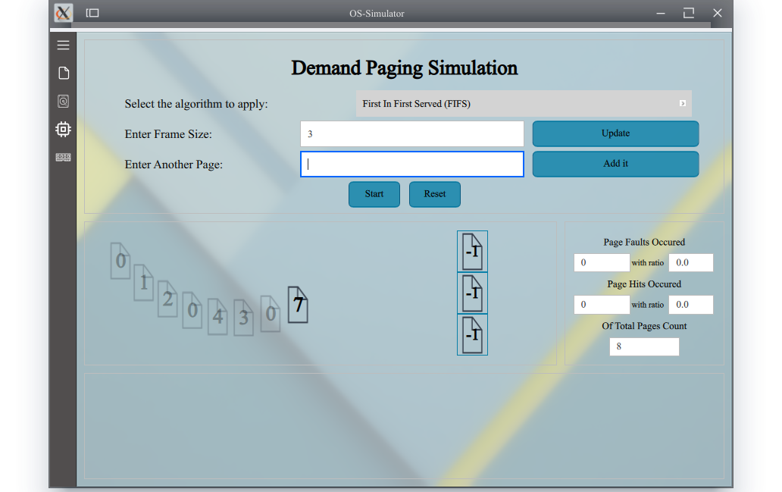
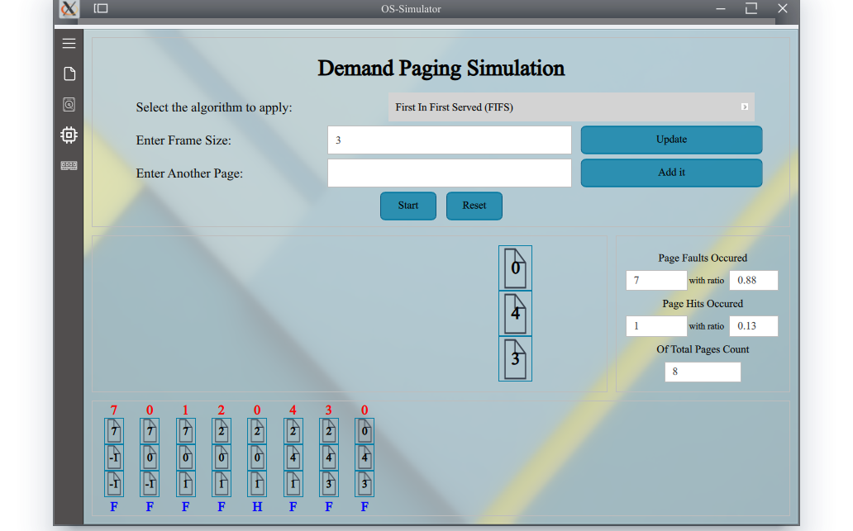
After Solving

