**Project Report Template**

**1 INTRODUCTION**

**1.1 Overview**

A brief description about your project

* The term Agriculture is derived from two Latin words ager or agri meaning soil and cultura meaning cultivation.
* Agriculture is an applied science which encompasses all aspects of crop production including horiculture ,livestock rearing , fisheries , forestry , etc.
* As an art it embraces knowledge of the way to perform the operations of the farm in a skilllful manner.
* As a science: utilizes all technologies developed on scientific principles such as crop breeding , production techniques , crop protection , economics , etc.to maximize the yield and profit.
* Agriculture as as business aims at maximum net return through the management of land labour , water and captial, employing the knowledge of varoius sciences for production of food , feed , fibre and fuel.

**1.2 Purpose**

The use of this project. What can be achieved using this.

Agriculture provides most of the worlds's food and fabrics. cotton, wool, and leather are all agricultural products . Agricultural also provides wood for construction and paper products. These products, as well as the agricultural methods used , may vary from one part of the world to another.

**2 Problem Definition & Design Thinking**

2.1 Empathy Map

Paste the empathy map screenshot

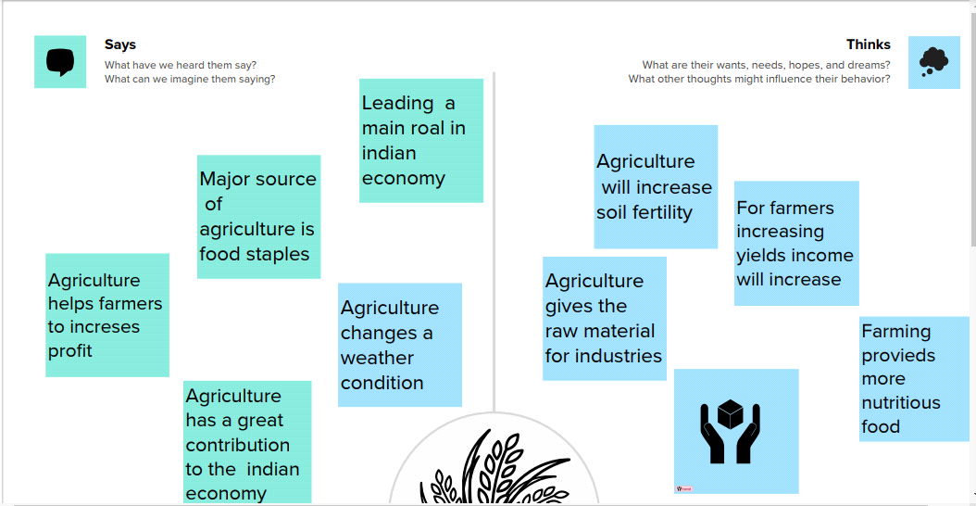

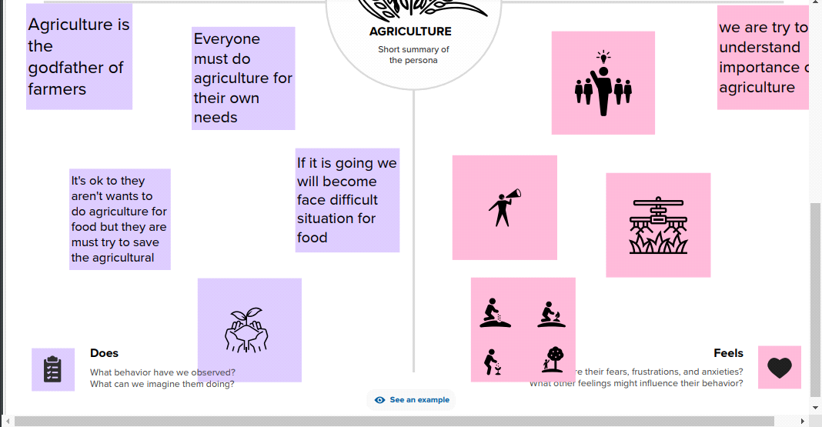

2.2 Ideation & Brainstorming Map

Paste the Ideation & brainstorming map screenshot

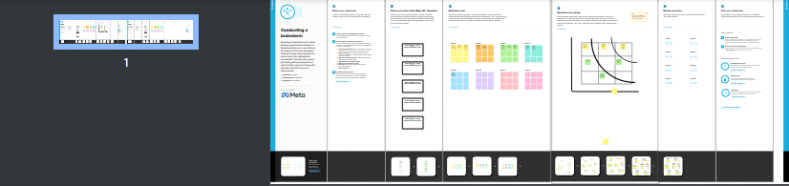

**3 RESULT**

Final findings (Output) of the project along with screenshots

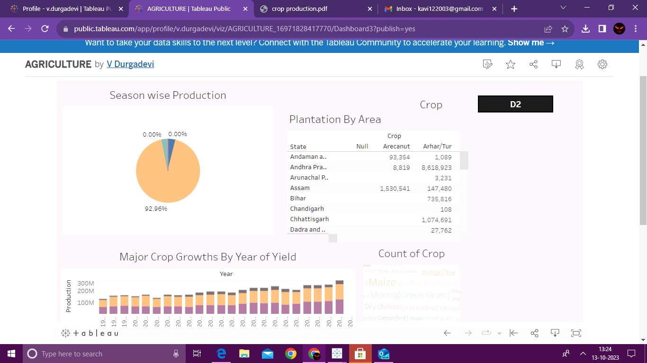

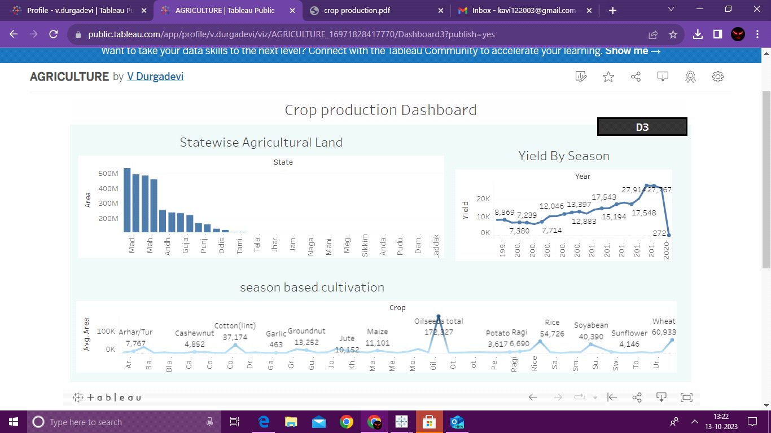

**4 ADVANTAGES & DISADVANTAGES**

List of advantages and disadvantages of the proposed solution

**Advantages:**

1. Moodren machines can control the efforts of farmers.
2. Reduce impact on the ecosystem.
3. Further, Improve the fertility of the soil.
4. Conservation of biodiversity.
5. Healthy food produced.

**Disadvantage:**

1. It is efficient but has many side effects and drawbacks.
2. Overuse of machines may lead to environmental damage.
3. Most of the framers are illiterates so they are unable to use the modern machines.
4. Acquisition of new management skills.
5. Food produced is not healthy.

**5 APPLICATIONS**

The areas where this solution can be applied

* Plains: Flat or gently rolling areas with fertile soil and favorable climate conditions for crop cultivation.
* River Valleys: Areas adjacent to rivers that benefit from fertile alluvial soil and access to water for irrigation.

**6 CONCLUSION**

Conclusion summarizing the entire work and findings.

* India has always been benefited by Agriculture
* Thus, the agricultural sector is playing a very important role in the country like India and the prosperity of the Indian Economy still largely depends on agriculture sector.
* Agriculture development is the basic pre condition of sectoral diversification and development of the economy.

**7 FUTURE SCOPE**

Enhancements that can be made in the future.

8 APPENDIX

A. Source Code

Attach the code for the solution built.