Assignment - 4

# Question 1:

Pull an image from docker hub and run it in docker playground.

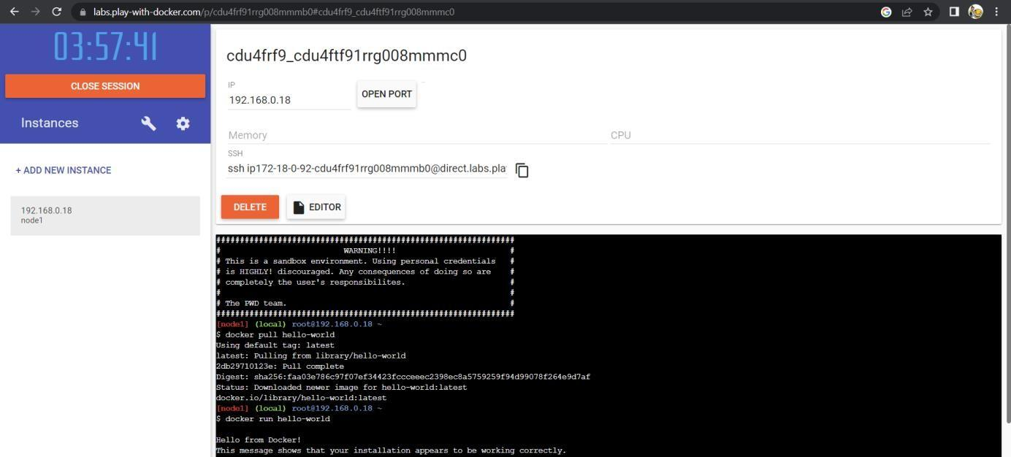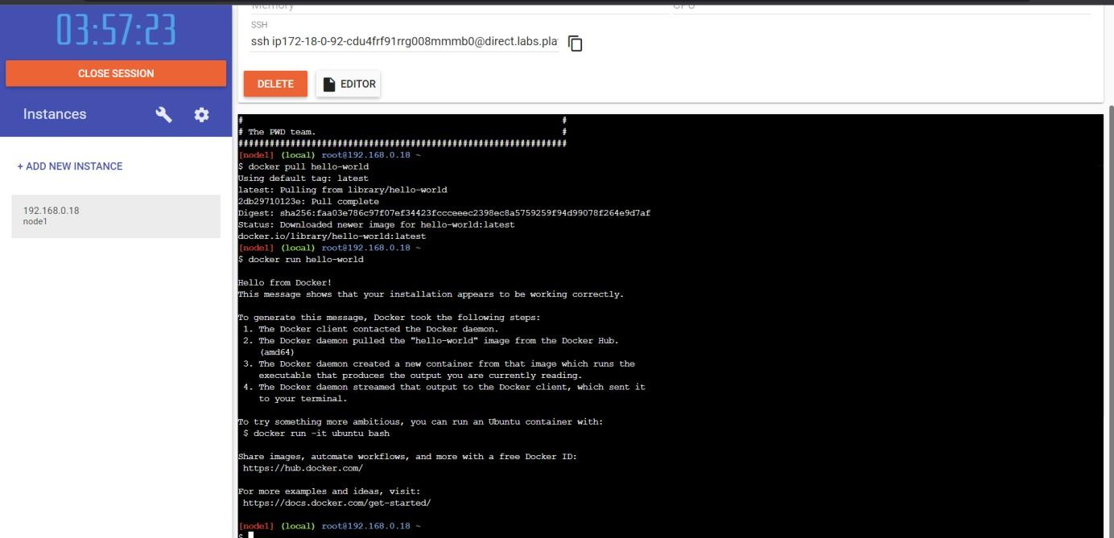

# Question 2:

Create a docker file for the job portal application and deploy it in Docker desktop application.

DOCKERFILE:

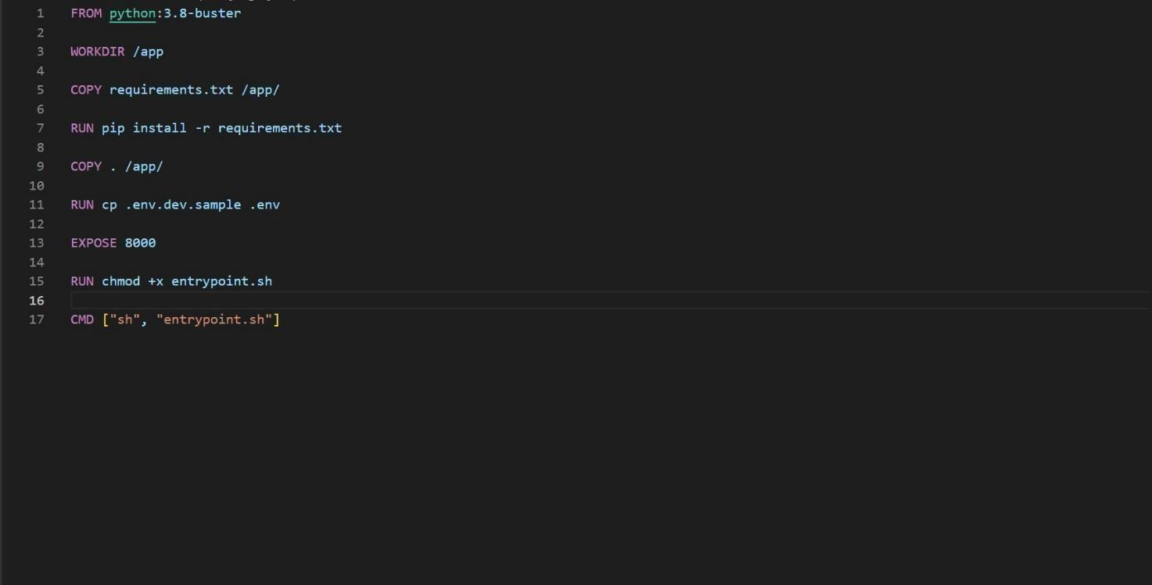

DEPLOYMENT OF JOBPORTAL APPLICATION:

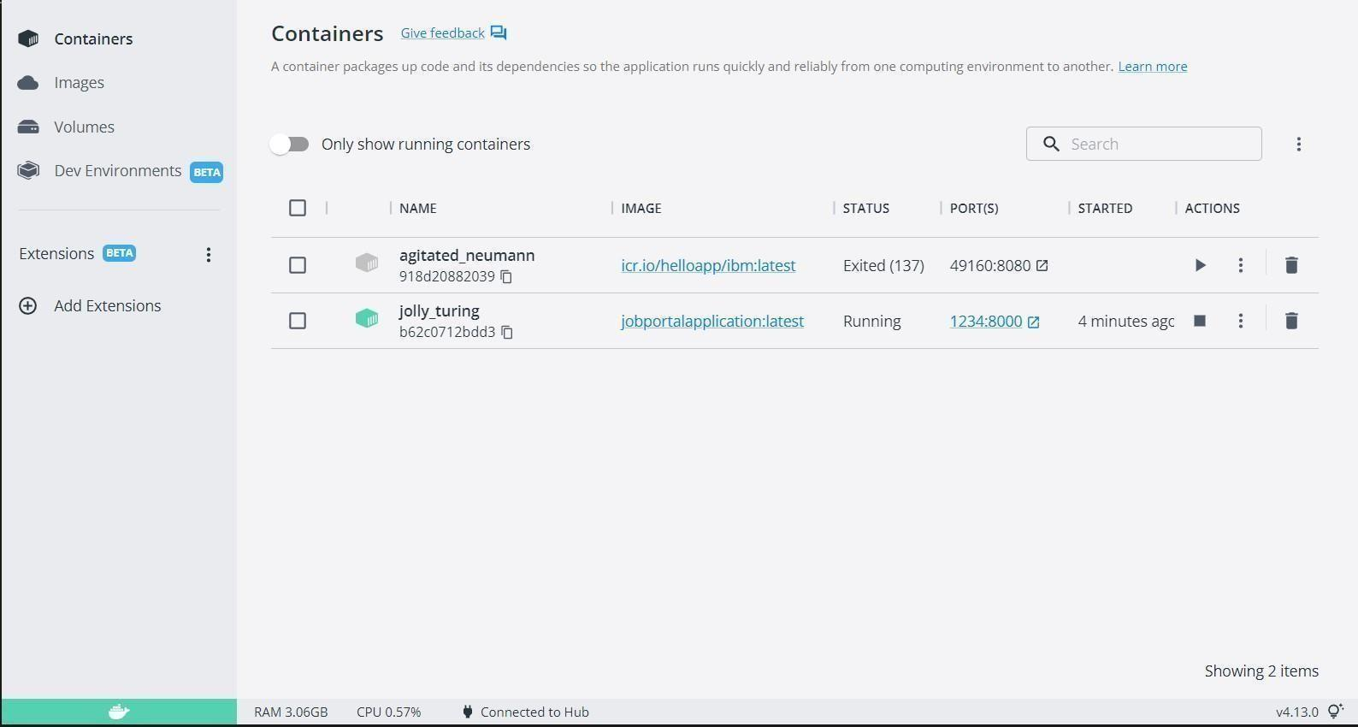

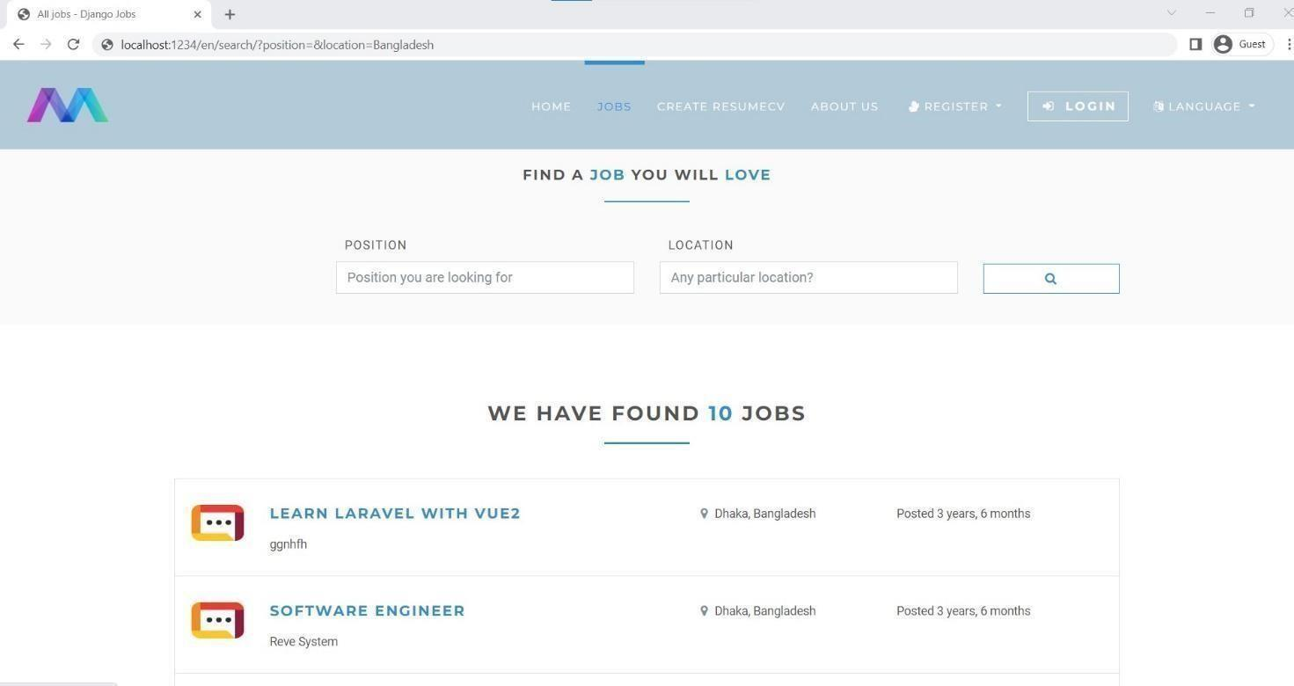

# Question 3:

Create an IBM container registry and deploy hello world app or job portal app. IBM CONTAINER REGISTRY DEPLOYMENT: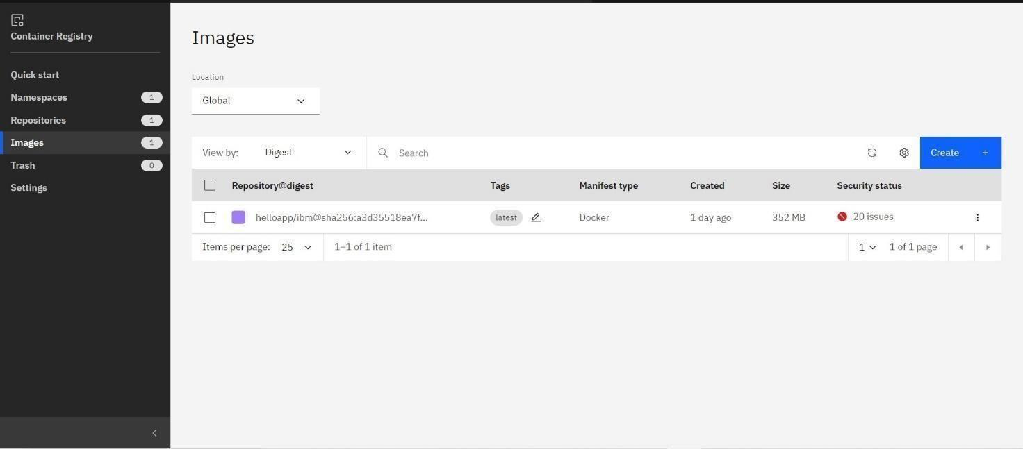



# Question 4:

Create a Kubernetes cluster in IBM cloud and deploy hello world image or job portal image and expose the same app to run in node port.

Creating Kubernetes cluster in IBM cloud and exposing node port:

