**项目测试报告**

**任务三**

**文法分析部分**

**1、准备工作**

**mini-c的正则表达式：**

|  |
| --- |
| letter = [a-zA-Z]  digit = [0-9]  _NUM100 = digit+( \. digit+)?  _ID200 = (_ | letter) ( _ | letter | digit ) *  _keyword300 = else | if | int | float | real | return | void | while | do  _left-curlybrace10 = {  _right-curlybrace20 = }  _left-squarebracket30 = \[  _right-squarebracket40 = \]  _left-roundbracket50 = \(  _right-roundbracket60 = \)  _relop600 = <= | < | > | >= | == | !=  _addop700 = \+ | -  _mulop800 = \* | / | % | ^  _assign-op900 = =  _divide-op1000 = ;  _comma-op1100 = ,  _annotation700 = ( letter | digit | _NUM | _ID | _keyword | _left-curlybrace | _right-curlybrace | _left-squarebracket | _left-squarebracket | _left-roundbracket | _right-roundbracket | _relop | _addop | _mulop | _assign-op | _divide-op | _comma-op) |

**sample.tny文件：**

|  |
| --- |
| real ans;    //fact  int fact(int x) {  if (x == 0) return 1;  else return fact(x - 1) * x;;  }    //main  int main(void) {  int n;  int t;  int x;  int a[10];  t = n = 10;  x = (x - 1) * x % 10 ^ x / (x + 1);  while (t >= 0) {  a[t] = fact(a[t]);  t = t - 1;  };  do {  ans = ans * a[t] * 0.1;  t = t + 1;  } while(t <= n);  if (ans < 0) {  ans = 0;  } else {  if (ans > 123456) ans = 123456;;  };  if (ans != 123456) ans = ans + 1;;  return 0;  } |

**2、NFA图**

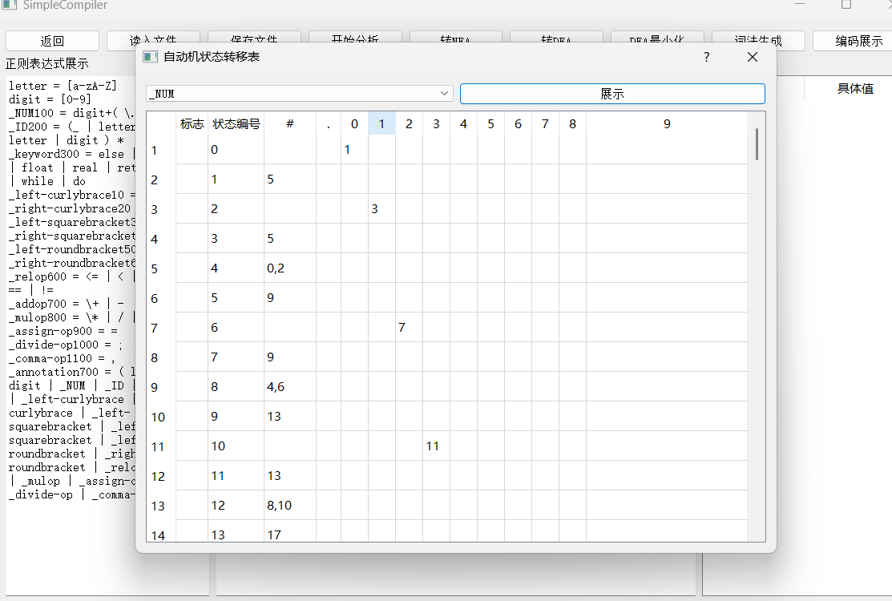

**3、DFA图**

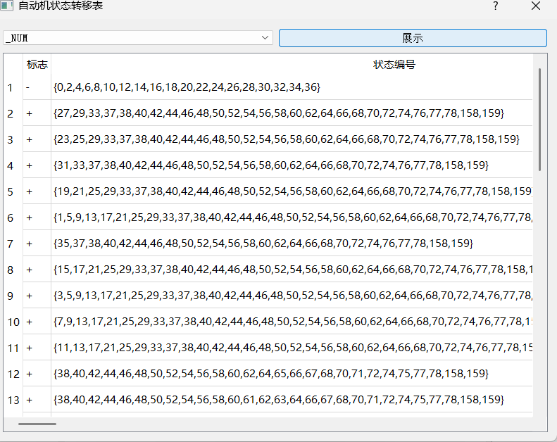

**4、DFA图最小化**

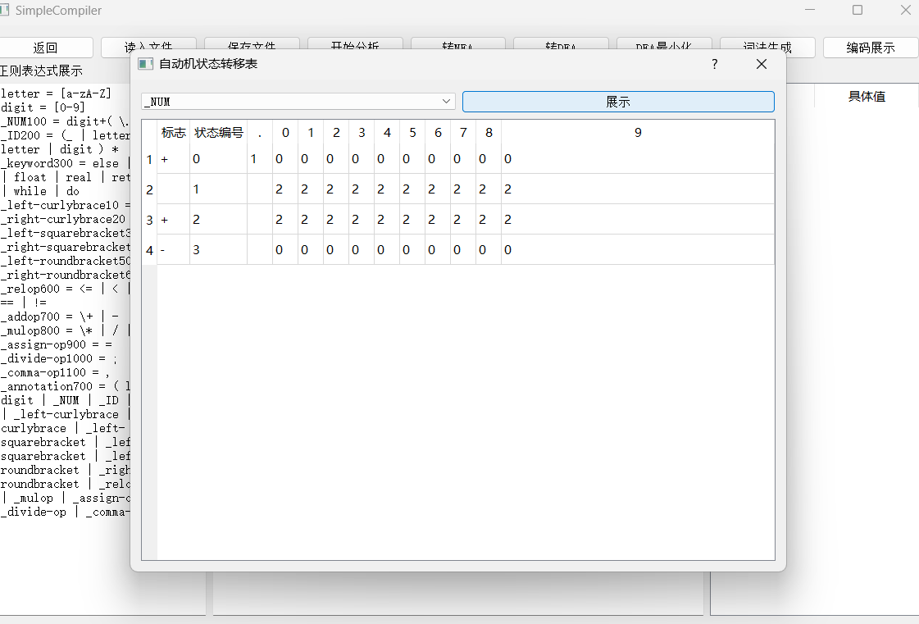

**5、生成词法程序**

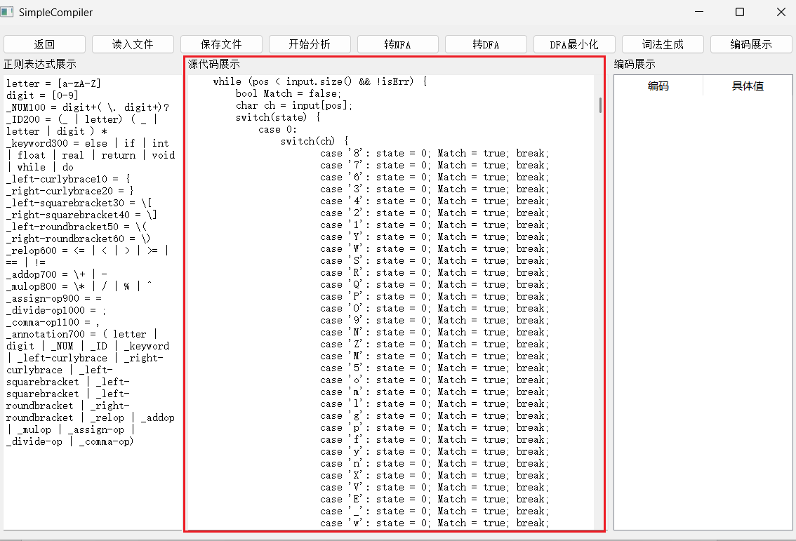

**6、编译cpp文件运行，并查看最终minic编码文件**

具体minic如下：

|  |
| --- |
| 300 real 200 ans 1000 ; 300 int 200 fact 50 ( 300 int 200 x 60 ) 10 { 300 if 50 ( 200 x 600 == 100 0 60 ) 300 return 100 1 1000 ; 300 else 300 return 200 fact 50 ( 200 x 700 - 100 1 60 ) 800 * 200 x 1000 ; 1000 ; 20 } 300 int 200 main 50 ( 300 void 60 ) 10 { 300 int 200 n 1000 ; 300 int 200 t 1000 ; 300 int 200 x 1000 ; 300 int 200 a 30 [ 100 10 40 ] 1000 ; 200 t 900 = 200 n 900 = 100 10 1000 ; 200 x 900 = 50 ( 200 x 700 - 100 1 60 ) 800 * 200 x 800 % 100 10 800 ^ 200 x 800 / 50 ( 200 x 700 + 100 1 60 ) 1000 ; 300 while 50 ( 200 t 600 >= 100 0 60 ) 10 { 200 a 30 [ 200 t 40 ] 900 = 200 fact 50 ( 200 a 30 [ 200 t 40 ] 60 ) 1000 ; 200 t 900 = 200 t 700 - 100 1 1000 ; 20 } 1000 ; 300 do 10 { 200 ans 900 = 200 ans 800 * 200 a 30 [ 200 t 40 ] 800 * 100 0.1 1000 ; 200 t 900 = 200 t 700 + 100 1 1000 ; 20 } 300 while 50 ( 200 t 600 <= 200 n 60 ) 1000 ; 300 if 50 ( 200 ans 600 < 100 0 60 ) 10 { 200 ans 900 = 100 0 1000 ; 20 } 300 else 10 { 300 if 50 ( 200 ans 600 > 100 123456 60 ) 200 ans 900 = 100 123456 1000 ; 1000 ; 20 } 1000 ; 300 if 50 ( 200 ans 600 != 100 123456 60 ) 200 ans 900 = 200 ans 700 + 100 1 1000 ; 1000 ; 300 return 100 0 1000 ; 20 } |

**语法分析部分**

**1、准备工作**

**tiny的文法**

|  |
| --- |
| program -> definition-list  definition-list -> definition-list definition | definition  definition -> variable-definition | function-definition  variable-definition -> type-indicator ID ; | type-indicator ID [ NUM ] ;  type-indicator -> int | float | real | void  function-definition -> type-indicator ID ( parameters ) compound-stmt  parameters -> parameter-list | void  parameter-list -> parameter-list , parameter | parameter  parameter -> type-indicator ID | type-indicator ID [ ]  compound-stmt-> { local-definitions statement-list }  local-definitions-> local-definitions variable-definition | #  statement-list-> statement-list statement | #  statement -> expression-stmt | compound-stmt | condition-stmt | while-stmt | dowhile-stmt | return-stmt  expression-stmt -> expression ; | ;  condition-stmt-> if ( expression ) statement ; | if ( expression ) statement else statement ;  while-stmt -> while ( expression ) statement ;  dowhile-stmt -> do statement while ( expression ) ;  return-stmt -> return ; | return expression ;  expression -> variable = expression | simple-expression  variable -> ID | ID [ expression ]  simple-expression -> additive-expression relop additive-expression | additive-expression  relop -> <= | < | > | >= | == | !=  additive-expression -> additive-expression addop term | term  addop -> + | -  term -> term mulop factor | factor  mulop -> * | / | % | ^  factor -> ( expression ) | variable | call | NUM  call -> ID ( arguments )  arguments -> argument-list | #  argument-list -> argument-list , expression | expression |

**minic的sample.minic编码文本（见上词法分析最终结果的编码文件）**

**tiny的语义动作表**

|  |
| --- |
| program -> stmt-sequence  1  stmt-sequence -> stmt-sequence ; statement  1 0 3  stmt-sequence -> statement  1  statement -> if-stmt  1  statement -> repeat-stmt  1  statement -> assign-stmt  1  statement -> read-stmt  1  statement -> write-stmt  1  if-stmt -> if exp then stmt-sequence end  1 2 0 2 0  if-stmt -> if exp then stmt-sequence end else stmt-sequence end  1 2 0 2 0 0 2 0  repeat-stmt -> repeat stmt-sequence until exp  1 2 0 2  assign-stmt -> identifier := exp  2 1 2  read-stmt -> read identifier  1 2  write-stmt -> write exp  1 2  exp -> simple-exp comparison-op simple-exp  2 1 2  exp -> simple-exp  1  comparison-op -> <  1  comparison-op -> >  1  comparison-op -> =  1  comparison-op -> <=  1  comparison-op -> <>  1  comparison-op -> >=  1  simple-exp -> simple-exp addop term  2 1 2  simple-exp -> term  1  addop -> +  1  addop -> -  1  term -> term mulop factor  2 1 2  term -> factor  1  mulop -> *  1  mulop -> /  1  mulop -> %  1  mulop -> ^  1  factor -> ( exp )  0 1 0  factor -> number  1  factor -> identifier  1 |

**2、开始测试**

1. **First集合：**

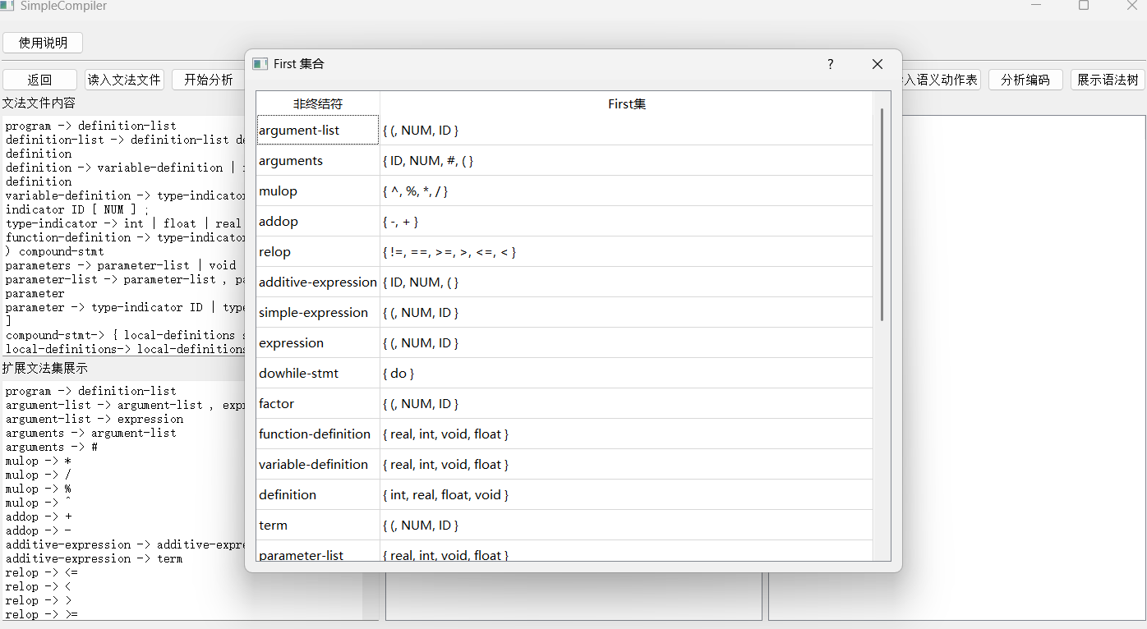

1. **Follow集合：**

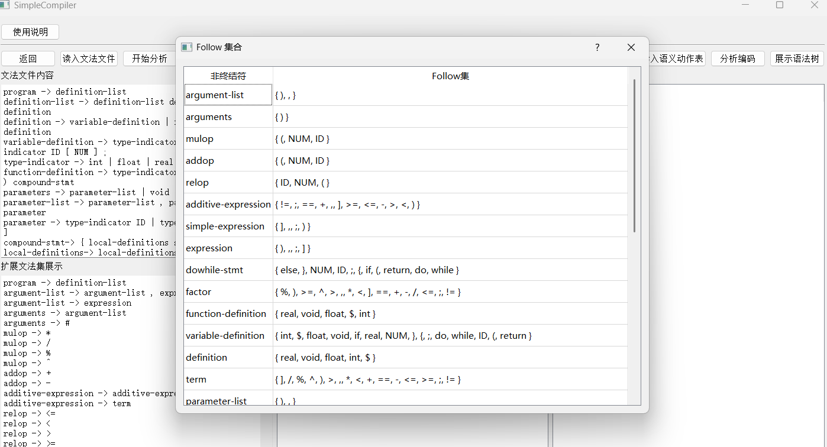

1. **LR0-DFA：**

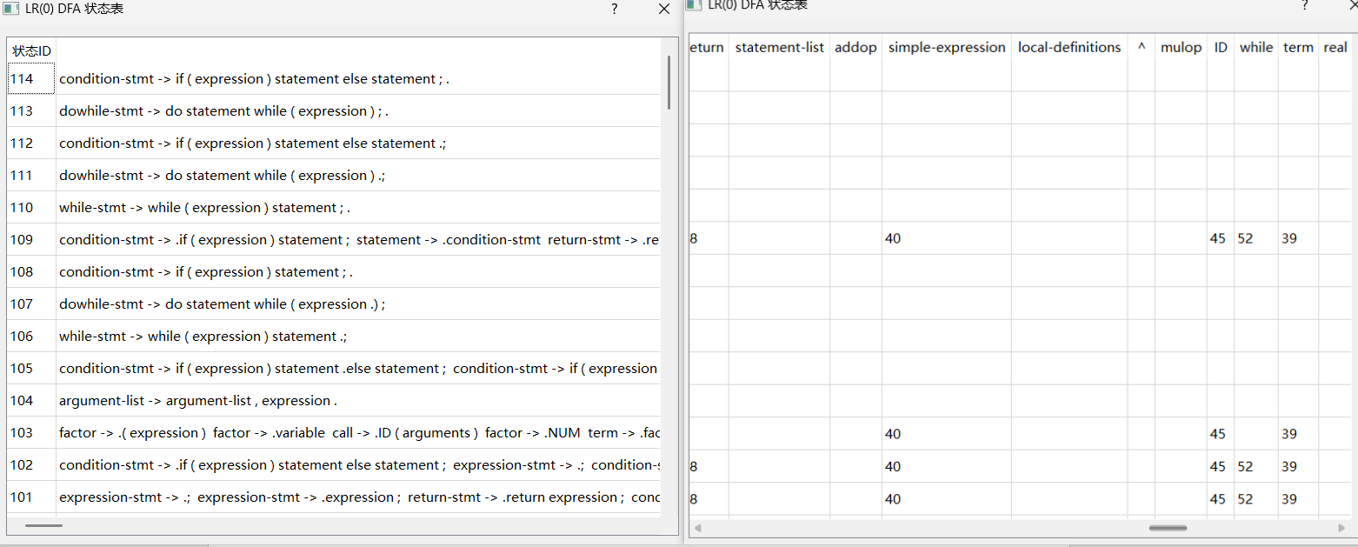

1. **判断是否为SLR1：**

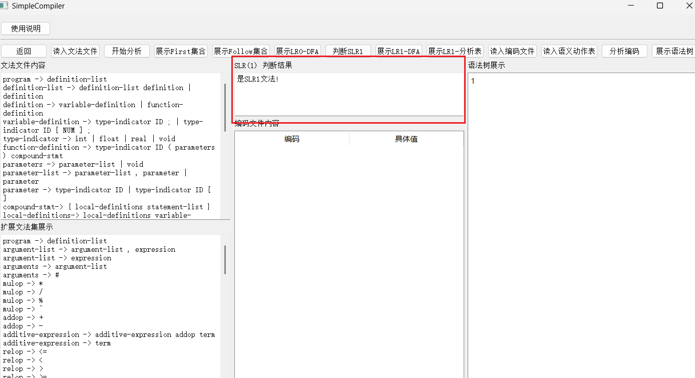

1. **LR1-DFA：**

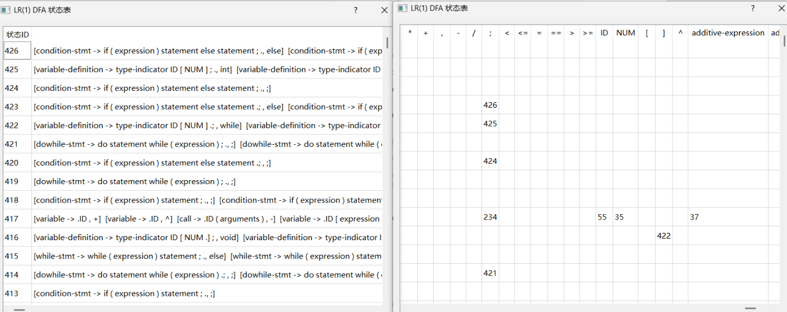

1. **LR1-分析表：**

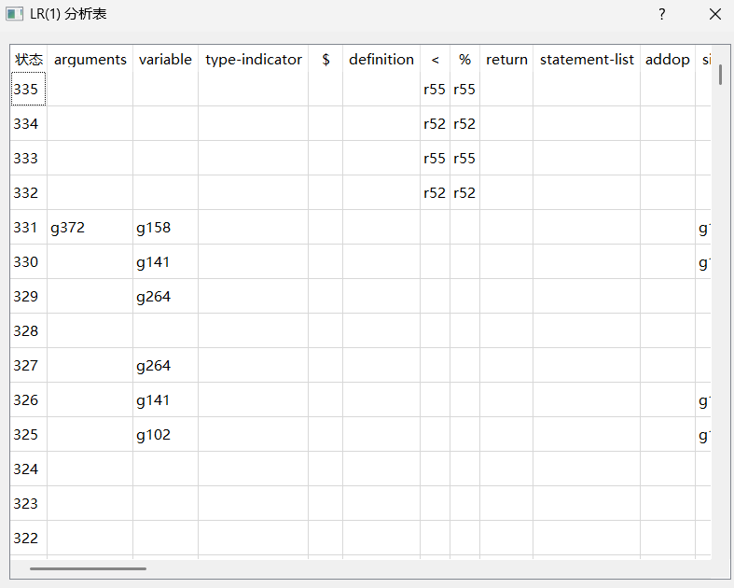

1. **分析编码过程展示**

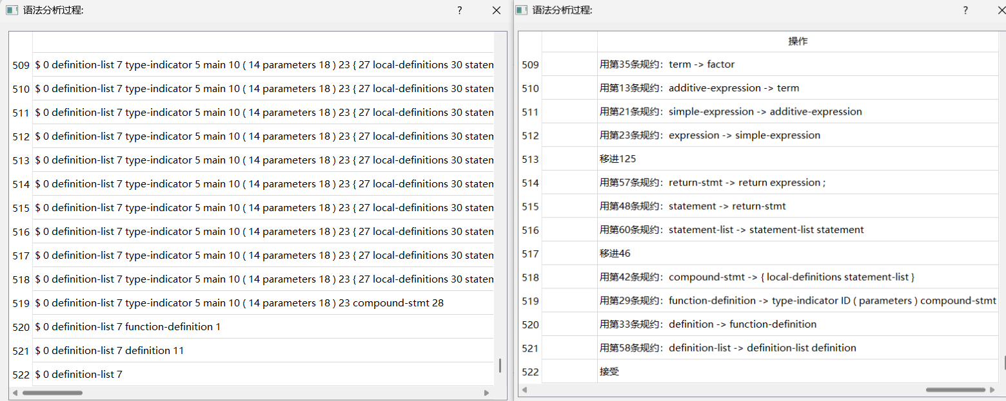

1. **语法树展示**

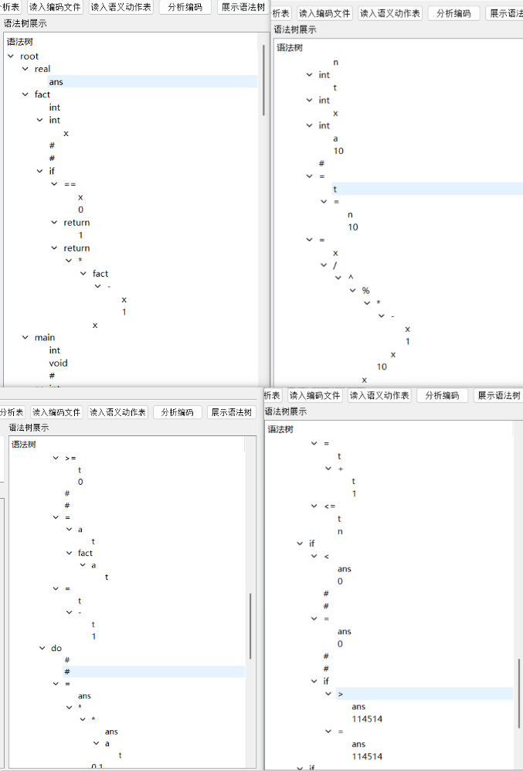

**总结：根据我们最后展示的语法分析过程的结果，以及语法树的展示结果来看，我们本次任务三的测试完全通过。**