Integrative transcriptomic analysis of SSRI exposure datasets identifies neurodevelopmental and stress-response signatures in human neural differentiation systems
Vajagathali Mohammed^{1*}, Sudhan Mookandi²
¹Department of Biochemistry and Biophysics, Stockholm University, Sweden
²Human Genetics Research Centre, Sree Balaji Dental College and Hospital, Bharath Institute of Higher Education and Research, Chennai, Tamil Nadu, India
*Correspondence
Vajagathali Mohammed
email: vajagathali.mohammed@dbb.su.se

Running title: SSRI-associated transcriptomic signatures in neural differentiation

Abstract
Selective serotonin reuptake inhibitors (SSRIs) are widely used antidepressants, including during reproductive and developmental periods, but their transcriptomic effects in human neural differentiation models remain incompletely characterized. We performed a reproducible integrative analysis of two publicly available RNA-seq datasets to assess SSRI-associated molecular signatures in human neural differentiation systems. GSE166297 was used as the primary fluoxetine dataset and was processed from raw RNA-seq reads using nf-core/rnaseq, Salmon quantification and DESeq2. The fluoxetine exposure groups were FLX_IC5 (10 μM) and FLX_IC20/100 (0.12 μM), based on hNPT viability-derived exposure conditions. GSE260888 was used as an independent citalopram comparison dataset and was reanalysed from unnormalized featureCounts data using an edgeR quasi-likelihood framework, while the processed CPM matrix was retained for normalized-expression analyses. Functional enrichment and curated module scoring indicated reduced expression of genes associated with developmental processes, cell communication, GABAergic signalling, glutamatergic signalling, synaptic function, glial/astrocyte identity and stress-response programs. Citalopram-associated responses varied substantially with differentiation day and exposure concentration, with the largest DEG burdens observed at D10_CIT200, D13_CIT100, D13_CIT200 and D13_CIT400. Using a 12,632-gene shared analysis universe after gene-symbol harmonization, global fluoxetine-citalopram fold-change correlations were weak, but formal overlap testing identified a limited subset of statistically enriched shared DEG overlaps. The strongest overlap was observed between FLX_IC5 and D13_CIT400, with 23 shared significant genes, 20 regulated in the same direction, after correction across all 24 fluoxetine-citalopram contrast pairs. These findings should be interpreted as hypothesis-generating transcriptomic signatures derived from public datasets and requiring future functional validation in relevant neural model systems.
Keywords: Selective serotonin reuptake inhibitors; Fluoxetine; Citalopram; RNA-seq; Transcriptomics; Human neural differentiation; Differential expression; Bioinformatics

Introduction
Selective serotonin reuptake inhibitors (SSRIs) are commonly prescribed antidepressants and may be used during pregnancy or other developmental periods when treatment of depression or anxiety is clinically needed. Interpreting developmental SSRI exposure is complex because molecular effects of drug exposure, maternal or patient condition, timing, dose and cellular context can overlap. Serotonin functions not only as an adult neurotransmitter but also as a developmental signalling molecule involved in cell proliferation, differentiation, migration, axonal growth, synaptogenesis, circuit maturation and behavioural adaptation (Brummelte et al., 2017; Oberlander, 2012). For this reason, human-relevant neural differentiation models and transcriptomic datasets provide a useful framework for examining molecular programs associated with SSRI exposure during neurodevelopmental processes.
Transcriptomic analysis is suitable for this question because it captures coordinated changes across developmental, synaptic, glial, metabolic and stress-response gene programs that may not be represented by single-marker assays. One relevant model is the human neural progenitor test (hNPT), in which human neural progenitor cells differentiate into neuron-astrocyte co-cultures. The original hNPT RNA-seq study showed that unexposed cultures undergo transcriptional changes related to neuronal and glial differentiation, neurite extension and synaptic signalling, and that selected compounds, including fluoxetine, altered subsets of these differentiation-associated programs (de Leeuw et al., 2022). A second independent public dataset examined citalopram exposure during human embryonic stem cell-derived neuronal differentiation and reported time- and dose-dependent changes in gene expression and DNA methylation, including genes implicated in neurodevelopmental and depression-related biology (Spildrejorde et al., 2024). Related stem-cell and neural-circuit studies have also examined fluoxetine, citalopram or paroxetine effects in neural stem cell-derived neurons and developing human cortical circuit models, while developmental neurotoxicity testing literature has emphasized the need for human-relevant stem-cell-based methods (Hosseini et al., 2024; Tate et al., 2021; Fritsche et al., 2018; Fritsche et al., 2018b). Together, these datasets and prior studies provide a framework for comparing SSRI-associated transcriptomic responses across distinct human neural differentiation systems.
In the present study, we conducted an integrated transcriptomic analysis of GSE166297 and GSE260888. GSE166297 was analysed as the primary fluoxetine dataset using a reproducible workflow beginning from raw RNA-seq reads, followed by Salmon quantification and DESeq2 differential expression analysis. GSE260888 was analysed as an independent citalopram comparison dataset using unnormalized featureCounts data for edgeR quasi-likelihood differential expression analysis, while the processed CPM matrix was retained for normalized-expression analyses such as module scoring. We combined differential expression analysis, functional enrichment, curated neurodevelopmental module scoring, formal cross-dataset overlap testing and gene-level concordance analysis. The study was designed to test whether independent SSRI exposure datasets show overlapping transcriptomic features while recognizing differences in compound, model system, exposure timing, exposure-selection rationale and analytical design. Accordingly, the findings are presented as comparative and hypothesis-generating molecular signatures rather than direct experimental validation of SSRI effects.

Materials and Methods

Study design
This study was developed as an integrated analysis of publicly available RNA-sequencing datasets to examine SSRI-associated transcriptomic signatures in human neural differentiation models. The two Gene Expression Omnibus datasets analysed were GSE166297, used as the primary fluoxetine dataset, and GSE260888, used as an independent citalopram comparison dataset. The workflow included dataset selection, metadata curation, raw-read processing for GSE166297, raw featureCounts-based reanalysis for GSE260888, differential expression analysis, functional enrichment, curated neurodevelopmental module scoring and gene-level cross-dataset comparison (Figure 1; Supplementary Tables 1 and 8). No new human participants, animals or biological samples were generated for this study.
Fluoxetine was treated as the primary dataset because raw RNA-seq reads were available and were processed through a standardized nf-core/rnaseq workflow. GSE260888 was treated as an independent citalopram comparison dataset because it differed from the fluoxetine study in neural differentiation model, exposure design and experimental timing. For the revised analysis, unnormalized featureCounts data from GSE260888 were used for differential-expression testing with an edgeR quasi-likelihood framework, while the processed CPM matrix was retained for normalized-expression analyses such as module scoring. Accordingly, cross-SSRI findings were interpreted as comparative transcriptomic convergence rather than direct experimental replication or biological validation.

GSE166297 fluoxetine dataset selection and RNA-seq processing
For the fluoxetine analysis, we identified samples from GSE166297 that compared Day 10 control cultures with Day 10 hNPT cultures exposed to fluoxetine. The three experimental conditions were Control_D10, FLX_IC5 and FLX_IC20/100, with eight biological replicates per condition (Supplementary Table 1). In the source study, the fluoxetine exposure concentrations were selected using hNPT cell-viability measurements. FLX_IC5 corresponded to a chosen concentration of 10 μM fluoxetine, whereas FLX_IC20/100 corresponded to 0.12 μM fluoxetine. The IC20/100 condition was defined as the estimated IC20 concentration divided by 100 and was reported to produce no measurable effect on cell viability, whereas the IC5 condition represented the higher exposure selected relative to the viability-based inhibitory concentration. The hNPT model and the original RNA-seq analysis have been reported previously (de Leeuw et al., 2022).
Raw sequencing files were obtained from the Sequence Read Archive and processed using nf-core/rnaseq v3.26.0 with Nextflow v26.04.1 and the Docker profile (Ewels et al., 2020). Read-quality assessment and preprocessing were performed using FastQC and fastp, respectively. The fastp component provided adapter trimming and read filtering (Chen et al., 2018). Transcript-level quantification was performed using Salmon v1.10.3 against the nf-core GRCh38 reference from the NCBI iGenomes resource. Salmon quantifications were collapsed into gene-level counts for downstream analyses. All 24 samples passed the workflow and were retained for downstream differential-expression analysis.
The experimental design included Control_D10 and two fluoxetine exposure conditions, FLX_IC5 (10 μM) and FLX_IC20/100 (0.12 μM). These exposure conditions were derived from hNPT viability measurements in the source study, and IC20/100 was reported as non-cytotoxic.

Differential expression analysis of GSE166297
Differential expression analysis for GSE166297 was performed using DESeq2 v1.42.1 in R v4.3.3 (Love et al., 2014). Gene-level count matrices were imported into DESeq2, Salmon-derived counts were rounded to integer-like counts, and genes with low expression were removed using the criterion that at least three samples had counts of 10 or greater. The final model used the design formula ~ batch + condition_group. The batch variable represented the sequencing/run group labelled run_1 through run_6 in the metadata. Control_D10 and FLX_IC20/100 each included two samples in run_1 and run_2 and one sample in run_3 through run_6; FLX_IC5 included one sample in run_1 through run_4 and two samples in run_5 and run_6. The design matrix was full rank, and no samples were excluded after QC. Because the PCA showed within-group substructure consistent with run-level variation, the batch term was retained in both the DESeq2 differential-expression model and the fluoxetine module-score model. DESeq2 models count data using negative binomial generalized linear models and applies empirical moderation to dispersion and fold-change estimation.
Two pairwise comparisons were performed: FLX_IC5 versus Control_D10 and FLX_IC20/100 versus Control_D10. Genes were considered significantly differentially expressed when they met both thresholds: false discovery rate (FDR)-adjusted p value < 0.05 and absolute log2 fold change >= 0.58. Differentially expressed genes were categorized as upregulated or downregulated according to the sign of the log2 fold change. PCA plots, volcano plots, DEG direction summaries and DEG overlap summaries were generated to visualize sample structure and differential expression results (Figure 2; Table 2; Supplementary Tables 2-4).

GSE260888 citalopram dataset selection and RNA-seq data sources
GSE260888 was selected as the independent citalopram comparison dataset. The dataset was generated from human embryonic stem cell-derived neuronal differentiation cultures exposed to citalopram at multiple concentrations and differentiation stages (Spildrejorde et al., 2024). Citalopram-treated groups received 50, 100, 200 or 400 nM citalopram (CIT50, CIT100, CIT200 and CIT400, respectively). These concentrations were selected in the source study to span exposures relevant to the in vivo situation, and the selected concentrations did not significantly affect cell viability after 24 h of exposure.
For the revised differential-expression analysis, the 89 publicly available unnormalized featureCounts files were obtained from GEO rather than modelling differential expression directly from the processed CPM matrix. Sample identifiers were parsed to obtain differentiation day, treatment group, concentration and biological replicate. Exact group sizes were n=6 for all D6 control and treatment groups; at D10, n=6 for control, CIT50 and CIT400 and n=5 for CIT100 and CIT200; and at D13, n=6 for control, CIT50 and CIT400 and n=5 for CIT100 and CIT200. One apparent typographical discrepancy was identified between the processed CPM header (291-D13-CIT40-D) and the corresponding raw-count file (291-D13-CIT50-D). The sample was matched using its unique sample number (291), and the raw-count filename and exposure metadata consistently identified it as CIT50.

Differential expression analysis of GSE260888
Differential expression was analysed using edgeR v4.0.16 in R v4.3.3 (Robinson et al., 2010). Genes with insufficient expression were removed using filterByExpr with the complete day-by-treatment design, reducing the dataset from 36,601 to 17,374 genes. Library composition was normalized using trimmed mean of M-values (TMM) normalization. A no-intercept design matrix representing the day-treatment groups was used, followed by dispersion estimation with estimateDisp, quasi-likelihood fitting with glmQLFit and contrast testing with glmQLFTest. Twelve predefined pairwise contrasts compared each citalopram concentration with its corresponding day-matched control at D6, D10 and D13. P values were corrected using the Benjamini-Hochberg procedure. Consistent with the fluoxetine analysis, genes were considered significant when FDR < 0.05 and absolute log2 fold change >= 0.58.
The day-matched pairwise contrasts were selected to evaluate concentration-specific transcriptional differences at each differentiation stage. This differs from the linear and nonlinear time- and dose-response models used as the principal analytical framework in the source study, and the resulting DEG sets therefore address related but non-equivalent statistical questions. The processed CPM matrix was retained for normalized-expression analyses, including the previously defined module-scoring framework.

Functional enrichment analysis
Functional enrichment analysis was conducted using the g:Profiler API, an enrichment and identifier-mapping system designed to handle multiple forms of biological evidence and functional annotation (Kolberg et al., 2023). The significant DEG sets were analyzed independently for each fluoxetine comparison group, including all significant DEGs, upregulated DEGs, downregulated DEGs and shared fluoxetine-responsive DEGs. Sources queried were Gene Ontology Biological Process, Molecular Function and Cellular Component, Reactome, KEGG and WikiPathways. The g:Profiler analysis used organism hsapiens, the annotated-domain background (domain_scope='annotated'), user threshold 0.05 and the default g:SCS multiple-testing correction rather than Benjamini-Hochberg adjustment. The top-ranked terms were output as summary tables and depicted graphically as enrichment plots (Figure 3; Supplementary Table 5).

Curated neurodevelopmental module scoring
Curated gene modules were developed a priori to assess coordination among neurodevelopmentally relevant transcriptional programs. Module genes were selected as compact marker and pathway representatives for biological programs that correspond to established Gene Ontology, Reactome and neurodevelopmental literature concepts rather than being selected from the SSRI differential-expression results. The modules represented neural progenitor/cell cycle regulation (10 input genes), neuronal differentiation (8), axonal/neuritic outgrowth (9), synaptic function (9), glutamatergic signalling (8), GABAergic signalling (8), serotonergic signalling (9), astrocyte/glial identity (8), oligodendrocyte/myelin biology (8), oxidative stress/apoptosis (9) and inflammatory/chemokine signalling (8). Module membership was fixed before dataset scoring; the input module list contained no gene overlap between modules, and 5-10 expressed genes per module were matched in GSE166297. Revised Supplementary Table 6 documents the source rationale, input genes, input size, expressed-gene matching and cross-module overlap status for each module. Module scores were determined using variance-stabilized expression data for GSE166297 and log-scaled CPM expression data for GSE260888. Expression values for each gene were standardized to gene-wise z-scores across samples and the module score was determined as the mean z-score for genes in a given module. Averages of sample-level module scores were used to determine condition-level module scores. Statistical assessments comparing modules were made between the respective control conditions using score ~ batch + condition_group for GSE166297. Results of fluoxetine on module levels are shown in Table 3 and Figure 4 (Supplementary Figure 1; Supplementary Tables 6 and 7).
As a competitive benchmark for the fluoxetine module results, each observed module shift was compared with 10,000 random gene sets matched to the number of expressed genes in that module. Random sets were sampled from the 15,926 expressed-gene universe after excluding the genes from the tested module. For each random set, the same gene-wise z-score averaging and score ~ batch + condition_group model were applied. Empirical two-sided p values were defined as the proportion of random sets with an absolute batch-adjusted treatment coefficient at least as large as the observed module coefficient, with Benjamini-Hochberg correction across the 22 module-contrast tests (Supplementary Table 16).

Cross-SSRI module and gene-level integration
Cross-dataset integration was used to compare fluoxetine-associated signatures identified in GSE166297 with citalopram-associated signatures identified in GSE260888. First, mean differences in module scores relative to dataset-matched controls were combined across studies and visualized as heatmaps (Supplementary Figure 4; Supplementary Table 12). Correlations between fluoxetine- and citalopram-associated module shifts were evaluated across curated neurodevelopmental modules. Second, gene-level integration was performed after harmonizing gene symbols. Differential-expression tables from both studies were collapsed to one entry per gene symbol; when duplicate mappings occurred, the entry with the greatest absolute log2 fold change within that contrast was retained to avoid multiple rows per gene in pairwise merges. All 24 fluoxetine-citalopram contrast pairs were then merged by shared gene symbols. Pearson and Spearman correlations across the full shared gene set were used as a threshold-free measure of global fold-change concordance. Shared significant DEG overlap was tested for each pair using a hypergeometric test based on the pair-specific shared gene universe, with Benjamini-Hochberg correction across the 24 fluoxetine-citalopram pairs. Shared significant DEGs were classified as concordant or discordant according to the direction of log2 fold change. As a mapping sensitivity analysis, the same overlap and correlation workflow was repeated after restricting both datasets to unambiguous one-to-one gene-symbol mappings (Supplementary Tables 13-15; Supplementary Figure 5).

Visualization and reproducibility
All analyses were performed using command-line workflows in a Linux/WSL environment. The fluoxetine workflow used nf-core/rnaseq v3.26.0, Nextflow v26.04.1, Salmon v1.10.3, DESeq2 v1.42.1 and the GRCh38 NCBI iGenomes reference bundle used by nf-core/rnaseq. The citalopram reanalysis used R v4.3.3, edgeR v4.0.16 and limma v3.58.1. Functional enrichment used the g:Profiler API with g:SCS correction and annotated-domain background rather than the whole-genome default universe. Figures were created using ggplot2 and related visualization tools. Output tables, figures, scripts and logs were organized into a reproducible project directory structure prepared for permanent repository deposition. The complete workflow generated a dataset overview figure, DEG summaries, enrichment plots, neurodevelopmental module summaries, size-matched random-set module benchmarks and cross-SSRI comparison outputs.

Results

RNA-seq data processing and dataset structure
The final study design included one primary fluoxetine dataset and one independent citalopram comparison dataset. For GSE166297, 24 raw RNA-seq samples were processed from three experimental groups: Control_D10, FLX_IC5 and FLX_IC20/100, with eight biological replicates per group. The nf-core/rnaseq pipeline completed successfully and generated Salmon-based gene-level count matrices for downstream analysis. For GSE260888, 89 unnormalized featureCounts files were assembled for differential expression, and 17,374 of 36,601 genes were retained after filterByExpr for edgeR quasi-likelihood testing. The processed CPM matrix was retained for normalized-expression and module-scoring analyses. The combined analytical design is summarized in Table 1 and Figure 1 (Supplementary Tables 1 and 8).

Fluoxetine exposure is associated with a predominantly downregulated transcriptomic response
Differential expression analysis of GSE166297 showed that fluoxetine exposure was associated with a broad transcriptomic response in both contrasts. FLX_IC5 produced 542 significant DEGs, including 119 upregulated and 423 downregulated genes, while FLX_IC20/100 produced 581 significant DEGs, including 131 upregulated and 450 downregulated genes. Thus, downregulated genes represented the larger component of the fluoxetine-associated response in both conditions (Figure 2; Table 2; Supplementary Tables 2 and 3).
Comparison of the two fluoxetine DEG lists identified 277 genes shared between FLX_IC5 and FLX_IC20/100, 264 genes unique to FLX_IC5 and 303 genes unique to FLX_IC20/100. This overlap indicates a shared fluoxetine-associated transcriptional component together with condition-specific differences in DEG composition (Figure 2; Supplementary Table 4).
The DEG summary, volcano plots, direction summaries and overlap results are shown in Figure 2 and Supplementary Tables 2-4.

Fluoxetine-responsive genes are enriched for developmental and cell communication processes
Functional enrichment analysis was performed to identify biological categories represented among fluoxetine-responsive DEGs. Enriched terms included multicellular organismal process, multicellular organism development, anatomical structure development, developmental process, system development, signalling, cell communication and response to stimulus. Many of these terms were enriched among downregulated DEG sets, suggesting that fluoxetine exposure was associated with reduced expression of genes participating in developmental and communication-related transcriptional programs in this model (Figure 3; Supplementary Table 5).
The enrichment pattern obtained from our analyses was consistent with the biological relevance of the hNPT system which includes major developmental processes involved in forming neurons, extending neurites, forming synapses, and synaptic signaling. Overall, the enrichment profile indicated broad alteration of multiple developmental and cell communication-related gene programs rather than a change in a single pathway.

Fluoxetine exposure is associated with reduced synaptic and glial-related module scores
Module-based neurodevelopmental scoring was used to evaluate coordinated changes across predefined transcriptional programs. Neurotransmitter-related modules showed reduced scores in both fluoxetine-treated groups. GABAergic signalling showed a mean module-score difference of -1.17 in FLX_IC5 and -0.73 in FLX_IC20/100 relative to Control_D10. Glutamatergic signalling was also reduced in FLX_IC5 and FLX_IC20/100, with mean module-score differences of -0.72 and -0.81, respectively (Figure 4; Table 3; Supplementary Tables 6 and 7).
Synaptic-function module scores were reduced in both fluoxetine-treated groups, with a larger mean difference in FLX_IC20/100 (-0.61) than in FLX_IC5 (-0.30). FLX_IC20/100 also showed reduced neuronal differentiation and oligodendrocyte/myelin-associated module scores, consistent with altered expression of genes related to neuronal maturation and glial lineage-associated programs (Supplementary Figure 1; Supplementary Table 7).
Astrocyte/glial identity module scores were reduced in both fluoxetine-exposure conditions, with a larger reduction in FLX_IC5. Oxidative stress/apoptosis module scores were also reduced in both conditions, with the largest reduction in FLX_IC20/100. Inflammatory/chemokine signalling increased in FLX_IC5 (mean difference 0.30; BH-adjusted p=0.0215) and was not significant in FLX_IC20/100 (mean difference -0.21; BH-adjusted p=0.158). Collectively, these results indicate broad fluoxetine-associated changes in synaptic, glutamatergic, GABAergic, glial identity, oxidative stress/apoptosis and maturation-related transcriptional modules (Table 3; Figure 4; Supplementary Figure 1; Supplementary Table 7).
The size-matched random-set benchmark supported the strongest GABAergic result while placing the remaining module findings in a stricter background context. GABAergic signalling in FLX_IC5 showed a batch-adjusted coefficient of -1.26 and remained significant relative to 10,000 same-size random gene sets after correction (empirical p=2.00 x 10^-4; BH-adjusted p=0.0044). Oxidative stress/apoptosis in FLX_IC20/100 was directionally strong (empirical p=0.0062) but did not remain significant after correction (BH-adjusted p=0.068). Astrocyte/glial identity, glutamatergic signalling and GABAergic signalling in FLX_IC20/100 also showed low empirical p values before correction but were not significant after the random-set BH adjustment. Thus, the random-set analysis supports the GABAergic FLX_IC5 module shift as larger than expected for same-size expressed gene sets, while other module changes should be interpreted as coordinated transcriptomic patterns rather than uniformly competitive gene-set-level effects (Supplementary Table 16).

Citalopram produces time- and dose-dependent transcriptional responses
Reanalysis of the GSE260888 raw featureCounts data using the edgeR quasi-likelihood framework identified marked differentiation-stage- and concentration-dependent differences in transcriptional response. Using FDR < 0.05 and absolute log2 fold change >= 0.58, D10_CIT200 yielded 257 significant DEGs (120 upregulated and 137 downregulated), while D13_CIT100 yielded 250 DEGs (64 upregulated and 186 downregulated). Substantial responses were also observed for D13_CIT200 (175 DEGs; 85 upregulated and 90 downregulated), D13_CIT400 (154; 113 upregulated and 41 downregulated), D10_CIT400 (80; 73 upregulated and 7 downregulated) and D6_CIT400 (50; 33 upregulated and 17 downregulated). In contrast, D6_CIT50, D10_CIT100 and D13_CIT50 produced no significant DEGs at the predefined combined FDR and fold-change threshold (Table 2; Supplementary Figure 3; Supplementary Tables 9 and 10).
The response was therefore not monotonic with concentration across differentiation stages. For example, the 200 nM condition produced the largest response at D10, whereas at D13 both 100 and 200 nM exposures produced larger or differently directed responses than would be predicted from a simple concentration-response gradient. These findings are consistent with the source study's observation of nonlinear and differentiation-stage-dependent transcriptional effects of citalopram, although the present analysis uses day-matched pairwise contrasts rather than longitudinal dose- or time-response modelling (Spildrejorde et al., 2024).
As a methodological robustness assessment, log2 fold-change estimates from the revised edgeR analysis were compared with those obtained from the initial processed-CPM/limma analysis. Across the 12 contrasts, Pearson correlations ranged from 0.840 to 0.943 and Spearman correlations from 0.909 to 0.987. Genome-wide direction agreement ranged from 91.0% to 96.9%, and genes classified as significant by both approaches showed complete directional agreement. However, the number of genes crossing the combined FDR and fold-change threshold differed between methods for several contrasts, demonstrating that thresholded DEG burden was more sensitive to the statistical framework than the underlying direction and relative magnitude of expression change. For this reason, all subsequent gene-level cross-dataset analyses were based on the revised edgeR results.

Cross-SSRI integration reveals weak global concordance but a focused shared downregulated subset
Gene-level integration using the revised edgeR citalopram results produced a 12,632-gene shared analysis universe after gene-symbol harmonization and duplicate-gene collapse. Full-gene fold-change correlations were weak across all 24 fluoxetine-citalopram pairs, with Pearson correlations ranging from -0.061 to 0.097 and Spearman correlations from -0.087 to 0.107, indicating limited transcriptome-wide concordance (Figure 5C; Supplementary Figure 5; Supplementary Table 13). Formal hypergeometric overlap testing identified 12 of 24 contrast pairs with significant shared DEG overlap after Benjamini-Hochberg correction. The strongest pair was FLX_IC5 versus D13_CIT400, with 23 shared significant genes, 20 regulated in the same direction and 18 downregulated in both datasets (overlap BH-adjusted p=1.05 x 10^-12). The FLX_IC20/100 versus D13_CIT400 pair showed a similar pattern, with 21 shared significant genes, 19 regulated in the same direction and 17 downregulated in both datasets (BH-adjusted p=1.07 x 10^-10). Restricting the analysis to unambiguous one-to-one gene-symbol mappings retained 12,617 shared genes, the same 12 significant overlap pairs and the same strongest pair, indicating that the main overlap result was not driven by duplicate-gene collapse. Across the BH-significant pairs, recurrent concordantly downregulated genes included SEMA3D, BDNF, CDH13, SH2D5, THRB, ASS1, ASNS, ATF5, CHAC1, EMP1, JDP2, PCK2, PHGDH, SESN2, SLC1A5 and TRIB3. These findings support limited, statistically tested cross-dataset convergence rather than complete replication of SSRI-associated transcriptomic responses (Figure 5D, E; Table 4; Supplementary Tables 12-15).

Discussion
This study presents a reproducible integrative analysis of public RNA-seq datasets examining SSRI-associated transcriptomic signatures in human neural differentiation systems. Using GSE166297 as the primary fluoxetine dataset and GSE260888 as an independent citalopram comparison dataset reanalysed from raw featureCounts data, the analysis identified four main observations. First, fluoxetine exposure was associated with a predominantly downregulated transcriptional response in neuron-astrocyte differentiation cultures. Second, fluoxetine-responsive genes were enriched for developmental, signalling and cell communication processes. Third, curated module scores indicated altered synaptic, glutamatergic, GABAergic, glial identity, inflammatory/chemokine and maturation-related transcriptional programs. Fourth, citalopram-associated responses were strongly dependent on differentiation stage and concentration, and only selected citalopram contrasts showed statistically supported overlap with the fluoxetine-associated signature. These findings indicate that independent SSRI exposure datasets may share a restricted subset of downregulated neurodevelopmental and stress-response genes while retaining substantial dataset- and compound-specific differences.
The developmental roles of serotonin provide a biological context for interpreting these transcriptomic patterns. Serotonin influences multiple neurodevelopmental processes before mature synaptic neurotransmission, including growth, differentiation, migration, circuit formation and behavioural adaptation (Brummelte et al., 2017; Oberlander, 2012). However, the present study does not establish clinical effects or functional toxicity. Instead, it identifies transcriptomic signatures in human neural differentiation models that may be useful for prioritizing genes and pathways for future experimental work.
An important consideration in interpreting the cross-dataset comparison is that the two studies used substantially different exposure-selection strategies. In GSE166297, FLX_IC5 (10 μM) and FLX_IC20/100 (0.12 μM) were selected from hNPT viability measurements, whereas GSE260888 used 50-400 nM citalopram concentrations selected to span in vivo-relevant exposure levels and reported no significant viability reduction after 24 h. These differences in compound, concentration range, exposure-selection rationale, model system and timing may contribute to the weak global concordance observed between the datasets. Differences in statistical formulation are also relevant: the present citalopram reanalysis evaluates predefined day-matched pairwise contrasts, whereas the source study's principal analyses modelled linear and nonlinear time- and concentration-response trajectories; the resulting DEG sets therefore address different but complementary aspects of the same exposure dataset.
A further interpretive limitation is that the source citalopram study reported absence of SLC6A4/SERT expression in the hESC-derived neuronal differentiation model. Because SERT is the primary pharmacological target of both fluoxetine and citalopram, the present transcriptomic comparison should not be interpreted as evidence that the two compounds acted through identical SERT-dependent mechanisms in these in vitro systems. Instead, shared genes are best viewed as candidate downstream transcriptomic responses that require validation in controlled experimental models.
Module-level analysis provided a program-level view of the fluoxetine-associated transcriptional response. Reduced GABAergic and glutamatergic signalling module scores are consistent with altered expression of genes related to inhibitory and excitatory neurotransmission. GABAergic signalling has established roles in early neuronal migration, differentiation, synaptogenesis and circuit formation before the mature inhibitory state is established (Le Magueresse and Monyer, 2013; Ben-Ari et al., 2007; Warm et al., 2022). Glutamatergic signalling also contributes to neuronal maturation and circuit refinement. Therefore, reduced GABAergic, glutamatergic and synaptic module scores suggest broad transcriptional alteration of communication-related maturation programs in the fluoxetine dataset.
The analysis also identified reduced astrocyte/glial identity and oligodendrocyte/myelin-related module scores. Astrocytes regulate synapse formation, neurotransmitter handling, metabolic coupling and network maturation, while oligodendrocyte-lineage and myelin-related programs contribute to axonal function. Reduced glial-related module scores may indicate that the fluoxetine-associated transcriptomic response includes genes related to glial developmental states in addition to neuronal programs. These module findings should be interpreted as transcriptomic associations and not as direct measurements of cell identity, protein abundance or cellular function. An important consideration in interpreting the cross-dataset comparison is that the two studies used substantially different exposure-selection strategies. In GSE166297, the fluoxetine conditions were selected relative to hNPT viability-based inhibitory concentrations, with 10 μM used for FLX_IC5 and 0.12 μM for FLX_IC20/100. In contrast, GSE260888 used 50–400 nM citalopram to span concentrations considered relevant to human exposure, and these concentrations did not significantly reduce viability after 24 h. Thus, differences in exposure magnitude and in the biological basis used to select the concentrations, in addition to differences in cell model and differentiation stage, may contribute to the weak global concordance observed between the datasets. A further consideration is that the citalopram neuronal differentiation model was reported not to express the serotonin transporter SLC6A4/SERT, despite expression of serotonin receptors (Spildrejorde et al., 2024). Because SERT is the canonical pharmacological target of citalopram and other SSRIs, transcriptomic responses observed in this model may include SERT-independent or indirect effects. Accordingly, the cross-dataset similarities identified here should be interpreted as shared transcriptional responses associated with exposure to two SSRI compounds rather than evidence for a common SERT-mediated mechanism.
The shared downregulated genes identified across selected fluoxetine and citalopram comparisons included candidates with known neurodevelopmental relevance. BDNF encodes brain-derived neurotrophic factor, which is involved in neuronal survival, differentiation, dendritic growth and synaptic connectivity (Cohen-Cory et al., 2010; Kowianski et al., 2018). GABRA2 links the shared signature to inhibitory neurotransmission, THRB relates to thyroid hormone signalling, and SEMA3D is part of the semaphorin family involved in axon guidance and neuronal migration (Bernal, 2022; Koncina et al., 2013). Other shared genes, including LGI1, CDH13 and SH2D5, are consistent with neuronal excitability, adhesion or synaptic signalling. These annotations support the biological plausibility of the shared subset but do not establish causal or functional effects.
The study also identified shared downregulation of genes related to amino-acid metabolism, integrated stress-response signalling and metabolic adaptation, including ATF5, ASNS, SESN2, TRIB3, SLC1A5, PHGDH, GPT2, CHAC1, PCK2 and ASS1. The integrated stress response coordinates cellular adaptation to amino-acid limitation, endoplasmic reticulum stress, mitochondrial dysfunction and oxidative stress through regulated stress-responsive transcriptional programs (Pakos-Zebrucka et al., 2016; Neill and Masson, 2023). Because metabolic adaptation is closely coupled to proliferation, differentiation and neurite development, these shared genes may represent candidates for future studies of SSRI-associated molecular responses during neural differentiation.
Several limitations should be considered. First, the study is based on publicly available datasets and therefore depends on the design, sample annotation, exposure conditions and data availability of the original studies. Second, the fluoxetine and citalopram datasets differed in compound, concentration range, exposure-selection rationale, exposure timing, cell model, SLC6A4/SERT context and statistical formulation, limiting direct comparability. Third, curated module scores summarize predefined gene sets and do not directly measure cell function, protein expression or cell-type abundance; the added size-matched random-set benchmark supports the strongest GABAergic shift but also shows that several directionally coherent module changes do not exceed random same-size gene sets after correction. Fourth, RNA expression does not always correspond to protein levels or downstream cellular outcomes. Finally, no new functional experiments were performed in this study. Therefore, the shared SSRI-associated signatures should be interpreted as hypothesis-generating transcriptomic candidates that require future validation using relevant neural differentiation systems and functional assays such as neurite outgrowth, synapse formation, glial maturation and network activity measurements.
In summary, this study demonstrates both divergence and limited convergence in fluoxetine- and citalopram-associated transcriptomic responses across two independent human neural differentiation datasets. The restricted shared downregulated subset is statistically supported for selected contrast pairs and includes genes plausibly related to neurodevelopmental signalling, synaptic biology, amino-acid metabolism and stress-response regulation. The combination of weak global concordance, non-monotonic citalopram responses and focused shared gene overlap argues against a single uniform SSRI transcriptomic response, while providing a reproducible list of candidate genes and pathways for future experimental testing.
Conclusion
This integrated analysis of public RNA-seq datasets identified SSRI-associated transcriptomic signatures in human neural differentiation systems. Fluoxetine exposure was associated with a predominantly downregulated response involving developmental, signalling and cell communication-related genes, together with altered module scores for synaptic function, glutamatergic signalling, GABAergic signalling, astrocyte/glial identity, oxidative stress/apoptosis, inflammatory/chemokine signalling and selected maturation-associated programs. The revised citalopram edgeR analysis showed a more differentiation-stage- and concentration-dependent response and did not reproduce the majority of the fluoxetine-associated transcriptomic pattern. Nevertheless, formal cross-dataset integration identified a limited subset of statistically enriched shared DEG overlaps, including concordantly downregulated genes such as SEMA3D, BDNF, CDH13, SH2D5, THRB, ASS1, ASNS, ATF5, CHAC1, EMP1, JDP2, PCK2, PHGDH, SESN2, SLC1A5 and TRIB3. These findings support a cautious, hypothesis-generating model in which selected SSRI-associated transcriptomic changes converge on neurodevelopmental and stress-response gene programs while remaining dependent on compound, dose, timing and model system. Future studies should test these candidate signatures using independent datasets and functional validation in relevant neural differentiation models.

Data availability statement
The RNA-seq datasets analysed in this study are publicly available in the Gene Expression Omnibus under accession numbers GSE166297 and GSE260888. All derived tables supporting the results are provided as supplementary tables. Analysis scripts, figure source data, processed result files and software/session logs are organized in the project revision package for deposition in a permanent public repository before PLOS ONE resubmission; the repository DOI or accession should be inserted in this statement once deposition is complete.

Author contributions
VM: conceptualization, data curation, formal analysis, investigation, methodology, project administration, software, visualization, writing - original draft, and writing - review and editing. SM: data curation, formal analysis, methodology, visualization, and writing - review and editing.

Funding
The author(s) declare that no specific funding was received for this work.

Conflict of interest
The author(s) declare that the research was conducted in the absence of any commercial or financial relationships that could be construed as a potential conflict of interest.

Acknowledgments
The author(s) acknowledge the investigators who generated and deposited the original GSE166297 and GSE260888 datasets, making this analysis possible.

References
Ben-Ari, Y., Gaiarsa, J.L., Tyzio, R., and Khazipov, R. (2007). GABA: a pioneer transmitter that excites immature neurons and generates primitive oscillations. Physiol. Rev. 87, 1215-1284. doi: 10.1152/physrev.00017.2006
Bernal, J. (2022). Thyroid hormones in brain development and function. In: Feingold, K.R., Anawalt, B., Blackman, M.R., et al., editors. Endotext. South Dartmouth (MA): MDText.com, Inc.
Brummelte, S., Mc Glanaghy, E., Bonnin, A., and Oberlander, T.F. (2017). Developmental changes in serotonin signaling: implications for early brain function, behavior and adaptation. Neuroscience 342, 212-231. doi: 10.1016/j.neuroscience.2016.02.037
Chen, S., Zhou, Y., Chen, Y., and Gu, J. (2018). fastp: an ultra-fast all-in-one FASTQ preprocessor. Bioinformatics 34, i884-i890. doi: 10.1093/bioinformatics/bty560
Cohen-Cory, S., Kidane, A.H., Shirkey, N.J., and Marshak, S. (2010). Brain-derived neurotrophic factor and the development of structural neuronal connectivity. Dev. Neurobiol. 70, 271-288. doi: 10.1002/dneu.20774
de Leeuw, V.C., van Oostrom, C.T.M., Wackers, P.F.K., Pennings, J.L.A., Hodemaekers, H.M., Piersma, A.H., et al. (2022). Neuronal differentiation pathways and compound-induced developmental neurotoxicity in the human neural progenitor cell test (hNPT) revealed by RNA-seq. Chemosphere 304, 135298. doi: 10.1016/j.chemosphere.2022.135298
Ewels, P.A., Peltzer, A., Fillinger, S., Patel, H., Alneberg, J., Wilm, A., et al. (2020). The nf-core framework for community-curated bioinformatics pipelines. Nat. Biotechnol. 38, 276-278. doi: 10.1038/s41587-020-0439-x
Fritsche, E., Barenys, M., Klose, J., Masjosthusmann, S., Nimtz, L., Schmuck, M., et al. (2018). Current availability of stem cell-based in vitro methods for developmental neurotoxicity testing. Toxicol. Sci. 165, 21-30. doi: 10.1093/toxsci/kfy178
Fritsche, E., Grandjean, P., Crofton, K.M., Aschner, M., Goldberg, A., Heinonen, T., et al. (2018b). Consensus statement on the need for innovation, transition and implementation of developmental neurotoxicity testing for regulatory purposes. Toxicol. Appl. Pharmacol. 354, 3-6. doi: 10.1016/j.taap.2018.02.004
Hosseini, K., Cediel-Ulloa, A., AL-Sabri, M.H., Forsby, A., and Fredriksson, R. (2024). Assessing the neurodevelopmental impact of fluoxetine, citalopram, and paroxetine on neural stem cell-derived neurons. Pharmaceuticals 17, 1392. doi: 10.3390/ph17101392
Kolberg, L., Raudvere, U., Kuzmin, I., Adler, P., Vilo, J., and Peterson, H. (2023). g:Profiler-interoperable web service for functional enrichment analysis and gene identifier mapping (2023 update). Nucleic Acids Res. 51, W207-W212. doi: 10.1093/nar/gkad347
Koncina, E., Roth, L., Gonthier, B., and Bagnard, D. (2013). Role of semaphorins during axon growth and guidance. Adv. Exp. Med. Biol. 1008, 50-64. doi: 10.1007/978-1-4614-5009-6_4
Kowianski, P., Lietzau, G., Czuba, E., Waskow, M., Steliga, A., and Morys, J. (2018). BDNF: a key factor with multipotent impact on brain signaling and synaptic plasticity. Cell. Mol. Neurobiol. 38, 579-593. doi: 10.1007/s10571-017-0510-4
Le Magueresse, C., and Monyer, H. (2013). GABAergic interneurons shape the functional maturation of the cortex. Neuron 77, 388-405. doi: 10.1016/j.neuron.2013.01.011
Love, M.I., Huber, W., and Anders, S. (2014). Moderated estimation of fold change and dispersion for RNA-seq data with DESeq2. Genome Biol. 15, 550. doi: 10.1186/s13059-014-0550-8
Neill, G., and Masson, G.R. (2023). A stay of execution: ATF4 regulation and potential outcomes for the integrated stress response. Front. Mol. Neurosci. 16, 1112253. doi: 10.3389/fnmol.2023.1112253
Oberlander, T.F. (2012). Fetal serotonin signaling: setting pathways for early childhood development and behavior. J. Adolesc. Health 51, S9-S16. doi: 10.1016/j.jadohealth.2012.04.009
Pakos-Zebrucka, K., Koryga, I., Mnich, K., Ljujic, M., Samali, A., and Gorman, A.M. (2016). The integrated stress response. EMBO Rep. 17, 1374-1395. doi: 10.15252/embr.201642195
Patro, R., Duggal, G., Love, M.I., Irizarry, R.A., and Kingsford, C. (2017). Salmon provides fast and bias-aware quantification of transcript expression. Nat. Methods 14, 417-419. doi: 10.1038/nmeth.4197
Ritchie, M.E., Phipson, B., Wu, D., Hu, Y., Law, C.W., Shi, W., et al. (2015). limma powers differential expression analyses for RNA-sequencing and microarray studies. Nucleic Acids Res. 43, e47. doi: 10.1093/nar/gkv007
Robinson, M.D., McCarthy, D.J., and Smyth, G.K. (2010). edgeR: a Bioconductor package for differential expression analysis of digital gene expression data. Bioinformatics 26, 139-140. doi: 10.1093/bioinformatics/btp616
Spildrejorde, M., Samara, A., Falck, M., Leithaug, M., Acharya, G., Lyle, R., et al. (2024). Citalopram exposure of hESCs during neuronal differentiation identifies dysregulated genes involved in neurodevelopment and depression. Front. Cell Dev. Biol. 12, 1428538. doi: 10.3389/fcell.2024.1428538
Tate, K., Kirk, B., Tseng, A., Ulffers, A., and Litwa, K. (2021). Effects of the selective serotonin reuptake inhibitor fluoxetine on developing neural circuits in a model of the human fetal cortex. Int. J. Mol. Sci. 22, 10457. doi: 10.3390/ijms221910457
Warm, D., Schroer, J., and Sinning, A. (2022). GABAergic interneurons in early brain development: conducting and orchestrated by cortical network activity. Front. Mol. Neurosci. 14, 807969. doi: 10.3389/fnmol.2021.807969

Figures
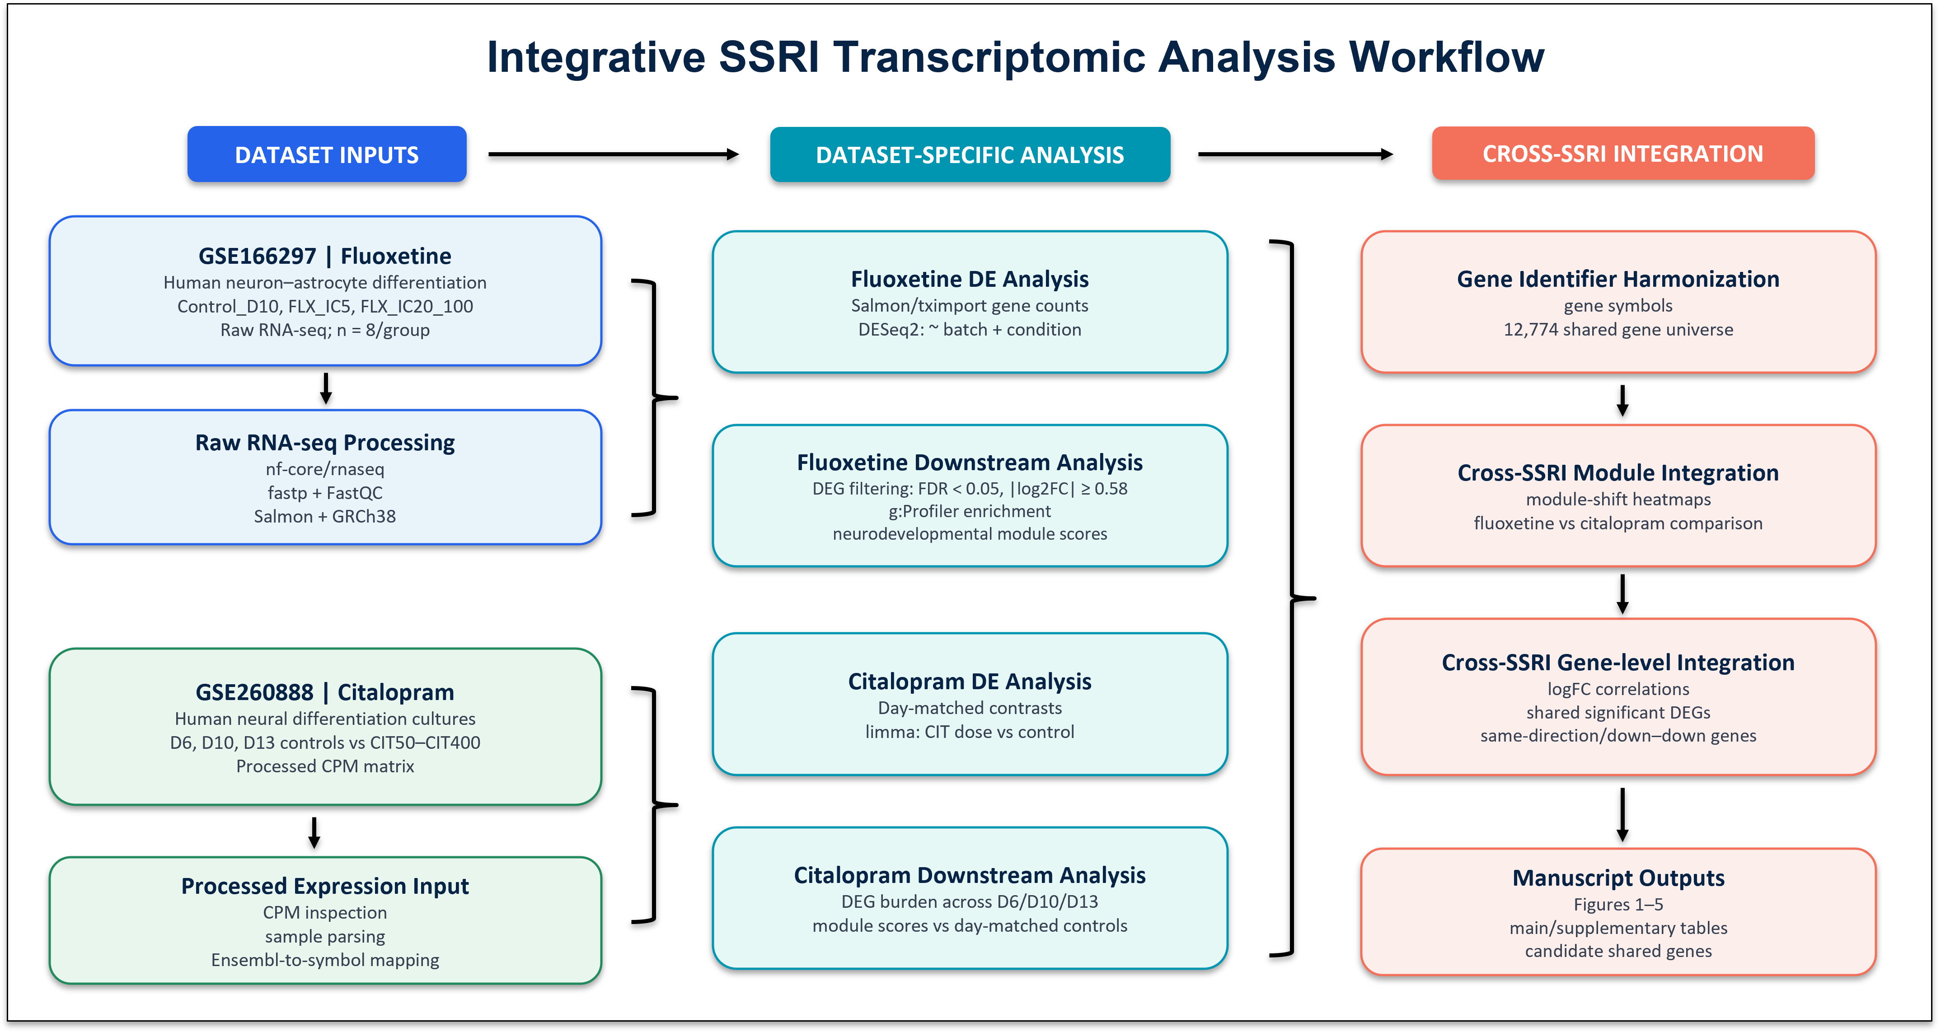

Figure 1. Transcriptomic analysis workflow for GSE166297 and GSE260888. The workflow summarizes dataset selection, RNA-seq processing, differential expression analysis, functional enrichment, curated neurodevelopmental module scoring and cross-SSRI integration. GSE166297 was analysed as the primary fluoxetine dataset using raw RNA-seq processing through nf-core/rnaseq, Salmon quantification and DESeq2. GSE260888 was analysed as an independent citalopram comparison dataset using unnormalized featureCounts data and edgeR quasi-likelihood modelling for differential expression, with processed CPM values retained for normalized-expression and module-scoring analyses.
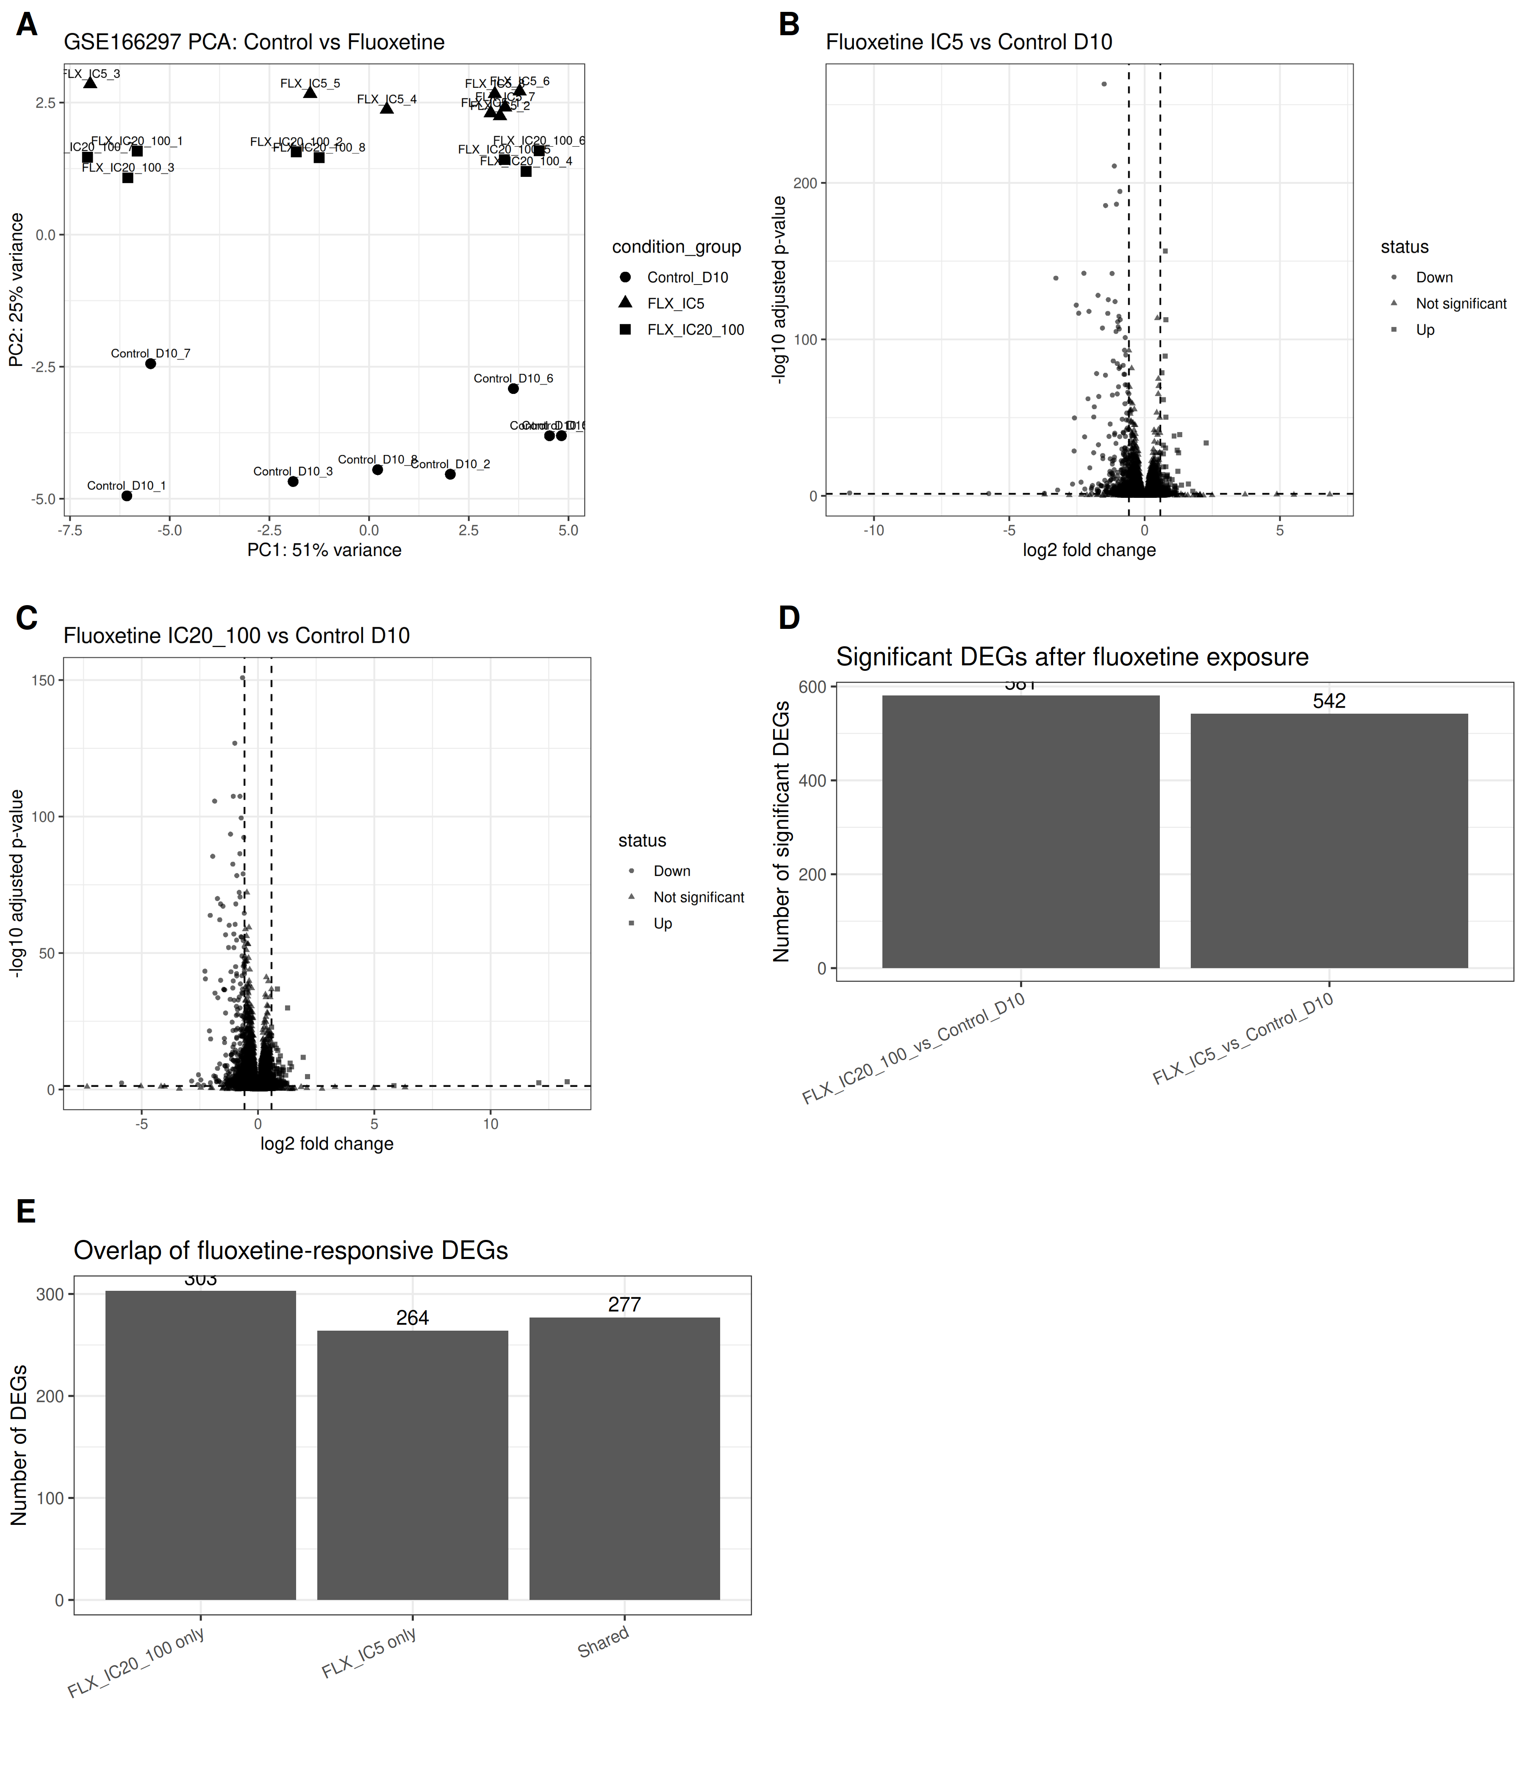
Figure 2. Fluoxetine exposure is associated with a predominantly downregulated transcriptomic response in human neural differentiation cultures. The figure shows the GSE166297 fluoxetine DEG overview (A), including sample-level structure, volcano plots for FLX_IC5 and FLX_IC20/100 versus Control_D10 (B and C), DEG direction summaries and overlap between the two fluoxetine contrasts (D and E). Both fluoxetine conditions produced more downregulated than upregulated DEGs.
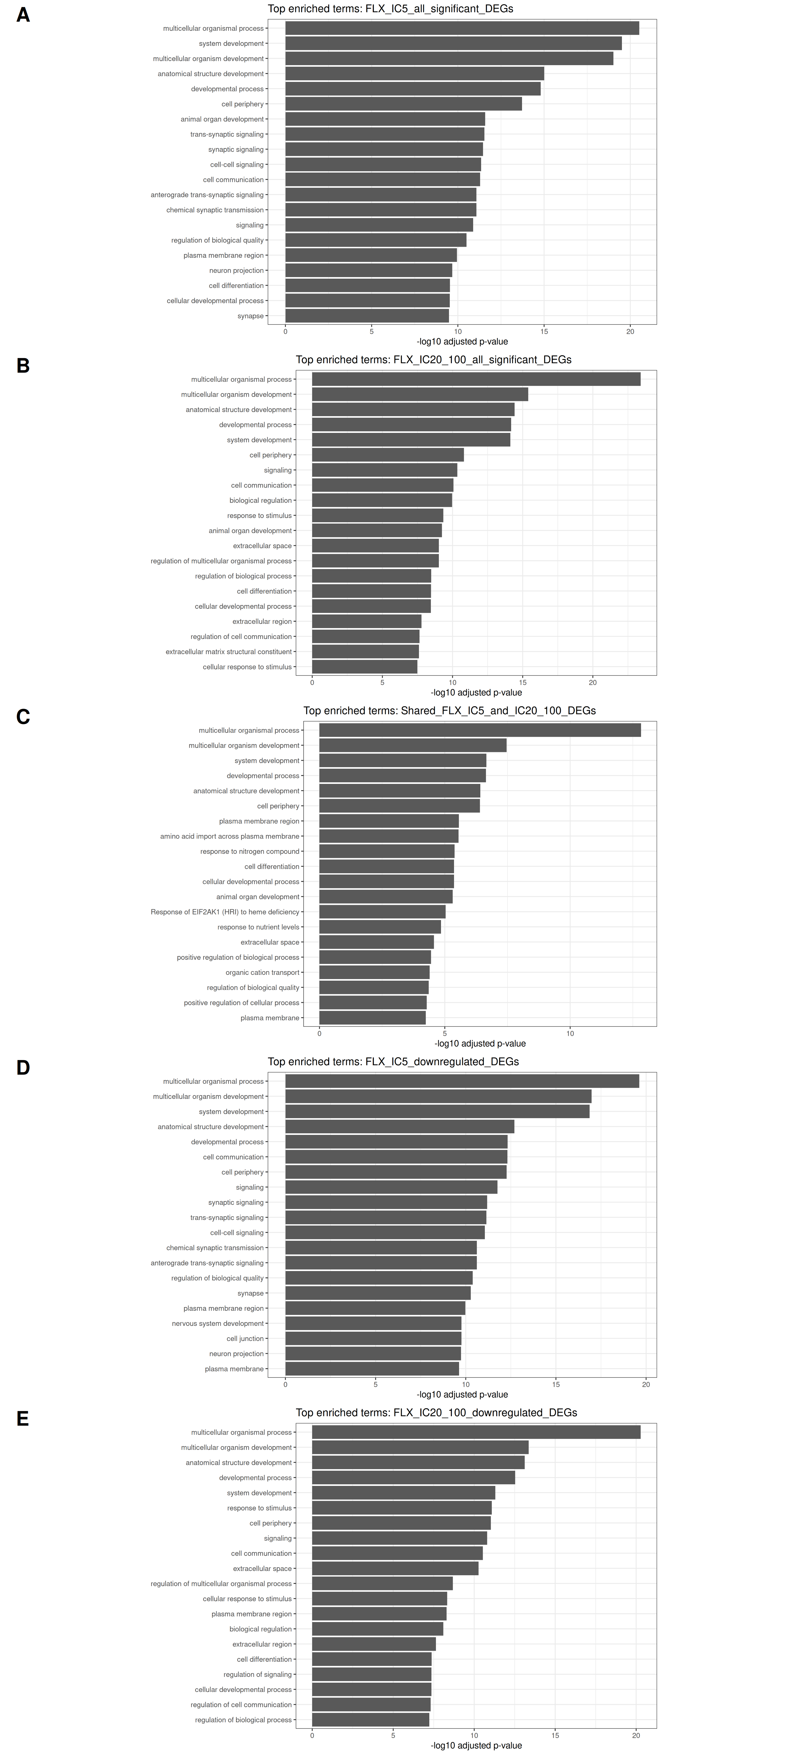
Figure 3. Functional enrichment identifies developmental and cell communication-related processes among fluoxetine-responsive genes. g:Profiler enrichment analysis was performed for fluoxetine-responsive DEG sets. Enriched terms included developmental process, anatomical structure development, system development, signaling and cell communication-related processes, with strongest enrichment among downregulated genes.
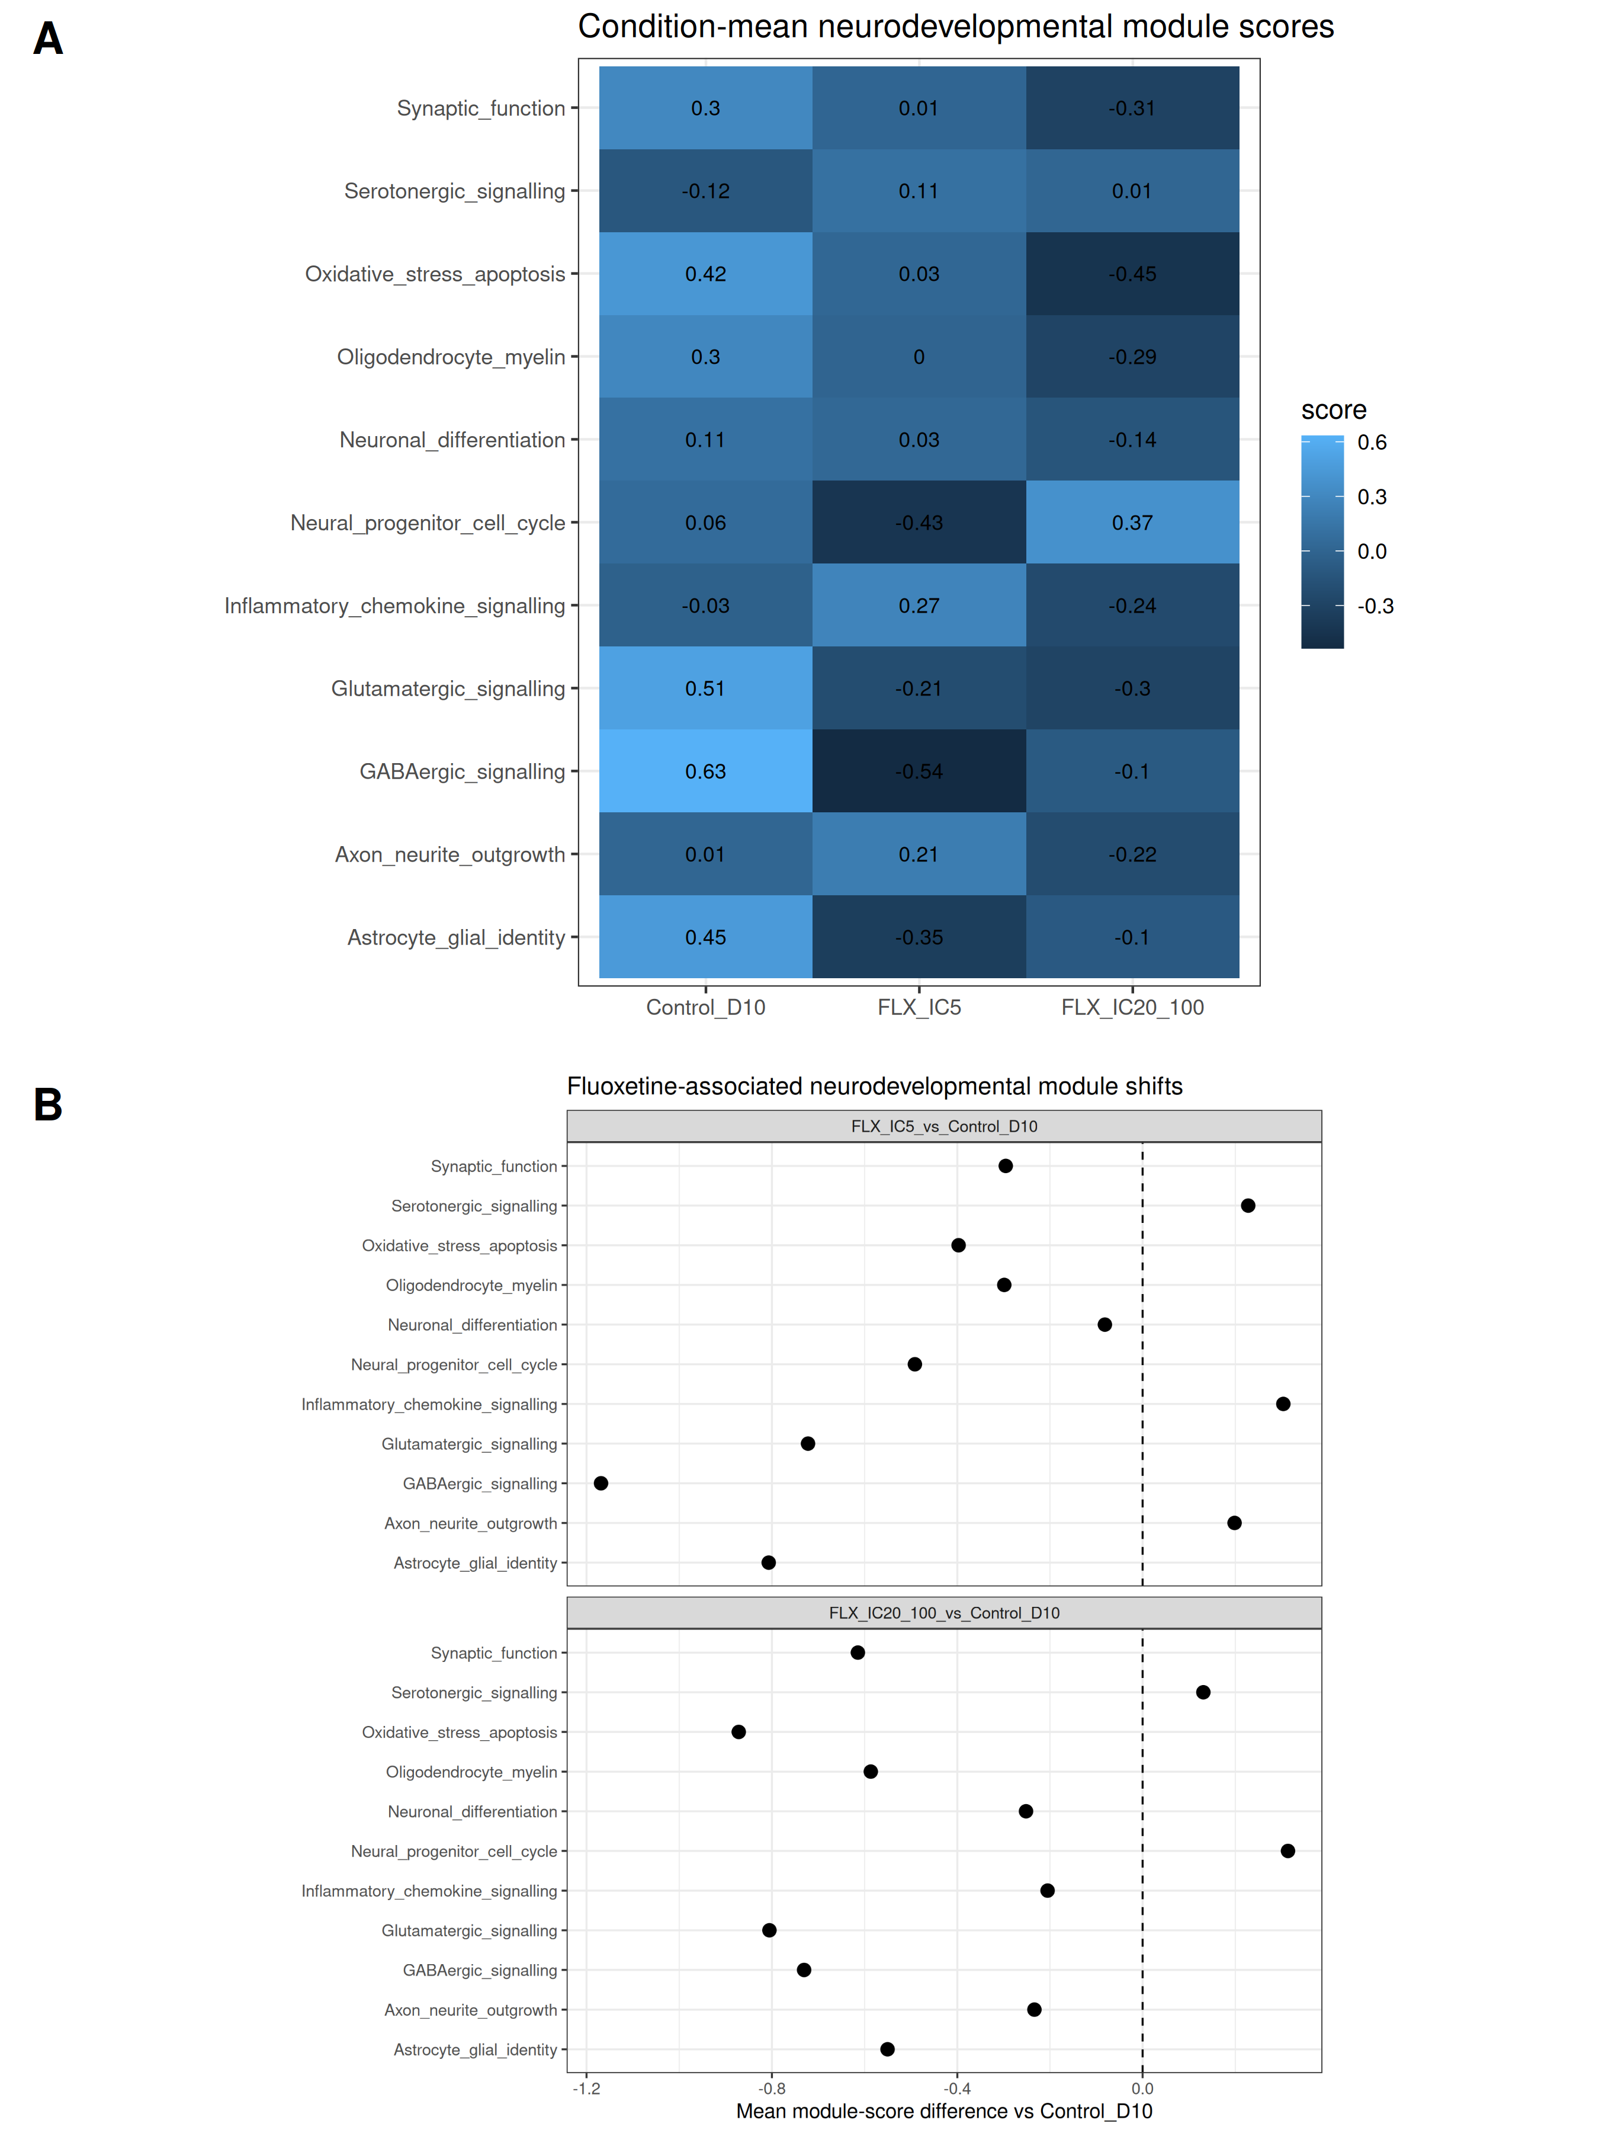
Figure 4. Fluoxetine-associated shifts in neurodevelopmental transcriptional modules. Curated module scoring identified reduced scores for GABAergic signalling, glutamatergic signalling, synaptic function, astrocyte/glial identity, oxidative stress/apoptosis and selected maturation-associated modules. Condition-level module scores are shown relative to Control_D10, with statistical summaries provided in Table 3.
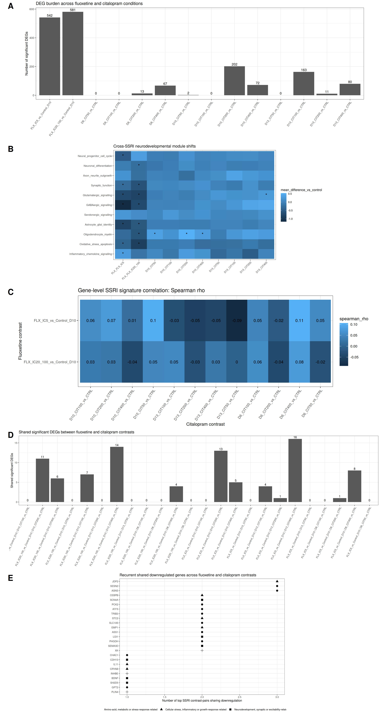
Figure 5. Cross-SSRI comparison of fluoxetine- and citalopram-associated transcriptomic signatures. (A) Significant DEG burden across fluoxetine and edgeR-reanalysed citalopram contrasts. (B) Cross-SSRI neurodevelopmental module-shift heatmap showing mean module-score differences relative to dataset-matched controls. (C) Gene-level Spearman correlation heatmap comparing fluoxetine and citalopram log2 fold-change profiles across the shared gene universe. (D) Shared significant DEG overlap across all 24 fluoxetine-citalopram contrast pairs, with overlap significance tested by hypergeometric tests and corrected across pairs. (E) Recurrent shared downregulated genes across BH-significant SSRI contrast pairs.
Table legends
Table 1. Dataset characteristics and analysis design. Summary of the public datasets analysed in this study, including dataset accession, compound, neural differentiation model, exposure groups, exposure concentration and selection basis, sample size, input data type, and processing and differential-expression strategy.
Dataset | Compound | Model system | Groups or timepoints | Exposure concentration and selection basis | Sample size | Input data | Processing and DE method
GSE166297 | Fluoxetine | hNPT neuron-astrocyte differentiation cultures | Control_D10, FLX_IC5, FLX_IC20/100 | FLX_IC5: 10 μM; FLX_IC20/100: 0.12 μM. Viability-derived conditions; IC20/100 reported non-cytotoxic. | n=8 per group; total n=24 | Raw RNA-seq FASTQ | nf-core/rnaseq v3.26.0; Salmon v1.10.3; GRCh38; DESeq2 v1.42.1; ~ batch + condition_group
GSE260888 | Citalopram | hESC-derived neuronal differentiation cultures | D6, D10 and D13 controls and CIT50/CIT100/CIT200/CIT400; D0 controls for descriptive analyses | CIT50/CIT100/CIT200/CIT400: 50/100/200/400 nM. In vivo-relevant range; no significant 24 h viability reduction. | D6: n=6 per group; D10/D13: CTRL, CIT50 and CIT400 n=6; CIT100 and CIT200 n=5 | Raw featureCounts for DE; processed CPM for module analyses | featureCounts assembly; filterByExpr; TMM; Ensembl-to-symbol mapping; edgeR v4.0.16 QL; glmQLFit/glmQLFTest
Table 2. Differentially expressed gene summary. Summary of fluoxetine and edgeR-reanalysed citalopram pairwise contrasts using FDR < 0.05 and absolute log2 fold change >= 0.58. The treatment column includes per-contrast treated and day-matched control sample sizes.
Dataset | Drug | Timepoint | Treatment and sample size | Contrast | Total significant DEGs | Upregulated | Downregulated
GSE166297 | Fluoxetine | D10 | FLX_IC5 (n=8; CTRL n=8) | FLX_IC5_vs_Control_D10 | 542 | 119 | 423
GSE166297 | Fluoxetine | D10 | FLX_IC20/100 (n=8; CTRL n=8) | FLX_IC20/100_vs_Control_D10 | 581 | 131 | 450
GSE260888 | Citalopram | D6 | CIT50 (n=6; CTRL n=6) | D6_CIT50_vs_CTRL | 0 | 0 | 0
GSE260888 | Citalopram | D6 | CIT100 (n=6; CTRL n=6) | D6_CIT100_vs_CTRL | 1 | 0 | 1
GSE260888 | Citalopram | D6 | CIT200 (n=6; CTRL n=6) | D6_CIT200_vs_CTRL | 9 | 5 | 4
GSE260888 | Citalopram | D6 | CIT400 (n=6; CTRL n=6) | D6_CIT400_vs_CTRL | 50 | 33 | 17
GSE260888 | Citalopram | D10 | CIT50 (n=6; CTRL n=6) | D10_CIT50_vs_CTRL | 4 | 2 | 2
GSE260888 | Citalopram | D10 | CIT100 (n=5; CTRL n=6) | D10_CIT100_vs_CTRL | 0 | 0 | 0
GSE260888 | Citalopram | D10 | CIT200 (n=5; CTRL n=6) | D10_CIT200_vs_CTRL | 257 | 120 | 137
GSE260888 | Citalopram | D10 | CIT400 (n=6; CTRL n=6) | D10_CIT400_vs_CTRL | 80 | 73 | 7
GSE260888 | Citalopram | D13 | CIT50 (n=6; CTRL n=6) | D13_CIT50_vs_CTRL | 0 | 0 | 0
GSE260888 | Citalopram | D13 | CIT100 (n=5; CTRL n=6) | D13_CIT100_vs_CTRL | 250 | 64 | 186
GSE260888 | Citalopram | D13 | CIT200 (n=5; CTRL n=6) | D13_CIT200_vs_CTRL | 175 | 85 | 90
GSE260888 | Citalopram | D13 | CIT400 (n=6; CTRL n=6) | D13_CIT400_vs_CTRL | 154 | 113 | 41

Table 3. Neurodevelopmental module statistics for fluoxetine exposure. Statistical summary of curated neurodevelopmental module-score comparisons for FLX_IC5 and FLX_IC20/100 versus Control_D10, including module name, mean differences, p values and adjusted p values. The size-matched random-set benchmark for these module shifts is provided in Supplementary Table 16.
Module and contrast | Mean control | Mean treated | Mean difference | Estimate from model | Std error | t value | p value | Design used | padj BH
Neural_progenitor_cell_cycle; FLX_IC5_vs_Control_D10 | 0.059 | -0.432 | -0.491 | -0.576 | 0.153 | -3.768 | 0.002 | score ~ batch + condition group | 0.003
Neural_progenitor_cell_cycle; FLX_IC20/100_vs_Control_D10 | 0.059 | 0.373 | 0.314 | 0.314 | 0.148 | 2.114 | 0.051 | score ~ batch + condition group | 0.074
Neuronal_differentiation; FLX_IC5_vs_Control_D10 | 0.111 | 0.030 | -0.081 | -0.117 | 0.083 | -1.411 | 0.177 | score ~ batch + condition group | 0.205
Neuronal_differentiation; FLX_IC20/100_vs_Control_D10 | 0.111 | -0.141 | -0.252 | -0.252 | 0.080 | -3.130 | 0.006 | score ~ batch + condition group | 0.011
Axon_neurite_outgrowth; FLX_IC5_vs_Control_D10 | 0.012 | 0.210 | 0.198 | 0.110 | 0.118 | 0.929 | 0.367 | score ~ batch + condition group | 0.384
Axon_neurite_outgrowth; FLX_IC20/100_vs_Control_D10 | 0.012 | -0.222 | -0.234 | -0.234 | 0.115 | -2.038 | 0.058 | score ~ batch + condition group | 0.080
Synaptic_function; FLX_IC5_vs_Control_D10 | 0.303 | 0.008 | -0.295 | -0.317 | 0.090 | -3.501 | 0.003 | score ~ batch + condition group | 0.005
Synaptic_function; FLX_IC20/100_vs_Control_D10 | 0.303 | -0.311 | -0.614 | -0.614 | 0.088 | -6.995 | 3.02E-06 | score ~ batch + condition group | 1.66E-05
Glutamatergic_signalling; FLX_IC5_vs_Control_D10 | 0.509 | -0.213 | -0.722 | -0.787 | 0.147 | -5.354 | 6.45E-05 | score ~ batch + condition group | 2.03E-04
Glutamatergic_signalling; FLX_IC20/100_vs_Control_D10 | 0.509 | -0.296 | -0.805 | -0.805 | 0.143 | -5.643 | 3.67E-05 | score ~ batch + condition group | 1.34E-04
GABAergic_signalling; FLX_IC5_vs_Control_D10 | 0.633 | -0.536 | -1.169 | -1.263 | 0.094 | -13.449 | 3.88E-10 | score ~ batch + condition group | 8.54E-09
GABAergic_signalling; FLX_IC20/100_vs_Control_D10 | 0.633 | -0.097 | -0.731 | -0.731 | 0.091 | -8.010 | 5.46E-07 | score ~ batch + condition group | 5.00E-06
Serotonergic_signalling; FLX_IC5_vs_Control_D10 | -0.120 | 0.108 | 0.228 | 0.279 | 0.203 | 1.375 | 0.188 | score ~ batch + condition group | 0.207
Serotonergic_signalling; FLX_IC20/100_vs_Control_D10 | -0.120 | 0.011 | 0.131 | 0.131 | 0.197 | 0.665 | 0.515 | score ~ batch + condition group | 0.515
Astrocyte_glial_identity; FLX_IC5_vs_Control_D10 | 0.452 | -0.354 | -0.807 | -0.921 | 0.143 | -6.428 | 8.36E-06 | score ~ batch + condition group | 3.68E-05
Astrocyte_glial_identity; FLX_IC20/100_vs_Control_D10 | 0.452 | -0.098 | -0.550 | -0.550 | 0.139 | -3.957 | 0.001 | score ~ batch + condition group | 0.003
Oligodendrocyte_myelin; FLX_IC5_vs_Control_D10 | 0.295 | -0.004 | -0.299 | -0.253 | 0.157 | -1.611 | 0.127 | score ~ batch + condition group | 0.158
Oligodendrocyte_myelin; FLX_IC20/100_vs_Control_D10 | 0.295 | -0.292 | -0.587 | -0.587 | 0.152 | -3.850 | 0.001 | score ~ batch + condition group | 0.003
Oxidative_stress_apoptosis; FLX_IC5_vs_Control_D10 | 0.423 | 0.026 | -0.397 | -0.459 | 0.114 | -4.027 | 9.75E-04 | score ~ batch + condition group | 0.003
Oxidative_stress_apoptosis; FLX_IC20/100_vs_Control_D10 | 0.423 | -0.449 | -0.872 | -0.872 | 0.111 | -7.874 | 6.81E-07 | score ~ batch + condition group | 5.00E-06
Inflammatory_chemokine_signalling; FLX_IC5_vs_Control_D10 | -0.033 | 0.271 | 0.304 | 0.366 | 0.132 | 2.770 | 0.014 | score ~ batch + condition group | 0.021
Inflammatory_chemokine_signalling; FLX_IC20/100_vs_Control_D10 | -0.033 | -0.238 | -0.205 | -0.205 | 0.128 | -1.600 | 0.129 | score ~ batch + condition group | 0.158
Table 4. Recurrent concordantly downregulated genes across statistically supported fluoxetine-citalopram contrast pairs. Rows summarize genes shared as significant and downregulated in both datasets across BH-significant overlap pairs from the revised edgeR-based cross-SSRI analysis.
Gene key | Functional category | Number of shared pair rows | Number of unique pairs | Pairs | mean logFC FLX | mean logFC CIT | min padj FLX | min padj CIT
ADM2 | Shared downregulated edgeR overlap candidate | 4 | 4 | FLX_IC20/100_vs_Control_D10__D13_CIT100_vs_CTRL; FLX_IC20/100_vs_Control_D10__D13_CIT400_vs_CTRL; FLX_IC5_vs_Control_D10__D13_CIT100_vs_CTRL; FLX_IC5_vs_Control_D10__D13_CIT400_vs_CTRL | -2.347 | -0.828 | 2.19E-29 | 0.025
ASS1 | Amino-acid, metabolic or stress-response related | 4 | 4 | FLX_IC20/100_vs_Control_D10__D13_CIT100_vs_CTRL; FLX_IC20/100_vs_Control_D10__D13_CIT400_vs_CTRL; FLX_IC5_vs_Control_D10__D13_CIT100_vs_CTRL; FLX_IC5_vs_Control_D10__D13_CIT400_vs_CTRL | -1.075 | -0.652 | 4.17E-65 | 0.013
EMP1 | Cellular stress, inflammatory or growth-response related | 4 | 4 | FLX_IC20/100_vs_Control_D10__D10_CIT200_vs_CTRL; FLX_IC20/100_vs_Control_D10__D13_CIT200_vs_CTRL; FLX_IC5_vs_Control_D10__D10_CIT200_vs_CTRL; FLX_IC5_vs_Control_D10__D13_CIT200_vs_CTRL | -1.147 | -0.888 | 2.12E-07 | 3.09E-04
JDP2 | Cellular stress, inflammatory or growth-response related | 4 | 4 | FLX_IC20/100_vs_Control_D10__D13_CIT100_vs_CTRL; FLX_IC20/100_vs_Control_D10__D13_CIT400_vs_CTRL; FLX_IC5_vs_Control_D10__D13_CIT100_vs_CTRL; FLX_IC5_vs_Control_D10__D13_CIT400_vs_CTRL | -1.743 | -0.739 | 3.97E-51 | 1.14E-04
NR4A1 | Shared downregulated edgeR overlap candidate | 4 | 4 | FLX_IC20/100_vs_Control_D10__D13_CIT100_vs_CTRL; FLX_IC20/100_vs_Control_D10__D13_CIT400_vs_CTRL; FLX_IC5_vs_Control_D10__D13_CIT100_vs_CTRL; FLX_IC5_vs_Control_D10__D13_CIT400_vs_CTRL | -0.657 | -0.832 | 2.28E-20 | 0.030
PCK2 | Amino-acid, metabolic or stress-response related | 4 | 4 | FLX_IC20/100_vs_Control_D10__D13_CIT100_vs_CTRL; FLX_IC20/100_vs_Control_D10__D13_CIT400_vs_CTRL; FLX_IC5_vs_Control_D10__D13_CIT100_vs_CTRL; FLX_IC5_vs_Control_D10__D13_CIT400_vs_CTRL | -2.086 | -0.783 | 1.29E-122 | 0.011
SEMA3D | Neurodevelopment, synaptic or excitability-related | 4 | 4 | FLX_IC20/100_vs_Control_D10__D10_CIT200_vs_CTRL; FLX_IC20/100_vs_Control_D10__D13_CIT200_vs_CTRL; FLX_IC5_vs_Control_D10__D10_CIT200_vs_CTRL; FLX_IC5_vs_Control_D10__D13_CIT200_vs_CTRL | -0.705 | -0.924 | 1.05E-07 | 0.004
SESN2 | Amino-acid, metabolic or stress-response related | 4 | 4 | FLX_IC20/100_vs_Control_D10__D13_CIT100_vs_CTRL; FLX_IC20/100_vs_Control_D10__D13_CIT400_vs_CTRL; FLX_IC5_vs_Control_D10__D13_CIT100_vs_CTRL; FLX_IC5_vs_Control_D10__D13_CIT400_vs_CTRL | -1.271 | -0.899 | 2.53E-117 | 0.001
ALMS1-IT1 | Shared downregulated edgeR overlap candidate | 2 | 2 | FLX_IC20/100_vs_Control_D10__D10_CIT400_vs_CTRL; FLX_IC5_vs_Control_D10__D10_CIT400_vs_CTRL | -0.752 | -0.902 | 5.57E-06 | 0.006
ASNS | Amino-acid, metabolic or stress-response related | 2 | 2 | FLX_IC20/100_vs_Control_D10__D13_CIT400_vs_CTRL; FLX_IC5_vs_Control_D10__D13_CIT400_vs_CTRL | -1.246 | -1.161 | 6.63E-264 | 4.91E-09
ATF3 | Shared downregulated edgeR overlap candidate | 2 | 2 | FLX_IC20/100_vs_Control_D10__D13_CIT200_vs_CTRL; FLX_IC5_vs_Control_D10__D13_CIT200_vs_CTRL | -1.190 | -0.629 | 9.55E-53 | 0.013
ATF5 | Amino-acid, metabolic or stress-response related | 2 | 2 | FLX_IC20/100_vs_Control_D10__D13_CIT400_vs_CTRL; FLX_IC5_vs_Control_D10__D13_CIT400_vs_CTRL | -2.053 | -0.821 | 6.07E-143 | 0.001
BDNF | Neurodevelopment, synaptic or excitability-related | 2 | 2 | FLX_IC5_vs_Control_D10__D10_CIT200_vs_CTRL; FLX_IC5_vs_Control_D10__D13_CIT200_vs_CTRL | -0.967 | -0.643 | 2.23E-05 | 0.001
CDH13 | Neurodevelopment, synaptic or excitability-related | 2 | 2 | FLX_IC5_vs_Control_D10__D10_CIT200_vs_CTRL; FLX_IC5_vs_Control_D10__D13_CIT200_vs_CTRL | -1.181 | -0.904 | 5.18E-15 | 0.017
CEBPB | Cellular stress, inflammatory or growth-response related | 2 | 2 | FLX_IC20/100_vs_Control_D10__D13_CIT400_vs_CTRL; FLX_IC5_vs_Control_D10__D13_CIT400_vs_CTRL | -2.436 | -0.676 | 1.63E-50 | 0.028
CHAC1 | Amino-acid, metabolic or stress-response related | 2 | 2 | FLX_IC20/100_vs_Control_D10__D13_CIT100_vs_CTRL; FLX_IC5_vs_Control_D10__D13_CIT100_vs_CTRL | -2.191 | -1.159 | 2.10E-117 | 0.013
FUT5 | Shared downregulated edgeR overlap candidate | 2 | 2 | FLX_IC20/100_vs_Control_D10__D13_CIT100_vs_CTRL; FLX_IC5_vs_Control_D10__D13_CIT100_vs_CTRL | -1.270 | -1.420 | 1.82E-09 | 0.045
GDF15 | Shared downregulated edgeR overlap candidate | 2 | 2 | FLX_IC20/100_vs_Control_D10__D13_CIT100_vs_CTRL; FLX_IC5_vs_Control_D10__D13_CIT100_vs_CTRL | -2.239 | -1.330 | 2.96E-41 | 0.040
IL11 | Cellular stress, inflammatory or growth-response related | 2 | 2 | FLX_IC20/100_vs_Control_D10__D10_CIT200_vs_CTRL; FLX_IC20/100_vs_Control_D10__D13_CIT200_vs_CTRL | -1.150 | -0.998 | 0.017 | 0.026
KIF17 | Shared downregulated edgeR overlap candidate | 2 | 2 | FLX_IC20/100_vs_Control_D10__D13_CIT100_vs_CTRL; FLX_IC5_vs_Control_D10__D13_CIT100_vs_CTRL | -0.669 | -0.889 | 2.31E-07 | 0.045
PHGDH | Amino-acid, metabolic or stress-response related | 2 | 2 | FLX_IC20/100_vs_Control_D10__D13_CIT400_vs_CTRL; FLX_IC5_vs_Control_D10__D13_CIT400_vs_CTRL | -0.817 | -0.626 | 4.43E-187 | 0.009
PRKCG | Shared downregulated edgeR overlap candidate | 2 | 2 | FLX_IC20/100_vs_Control_D10__D13_CIT100_vs_CTRL; FLX_IC5_vs_Control_D10__D13_CIT100_vs_CTRL | -1.151 | -0.631 | 2.18E-14 | 0.031
SCN4A | Neurodevelopment, synaptic or excitability-related | 2 | 2 | FLX_IC20/100_vs_Control_D10__D13_CIT400_vs_CTRL; FLX_IC5_vs_Control_D10__D13_CIT400_vs_CTRL | -2.246 | -0.611 | 3.28E-08 | 0.038
SHMT2 | Shared downregulated edgeR overlap candidate | 2 | 2 | FLX_IC20/100_vs_Control_D10__D13_CIT400_vs_CTRL; FLX_IC5_vs_Control_D10__D13_CIT400_vs_CTRL | -1.253 | -0.746 | 2.86E-186 | 0.037
SLC1A5 | Amino-acid, metabolic or stress-response related | 2 | 2 | FLX_IC20/100_vs_Control_D10__D13_CIT400_vs_CTRL; FLX_IC5_vs_Control_D10__D13_CIT400_vs_CTRL | -1.148 | -0.745 | 4.20E-126 | 0.012
SLC7A5 | Shared downregulated edgeR overlap candidate | 2 | 2 | FLX_IC20/100_vs_Control_D10__D13_CIT400_vs_CTRL; FLX_IC5_vs_Control_D10__D13_CIT400_vs_CTRL | -1.781 | -0.675 | 1.31E-118 | 0.019
STC2 | Cellular stress, inflammatory or growth-response related | 2 | 2 | FLX_IC20/100_vs_Control_D10__D13_CIT400_vs_CTRL; FLX_IC5_vs_Control_D10__D13_CIT400_vs_CTRL | -1.692 | -0.591 | 6.78E-79 | 1.37E-05
TFPI2 | Shared downregulated edgeR overlap candidate | 2 | 2 | FLX_IC5_vs_Control_D10__D10_CIT200_vs_CTRL; FLX_IC5_vs_Control_D10__D13_CIT200_vs_CTRL | -0.775 | -0.703 | 0.005 | 0.027
TRIB3 | Amino-acid, metabolic or stress-response related | 2 | 2 | FLX_IC20/100_vs_Control_D10__D13_CIT400_vs_CTRL; FLX_IC5_vs_Control_D10__D13_CIT400_vs_CTRL | -1.719 | -0.777 | 1.06E-70 | 0.018
COL1A1 | Shared downregulated edgeR overlap candidate | 1 | 1 | FLX_IC20/100_vs_Control_D10__D13_CIT200_vs_CTRL | -0.899 | -1.491 | 1.43E-11 | 0.006
CRYAB | Cellular stress, inflammatory or growth-response related | 1 | 1 | FLX_IC20/100_vs_Control_D10__D13_CIT200_vs_CTRL | -1.107 | -3.341 | 0.014 | 8.79E-04

Supporting information captions
Supplementary Figure 1. Sample-level neurodevelopmental module-score heatmap for GSE166297 fluoxetine samples.
Supplementary Figure 2. Supporting fluoxetine differential-expression visualizations for GSE166297.
Supplementary Figure 3. Supporting citalopram differential-expression visualizations from the edgeR quasi-likelihood reanalysis of GSE260888.
Supplementary Figure 4. Cross-SSRI module-shift heatmaps comparing fluoxetine and citalopram contrasts across curated neurodevelopmental modules.
Supplementary Figure 5. Cross-dataset gene-level correlation and mapping-sensitivity plots for fluoxetine-citalopram comparisons.
Supplementary Table 1. GSE166297 fluoxetine sample metadata used for raw-read processing and differential-expression analysis.
Supplementary Table 2. Complete DESeq2 differential-expression results for the FLX_IC5 versus Control_D10 and FLX_IC20/100 versus Control_D10 contrasts.
Supplementary Table 3. Significant fluoxetine differentially expressed genes for the GSE166297 contrasts.
Supplementary Table 4. Fluoxetine DEG direction summaries and overlap summaries.
Supplementary Table 5. g:Profiler functional-enrichment results for fluoxetine DEG sets.
Supplementary Table 6. Curated neurodevelopmental module definitions, source rationale, input genes, expressed genes, module sizes and cross-module overlap checks.
Supplementary Table 7. Fluoxetine neurodevelopmental module-score statistics.
Supplementary Table 8. GSE260888 citalopram sample metadata used for the raw featureCounts-based edgeR reanalysis.
Supplementary Table 9. Complete edgeR quasi-likelihood differential-expression results for all GSE260888 citalopram contrasts.
Supplementary Table 10. Significant citalopram differentially expressed genes and citalopram DEG summary outputs.
Supplementary Table 11. Citalopram neurodevelopmental module-score statistics relative to day-matched controls.
Supplementary Table 12. Cross-SSRI module-shift summaries across fluoxetine and citalopram contrasts.
Supplementary Table 13. Gene-level log2 fold-change correlations across the 24 fluoxetine-citalopram contrast pairs.
Supplementary Table 14. Hypergeometric shared DEG overlap tests across all 24 fluoxetine-citalopram contrast pairs.
Supplementary Table 15. Recurrent concordantly downregulated genes across statistically supported fluoxetine-citalopram overlap pairs.
Supplementary Table 16. Size-matched random-set benchmark results for fluoxetine curated module shifts.

