Oracle-lab assignment (1)

1. Retrieve employee names that are getting salary more than 30000.
2. Find employee details in the order of their salary.
3. Retrieve employee no with their name and city who are living in city other than

‘rajkot’ as well ‘baroda’.

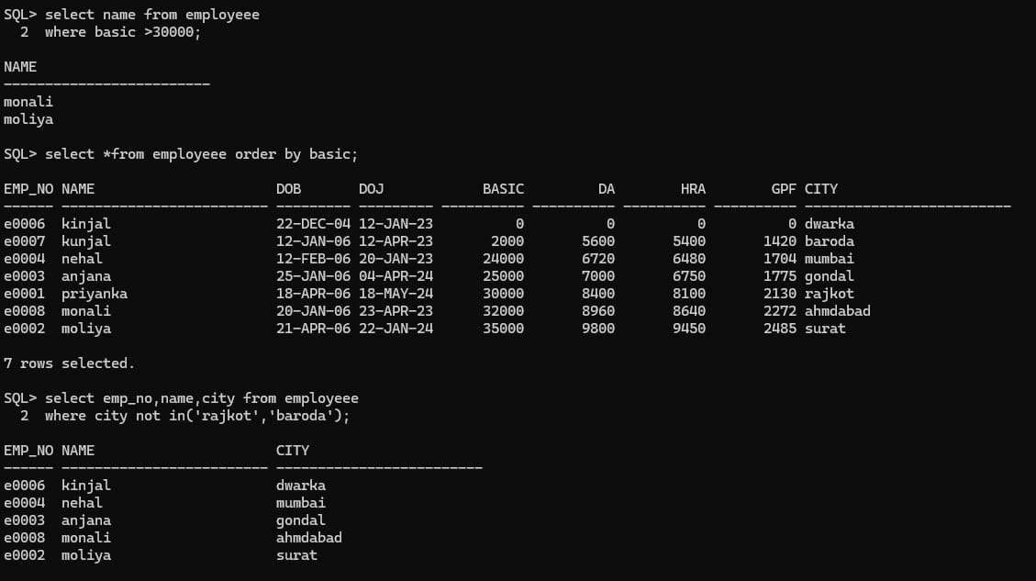

1. Find name of all employees who have not been paid salary.
2. Retrieve employee number, name and city whose name are of minimum of six letters and starts with first letter as ‘r’ and third letter as ‘j’.
3. Retrieve name of employees who have not opted for HRA.
4. Find name of employees with their total salary.Total Salary = Basic+DA+HRA-GPF

