Profitlion :: Task Management :: Zendesk

URL | : | https://profitlion.zendesk.com/hc/en-us
USERNAME | : | shubhra@digiprima.com
PASSWORD | : | Indore@2012

Profitlion :: Dev Server

URL | : | https://demo.profitlion.com/app/index.php/zurmo/default/login
USERNAME | : | super
PASSWORD | : | v3r1war3#

Profitlion :: Instances Details
https://docs.google.com/spreadsheets/d/1lX7bXNtwv0KAzNr4QAqK8UVpCeiiadvzok_QSEQfazI/edit?usp=sharing

The demo/development url is not working.
This 'https://hometurf.profitlion.com/app/index.php/zurmo/default/login' is for hometurf live instance, the
username & password are same for super admin.

https://profitlion.zendesk.com/
shubhra@digiprima.com
digi@123

DOC URL - https://docs.google.com/document/d/1ysTlHuKLCvviVeyyzgpIcnq6c5sUsjAcVigSCvy7e1I/edit#
DOC GICRM - https://docs.google.com/spreadsheets/d/1lX7bXNtwv0KAzNr4QAqK8UVpCeiiadvzok_QSEQfazI/edit#gid=566146904

DATABASE URL -
http://localhost/adminer.php/?server=127.0.0.1%3A3336&username=root&db=GICRM
server – 127.0.0.1:3336
username – root
password - pr0sc@p3#
database – GICRM

ZURMO crm – in php
DATABASE NAME -Database: GICRM

login into database server from command prompt commands -
1. systemctl start mysql
2. ssh -i "~/ssh/Gicrm.pem" -N -L 3336:127.0.0.1:3306 ubuntu@52.204.121.173
3. ssh -i "Gicrm.pem" -N -L 3336:127.0.0.1:3306 ubuntu@52.204.121.173
or
ssh -i "~/ssh/Gicrm.pem" -N -L 3336:127.0.0.1:3306 ubuntu@3.17.238.112
3.17.238.112 this are the IP address for different server change it to login with respective database
password - pr0sc@p3#

server Login (Internet should be DIGI-TP-5G)
ssh -i "ssh/Gicrm.pem" ubuntu@ec2-3-219-59-61.compute-1.amazonaws.com
GICRM server restart-
sudo service apache2 restart
Pentaho server start command – inside server cd /var/www/html/ cd pentaho-server
./start-pentaho.sh

Reports username and password
username - profitlion
password - Pr0f!tL!0n

AWS Credential-
https://us-east-1.signin.aws.amazon.com/oauth?response_type=code&client_id=arn%3Aaws%3Aiam%3A%3A015428540659%3Auser%2Fec2&redirect_uri=https%3A%2F%2Fus-east-1.console.aws.amazon.com%2Fec2%2Fv2%2Fhome%3Fregion%3Dus-east-1%26state%3DhashArgs%2523Instances%253A%26isauthcode%3Dtrue&forceMobileLayout=0&forceMobileApp=0&code_challenge=F-y0H9JSkFlpvMoLxE1S6NGbKQsur5V-70DouzyxUZU&code_challenge_method=SHA-256
username - DIGIPRIMA
password – kVx}819&
Account ID – gicrm

Sendgrid Credentials
https://app.sendgrid.com/validate_2fa?redirect_to=%2Flogin%2F
EC2 – elastic compute cloud

To download Database
ec2-52-54-165-204.compute-1.amazonaws.coma
1. ssh to the server ssh -i "/home/vaishali/ssh/Gicrm.pem" ubuntu@ec2-52-204-121-173.compute-1.amazonaws.com
2. take the database dump mysqldump -P 3306 -h localhost -u root --add-drop-database --add-drop-table --add-locks --create-options --routines -p GICRM > /home/ubuntu/GICRM_EARTHSCAPES_03Nov2020.sql
3. download the database dump file from server scp -i "/home/anupam/.ssh/Gicrm.pem" ubuntu@ec2-52-204-121-173.compute-1.amazonaws.com:/tmp/gicrm_twinoak12.sql.gz /home/anupam/profitlion/docs/databasedumps

for bad permission-sudo chmod 400 /home/dell1/ssh/Gicrm.pem

one of the field for increase length of password in DB
EmailSmtpConfigurationForm- file for password length

ssh.zip file

DOC GICRM Instance Detail-
https://docs.google.com/spreadsheets/d/1lX7bXNtwv0KAzNr4QAqK8UVpCeiiadvzok_QSEQfazI/edit#gid=566146904
https://docs.google.com/spreadsheets/d/1Fti31feiEJIkKjhypbIHc77HBlZHEOnAMHCXuKFLsfs/edit#gid=0

ProfitLion Important Details-
https://docs.google.com/document/d/1ysTlHuKLCvviVeyyzgpIcnq6c5sUsjAcVigSCvy7e1I/edit#heading=h.oxuvq3xaeeb4

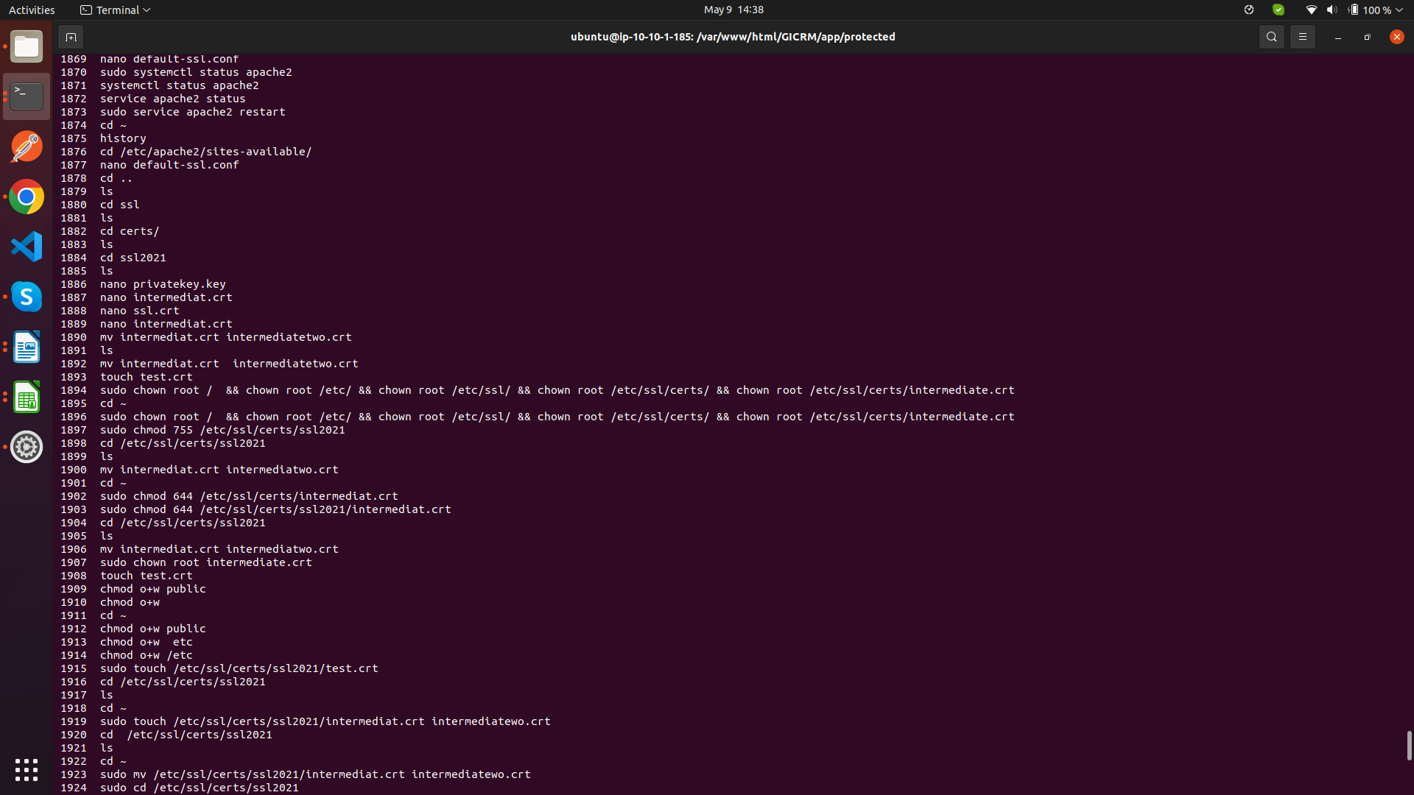

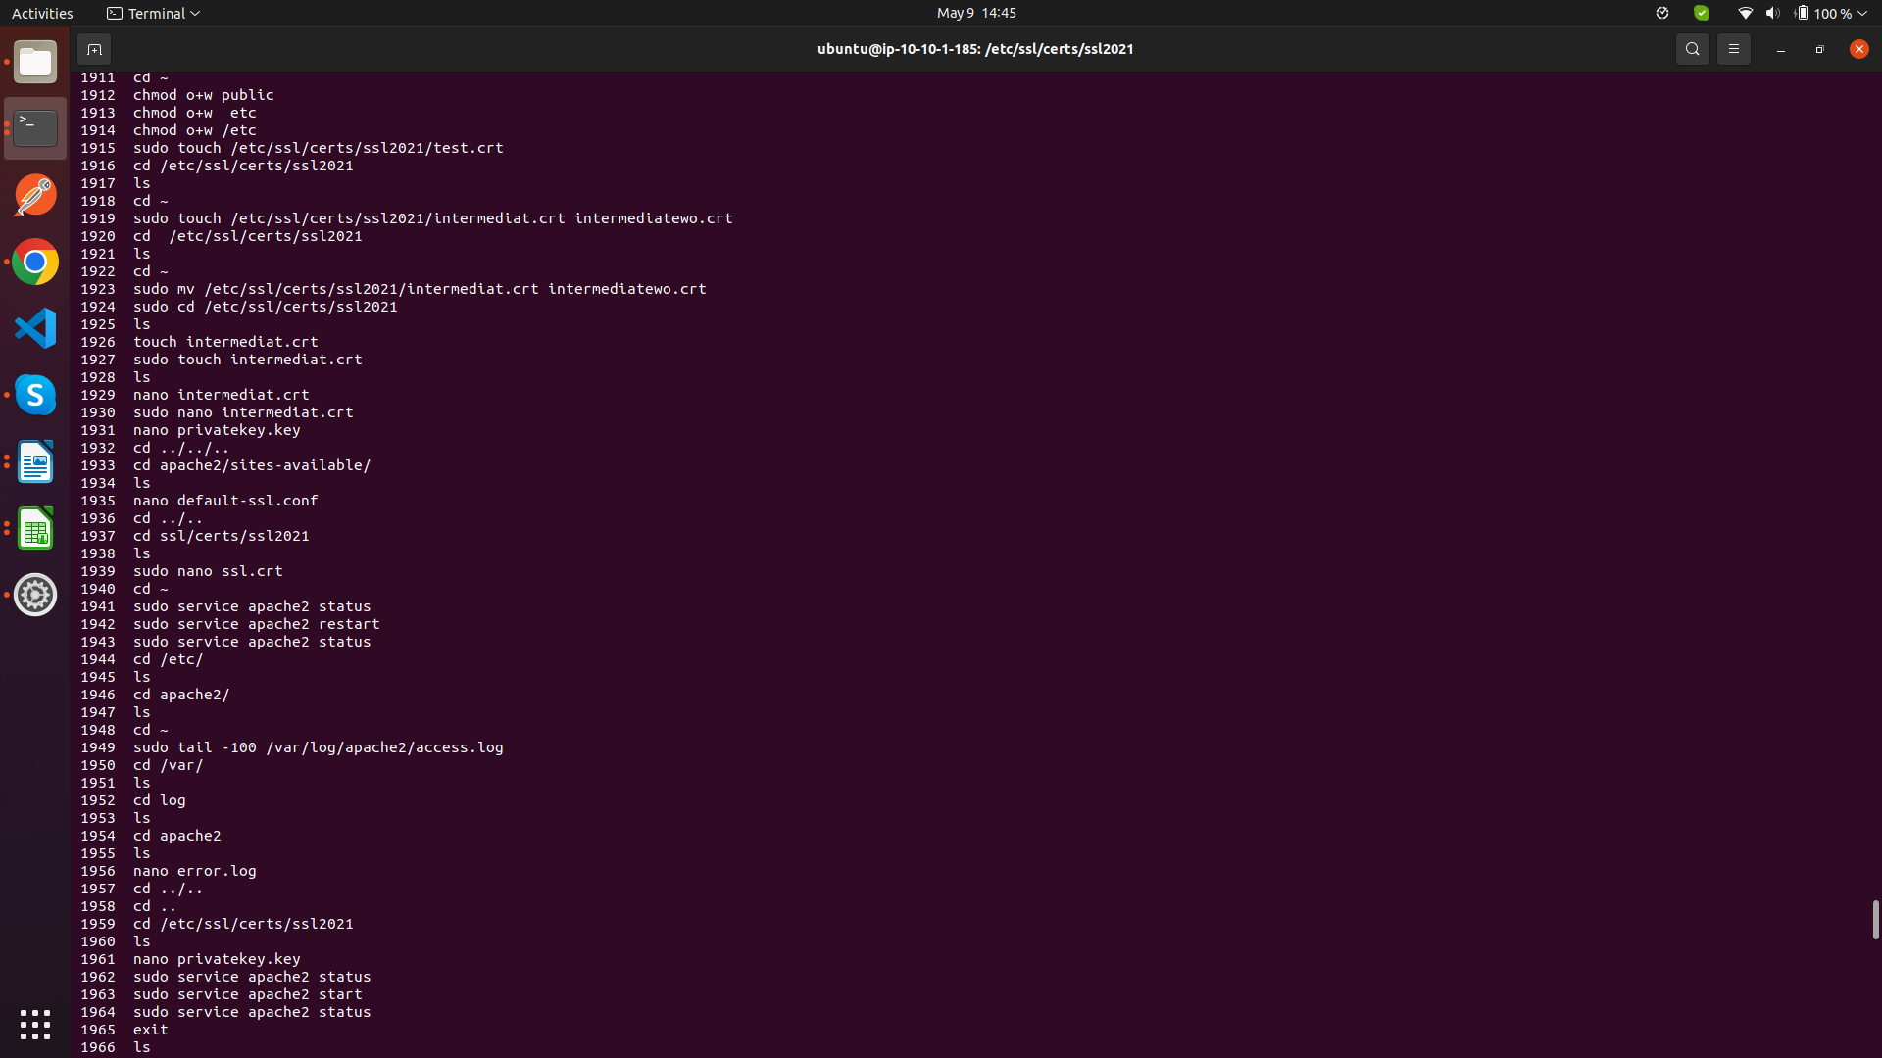
https://ttg.profitlion.com
https://southernscapes.profitlion.com/app/index.php/home/default
https://southernscapes.profitlion.com/
https://bbp.profitlion.com/
https://twinoaks.profitlion.com
https://trace.profitlion.com/
https://wildwood.profitlion.com/
https://nurney.profitlion.com/
https://hometurf.profitlion.com/

https://twinoaks.profitlion.com/app/index.php/zurmo/default/login
super
v3r1war3#

https://twinoaks.profitlion.com/app/index.php/emailMessages/default/configurationEditOutbound

http://localhost/adminer/adminer/?server=127.0.0.1%3A3336&username=root&db=GICRM&select=contact&where[0][op]=LIKE+%25%25&where[0][val]=Irrigation+-+Install+%26+Maintenance+lead

contact
person

mitush@mitush-ThinkPad-W540:~/Downloads$ ssh -i"Gicrm.pem" ubuntu@ec2-3-219-59-61.compute-1.amazonaws.com
@@@@@@@@@@@@@@@@@@@@@@@@@@@@@@@@@@@@@@@@@@@@@@@@@@@@@@@@@@@
@ WARNING: UNPROTECTED PRIVATE KEY FILE! @
@@@@@@@@@@@@@@@@@@@@@@@@@@@@@@@@@@@@@@@@@@@@@@@@@@@@@@@@@@@
Permissions 0664 for 'Gicrm.pem' are too open.
It is required that your private key files are NOT accessible by others.
This private key will be ignored.
Load key "Gicrm.pem": bad permissions
ubuntu@ec2-3-219-59-61.compute-1.amazonaws.com: Permission denied (publickey).
mitush@mitush-ThinkPad-W540:~/Downloads$ chmod 400 Gicrm.pem
mitush@mitush-ThinkPad-W540:~/Downloads$ ssh -i"Gicrm.pem" ubuntu@ec2-3-219-59-61.compute-1.amazonaws.com

ssh -i "Gicrm.pem" ubuntu@ec2-3-219-59-61.compute-1.amazonaws.com

sudo reboot

SOUTHERN INSTANCE
ssh -i "Gicrm.pem" ubuntu@ec2-3-17-238-112.us-east-2.compute.amazonaws.com
sudo reboot
sudo service apache2 restart
cd /var/www/html/pentaho-server
./start-pentaho.sh
exit;

https://johnsonpools.profitlion.com/ -Done
52.54.165.204

Dev Instance – Didnot work
18.207.8.170

Wilmington/heffener2 - Didnot work
18.219.120.178

Kueker’s nursery and landscape – Did not work
18.220.13.103

Good2Great – didnot work
18.221.45.17
Through the Garden - Done
18.224.203.68

Pro Terra landscapes – did not work
3.18.35.185

Old Mill Iron - did not work
34.205.180.35

Proscape (Luke)/visvero - did not work
52.200.26.166

Steven Bach - Done
52.200.44.181

Barry – Burkholder - did not work
3.220.195.19

Twin Oak - Done
52.204.121.173

Procare(Dirk instance) - did not work
54.237.79.176

EarthScapes - did not work
3.221.12.114

Trace landscaping - Done
3.219.59.61

Heffner landscaping - Done
3.221.154.55

Wildwood landscaping - Done
3.221.29.107

Nurney landscaping - Done
3.212.170.182

Mud Worx - did not work
3.13.125.118

Vertware - did not work
54.85.225.254

Precision - did not work
35.174.227.200

Home Turf Inc - did not work
3.221.237.222

inside new server if we want to add url

1. cd /var/www/html/pentaho-server/
2 . nano /etc/apache2/sites-available/000-default.conf

ServerName ec2-18-207-147-187.compute-1.amazonaws.profitlion.com
RewriteRule (.*) http://ec2-18-207-147-187.compute-1.amazonaws.profitlion.com%{REQUEST_URI}

Command to run instances
ssh -i "Gicrm.pem" ubuntu@34.237.187.88
sudo reboot
sudo service apache2 restart
cd /var/www/html/pentaho-server
./start-pentaho.sh
exit;

