Introduction:

This report explains how I resolved the problem for the Beauty Pegaent contest organizers. They had a lot of problems last year because of the manual scoring, which created a lot of delays during the competition. They have several standards that must be met in order for the contest to function smoothly and efficiently.

The following are the requirements:

* Easily input scores as the judges enter them.
* Calculate weighted scores and rankings quickly and accurately based on multiple criteria.

Procedure:

I used Power Pivot and Power Query to examine and visualize the data, and I created the suitable Pivot table to meet the above requirements. The given excel data contains the following tables to generate the particular results:

**Judges:** We have six judges.

**Contestants:** We have two groups of contestants (Miss, Mrs categories); a number identifies each contestant that the judges will use for scoring.

**Rounds:** We have multiple rounds on day one and day two. Each round receives separate scores for presentation and performance. The top three contestants from each category would go on to the Q&A round, where the final winners would be decided.

**Scoring sheets:** Judges enter the scores on paper scoring sheets, which would need to be collected and quickly entered into our data model

1. Firstly data is added to the sheets of Judges, Contestants, Rounds and Scoring sheets in the Power Pivot data model.

2.Now loaded the tables Judge1, Judge2, Judge3, Judge4, Judge5, Judge6 in the Power Query editer.

3. Converted the first row as headers in all the loaded table and appended the 6 tables into one and renamed it as “Scoring”.

4. New Scoring table is created which contains all the table data, Name column is removed and unpivoted all the round type columns and changed its data types.

5. Now the relationships between the data tables is created and added to the data model. The judge to Judge No pf Judge table, Number to Contestants of Contestand table, Attribute to Round score of Round table.

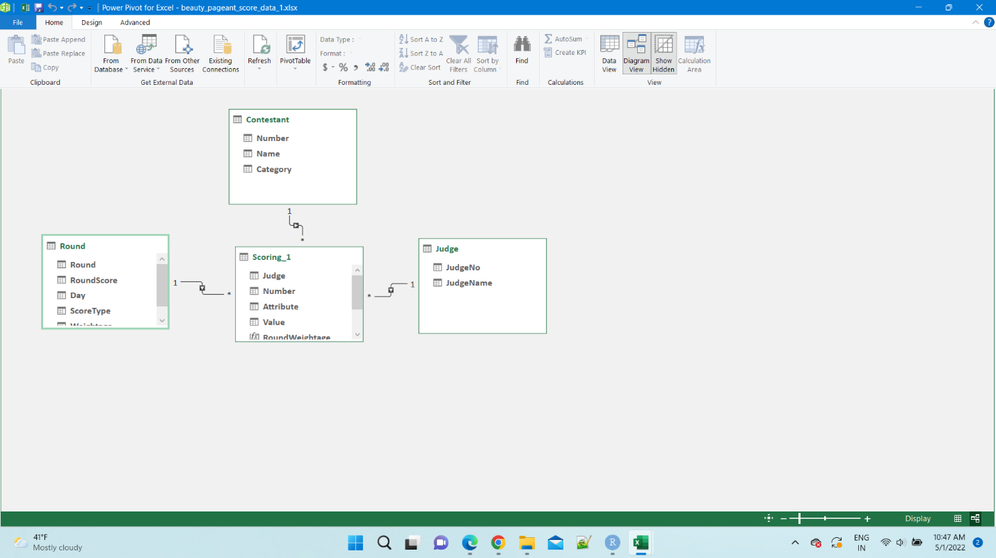

6. Now new sheet is created in the name of Results in which dashboard is created with the slicers.

7. Now Pivot table is created in the new sheet and added the name and number column in the pivot table by dragging and placing in the Rows.

8. Now slicers for Category, Day, Round, ScoreType, JudgeName added in the sheet for filtering and checking the results.

9. Now I created the new column ScoreTotal, ScoreWeighted, Rank by using the new measures and adding the below dax fomulas. And added to the values.

ScoreTotal: SUM(SCORE_1[VALUE_1])

ScoreWeighted: =SUMX(Scoring_1,RELATED('Round'[Weightage])*Scoring_1[Value])

Rank: =IF(ISBLANK([ScoreWeightage]), BLANK(),RANKX(ALLSELECTED(Contestant), [ScoreWeightage]))

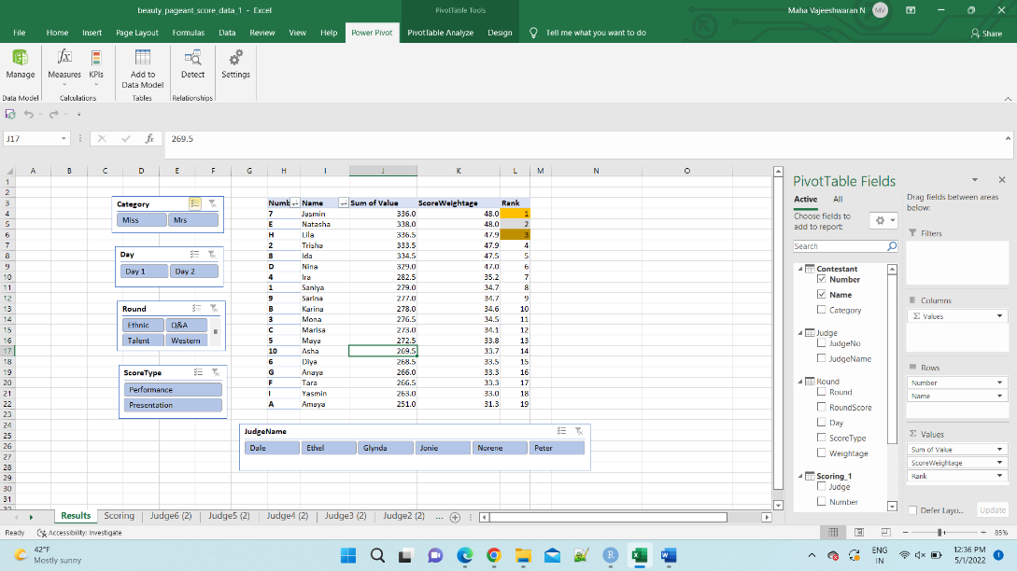

Answers to the Question:

a) Which contestants advance to the final round?

By selecting the slicers Q&A in the Round it displays the contestents who selected for the final round.

Trisha, Natasha, Jasmin, Nina, Ida, Lila advances for the final round.

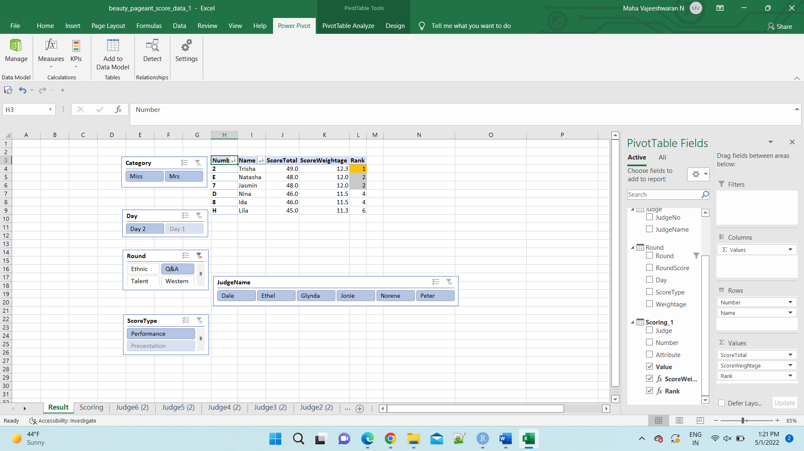

b) Who are the overall winners after the final round?

The Winners for the Miss category is shown below. The winners for the Miss category is Natasha, Nina, Lila.

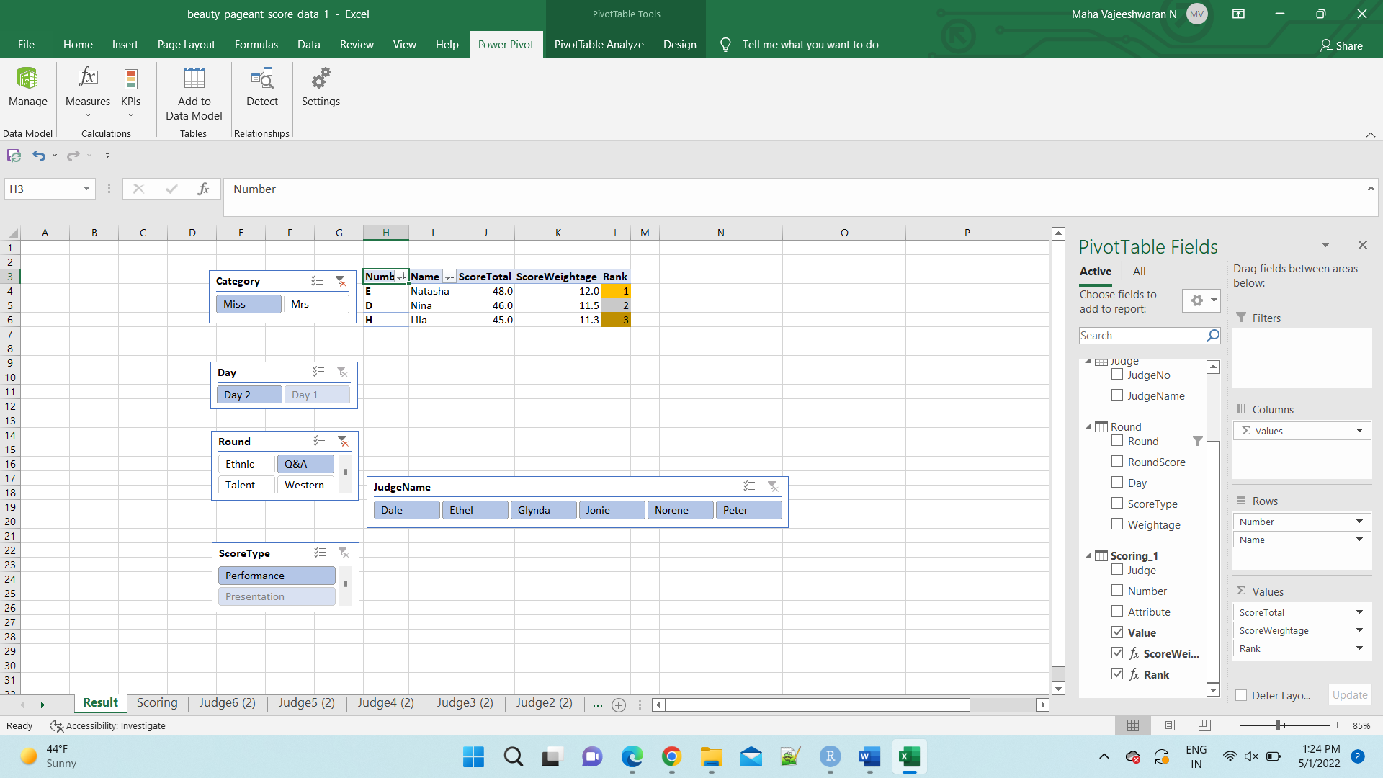

The winners for the Mrs category is shown below. Trisha, Jasmin, Ida are the winners for the Mrs category.

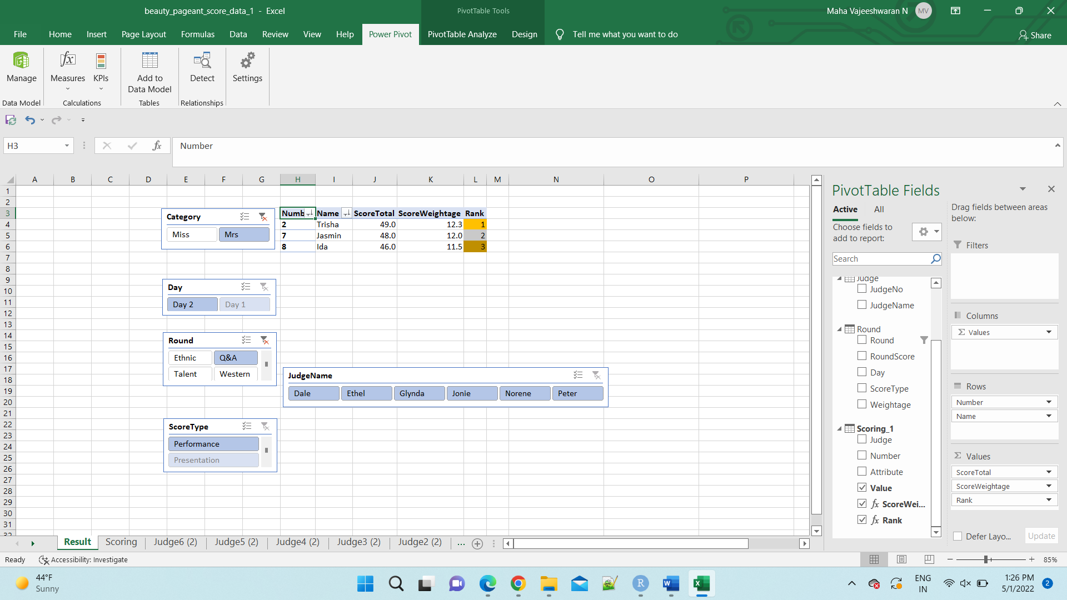

c) Who gets specific awards like Miss Talent (based on the scores in the Talent Round)?

By selecting the Miss in Category and Talent in Round we can filter to see the Miss Talent who gets .

Need to check.

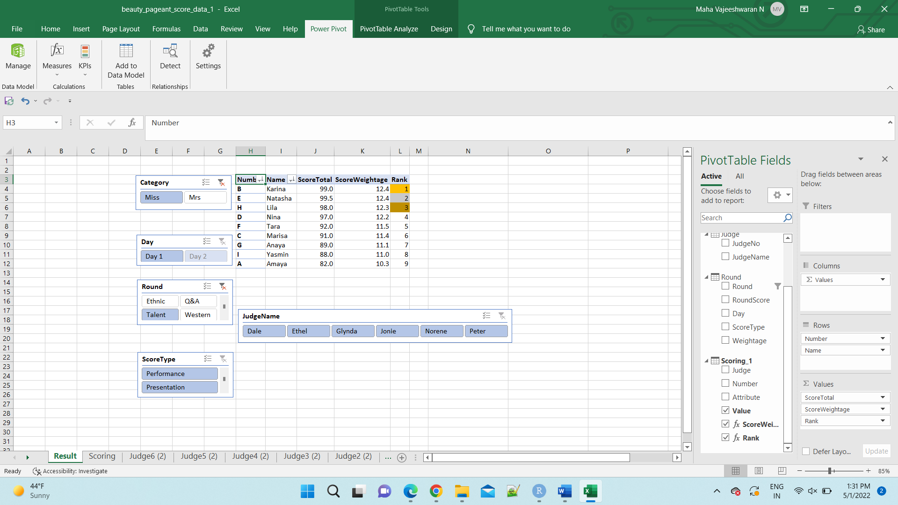

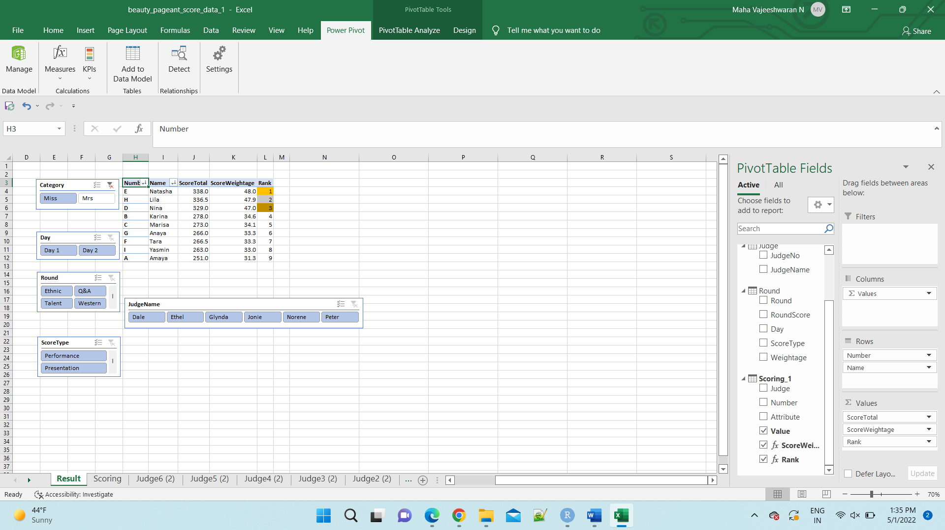

Conclusion:

The organizers may alter any scores to the participants using the attached Excel file, save the file, and reset the Pivot table, and the data will be updated, and also the new findings will be posted well without problems or additional work.