Web Design and Development

4COSC011W

Report

Author:

Student ID:

Group Number:

Student Role:

Link(s) to WebSite

URL:

Content 2

1. Introduction 3

2. Technical Discussion 3

• Presentation Page 3

• Main Page 3

• Font size change 3

• Comments Form 3

• Buy products 3

• Quiz 3

• View images and change text/background colour 3

3. Discussion of UI and application of UX principles 3

3.1 Information architecture 3

a. Design 3

b. Code to achieve good Information architecture 4

3.2 Colour balance/composition/graphics/consistency 4

a. Design 4

b. Code to achieve good colour balance & ensure consistency 4

c. Colour contrast test results 4

3.3 Typography / consistency 4

a. Design 4

b. Code to achieve good typography / consistency 5

3.4 Gestalt principles grouping 5

3.5 Accessibility (graphics/forms) 7

a. Graphical elements - Design/Code 7

b. Form completion - Design/Code 7

3.6 Error prevention and recovery 7

a. Design 7

b. Code to address error prevention and recovery 8

4 Janet 8

5 Conclusions 8

References 8

Appendices 8

Appendix A: Code 8

Appendix B: Screenshots 8

Appendix C: Individual Statement 8

# Introduction

In the coursework we have to create a website under some guidelines in the web designing and development module. For that we created a web site about sports.

1. Student 01 :-

Student 01 has been finished the introduction page with title and name of every member. Following four seconds, second page will be shown, and which is the principle page. Just as understudy 01 use Java Script to make the usefulness to increment/decline the text dimension utilized on the web site. The fundamental usefulness ought to incorporate two buttons – a catch to make the text dimension littler and a catch to make the text dimension bigger. Propelled usefulness will consider the text dimension to increment in the progression here and there. Aside from that understudy 01 expected to make a shopping basket identified with science and innovation. That page contains a structure to permit clients to purchase items.

1. Student 02 :-

Our main page is structured by student 02. Client can get to a few products of this site through this fundamental page. The links on our web page look like buttons and have a drift impact that was made utilizing CSS. Our web site incorporates a form to send comments about our web site. In that form we can see input fields for the client to enter their details, a field to enter comments and an approach to rate the web site

1. Student 03:-

Our web site contains a MCQ quiz. When the quiz has been finished by the user, it gives the user the last marks on the user performed. The quiz is time limited. At the point when the quiz is done the summery of the user performance likewise will be shown. Answers which were right or wrong and if answer is wrong correct answers are will be in the score page. Aside from that a web page has been structured the understudy details page that permits the user to see pictures of the designers of the web site. This page contains four photos of our group members. At the point when the user moves the mouse over the image, the details of that part will be shown on the page.

1. Student 04:-

The site map of our web page was structured by student 04. The site map has route links to the proper piece of the gathering web site and created in SVG. Just as student 03 made a page that permits the user to see pictures. This page contains a form, 5 thumbnail pictures, and 2 draw down menus (to choose the page foundation shading and the page content shading) and a territory to show a bigger picture and related description of that picture.

# Technical Discussion

*Max 1000 words*

Section guidelines:

* Discuss the development of the tasks that **you were allocated**. This technical discussion must include the approach taken, and explanations of how the required functionality was implemented. Illustrate your explanation with code snippets and screenshots. Also explain the difficulties you faced and how you solved them.
* Illustrate your technical discussion with screenshots and code samples.
* **Discuss only the following tasks that you were allocated. State if any of your allocated tasks were not completed.**

## (Student 1) Presentation Page

## (Student 1) Font size change

## (Student 1) Buy products

## (Student 2) Main Page

## (Student 2) Comments Form

* (Student 2) External CSS

## (Student 3) Quiz

* (Student 3) Student details

* (Student 4)Diagram (Site Map in SVG)

## (Student 4) View images and change text/background colour

* (All students) Page Editor Page

--------------------------------------------------------------------------------------------------------------------------

# Discussion of UI and application of UX principles

*Max 1000 words*

Section guidelines:

* Explain how you met the following UX principles to achieve a good aesthetical result, appealing to the target audience of the web site, with good visual balance between all the UI elements (background, header, footer, text, borders, graphics etc.), making content legible, clear and discoverable.
* Illustrate each of your discussion with screenshots and code samples.

---------------------------------------------------------------------------------------------------------------------------

## 3.1 Information architecture

### a. Design

Section guidelines:

* Explain how you structured the web site (the organization of the web site folders) and how you designed the web site navigation to ensure that content is discoverable, that users are aware at any time of their position (use of breadcrumb or breadcrumb trail) on the web site and they can easily (with the minimum number of steps) jump to different sections of the web site. Did you consider how you can assist the users to search for content?
* How did you implement the web site navigation system? Provide relevant HTML & CSS code.
* How do you structure each page to direct the user to content (when multiple pages use the same style you need to explain only the template that those pages follow)? Do you differentiate the importance of content (e.g. primary, footnotes)?

--------------------------------------------------------------------------------------------------------------------------

### b. Code to achieve good Information architecture

Section guidelines: E.g., the template created for your individual pages and for navigation.

## 3.2 Colour balance/composition/graphics/consistency

### a. Design

Section guidelines:

* Explain the colour combination, the composition (visual structural elements) and graphics (images, logo, icons) you used to ensure the proposed web site is appealing for its purpose, it reveals its’ identify and complies with the brand.
* Good aesthetical result such as good visual balance between all the UI elements (background, header, footer, text, borders etc.) and also ensure good legibility of the web site.

--------------------------------------------------------------------------------------------------------------------------

### b. Code to achieve good colour balance & ensure consistency

Section guidelines:

* What CSS did you write to ensure good and consistent colour balance.
* What HTML code you wrote to structure your we site in order to ensure good and consistent composition
* Did you write any CSS to consistently format the appearance of graphics?

--------------------------------------------------------------------------------------------------------------------------

### c. Colour contrast test results

Section guidelines: Text vs background colour contrast. Include screen shot of test results from a colour contrast checking tool such as: <https://snook.ca/technical/colour_contrast/colour.html#fg=FFFFFE,bg=000000>

## Typography / consistency

### a. Design

Section guidelines: Explain the fonts, font sizes, colours and styles you used to ensure the proposed web site is appealing and suitable for its purpose and at the same time legible. Explain how you ensured content relevance and consistency (e.g. paragraph titles, subtitles, text, small font).

### b. Code to achieve good typography / consistency

Section guidelines:

* What CSS you created to modify text.
* Did you use any of the online tools to test the legibility of your web site? What were the test results?
* How did you write the CSS to ensure consistency?

---------------------------------------------------------------------------------------------------------------------------

## Gestalt principles grouping

Section guidelines:

* How did you apply the Gestalt principles of grouping to reveal the purpose of the content, to direct the user to content and to increase the legibility of your web site? Use screenshots of your page to better support your justification.
* E.g. for the example below you could write something like that:

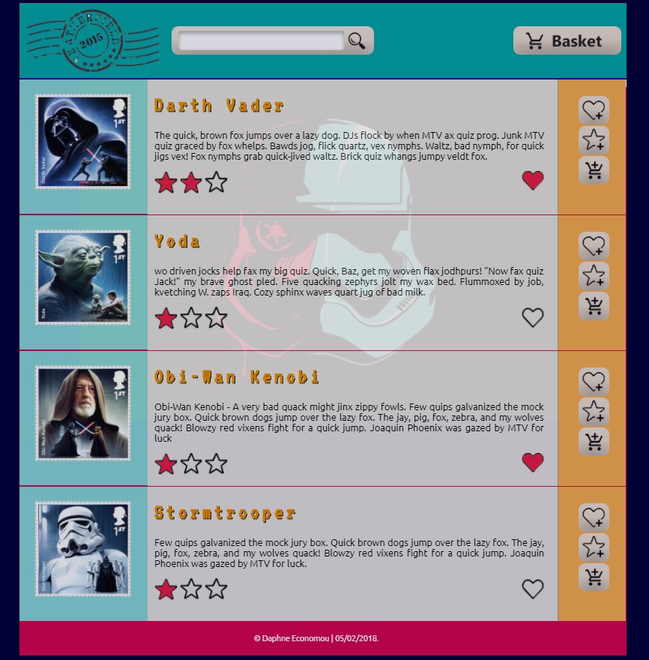

* In the above example **proximity** that states that "objects or shapes that are close to one another appear to form groups” has been applied in the following elements:
  + aligning the title, textual description for each stamp and rating star graphics close to each other creates a group, aligning this group of elements next to the stamp graphic creates a relation of the description to the stamp. Similarly aligning the favourite, rating and add to basket icons close to each other makes them a group. Aligning the stamp (blue box), the description (grey box), and icons (orange box) next to each other creates a relevance between those elements.
  + leaving space vertically between each stamp, description and icons box separates the stamps, their description and the icons to interact with each stamp respectively.
* In addition, **closure** is applied by drawing a line between stamps makes those groups more explicit. Placing the stamp inside a blue box, the description in a grey box, and icons in the orange box is another way of applying closure to make more explicit that this content belongs in the same group.
* Closure is also applied by drawing a line after the header and by using different colours in the header, footer and the main part of the page (container) to make the type of content more explicit and to enhance legibility and discoverability.
* **Continuation** users "tend to continue shapes beyond their ending points". The box that contain the stamp thumbnail, the stamp description related icons and buttons, appear in discrete boxes with different colour, however we tend to perceive that those boxes are enclosed in a wider box.
* **Similarity** stands for the things which share visual characteristics such as shape, size, colour, texture, or value will be seen as belonging together in the viewer’s mind. In this example this principle is applied by repeating the same style to the boxes that contain the stamp thumbnail, the stamp description and related icons and buttons indicate that enclosed content is of similar type.

--------------------------------------------------------------------------------------------------------------------------

## 3.5 Accessibility (graphics/forms)

### a. Graphical elements - Design/Code

Section guidelines: Explain how you addressed accessibility on the design of the web site. E.g., for the following graphical elements what accessibility tags have been used in order to make sure that in case that the graphics cannot be displayed the users would still get the required information and would still be able to interact with buttons and icons.

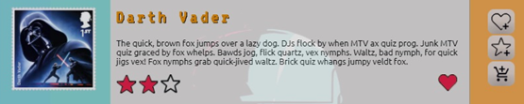

### b. Form completion - Design/Code

Section guidelines: State how you ensure good accessibility, for example in form completion. Explain the tags you used.

## 3.6 Error prevention and recovery

### a. Design

Section guidelines:

* In cases of form completing how did you assist the user to complete all the required field, to enter the information correctly and eliminate error and how did you address error recovery? E.g., did you use any instructions for completing the form? Did you provide any meaningful error messages in case the users did not completed the form correctly to help them correct their mistakes?
* How have you addressed accessibility in the design. E.g., instructions for form completion, inclusion of images for descriptive or decorative purposes, or system response and error messages.
* Illustrate your discussion with screenshots.

--------------------------------------------------------------------------------------------------------------------------

### b. Code to address error prevention and recovery

Section guidelines: Provide the code you used to address accessibility, e.g. for form completion, graphics, or system response and error messages.

# Janet

Section guidelines: Explain how your web site complied with Janet Regulations, [Janet Policies and Legal Requirements](https://community.jisc.ac.uk/library/janet-services-documentation/janet-policies-and-legal-requirements). Max 200 words

# Conclusions

Section guidelines: This should include reflection on the work carried out, how you worked as a team, problems encountered as part of your technical development, lessons learnt and suggested improvements.

# References

Provide references to resources you have used.

# Appendices

## Appendix A: Code

Provide a full listing of your files, with well indented and commented code in the following format:

Filename

Code

## Appendix B: Screenshots

Provide a screenshot of all your web pages, in the following format:

Filename

Screenshot(s)

## Appendix C: Individual Statement

|  |  |  |  |
| --- | --- | --- | --- |
| Student Name: |  | Student Id: |  |
| State what tasks you carried out in the project. | | | |
|  | | | |
| State what you enjoyed and did not enjoy about teamwork. | | | |
|  | | | |
| State what you learnt about teamwork. | | | |
|  | | | |
| State what skills you gained/learnt from undertaking the project. | | | |
|  | | | |
| State any strengths about yourself that emerged whilst undertaking the project. | | | |
|  | | | |
| State any weaknesses about yourself that emerged whilst undertaking the project. | | | |
|  | | | |
| State how you would do things better if you were to undertake the project again. | | | |
|  | | | |
| Additional general or project specific comments: | | | |
|  | | | |
| Student Signature: |  | Date: |  |