A NEW HINT TO TRANSPORTATION-ANALYSIS OF THE NYC BIKE SHARE SYSTEM

Website link:
https://krishnaganesh01.github.io/Analysis-of-the-NYC-bike-share-system/

Smart bridge Data Analytics Final Project
by Team-165

Student Name Registration No. Email
Kanugo Krishna Ganesh 20BCI0149 kanugokrishna.ganesh2020@vitstudent.ac.in
Yenigandla Venislaus Ashish 20BCI0016 venislaus.ashish2020@vitstudent.ac.in
V Rahul Chowdary 20MID0018 rahulchowdary.v2020@vitstudent.ac.in
Akash Kulkarni 20MID0147 akash.kulkarni2020@vitstudent.ac.in

TABLE OF CONTENTS

1 INTRODUCTION
1.1 Overview
1.2 Purpose

2 LITERATURE SURVEY
2.1 Existing problem
  - Proposed solution

3.THEORITICAL ANALYSIS
3.1 Block diagram
  - Hardware / Software designing

4.EXPERIMENTAL INVESTIGATIONS

5.FLOWCHART

6.RESULT

7.ADVANTAGES & DISADVANTAGES

8.APPLICATIONS

9.CONCLUSION

10.FUTURE SCOPE

11.BIBILOGRAPHY

APPENDIX

Source Code

1. INTRODUCTION
1.1 PROJECT OVERVIEW

Bike sharing initiatives have experienced a surge in popularity in recent years, being promoted as a more environmentally friendly alternative to conventional transportation methods. The global interest in bicycle sharing has grown exponentially over the past decade, leading to the implementation of bike share systems in 712 cities worldwide. These systems consist of 806,000 bicycles and 37,500 stations (Shaheen et al., 2014).

The success of bike sharing can be primarily attributed to the integration of information technology into docking stations and mobile devices, as well as improvements in logistics to ensure efficient management of the bike supply. Cities have high hopes for bike sharing, anticipating benefits such as expanded transit access, reduced reliance on motorized transportation, and the encouragement of non-cyclists to give cycling a try (Shaheen et al., 2014).

Bicycle sharing operates on the principle of short-term bike rentals, offering varying membership options. Users of the bike share network have access to stations equipped with pay-stations and multiple bike docks. Bicycles can be checked out from one station and returned to another closest to their destination.

The appeal of bike share membership lies in the convenience of 24/7 access to an automated bike rental network and the utility of bikes for "last-kilometer connections." Members can enjoy the benefits of cycling without the concerns of storage or maintenance. The pricing structure is designed to incentivize shorter trips, typically within a 30-minute timeframe. Additional fees may apply for any time used beyond the maximum duration.

Research indicates that bike share users often switch from motorized modes of transport, such as buses and cars, which has the potential to lead to significant reductions in transportation-related greenhouse gas emissions or CO2e (Shaheen et al., 2014). However, it's important to note that there is considerable variation between cities, suggesting that the CO2e reduction benefits of implementing bike share programs are not guaranteed. Factors such as trip substitution and the displacement of walking and private bicycle trips can impact the overall outcomes (Shaheen et al., 2014).

1.2 PURPOSE
The purpose of this project is to conduct a comprehensive analysis of the NYC Bike Share System utilizing the power of Tableau, a data visualization tool. By examining the dataset associated with the bike share system, we aim to gain valuable insights into transportation patterns, usage trends, and the overall effectiveness of the program. This project seeks to provide a deeper understanding of the bike share system's impact on urban mobility and explore opportunities for improving its functionality and optimizing resources.
Understanding Transportation Patterns:
One of the primary goals of this project is to unravel transportation patterns within the NYC Bike Share System. By analyzing the dataset, we can identify peak usage hours, popular routes, and areas with high demand for bike sharing. This information can assist transportation planners and policymakers in making informed decisions regarding infrastructure development, station placement, and resource allocation. Moreover, understanding transportation patterns can help optimize system operations, ensuring bikes are readily available at high-demand stations and reducing instances of bike shortages or overcrowding.
Evaluating User Behavior:
By delving into the dataset, we aim to gain insights into user behavior within the bike share system. This includes analyzing factors such as trip duration, frequency of usage, and user demographics. Understanding user behavior can help determine the effectiveness of the bike share program in meeting the needs of different user groups, such as commuters, tourists, and recreational cyclists. Furthermore, this analysis can shed light on potential barriers or incentives for users to adopt bike sharing as a preferred mode of transportation.
Assessing System Performance:
Another crucial aspect of this project is to assess the performance of the NYC Bike Share System. By examining metrics such as bike availability, station utilization rates, and customer satisfaction, we can gauge the overall efficiency and reliability of the system. This evaluation can provide valuable insights for system operators to optimize operations, enhance user experience, and identify areas for improvement. Additionally, assessing system performance can help quantify the environmental impact of bike sharing, such as reductions in greenhouse gas emissions and congestion.
Informing Policy and Decision-Making:
The insights derived from this project can be instrumental in informing policy and decision-making processes related to urban transportation. By understanding how the bike share system integrates with other modes of transportation, policymakers can develop strategies to promote sustainable transportation alternatives, reduce traffic congestion, and improve air quality. Additionally, the findings can help guide future investments in expanding the bike share network, improving infrastructure, and implementing targeted marketing campaigns to encourage broader adoption of bike sharing among different user segments.

2. LITERATURE SURVEY
2.1 EXISTING PROBLEM
Bike sharing is an emerging industry and it is very popular in western countries, while people have tried to start the same in India, we will look into some of the stats regarding how many people use bike sharing systems. According to Wikipedia by August 2014 only 600 cities in the world had bike sharing systems and most of them were in western countries with a fleet of about 500000 bicycles with them. There is a sharp increase in Next Bike Cog Bike Share are some of the leading Bike Sharing systems that are currently in operation in the world.
While considering Indian perspective in the Bike Share industry, India has not yet adapted the application of this emerging industry. Currently there are a few bike share systems.

References:
Burrows; et al. (1999). Gotham. Oxford Press. ISBN 0-19-511634-8. Koeppel, Gerard (2015). City on a Grid: How New York Became New York. Boston: Da CapoPress. ISBN 978-0-306-82284-1.
"Glorification! The Cities Celebrate the Work That Makes Them One". Brookly n Daily Eagle. May 24, 1883. p. 12. Retrieved June 26, 2019 – via Brooklyn Public Library; newspapers.comopen access.
Walker, James Blaine (1918). Fifty Years of Rapid Transit, 1864–1917. Retrieved January 7,2015. Caro, Robert (1974). The Power Broker: Robert Moses and the Fall of New York. New York: Knopf. ISBN 978-0-394-48076-3. OCLC 834874. U.S. Census Bureau, American Community Survey 2006, Table S0802.
Metropolitan Transportation Authority. "The MTA Network". Retrieved July 15, 2016. Bureau of Transportation Statistics, U.S. Department of Transportation (2001). "Highlights of the 2001 National Household Travel Survey ". Archived from the original on October 2, 2006. Retrieved May 21, 2006.
Bellafante, Ginia (July 12, 2019). "New York Was Supposedly Getting Better for Cyclists. WhatHappened?". The New York Times. ISSN 0362-4331. Retrieved November 5, 2019.

2.2 PROPOSED SOLUTION
Data Gathering: Obtain the NYC bike ride data for the year 2018 from the Citi Bike program. This data should include information such as trip duration, start and end stations, customer age group, gender, and subscriber status.
Data Preparation: Clean and preprocess the data to ensure it is in a suitable format for analysis. Handle missing values, remove duplicates, and perform any necessary transformations or calculations.
Trip Analysis: Create visualizations in Tableau to analyze the total number of trips taken during the year 2018. You can create bar charts, line graphs, or heat maps to show the trends and patterns in trip volume. This analysis will provide insights into the demand for bike-sharing and help assess the program's financial viability.

Top Bikes Analysis: Identify the bikes that are most frequently used based on trip duration. Calculate the average trip duration for each bike and determine the top bikes used. Visualize this information using charts or tables in Tableau. This analysis will help Citi Bike officials understand which bikes are popular among users and can guide decisions regarding bike production and maintenance.
Start Station Analysis: Determine the top 10 start station names with respect to customer age group. Group the data by start station and age group, and calculate the number of trips for each combination. Create a visualization, such as a bar chart or map, to display the results in Tableau. This analysis will assist the government in identifying stations that are popular among different age groups and guide their efforts to increase the number of bikes available in those stations.
Customer Gender and Age Group Analysis: Analyze the gender of customers and subscribers and assess the number of bikes used by respective age groups. Utilize Tableau's capabilities to create visualizations, such as pie charts or stacked bar charts, to showcase the distribution of customers and subscribers by gender and age group. This analysis will provide insights into the program's user demographics and help tailor marketing and outreach efforts accordingly.
Create the Operating Report: Consolidate the findings from the previous analyses into an operating report for Citi Bike in 2018. Include key insights, visualizations, and recommendations based on the data analysis. The report should address the goals of enhancing the system, improving financial viability, and broadening the reach of the bike-sharing program.
By leveraging Tableau's powerful visualization and data analysis capabilities, we can effectively analyze the NYC bike ride data and generate actionable insights for enhancing the Citi Bike system.

3 THEORITICAL ANALYSIS
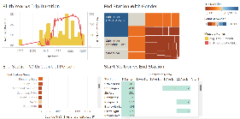
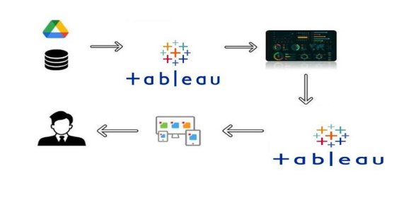
3.1 BLOCK DIAGRAM
3.2 HARDWARE/ SOFTWARE REQUIREMENTS:
Hardware Requirements:
- Computer: A reliable computer system capable of running the required software efficiently.
- Processor: A multi-core processor (e.g., Intel Core i5 or higher) for faster data processing.
- RAM: Sufficient RAM (e.g., 8 GB or higher) to handle large datasets and complex computations.
- Storage: Adequate storage space to store the dataset and analysis results.
- Display: A monitor or display screen with a suitable resolution for data visualization.
Software Requirements:
- Tableau: The primary software tool for data analysis and visualization. You will need Tableau Desktop, which provides a comprehensive suite of features for data exploration, visualization, and reporting.
- Database Software: Depending on the format of the NYC bike ride data, you may need a database management system (e.g., MySQL, PostgreSQL, or Microsoft SQL Server) to store and manage the data efficiently.
- Data Cleaning Tools: Software tools like Microsoft Excel or OpenRefine can be used for data cleaning and preprocessing tasks.
- Programming Language: Depending on the complexity of the analysis, you may need a programming language like Python or R to perform advanced data manipulation or statistical analysis if required.
- Operating System: Any major operating system (e.g., Windows, macOS, or Linux) that is compatible with the chosen software tools.
4 EXPERIMENTAL INVESTIGATIONS

Here are the experimental investigations or analyses that can be conducted while working on the solution for the NYC bike ride data analysis project:
Trip Duration Analysis: Investigate the distribution of trip durations to identify any outliers or patterns. Calculate statistics such as mean, median, and standard deviation of trip durations. Visualize the distribution using histograms or box plots to gain insights into the typical trip duration and identify any unusual trip durations.
Time Series Analysis: Explore the variation in bike usage throughout the year by analyzing the data on a monthly, weekly, or daily basis. Identify any seasonality or trends in bike rentals over time. Visualize the time series data using line graphs or heat maps to understand the patterns of bike usage and identify peak periods.
Geographic Analysis: Utilize geographical information to analyze the popularity of different start and end stations. Create maps and heat maps to visualize the distribution of bike trips across different areas of NYC. Identify high-demand areas and assess the need for additional bike availability or infrastructure improvements.
Customer Behavior Analysis: Investigate customer behavior by analyzing factors such as the frequency of bike rentals, the duration between rentals, and the distance traveled. Identify patterns in customer behavior based on age group, gender, or subscription status (subscriber vs. customer). This analysis can help understand user preferences and guide marketing and outreach efforts.
Customer Satisfaction Analysis: If available, consider analyzing customer feedback or satisfaction ratings related to the bike-sharing experience. Conduct sentiment analysis on customer reviews or surveys to identify common themes or areas for improvement. This analysis can provide valuable insights into customer perceptions and help enhance the bike-sharing system.
Predictive Modeling: Build predictive models to forecast future bike usage based on historical data. Utilize techniques such as regression analysis or time series forecasting to predict the demand for bikes and identify potential issues or opportunities. This analysis can help optimize bike availability, resource allocation, and system planning.

These experimental investigations and analyses will provide deeper insights into the NYC bike ride data, allowing for a better understanding of user behavior, system performance, and opportunities for improvement. The specific investigations conducted will depend on the available data, project goals, and desired outcomes.

5 FLOWCHART

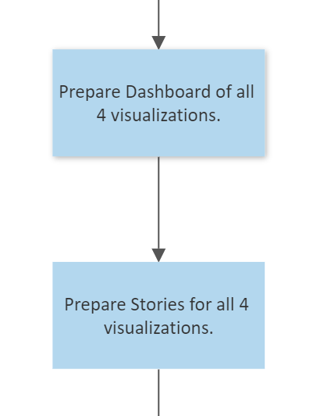
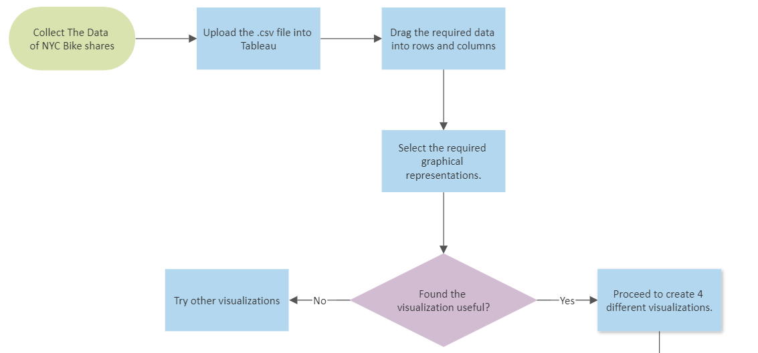

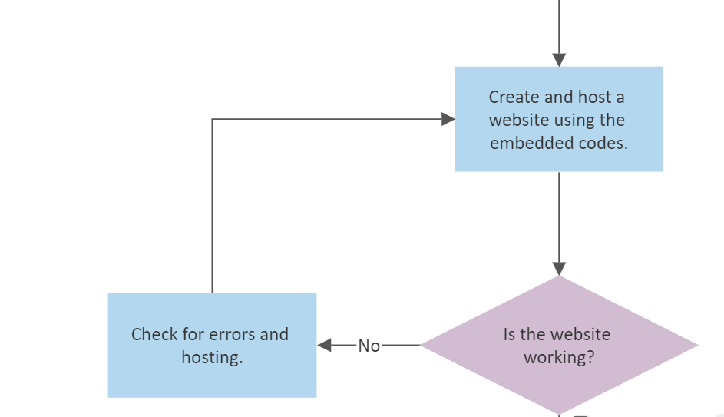

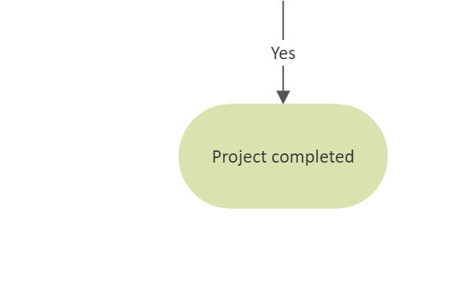

6 RESULT
Screenshots:
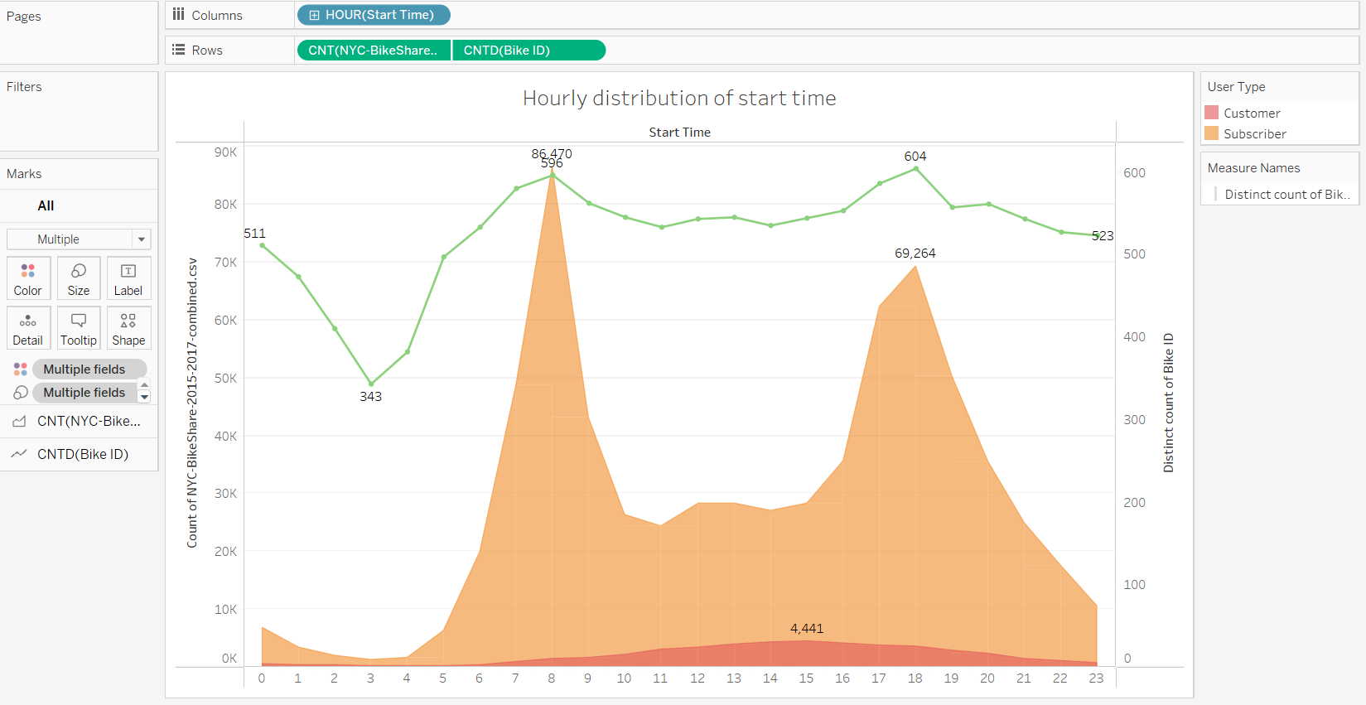
1.The trends of count of NYC-BikeShare-2015-2017-combined.csv and distinct count of Bike ID for Start Time Hour. For pane Count of NYC-BikeShare-2015-2017-combined.csv: Color shows details about User Type. Details are shown for count of NYC-BikeShare-2015-2017-combined.csv and distinct count of Bike ID. For pane Distinct count of Bike ID: Size shows details about count of NYC-BikeShare-2015-2017-combined.csv and distinct count of Bike ID.

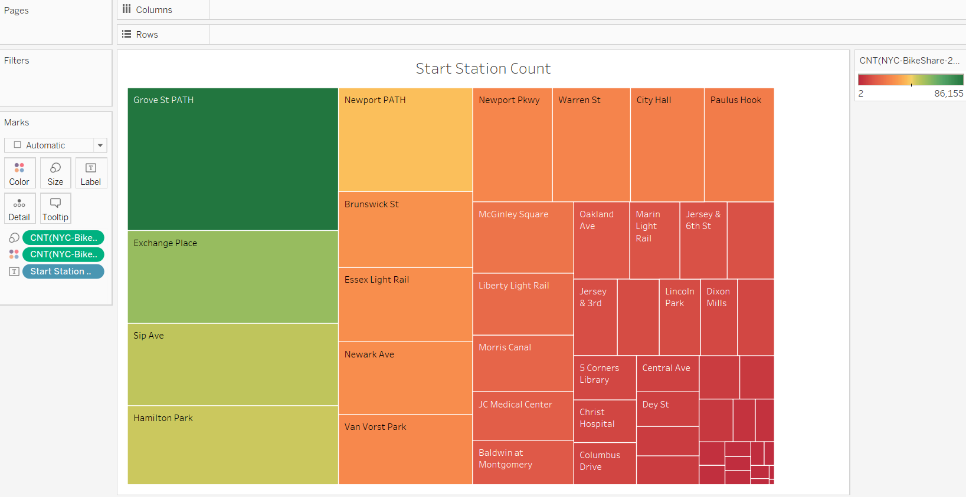
2. Start Station Name. Color shows count of NYC-BikeShare-2015-2017-combined.csv. Size shows count of NYC-BikeShare-2015-2017-combined.csv. The marks are labeled by Start Station Name.
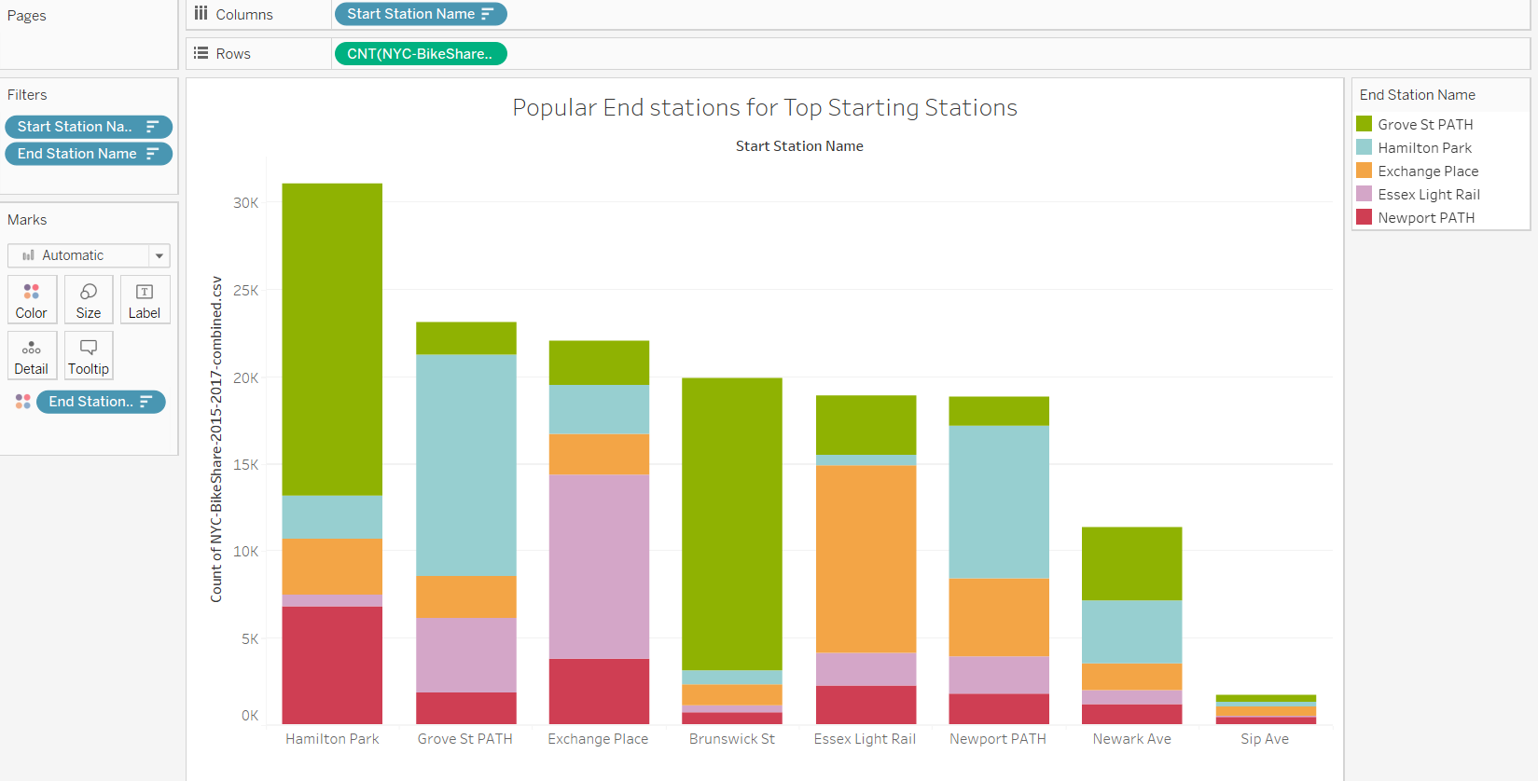
3. Count of NYC-BikeShare-2015-2017-combined.csv for each Start Station Name. Color shows details about End Station Name. The view is filtered on Start Station Name and End Station Name. The Start Station Name filter keeps 8 of 51 members. The End Station Name filter keeps Essex Light Rail, Exchange Place, Grove St PATH, Hamilton Park and Newport PATH.

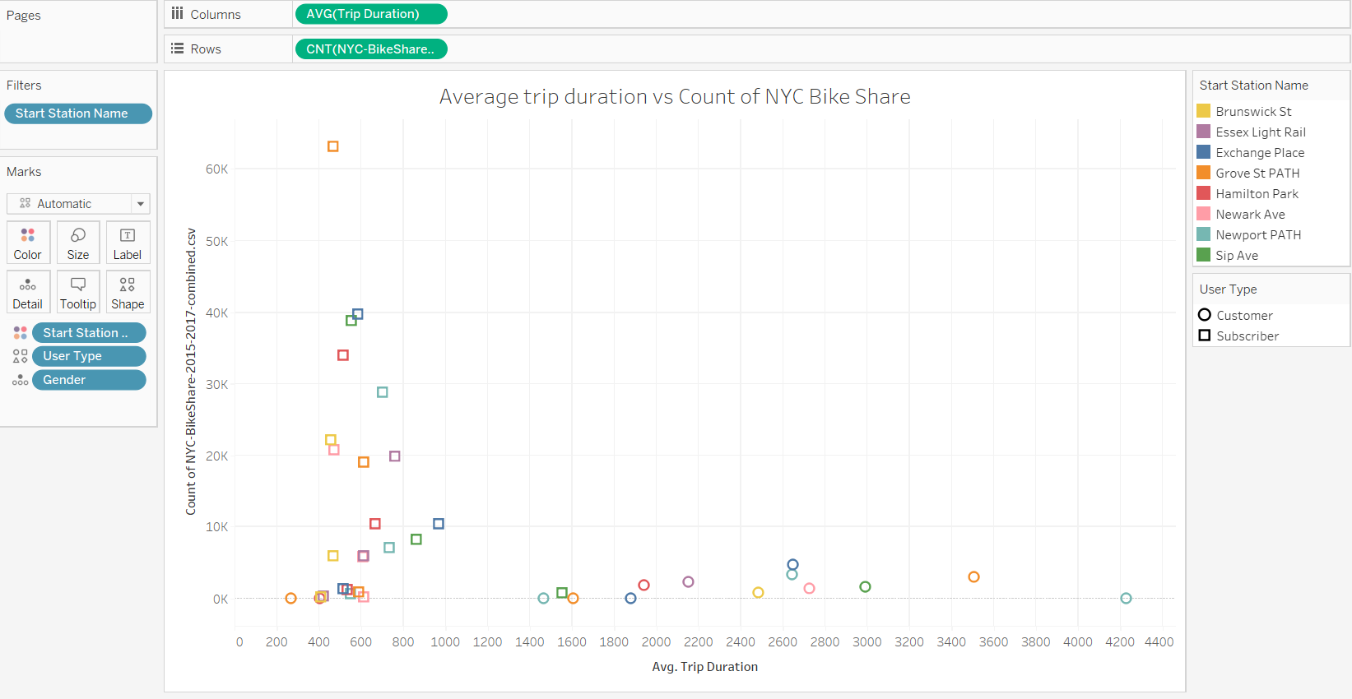
4. Average of Trip Duration vs. count of NYC-BikeShare-2015-2017-combined.csv. Color shows details about Start Station Name. Shape shows details about User Type. Details are shown for Gender. The view is filtered on Start Station Name, which keeps Exchange Place, Grove St PATH, Hamilton Park, Newport PATH and Sip Ave.

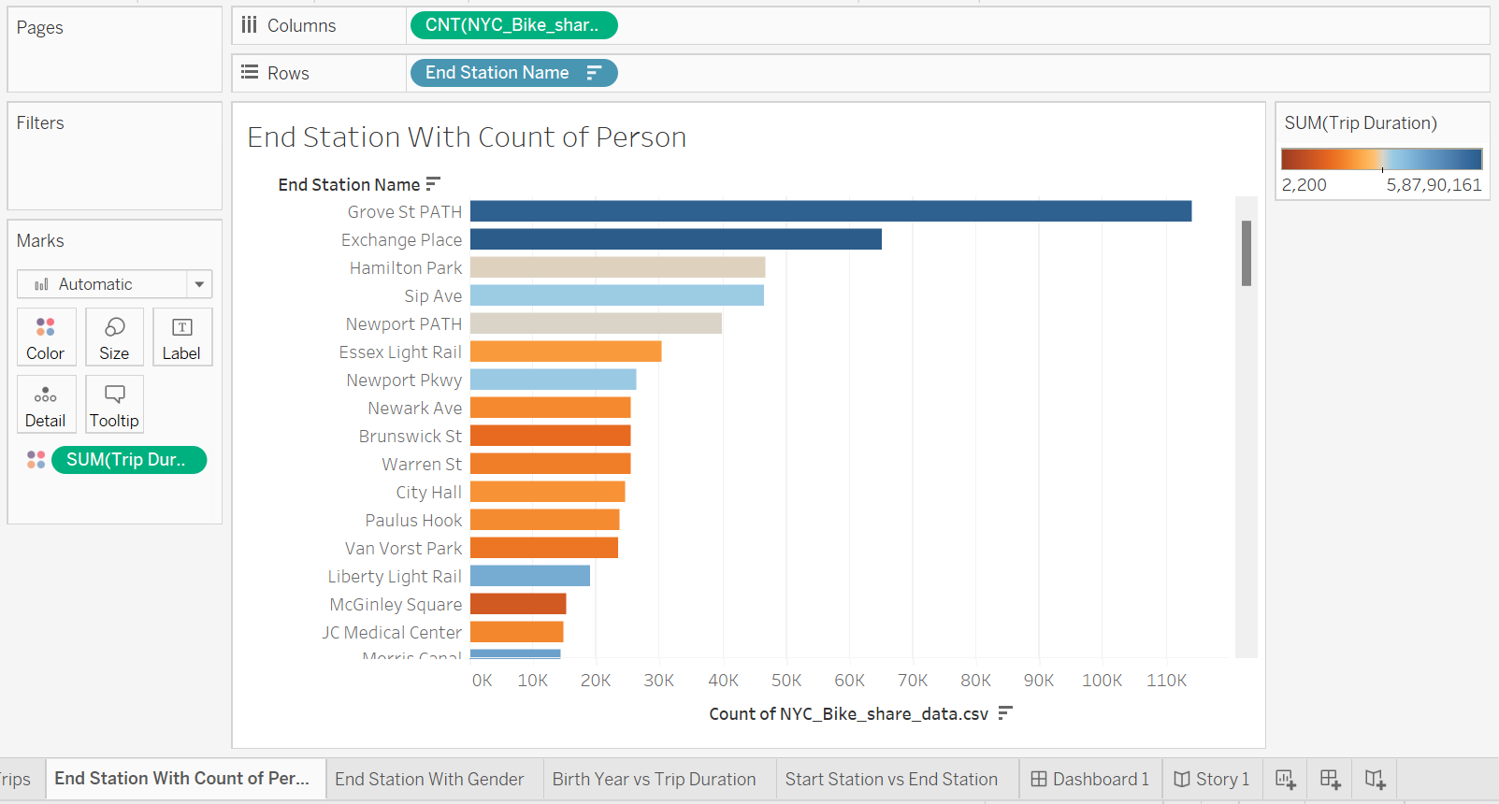
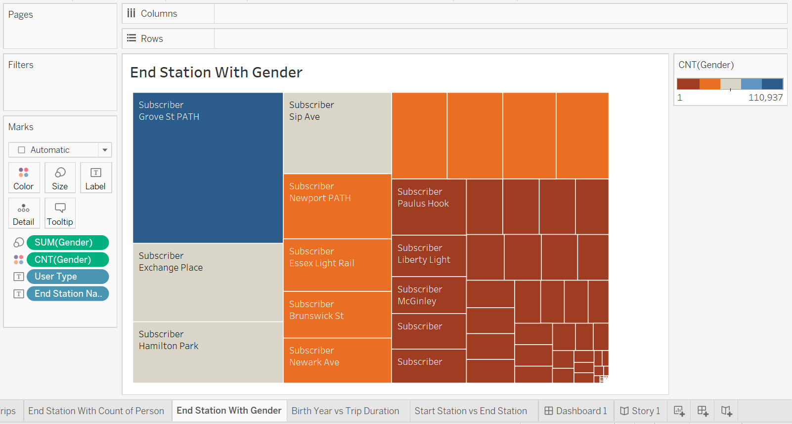
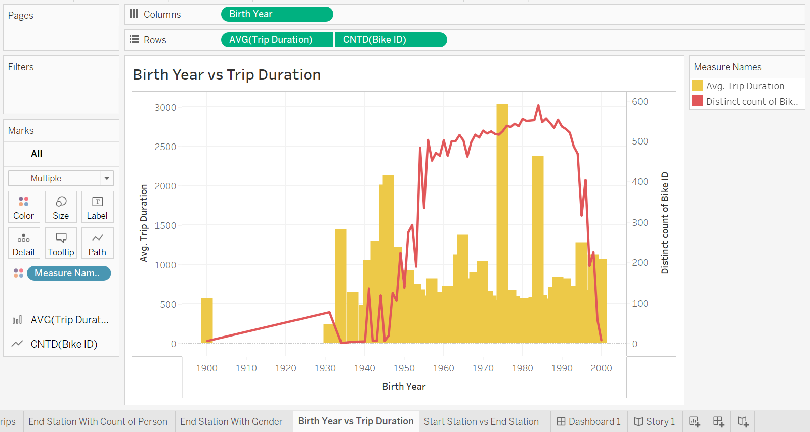
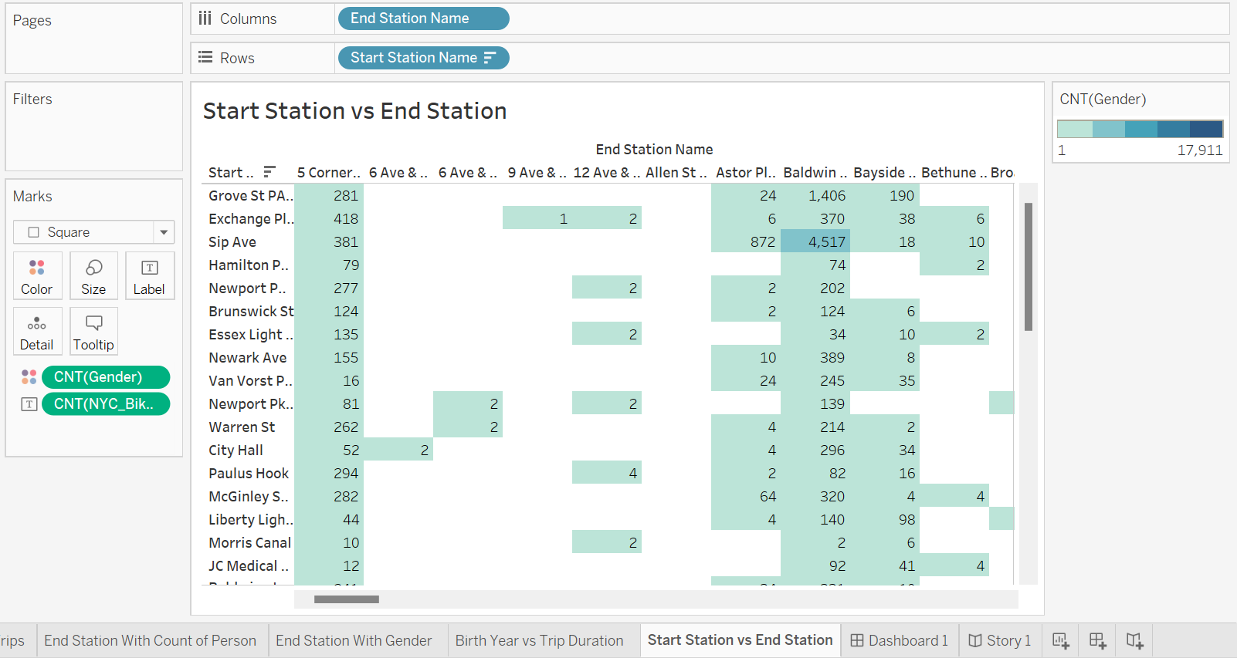

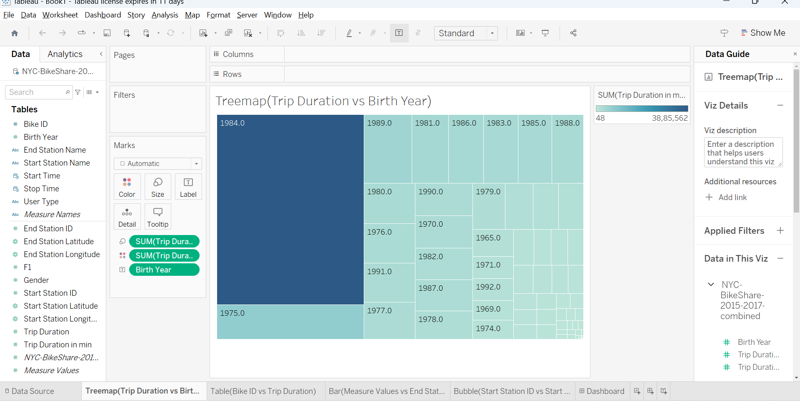
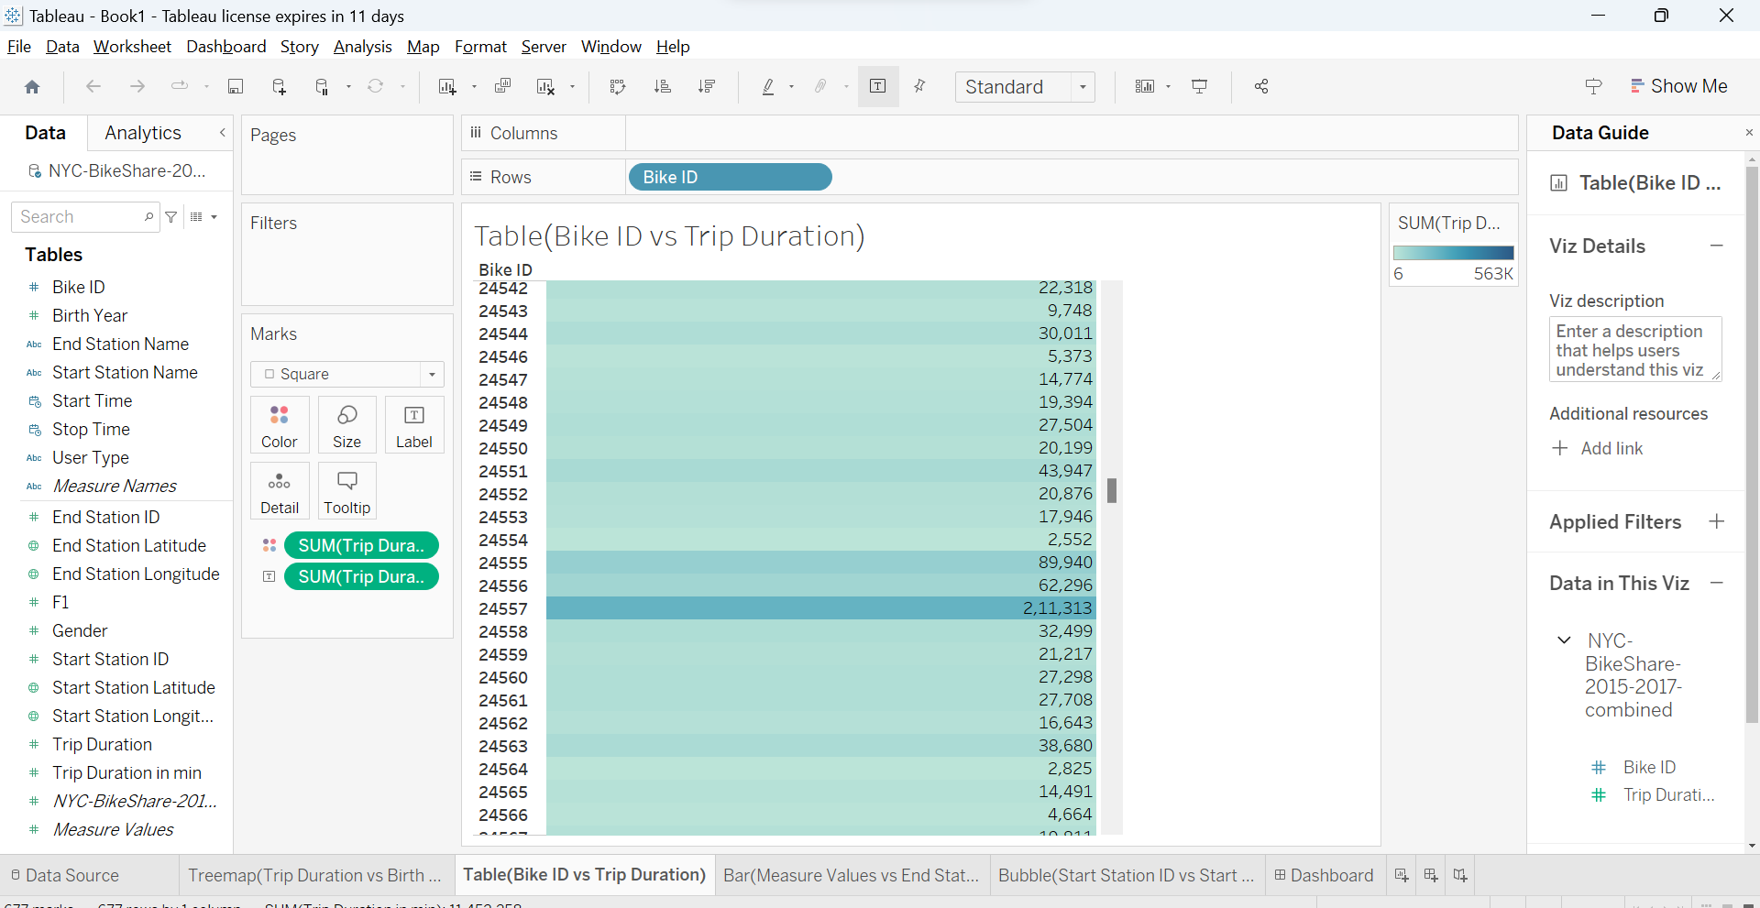

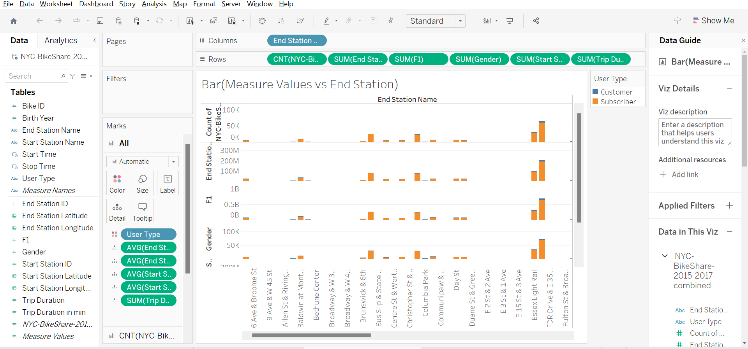
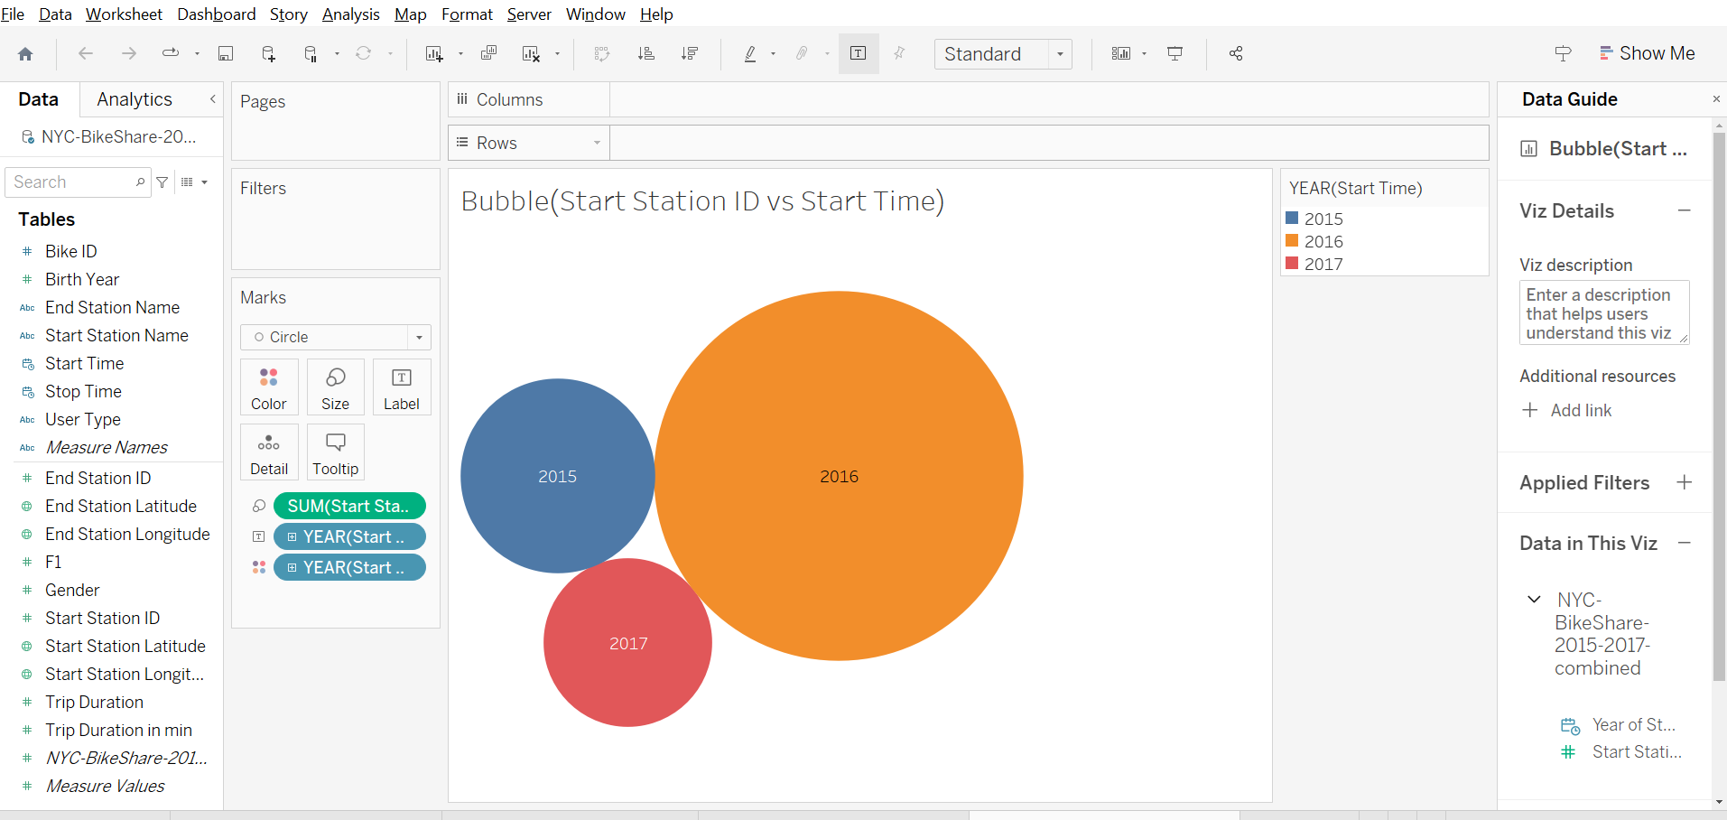

Dashboards:
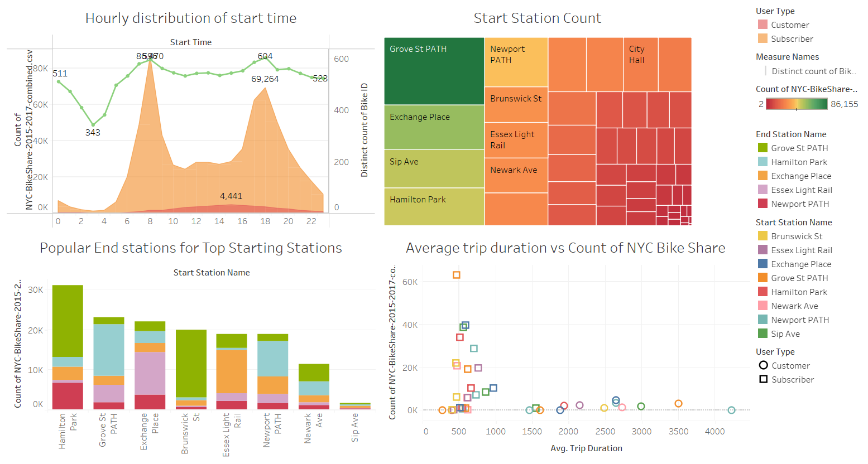

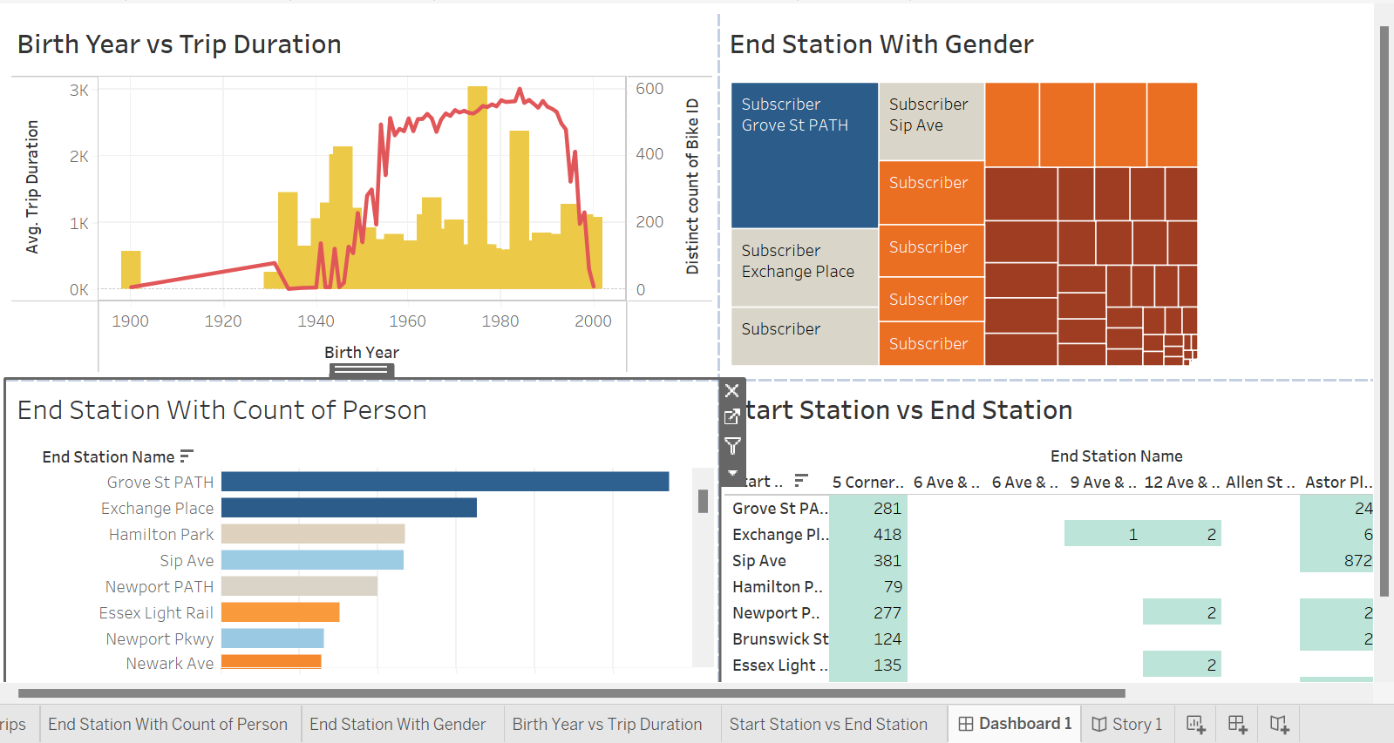

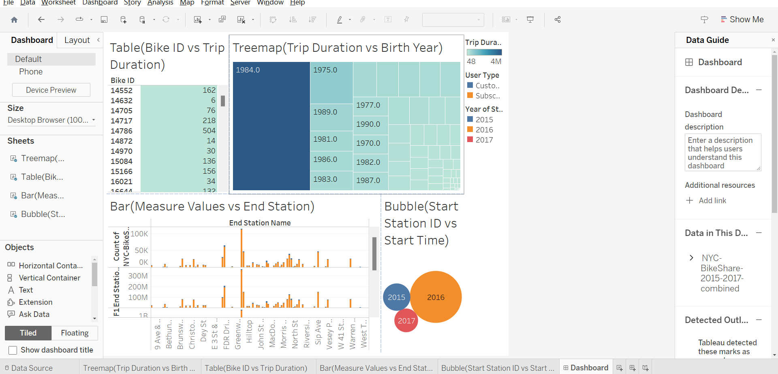

Stories:
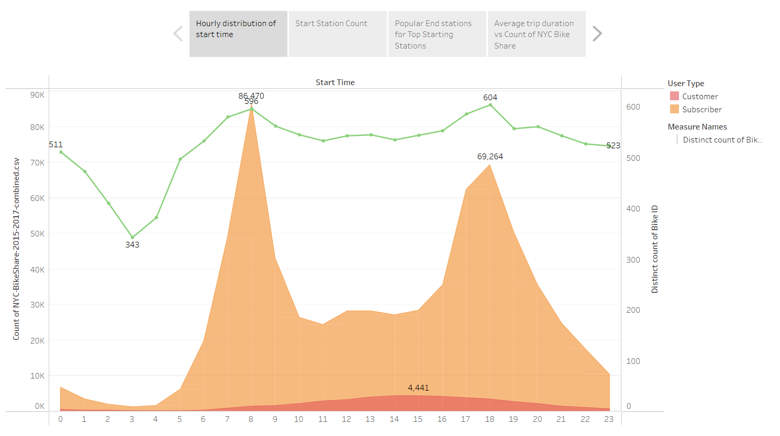
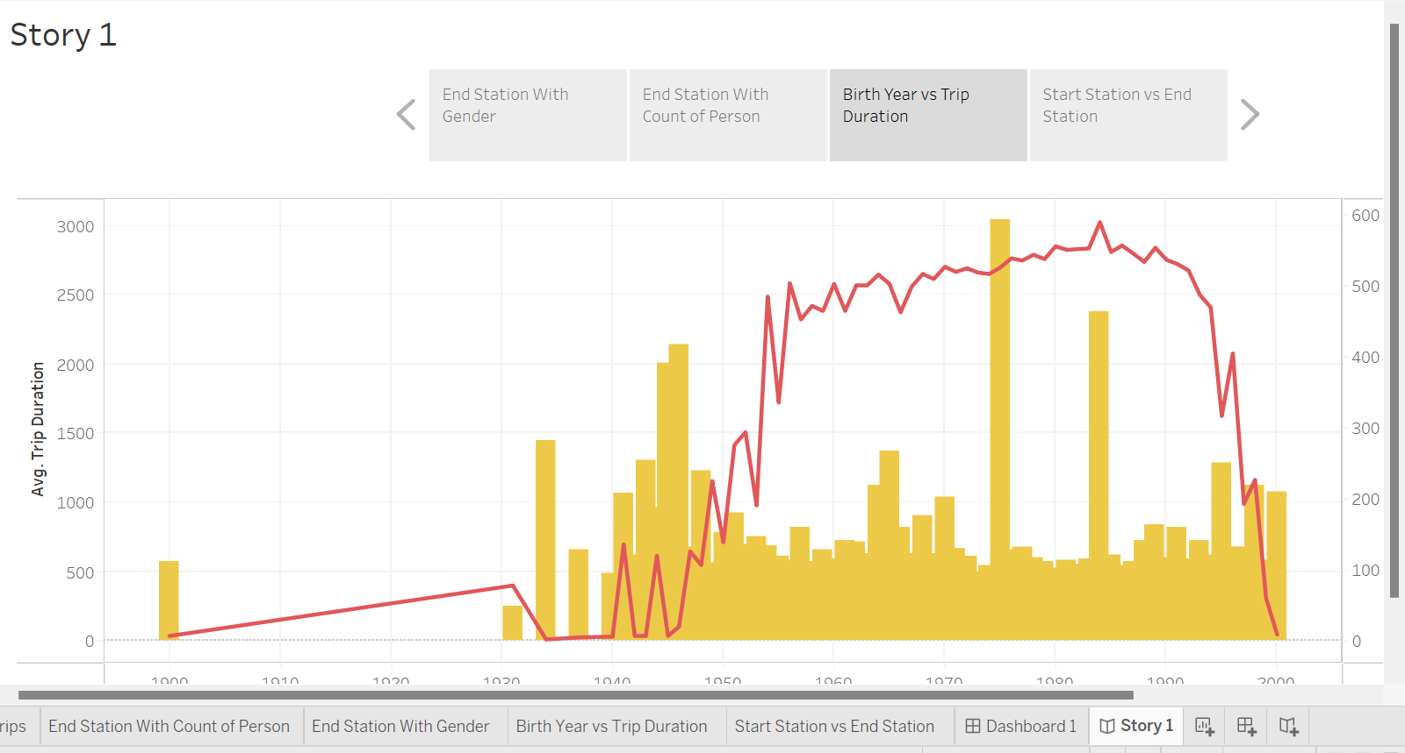

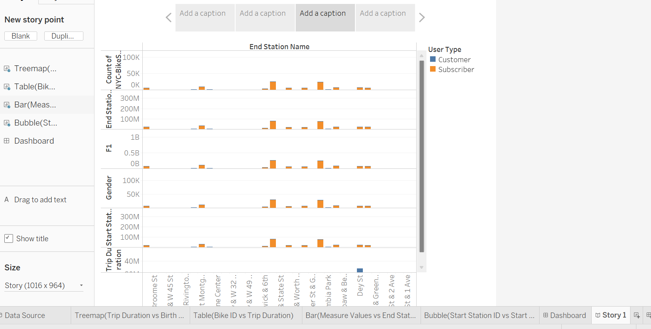

Screenshots of the Website:
Home:
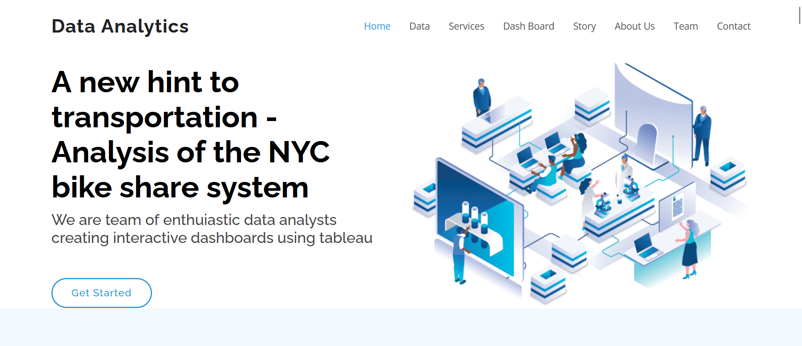
About the data:
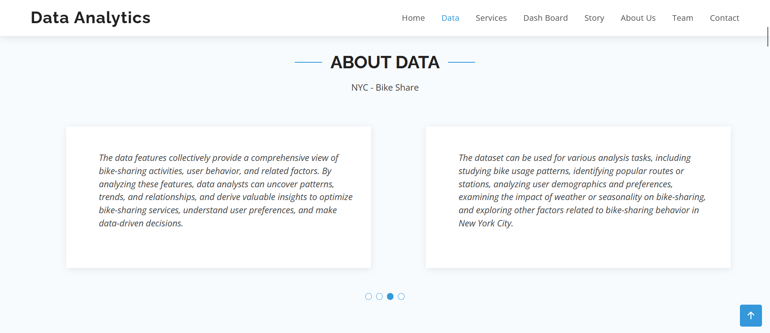
Services:
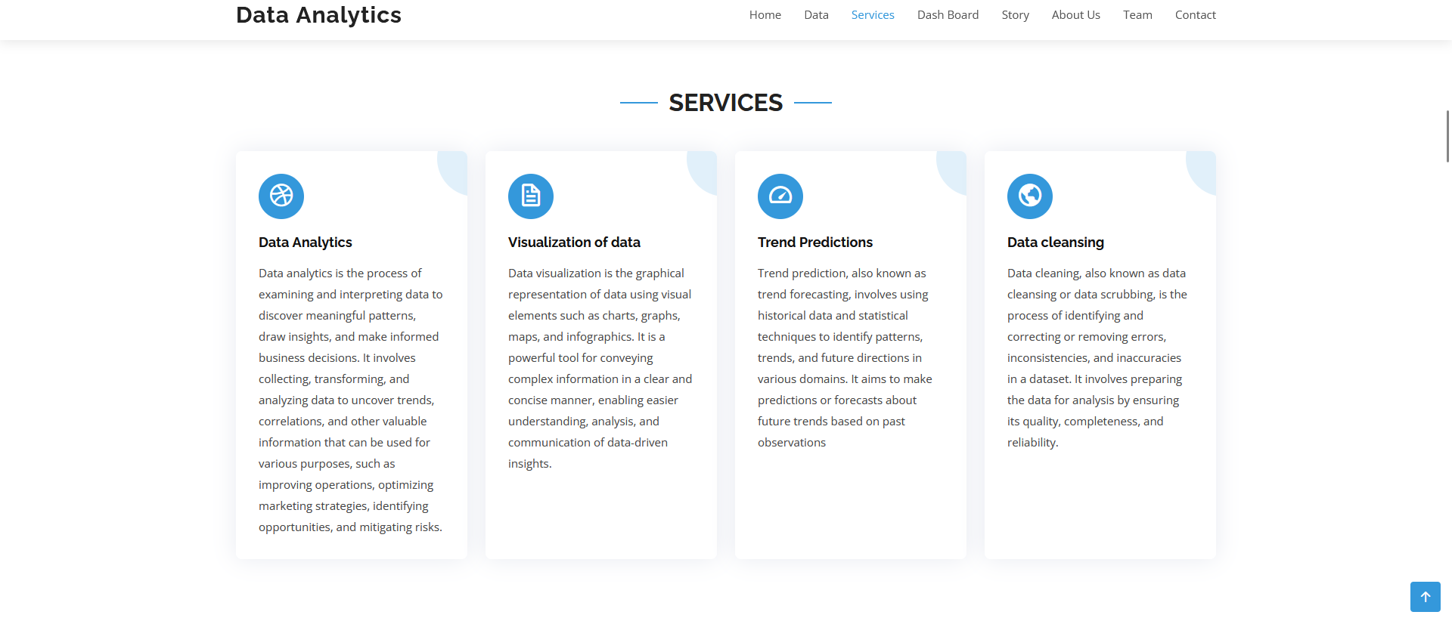
Dashboard:
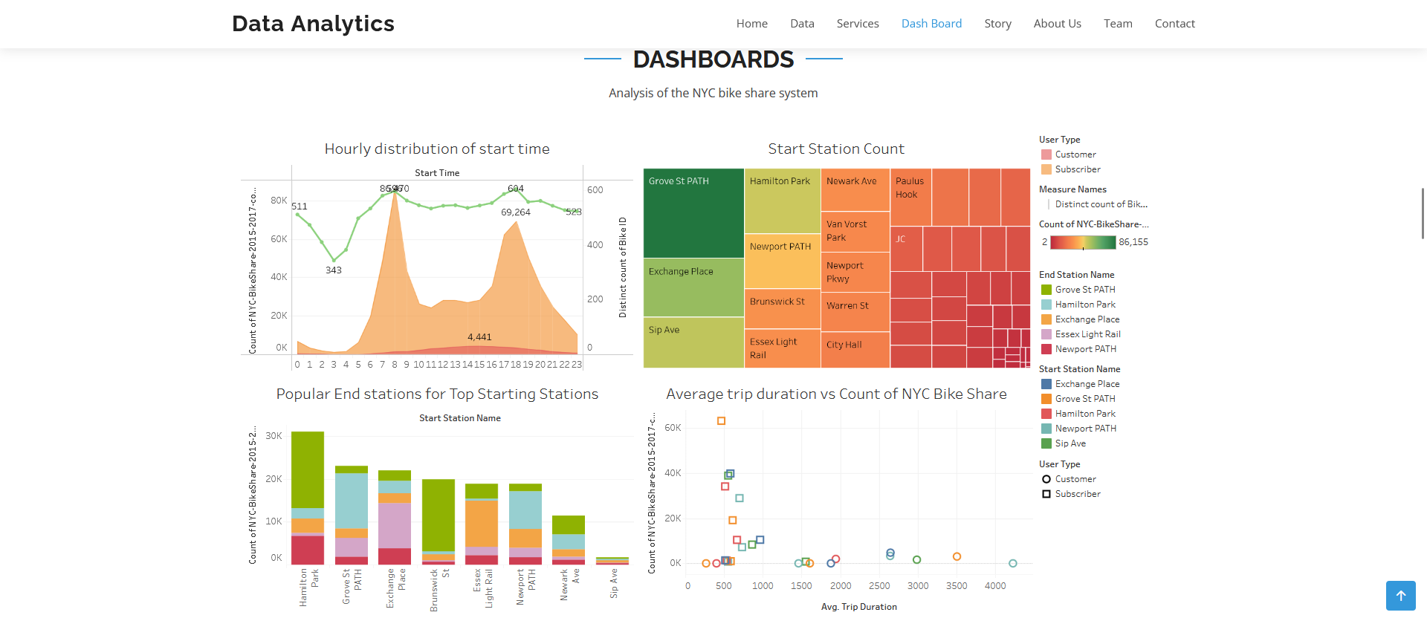
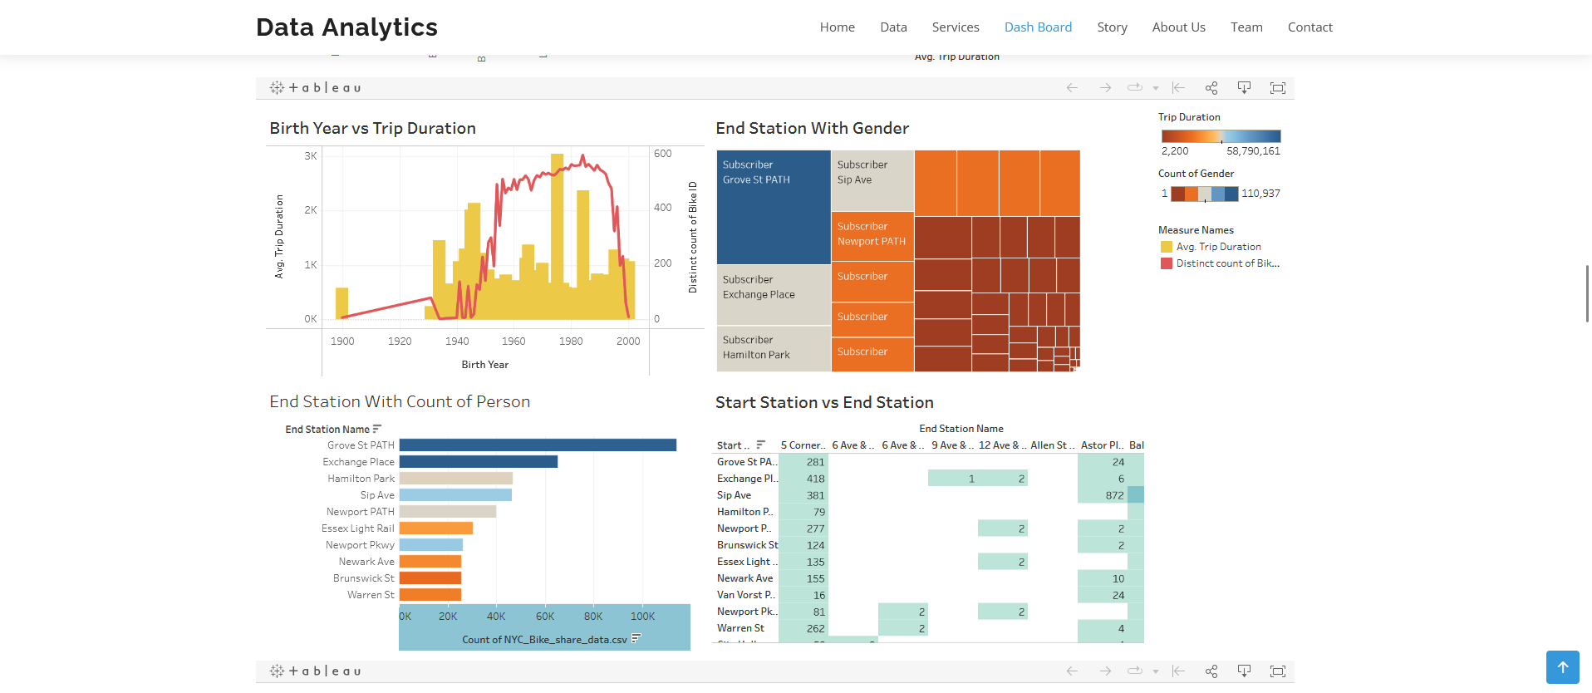
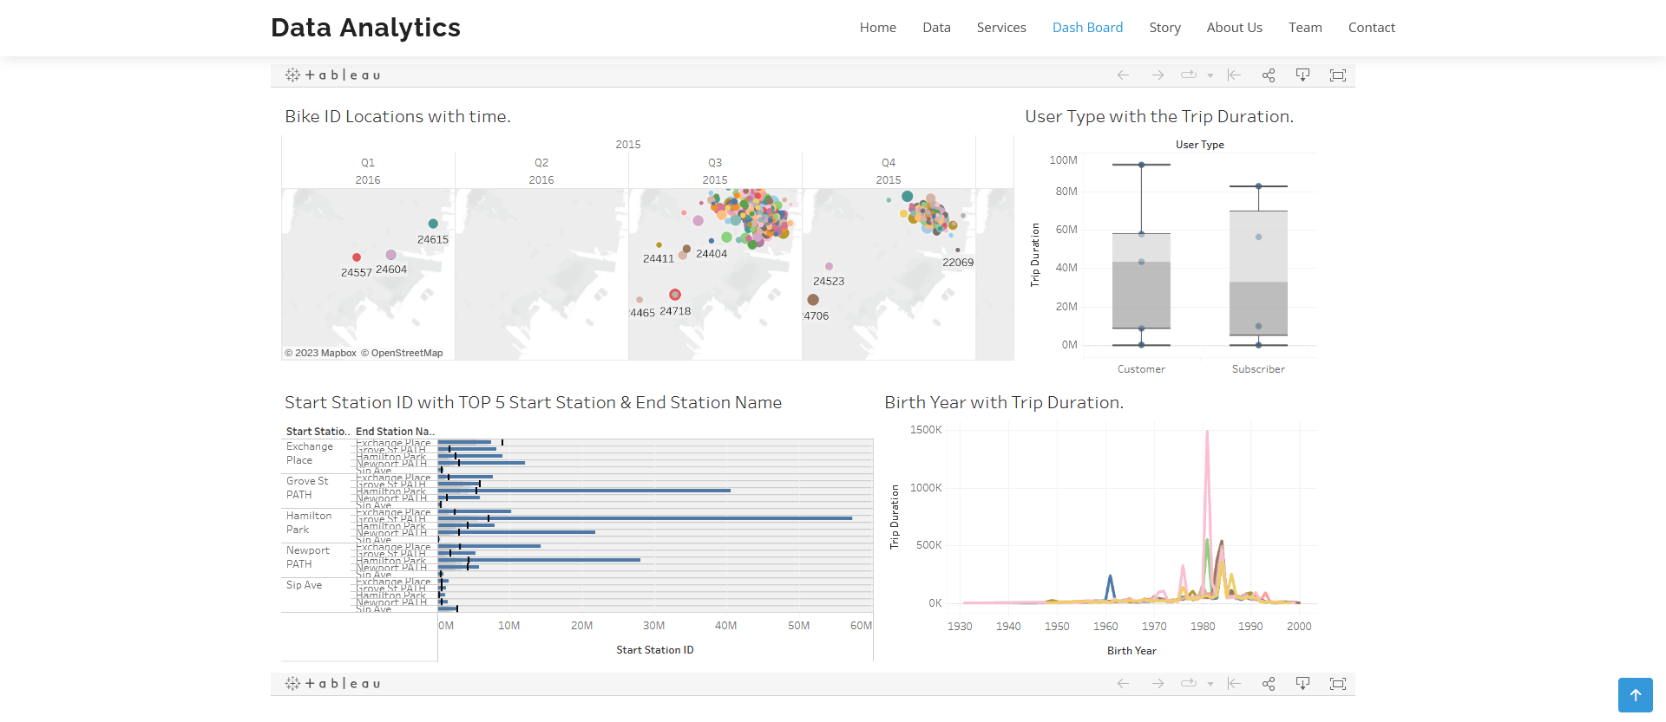
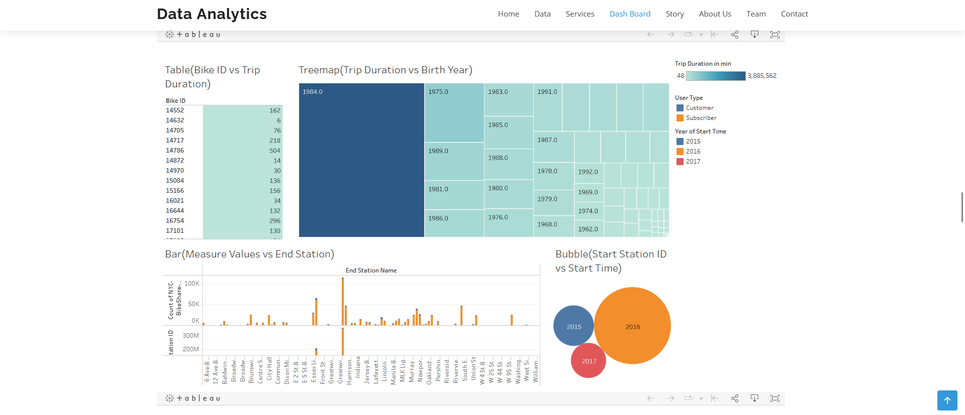

Stories:
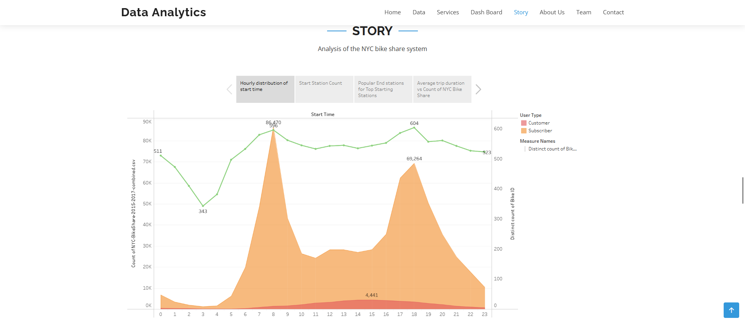
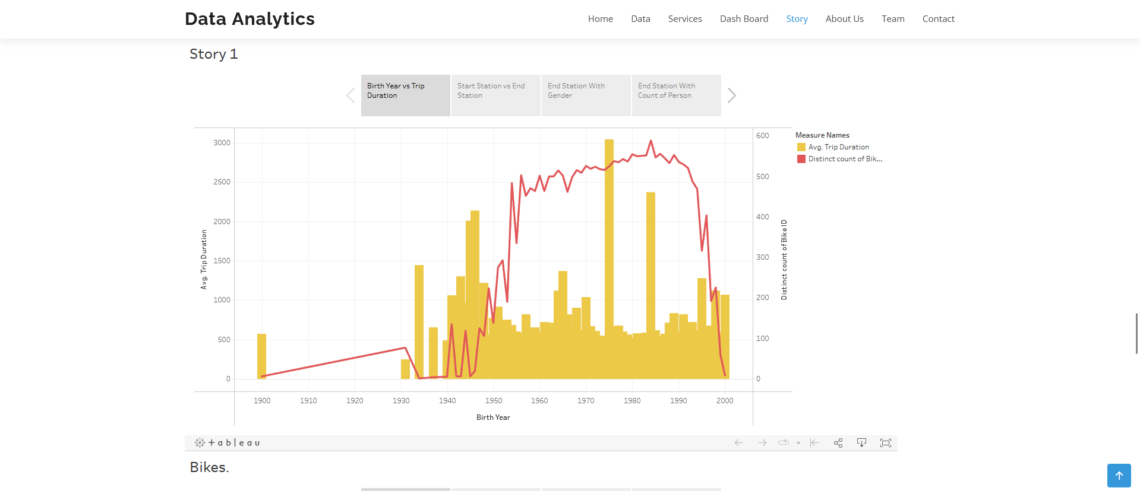
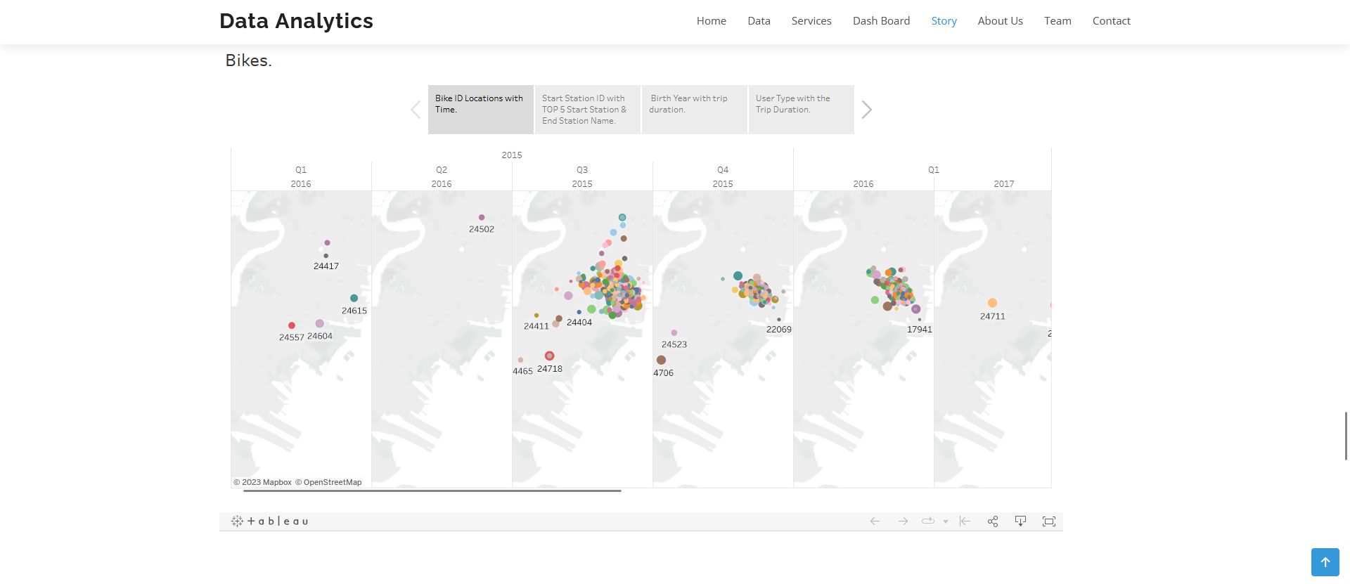
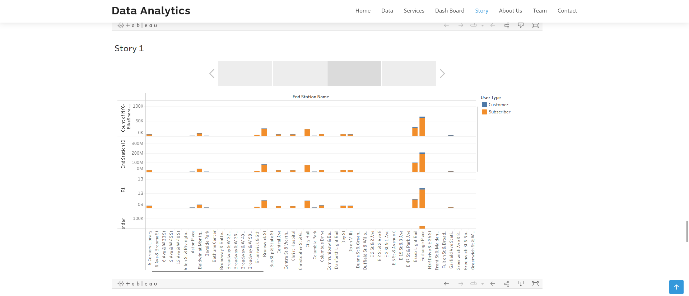

Contact:
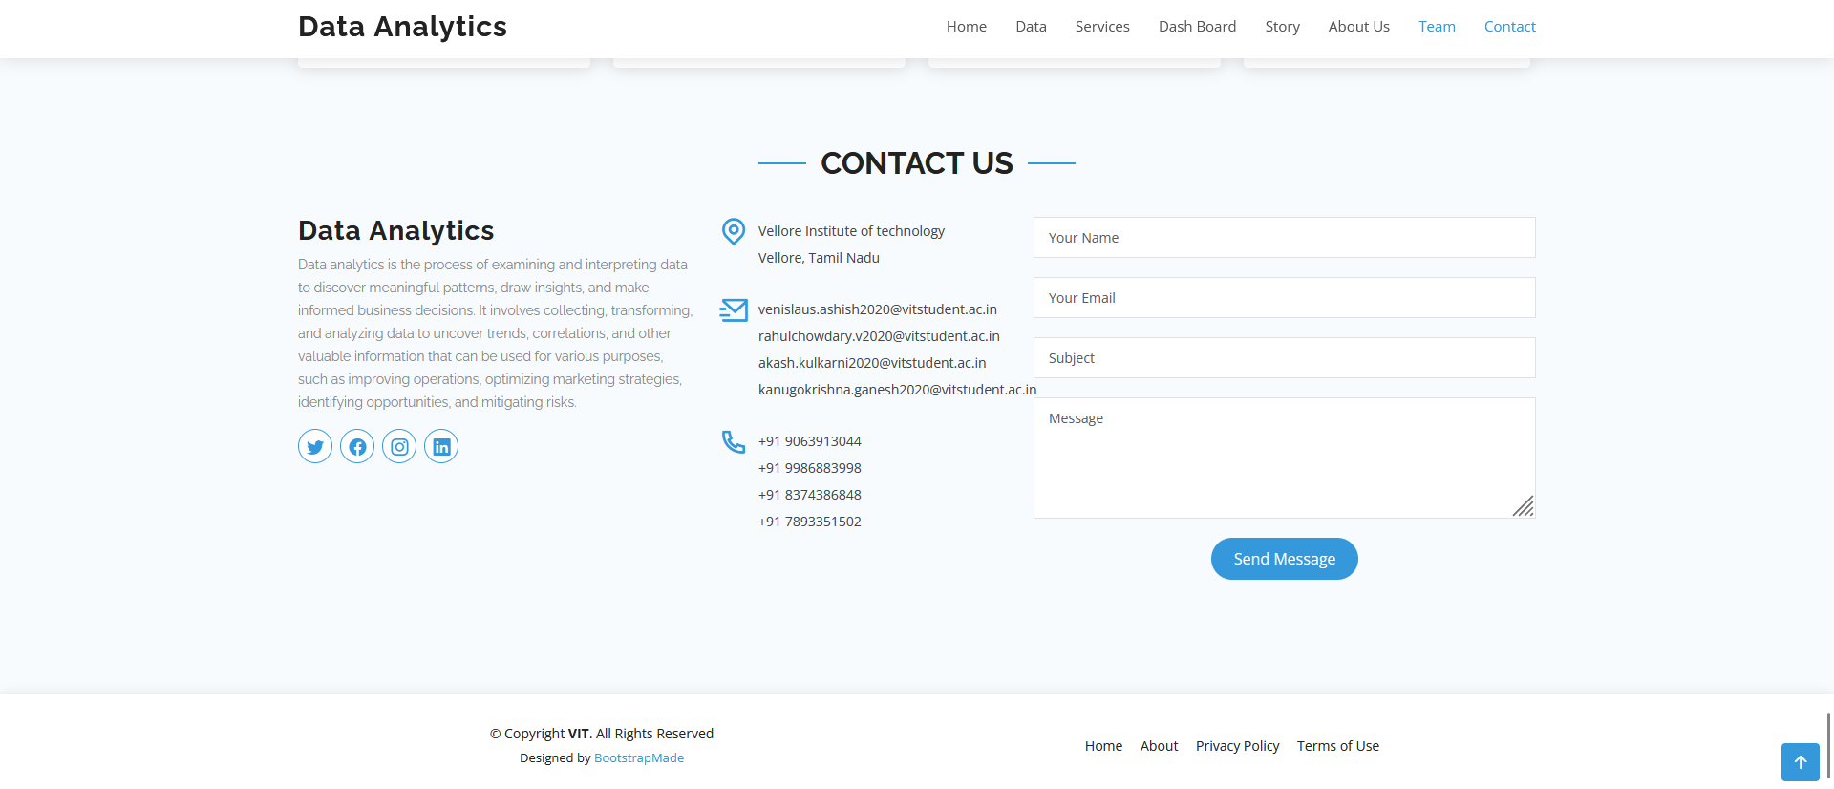

Activity 1: Visualizing the data and making of Dashboards and Story:

Explanatory video for visualizations:

- https://drive.google.com/file/d/1iTbENmzbxv1G0Ly4DUMwddYRj5KB2MdH/view?usp=drive_link
- https://drive.google.com/file/d/1X9SRAxcydHCDcWmd5fIWTs69AWm1wRXz/view?usp=drive_link
- https://drive.google.com/file/d/1FaLcZIEXMMDGVmGdw_DQ6sVDJzuUZngF/view?usp=drive_link
- https://drive.google.com/file/d/1_AY6EOXPvJeMkNmWKeSv6XlpEC5fctE-/view?usp=drive_link

- https://drive.google.com/file/d/1r7at-MYEHO1m57jIH6pYwsr5F72XBVVd/view?usp=sharing
- https://drive.google.com/file/d/1Bprnd5vw2KK5w8D5nekU1IQCII6XFAJh/view?usp=sharing
- https://drive.google.com/file/d/1opVy2OUcqyp1TLE8_-koyON63uD7YcpZ/view?usp=sharing
- https://drive.google.com/file/d/17qJZlKGraBeKb9ov3ze1sGDm9XBfLRvE/view?usp=sharing

- https://drive.google.com/file/d/1G32MxQyOEx_dqMkDyXd5Zsmoa5M8kjZd/view?usp=sharing
- https://drive.google.com/file/d/125L-xSgNbOEiEpQVX9e0jytZCNcj2s6U/view?usp=sharing
- https://drive.google.com/file/d/1xGnNf5s4u5138xXJ77xI4QLxl6Ip-JTK/view?usp=sharing
- https://drive.google.com/file/d/1M7MQ-VoZIoxNDvRQf2lHN5PNVXziypBW/view?usp=sharing

- Link
- Link
- Link
- Link

Explanatory video for Dashboard and Story:

- https://drive.google.com/file/d/1kT9tpSzy-0iWLnI3ooYQMBy4oHvCxK5P/view?usp=drive_link
- https://drive.google.com/file/d/1CqFAevBtpqsmaMM_430wTGSlmrnamzTU/view?usp=sharing
- https://drive.google.com/file/d/1Zxp9XTnFhWLh3l9kYaAoKaFklGUOz-6z/view?usp=sharing
- Link
- link

Activity 2: Integrating with bootstrap website
Explanatory video:

https://drive.google.com/file/d/1dNG5Hm0zkQnaxJe0hFKqwv9QRsM9yF5A/view?usp=drive_link

Activity 3: Implementing Flask

Explanatory video:

https://drive.google.com/file/d/1gJpoyUOUy_2ih6YK7MO70f90x4g9xc6L/view?usp=sharing

Activity 4: Hosting the website using Github pages

Explanatory video:
https://drive.google.com/file/d/1KPAXxQQdbjR889TxOuzzSKv-LEkxblqj/view?usp=drive_link

Final Website Link: https://krishnaganesh01.github.io/Analysis-of-the-NYC-bike-share-system/

7 ADVANTAGES AND DISADVANTAGES:

ADVANTAGES:

1. Convenient Mode of Transportation The most common benefit of this program is its accessibility. If you are fond of cycling, you will find this method helpful as there are numerous systems just about everywhere for you to use. Bigger cities are supporting the use of bike-sharing. This is why it is common to find bikesharing systems in downtown areas. Driving a car through congested avenues can be frustrating and irritating. This makes bike sharing very convenient.

2. Healthy Method for Traveling Wellness, fitness, and health are an essential part of your life. You should care about what you consume and what your daily activity is. Bike-sharing systems can help and encourage you to live a better and healthier life. They help you stay in shape even when you are away from home vacationing.

3. Environmental Benefits Maintaining a clean environment is as important as maintaining your health. Living in a heavily polluted environment can cause various health issues. Bikes do not release greenhouse gases, unlike buses and cars. So, if you are renting a bike from a bike-sharing system, you reduce the carbon footprint and take measures to keep your environment safe.

DISADVANTAGES :

1. Congestion in the Users of Bike Sharing As bike-sharing systems can help you travel throughout the city, they do not exist in infinite numbers. Waiting can be annoying if the bike is not available. You may face this problem during peak hours.

2. A Helmet is a Requirement When you are planning to ride a bike, you need to keep safety measures in your mind. Therefore, wearing a helmet is essential. Some bike sharing systems may require you to use a helmet but might not provide them for you. Sometimes you will need to bring your own which can be a hassle.

3. Bikes Are Not Clean Shared bikes can be unhygienic as many people have probably used it before you. The seat and handlebars are a particularly high-traffic area for germs, so cleanliness is always a concern.

8 APPLICATIONS:

The analysis of the NYC bike share system dataset using Tableau offers a wide range of applications across various domains. The insights gained from the analysis can be utilized in the following areas:

a) Transportation Planning and Infrastructure Development: The analysis provides valuable information for transportation planners and policymakers to make informed decisions regarding the expansion and improvement of the bike share system. By identifying usage patterns, popular routes, and high-demand areas, planners can strategically allocate resources, plan station placements, and develop infrastructure to optimize the system's efficiency and effectiveness.

b) Urban Mobility and Sustainable Transportation: The bike share system analysis contributes to promoting sustainable transportation solutions in urban environments. The insights gained from the analysis can be used to encourage the use of bikes as an eco-friendly mode of transportation, reduce congestion, and improve air quality. This promotes healthier and greener urban mobility options, aligning with sustainability goals.

c) Public Health and Fitness Promotion: The bike share system encourages physical activity and supports public health initiatives. By analyzing user behavior and trip characteristics, health authorities and organizations can gain insights into patterns of physical activity. This information can be used to design targeted fitness programs, promote active transportation, and improve public health outcomes.

d) Tourism and Visitor Experience Enhancement: The analysis of the bike share system dataset can benefit the tourism industry by providing insights into popular routes and destinations. Tourist attractions and visitor hotspots can be identified, allowing tourism agencies to develop tailored itineraries and promote bike-based exploration of the city. This enhances the visitor experience and contributes to the tourism industry's growth.

e) Marketing and Promotions: The analysis of user demographics and behavior allows for targeted marketing efforts. Bike share operators can identify specific user segments, such as commuters, tourists, or leisure riders, and tailor marketing campaigns accordingly. This can help increase awareness, drive user engagement, and attract new users to the bike share system.

f) Traffic Management and Congestion Reduction: By understanding usage patterns and identifying peak hours, the analysis can contribute to traffic management and congestion reduction strategies. By promoting bike usage during peak commuting times or in areas with high traffic congestion, the bike share system can provide an alternative transportation option, easing congestion and improving traffic flow.

g) Research and Academia: The dataset and analysis findings can serve as valuable resources for research and academic studies. Researchers can explore the dataset to investigate topics such as transportation behavior, urban mobility, user preferences, and the impact of bike share systems on cities. The analysis can contribute to academic research, furthering knowledge and understanding in relevant fields.

9 CONCLUSION:

Bike sharing systems can be the new boom in India, with use of various prediction models the ease of operations will be increased. The four algorithms are applied on the bikeshare dataset for predicting the count of bicycles that will be rented per hour. We got some good results and accuracy with random forest and by using Tune RF function with the original random forest algorithm. The accuracy and performance has been compared between the models using Root Mean Squared Logarithmic Error (RMSLE). If these systems include the use of analytics the probability of building a successful system will increase. Also this project successfully analyzed the NYC bike share system using Tableau. Valuable insights were obtained regarding usage patterns, user demographics, popular routes, and other relevant factors. The findings can be utilized for transportation planning, infrastructure development, and improving the bike share system. The use of Tableau allowed for effective data visualization and facilitated the interpretation of the analysis results.

In conclusion, this project aims to analyze the NYC Bike Share System using Tableau as a powerful data visualization tool. By uncovering transportation patterns, evaluating user behavior, assessing system performance, and informing policy decisions, we seek to contribute to the optimization and growth of the bike share system. Through a comprehensive analysis of the dataset, we aim to provide valuable insights that can drive improvements in urban mobility, promote sustainable transportation, and enhance the overall effectiveness of the NYC Bike Share System.

10. FUTURE SCOPE

One aspect of the data that I did not explore in great detail is the intra-day variation in usage of the system. This is also a key aspect that bike share system operators are interested in because knowing the variation in demand on an hourly basis is another very useful metric for identifying the times of the day when the need for artificial rebalancing is maximum. Additionally, this work will feed into a larger study calculating the life cycle environmental impacts of a bikeshare system and its ability to substitute other modes of transit with the aim of reducing the overall Greenhouse gas (GHG) emissions due to transportation.
- Real-time analysis: Incorporating real-time data feeds to monitor and analyze the bike share system dynamically.
- Predictive modelling: Developing predictive models to forecast bike share demand and optimize operations.
- Integration with other data sources: Incorporating additional datasets, such as weather data or demographic information, for a more comprehensive analysis.
- Comparative analysis: Comparing the NYC bike share system with other similar systems to identify best practices and areas for improvement.

11 SOURCE CODE:
Index.html:

<!DOCTYPE html>
<html lang="en">

<head>
<meta charset="utf-8">
<meta content="width=device-width, initial-scale=1.0" name="viewport">

<title>Analysis of the NYC bike share system</title>
<meta content="" name="description">
<meta content="" name="keywords">

<!-- Favicons -->
<link href="assets/img/favicon.png" rel="icon">
<link href="assets/img/apple-touch-icon.png" rel="apple-touch-icon">

<!-- Google Fonts -->
<link href="https://fonts.googleapis.com/css?family=Open+Sans:300,300i,400,400i,600,600i,700,700i|Raleway:300,300i,400,400i,500,500i,600,600i,700,700i|Poppins:300,300i,400,400i,500,500i,600,600i,700,700i" rel="stylesheet">

<!-- Vendor CSS Files -->
<link href="assets/vendor/aos/aos.css" rel="stylesheet">
<link href="assets/vendor/bootstrap/css/bootstrap.min.css" rel="stylesheet">
<link href="assets/vendor/bootstrap-icons/bootstrap-icons.css" rel="stylesheet">
<link href="assets/vendor/boxicons/css/boxicons.min.css" rel="stylesheet">
<link href="assets/vendor/glightbox/css/glightbox.min.css" rel="stylesheet">
<link href="assets/vendor/remixicon/remixicon.css" rel="stylesheet">
<link href="assets/vendor/swiper/swiper-bundle.min.css" rel="stylesheet">

<!-- Template Main CSS File -->
<link href="assets/css/style.css" rel="stylesheet">

<!-- =======================================================
* Template Name: Vesperr
* Updated: May 30 2023 with Bootstrap v5.3.0
* Template URL: https://bootstrapmade.com/vesperr-free-bootstrap-template/
* Author: BootstrapMade.com
* License: https://bootstrapmade.com/license/
======================================================== -->
</head>

<body>

<!-- ======= Header ======= -->
<header id="header" class="fixed-top d-flex align-items-center">
<div class="container d-flex align-items-center justify-content-between">

<div class="logo">
<h1><a href="index.html">Data Analytics</a></h1>
<!-- Uncomment below if you prefer to use an image logo -->
<!-- <a href="index.html"><img src="assets/img/logo.png" alt="" class="img-fluid"></a>-->
</div>

<nav id="navbar" class="navbar">
<ul>
<li><a class="nav-link scrollto active" href="#hero">Home</a></li>
<li><a class="nav-link scrollto" href="#testimonials">Data</a></li>
<li><a class="nav-link scrollto" href="#services">Services</a></li>
<li><a class="nav-link scrollto" href="#pricing">Dash Board</a></li>
<li><a class="nav-link scrollto " href="#portfolio">Story</a></li>
<li><a class="nav-link scrollto" href="#about">About Us</a></li>
<li><a class="nav-link scrollto" href="#team">Team</a></li>
<li><a class="nav-link scrollto" href="#contact">Contact</a></li>
</ul>
<i class="bi bi-list mobile-nav-toggle"></i>
</nav><!-- .navbar -->

</div>
</header><!-- End Header -->

<!-- ======= Hero Section ======= -->
<section id="hero" class="d-flex align-items-center">

<div class="container">
<div class="row">
<div class="col-lg-6 pt-5 pt-lg-0 order-2 order-lg-1 d-flex flex-column justify-content-center">
<h1 data-aos="fade-up">A new hint to transportation - Analysis of the NYC bike share system</h1>
<h2 data-aos="fade-up" data-aos-delay="400">We are team of enthuiastic data analysts creating interactive dashboards using tableau</h2>
<div data-aos="fade-up" data-aos-delay="800">
<a href="#about" class="btn-get-started scrollto">Get Started</a>
</div>
</div>
<div class="col-lg-6 order-1 order-lg-2 hero-img" data-aos="fade-left" data-aos-delay="200">
<img src="assets/img/hero-img.png" class="img-fluid animated" alt="">
</div>
</div>
</div>

</section><!-- End Hero -->

<main id="main">

<!-- ======= Clients Section ======= -->
<section id="clients" class="clients clients">
<div class="container">

<div class="row">

<div class="col-lg-2 col-md-4 col-6">
<img src="assets/img/clients/client-1.png" class="img-fluid" alt="" data-aos="zoom-in">
</div>

<div class="col-lg-2 col-md-4 col-6">
<img src="assets/img/clients/client-2.png" class="img-fluid" alt="" data-aos="zoom-in" data-aos-delay="100">
</div>

<div class="col-lg-2 col-md-4 col-6">
<img src="assets/img/clients/client-3.png" class="img-fluid" alt="" data-aos="zoom-in" data-aos-delay="200">
</div>

<div class="col-lg-2 col-md-4 col-6">
<img src="assets/img/clients/client-4.png" class="img-fluid" alt="" data-aos="zoom-in" data-aos-delay="300">
</div>

<div class="col-lg-2 col-md-4 col-6">
<img src="assets/img/clients/client-5.png" class="img-fluid" alt="" data-aos="zoom-in" data-aos-delay="400">
</div>

<div class="col-lg-2 col-md-4 col-6">
<img src="assets/img/clients/client-6.png" class="img-fluid" alt="" data-aos="zoom-in" data-aos-delay="500">
</div>

</div>

</div>
</section><!-- End Clients Section -->

<!-- ======= Testimonials Section ======= -->
<section id="testimonials" class="testimonials section-bg">
<div class="container">

<div class="section-title" data-aos="fade-up">
<h2>About Data</h2>
<p>NYC - Bike Share</p>
</div>

<div class="testimonials-slider swiper" data-aos="fade-up" data-aos-delay="100">
<div class="swiper-wrapper">

<div class="swiper-slide">
<div class="testimonial-wrap">
<div class="testimonial-item">
<p>
The dataset is sourced from the New York City Bike Share program, which operates a bike-sharing system in New York City. It is intended for analysis and exploration of bike-sharing patterns, user behavior, and other related factors in New York City.

</p>
</div>
</div>
</div><!-- End testimonial item -->

<div class="swiper-slide">
<div class="testimonial-wrap">
<div class="testimonial-item">

<p>
The dataset contains a variety of features, including trip duration, start and end times of trips, start and end station IDs, user types (subscriber or customer), gender, birth year, and more. These features provide valuable insights into bike-sharing activities and user characteristics.

</p>
</div>
</div>
</div><!-- End testimonial item -->

<div class="swiper-slide">
<div class="testimonial-wrap">
<div class="testimonial-item">

<p>

The data features collectively provide a comprehensive view of bike-sharing activities, user behavior, and related factors. By analyzing these features, data analysts can uncover patterns, trends, and relationships, and derive valuable insights to optimize bike-sharing services, understand user preferences, and make data-driven decisions.

</p>
</div>
</div>
</div><!-- End testimonial item -->

<div class="swiper-slide">
<div class="testimonial-wrap">
<div class="testimonial-item">

<p>

The dataset can be used for various analysis tasks, including studying bike usage patterns, identifying popular routes or stations, analyzing user demographics and preferences, examining the impact of weather or seasonality on bike-sharing, and exploring other factors related to bike-sharing behavior in New York City.

</p>
</div>
</div>
</div><!-- End testimonial item -->

</div>
<div class="swiper-pagination"></div>
</div>

</div>
</section><!-- End Testimonials Section -->

<!-- ======= Counts Section ======= -->
<section id="counts" class="counts">
<div class="container">

<div class="row">
<div class="image col-xl-5 d-flex align-items-stretch justify-content-center justify-content-xl-start" data-aos="fade-right" data-aos-delay="150">
<img src="assets/img/counts-img.svg" alt="" class="img-fluid">
</div>

<div class="col-xl-7 d-flex align-items-stretch pt-4 pt-xl-0" data-aos="fade-left" data-aos-delay="300">
<div class="content d-flex flex-column justify-content-center">
<div class="row">
<div class="col-md-6 d-md-flex align-items-md-stretch">
<div class="count-box">
<i class="bi bi-emoji-smile"></i>
<span data-purecounter-start="0" data-purecounter-end="1000" data-purecounter-duration="1" class="purecounter"></span>
<p><strong>Happy Clients</strong> Satisfied with our work</p>
</div>
</div>

<div class="col-md-6 d-md-flex align-items-md-stretch">
<div class="count-box">
<i class="bi bi-journal-richtext"></i>
<span data-purecounter-start="0" data-purecounter-end="85" data-purecounter-duration="1" class="purecounter"></span>
<p><strong>Projects</strong> we worked on so far </p>
</div>
</div>

<div class="col-md-6 d-md-flex align-items-md-stretch">
<div class="count-box">
<i class="bi bi-award"></i>
<span data-purecounter-start="0" data-purecounter-end="15" data-purecounter-duration="1" class="purecounter"></span>
<p><strong>Awards</strong> for our work</p>
</div>
</div>
</div>
</div><!-- End .content-->
</div>
</div>

</div>
</section><!-- End Counts Section -->

<!-- ======= Services Section ======= -->
<section id="services" class="services">
<div class="container">

<div class="section-title" data-aos="fade-up">
<h2>Services</h2>
<p></p>
</div>

<div class="row">
<div class="col-md-6 col-lg-3 d-flex align-items-stretch mb-5 mb-lg-0">
<div class="icon-box" data-aos="fade-up" data-aos-delay="100">
<div class="icon"><i class="bx bxl-dribbble"></i></div>
<h4 class="title"><a href="">Data Analytics</a></h4>
<p class="description">Data analytics is the process of examining and interpreting data to discover meaningful patterns, draw insights, and make informed business decisions. It involves collecting, transforming, and analyzing data to uncover trends, correlations, and other valuable information that can be used for various purposes, such as improving operations, optimizing marketing strategies, identifying opportunities, and mitigating risks.</p>
</div>
</div>

<div class="col-md-6 col-lg-3 d-flex align-items-stretch mb-5 mb-lg-0">
<div class="icon-box" data-aos="fade-up" data-aos-delay="200">
<div class="icon"><i class="bx bx-file"></i></div>
<h4 class="title"><a href="">Visualization of data</a></h4>
<p class="description">Data visualization is the graphical representation of data using visual elements such as charts, graphs, maps, and infographics. It is a powerful tool for conveying complex information in a clear and concise manner, enabling easier understanding, analysis, and communication of data-driven insights.</p>
</div>
</div>

<div class="col-md-6 col-lg-3 d-flex align-items-stretch mb-5 mb-lg-0">
<div class="icon-box" data-aos="fade-up" data-aos-delay="300">
<div class="icon"><i class="bx bx-tachometer"></i></div>
<h4 class="title"><a href="">Trend Predictions</a></h4>
<p class="description">Trend prediction, also known as trend forecasting, involves using historical data and statistical techniques to identify patterns, trends, and future directions in various domains. It aims to make predictions or forecasts about future trends based on past observations</p>
</div>
</div>

<div class="col-md-6 col-lg-3 d-flex align-items-stretch mb-5 mb-lg-0">
<div class="icon-box" data-aos="fade-up" data-aos-delay="400">
<div class="icon"><i class="bx bx-world"></i></div>
<h4 class="title"><a href="">Data cleansing</a></h4>
<p class="description">Data cleaning, also known as data cleansing or data scrubbing, is the process of identifying and correcting or removing errors, inconsistencies, and inaccuracies in a dataset. It involves preparing the data for analysis by ensuring its quality, completeness, and reliability.</p>
</div>
</div>

</div>

</div>
</section><!-- End Services Section -->

<!-- ======= Features Section ======= -->
<section id="features" class="features">
<div class="container">

<div class="section-title" data-aos="fade-up">
<h2>Features</h2>
<p></p>
</div>

<div class="row" data-aos="fade-up" data-aos-delay="300">

<div class="col-lg-3 col-md-4 mt-4 mt-md-0">
<div class="icon-box">
<i class="ri-bar-chart-box-line" style="color: #5578ff;"></i>
<h3><a href="">Dashboards</a></h3>
</div>
</div>
<div class="col-lg-3 col-md-4 mt-4 mt-md-0">
<div class="icon-box">
<i class="ri-calendar-todo-line" style="color: #e80368;"></i>
<h3><a href="">Stories</a></h3>
</div>
</div>
<div class="col-lg-3 col-md-4 mt-4 mt-lg-0">
<div class="icon-box">
<i class="ri-paint-brush-line" style="color: #e361ff;"></i>
<h3><a href="">Vizualizations</a></h3>
</div>
</div>

<div class="col-lg-3 col-md-4 mt-lg-0">
<div class="icon-box">
<i class="ri-file-list-3-line" style="color: #11dbcf;"></i>
<h3><a href="">Report</a></h3>
</div>
</div>

</div>

</div>
</section><!-- End Features Section -->

</section><!-- End Team Section -->

<!-- ======= Pricing Section ======= -->
<section id="pricing" class="pricing">
<div class="container">

<div class="section-title">
<h2>Dashboards</h2>
<p>Analysis of the NYC bike share system</p>
</div>

<div class='tableauPlaceholder' id='viz1687802488880' style='position: relative'><noscript><a href='#'><img alt='Dashboard 1 ' src='https:&#47;&#47;public.tableau.com&#47;static&#47;images&#47;PR&#47;PROJECT_16877898185280&#47;Dashboard1&#47;1_rss.png' style='border: none' /></a></noscript><object class='tableauViz' style='display:none;'><param name='host_url' value='https%3A%2F%2Fpublic.tableau.com%2F' /> <param name='embed_code_version' value='3' /> <param name='site_root' value='' /><param name='name' value='PROJECT_16877898185280&#47;Dashboard1' /><param name='tabs' value='no' /><param name='toolbar' value='yes' /><param name='static_image' value='https:&#47;&#47;public.tableau.com&#47;static&#47;images&#47;PR&#47;PROJECT_16877898185280&#47;Dashboard1&#47;1.png' /> <param name='animate_transition' value='yes' /><param name='display_static_image' value='yes' /><param name='display_spinner' value='yes' /><param name='display_overlay' value='yes' /><param name='display_count' value='yes' /><param name='language' value='en-US' /><param name='filter' value='publish=yes' /></object></div> <script type='text/javascript'> var divElement = document.getElementById('viz1687802488880'); var vizElement = divElement.getElementsByTagName('object')[0]; if ( divElement.offsetWidth > 800 ) { vizElement.style.width='1250px';vizElement.style.height='702px';} else if ( divElement.offsetWidth > 500 ) { vizElement.style.width='1250px';vizElement.style.height='702px';} else { vizElement.style.width='100%';vizElement.style.height='1627px';} var scriptElement = document.createElement('script'); scriptElement.src = 'https://public.tableau.com/javascripts/api/viz_v1.js'; vizElement.parentNode.insertBefore(scriptElement, vizElement); </script>

</div>
</section><!-- End Pricing Section -->

<!-- ======= Portfolio Section ======= -->
<section id="portfolio" class="portfolio">
<div class="container">

<div class="section-title" data-aos="fade-up">
<h2>STORY</h2>
<p>Analysis of the NYC bike share system</p>
</div>

<div class='tableauPlaceholder' id='viz1687804504168' style='position: relative'><noscript><a href='#'><img alt='Story 1 ' src='https:&#47;&#47;public.tableau.com&#47;static&#47;images&#47;PR&#47;PROJECT_story&#47;Story1&#47;1_rss.png' style='border: none' /></a></noscript><object class='tableauViz' style='display:none;'><param name='host_url' value='https%3A%2F%2Fpublic.tableau.com%2F' /> <param name='embed_code_version' value='3' /> <param name='site_root' value='' /><param name='name' value='PROJECT_story&#47;Story1' /><param name='tabs' value='no' /><param name='toolbar' value='yes' /><param name='static_image' value='https:&#47;&#47;public.tableau.com&#47;static&#47;images&#47;PR&#47;PROJECT_story&#47;Story1&#47;1.png' /> <param name='animate_transition' value='yes' /><param name='display_static_image' value='yes' /><param name='display_spinner' value='yes' /><param name='display_overlay' value='yes' /><param name='display_count' value='yes' /><param name='language' value='en-US' /><param name='filter' value='publish=yes' /></object></div> <script type='text/javascript'> var divElement = document.getElementById('viz1687804504168'); var vizElement = divElement.getElementsByTagName('object')[0]; vizElement.style.width='1200px';vizElement.style.height='697px'; var scriptElement = document.createElement('script'); scriptElement.src = 'https://public.tableau.com/javascripts/api/viz_v1.js'; vizElement.parentNode.insertBefore(scriptElement, vizElement); </script>

</div>
</section><!-- End Portfolio Section -->

<!-- ======= About Us Section ======= -->
<section id="about" class="about">
<div class="container">

<div class="section-title" data-aos="fade-up">
<h2>About Us</h2>
</div>

<div class="row content">
<div class="col-lg-6" data-aos="fade-up" data-aos-delay="150">
<p>
We are a team of dedicated and passionate students who specialize in data analysis. Our mission is to apply our skills and knowledge in data analytics to provide valuable insights and solutions for various projects and organizations.
</p>
<ul>
<li><i class="ri-check-double-line"></i> Worked for various projects on tableau</li>
<li><i class="ri-check-double-line"></i> Created number of vizualizations</li>
<li><i class="ri-check-double-line"></i> Problem solving based approach </li>
</ul>
</div>
<div class="col-lg-6 pt-4 pt-lg-0" data-aos="fade-up" data-aos-delay="300">
<p>
As students, we understand the importance of practical experience and the real-world application of data analysis techniques. We are eager to utilize our analytical skills to help businesses, non-profit organizations, educational institutions, and other entities make data-driven decisions and solve complex problems.Our team consists of students from diverse academic backgrounds, including statistics, mathematics, computer science, economics, and other relevant fields. We bring a unique blend of analytical expertise, creativity, and a fresh perspective to every project we undertake.
</p>
<a href="#" class="btn-learn-more">Learn More</a>
</div>
</div>

</div>
</section><!-- End About Us Section -->

<!-- ======= Team Section ======= -->
<section id="team" class="team section-bg">
<div class="container">

<div class="section-title" data-aos="fade-up">
<h2>Team</h2>
<p>Students of Vellore Institue of technology</p>
</div>

<div class="row">

<div class="col-lg-3 col-md-6 d-flex align-items-stretch">
<div class="member" data-aos="fade-up" data-aos-delay="100">
<div class="member-img">
<img src="assets/img/team/team-1.jpg" class="img-fluid" alt="">
<div class="social">
<a href=""><i class="bi bi-twitter"></i></a>
<a href=""><i class="bi bi-facebook"></i></a>
<a href=""><i class="bi bi-instagram"></i></a>
<a href=""><i class="bi bi-linkedin"></i></a>
</div>
</div>
<div class="member-info">
<h4>Kanugo Krishna Ganesh</h4>
<span>Team Member</span>
</div>
</div>
</div>

<div class="col-lg-3 col-md-6 d-flex align-items-stretch">
<div class="member" data-aos="fade-up" data-aos-delay="200">
<div class="member-img">
<img src="assets/img/team/team-2.jpg" class="img-fluid" alt="">
<div class="social">
<a href=""><i class="bi bi-twitter"></i></a>
<a href=""><i class="bi bi-facebook"></i></a>
<a href=""><i class="bi bi-instagram"></i></a>
<a href=""><i class="bi bi-linkedin"></i></a>
</div>
</div>
<div class="member-info">
<h4>Yenigandla Venislaus Ashish</h4>
<span>Team Memeber</span>
</div>
</div>
</div>

<div class="col-lg-3 col-md-6 d-flex align-items-stretch">
<div class="member" data-aos="fade-up" data-aos-delay="300">
<div class="member-img">
<img src="assets/img/team/team-3.jpg" class="img-fluid" alt="">
<div class="social">
<a href=""><i class="bi bi-twitter"></i></a>
<a href=""><i class="bi bi-facebook"></i></a>
<a href=""><i class="bi bi-instagram"></i></a>
<a href=""><i class="bi bi-linkedin"></i></a>
</div>
</div>
<div class="member-info">
<h4>V Rahul Chowdary</h4>
<span>Team Member</span>
</div>
</div>
</div>

<div class="col-lg-3 col-md-6 d-flex align-items-stretch">
<div class="member" data-aos="fade-up" data-aos-delay="400">
<div class="member-img">
<img src="assets/img/team/team-4.jpg" class="img-fluid" alt="">
<div class="social">
<a href=""><i class="bi bi-twitter"></i></a>
<a href=""><i class="bi bi-facebook"></i></a>
<a href=""><i class="bi bi-instagram"></i></a>
<a href=""><i class="bi bi-linkedin"></i></a>
</div>
</div>
<div class="member-info">
<h4>Anurag Kulkarni</h4>
<span>Team Member</span>
</div>
</div>
</div>

</div>

</div>

<!-- ======= Contact Section ======= -->
<section id="contact" class="contact">
<div class="container">

<div class="section-title" data-aos="fade-up">
<h2>Contact Us</h2>
</div>

<div class="row">

<div class="col-lg-4 col-md-6" data-aos="fade-up" data-aos-delay="100">
<div class="contact-about">
<h3>Data Analytics</h3>
<p>Data analytics is the process of examining and interpreting data to discover meaningful patterns, draw insights, and make informed
business decisions. It involves collecting, transforming, and analyzing data to uncover trends, correlations, and other valuable information
that can be used for various purposes, such as improving operations, optimizing marketing strategies, identifying opportunities, and mitigating
risks.</p>
<div class="social-links">
<a href="#" class="twitter"><i class="bi bi-twitter"></i></a>
<a href="#" class="facebook"><i class="bi bi-facebook"></i></a>
<a href="#" class="instagram"><i class="bi bi-instagram"></i></a>
<a href="#" class="linkedin"><i class="bi bi-linkedin"></i></a>
</div>
</div>
</div>

<div class="col-lg-3 col-md-6 mt-4 mt-md-0" data-aos="fade-up" data-aos-delay="200">
<div class="info">
<div>
<i class="ri-map-pin-line"></i>
<p>Vellore Institute of technology<br>Vellore, Tamil Nadu</p>
</div>

<div>
<i class="ri-mail-send-line"></i>
<p> venislaus.ashish2020@vitstudent.ac.in <br> rahulchowdary.v2020@vitstudent.ac.in <br> akash.kulkarni2020@vitstudent.ac.in <br> kanugokrishna.ganesh2020@vitstudent.ac.in</p>
</div>

<div>
<i class="ri-phone-line"></i>
<p>+91 9063913044
<br>+91 9986883998<br>
+91 8374386848<br> +91 7893351502</p>
</div>

</div>
</div>

<div class="col-lg-5 col-md-12" data-aos="fade-up" data-aos-delay="300">
<form action="forms/contact.php" method="post" role="form" class="php-email-form">
<div class="form-group">
<input type="text" name="name" class="form-control" id="name" placeholder="Your Name" required>
</div>
<div class="form-group">
<input type="email" class="form-control" name="email" id="email" placeholder="Your Email" required>
</div>
<div class="form-group">
<input type="text" class="form-control" name="subject" id="subject" placeholder="Subject" required>
</div>
<div class="form-group">
<textarea class="form-control" name="message" rows="5" placeholder="Message" required></textarea>
</div>
<div class="my-3">
<div class="loading">Loading</div>
<div class="error-message"></div>
<div class="sent-message">Your message has been sent. Thank you!</div>
</div>
<div class="text-center"><button type="submit">Send Message</button></div>
</form>
</div>

</div>

<div></div>

</div>
</section><!-- End Contact Section -->

</main><!-- End #main -->

<!-- ======= Footer ======= -->
<footer id="footer">
<div class="container">
<div class="row d-flex align-items-center">
<div class="col-lg-6 text-lg-left text-center">
<div class="copyright">
&copy; Copyright <strong>VIT</strong>. All Rights Reserved
</div>
<div class="credits">
<!-- All the links in the footer should remain intact. -->
<!-- You can delete the links only if you purchased the pro version. -->
<!-- Licensing information: https://bootstrapmade.com/license/ -->
<!-- Purchase the pro version with working PHP/AJAX contact form: https://bootstrapmade.com/vesperr-free-bootstrap-template/ -->
Designed by <a href="https://bootstrapmade.com/">BootstrapMade</a>
</div>
</div>
<div class="col-lg-6">
<nav class="footer-links text-lg-right text-center pt-2 pt-lg-0">
<a href="#intro" class="scrollto">Home</a>
<a href="#about" class="scrollto">About</a>
<a href="#">Privacy Policy</a>
<a href="#">Terms of Use</a>
</nav>
</div>
</div>
</div>
</footer><!-- End Footer -->

<a href="#" class="back-to-top d-flex align-items-center justify-content-center"><i class="bi bi-arrow-up-short"></i></a>

<!-- Vendor JS Files -->
<script src="assets/vendor/purecounter/purecounter_vanilla.js"></script>
<script src="assets/vendor/aos/aos.js"></script>
<script src="assets/vendor/bootstrap/js/bootstrap.bundle.min.js"></script>
<script src="assets/vendor/glightbox/js/glightbox.min.js"></script>
<script src="assets/vendor/isotope-layout/isotope.pkgd.min.js"></script>
<script src="assets/vendor/swiper/swiper-bundle.min.js"></script>
<script src="assets/vendor/php-email-form/validate.js"></script>
<!-- Template Main JS File -->
<script src="assets/js/main.js"></script>
</body>
</html>

App.py:
from flask import Flask, render_template

app = Flask(__name__)
@app.route("/")
def home():
return render_template(r"index.html")

if __name__ == "__main__":
app.run(debug=False,port=5500)

