A note regarding the Physiographic and Socioeconomic Macroregions of China

G. William Skinner, Mark Henderson, and Zumou Yue
University of California, Davis

Our GIS map of physiographic macroregions specifies our informed decisions as to (1) the precise location of cutpoints in river systems that extend across regional systems, (2) the macroregional affiliation of small coastal river systems, and (3) which internal drainage basins along the Inner Asian frontier should be included in China Proper. The coding here reflects the mapped data. In the case of three macroregions (Northwest China, Middle Yangzi, and Southeast Coast), the internal physiography that structures subregional systems is sharp and clear, and in these cases the physiographic subregions are mapped and coded. The other six macroregions are coded as if they were internally undifferentiated.

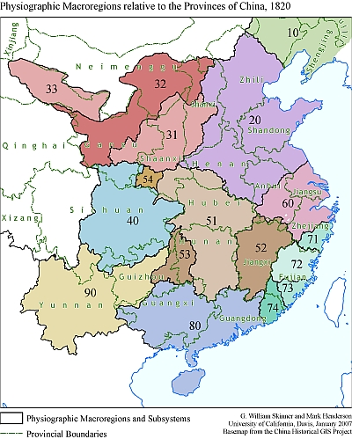

10 | Northeast China (Manchuria) | 东北区
20 | North China | 华北区
3 | Northwest China | 西北区
 | 31 Wei-Fen Basins | 渭汾流域分区
 | 32 Upper Huang Basin | 黄河上游分区
 | 33 Gansu Corridor | 河西(甘肃)走廊分区
40 | Upper Yangzi | 长江上游区
5 | Middle Yangzi | 长江中游区
 | 51 Middle Yangzi proper | 长江中游分区
 | 52 Gan Basin | 赣江流域分区
 | 53 Yuan Basin | 沅江流域分区
 | 54 Upper Han Basin | 汉江上游分区
60 | Lower Yangzi | 长江下游区
7 | Southeast Coast | 东南沿海区
 | 71 Ou-Ling Basins | 瓯灵流域分区
 | 72 Min Basin | 闽江流域分区
 | 73 Zhang-Quan | 漳泉分区
 | 74 Han Basin | 韩江流域分区
 | 75 Taiwan | 台湾分区
80 | Lingnan | 岭南区
90 | Yungui | 云贵区

On our analysis, 20th-century China has nine macroregional economies/societies, excluding Inner Asian territories. We have analyzed the urban and the associated local and regional system hierarchies of these macroregions during the 1982-2000 period. In contemporary China, all nine macroregions exhibit fully developed hierarchies of cities and regional systems. A century earlier, however, two of them, Manchuria and Yungui, were merely emergent, their hierarchical relationships in flux. While the apex metropolises of the nine macroregions have not changed since the late 19th century, their territorial extant most certainly has. Therefore, the macroregional boundaries revealed for the late 20th-century Reform era do not apply to the 19th-century. In our analyses of contemporary China, we let the socioeconomic data pinpoint the boundaries among macroregional systems, but for the nineteenth century we lack data of sufficient quality and detail to proceed in this fashion. Prior to any consequential transport modernization, the logic of regional systems suggests that the human transactions that give rise to the systems hierarchy would be largely contained within physiographic macroregions. Thus, we believe that physiographic regions are the closest possible approximation of 19th-century socioeconomic macroregional systems.

