NETRA · HIGH-LEVEL DESIGN

Two collection layers, one platform
Cloud-side OAuth grants and device-side installs are genuinely different data sources — neither alone sees everything, so NETRA combines both — and both are now built.
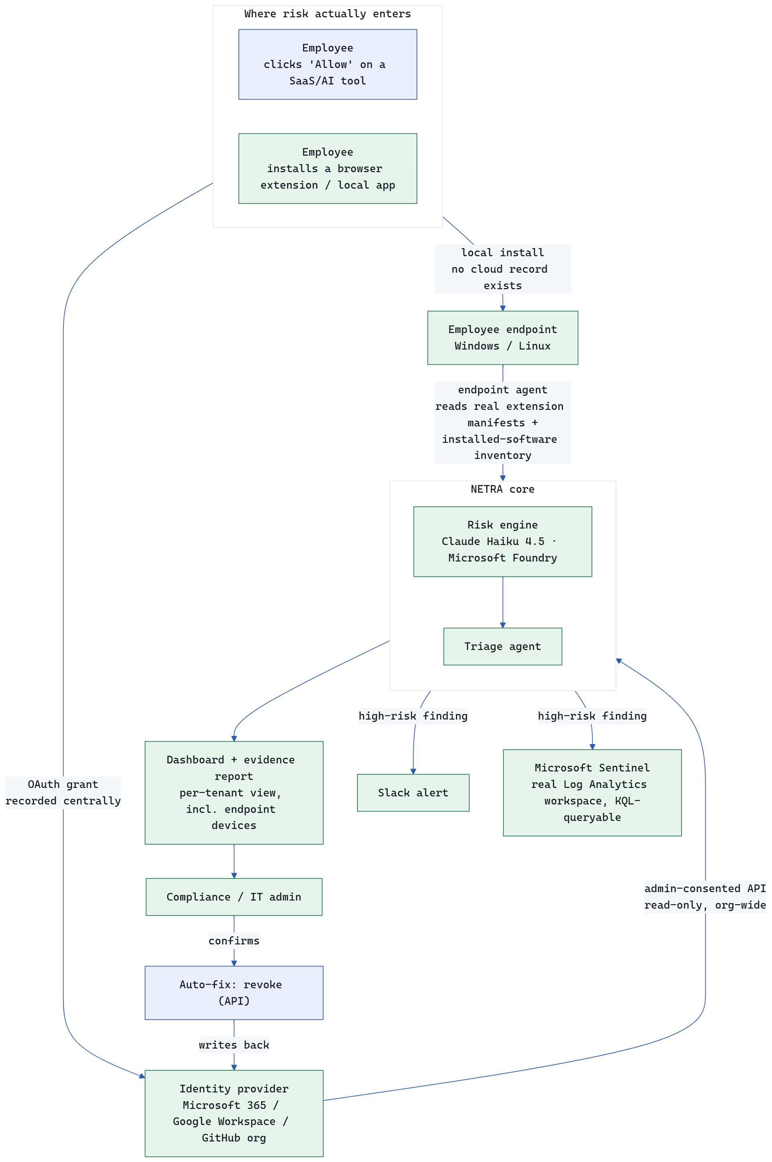
fig. 1 — high-level architecture

What each layer catches
- OAuth / admin API layer — cloud SaaS & AI tool connections (e.g. “Sign in with Google”), captured centrally, zero device footprint. Live today via the GitHub org and the Foundry-based risk engine. BUILT
- Endpoint agent layer — browser extensions and locally-installed software that never touch OAuth at all, confirmed with ESDS's own IT (ManageEngine) as a real, separate blind spot. Read-only: reads real extension manifests and the OS's own installed-software inventory, reports into the same risk-scoring pipeline as OAuth-discovered tools. Verified against real production data — 77 genuine findings from a real machine, correctly risk-scored, including the Claude desktop app itself and the ManageEngine agent flagged for the very same kind of visibility gap it helps solve. Deliberately does not install, remove, or block anything — no push-install or block-extension capability exists or is planned; that would need signed installers and a real device fleet to test against, which is out of scope here. BUILT

What the endpoint agent adds
- Scheduled auto-scan — the agent itself is a one-shot script; running it nightly is a user-configured Windows Task Scheduler / cron entry, the same model as an antivirus console's scheduled scan BUILT
- DPDP cross-border flag on AI tools (Claude, ChatGPT, etc.), even for personal use — covered by the same foreign-hosted/cross-border-transfer flags the risk engine already applies to every discovered tool regardless of source; confirmed working on a real endpoint finding (the Claude desktop app was flagged this way) BUILT
- Per-employee drill-down — select a person, see exactly what's on their system — the underlying data exists today (the Endpoint Devices dashboard view lists each device with its employee/department), but no dedicated per-employee screen has been built on top of it yet PLANNED
- Fast-path option: integrate ManageEngine's existing API instead of relying solely on the custom agent — code is written and dormant, blocked on Zeeshan's team actually supplying API credentials PLANNED

Illustrative example — banking
OAUTH LAYER CATCHES THIS
A loan officer clicks “Sign in with Microsoft” to connect an AI meeting-notetaker inside Teams — no file downloaded, no firewall rule fires. Months later they change departments; that access is never revoked, because nothing was ever installed for IT to notice. NETRA's live scan flags it: dormant access, broad mail/calendar scope, cited against RBI's periodic access-review clause.
ENDPOINT AGENT LAYER CATCHES THIS TOO
The same officer installs a “PDF-to-Excel” browser extension to process loan documents containing PAN, Aadhaar, and salary data. No OAuth involved, so the admin-API layer never sees it — the endpoint agent catches it by reading the extension's own manifest permissions directly off the device, exactly the mechanism verified in production on real machines.
NETRA — Team Vajra · HLD, revised after the mentor session with Zeeshan Shaikh and after the endpoint agent was actually built, deployed, and verified against real production data

