NETRA · LOW-LEVEL DESIGN

Request path, component by component
Both the API/OAuth path and the endpoint-agent path below are the actual running pipeline — the agent path started as the mentor session's planned addition and has since been built, deployed, and verified against real production data (77 genuine findings from a real machine, correctly risk-scored).
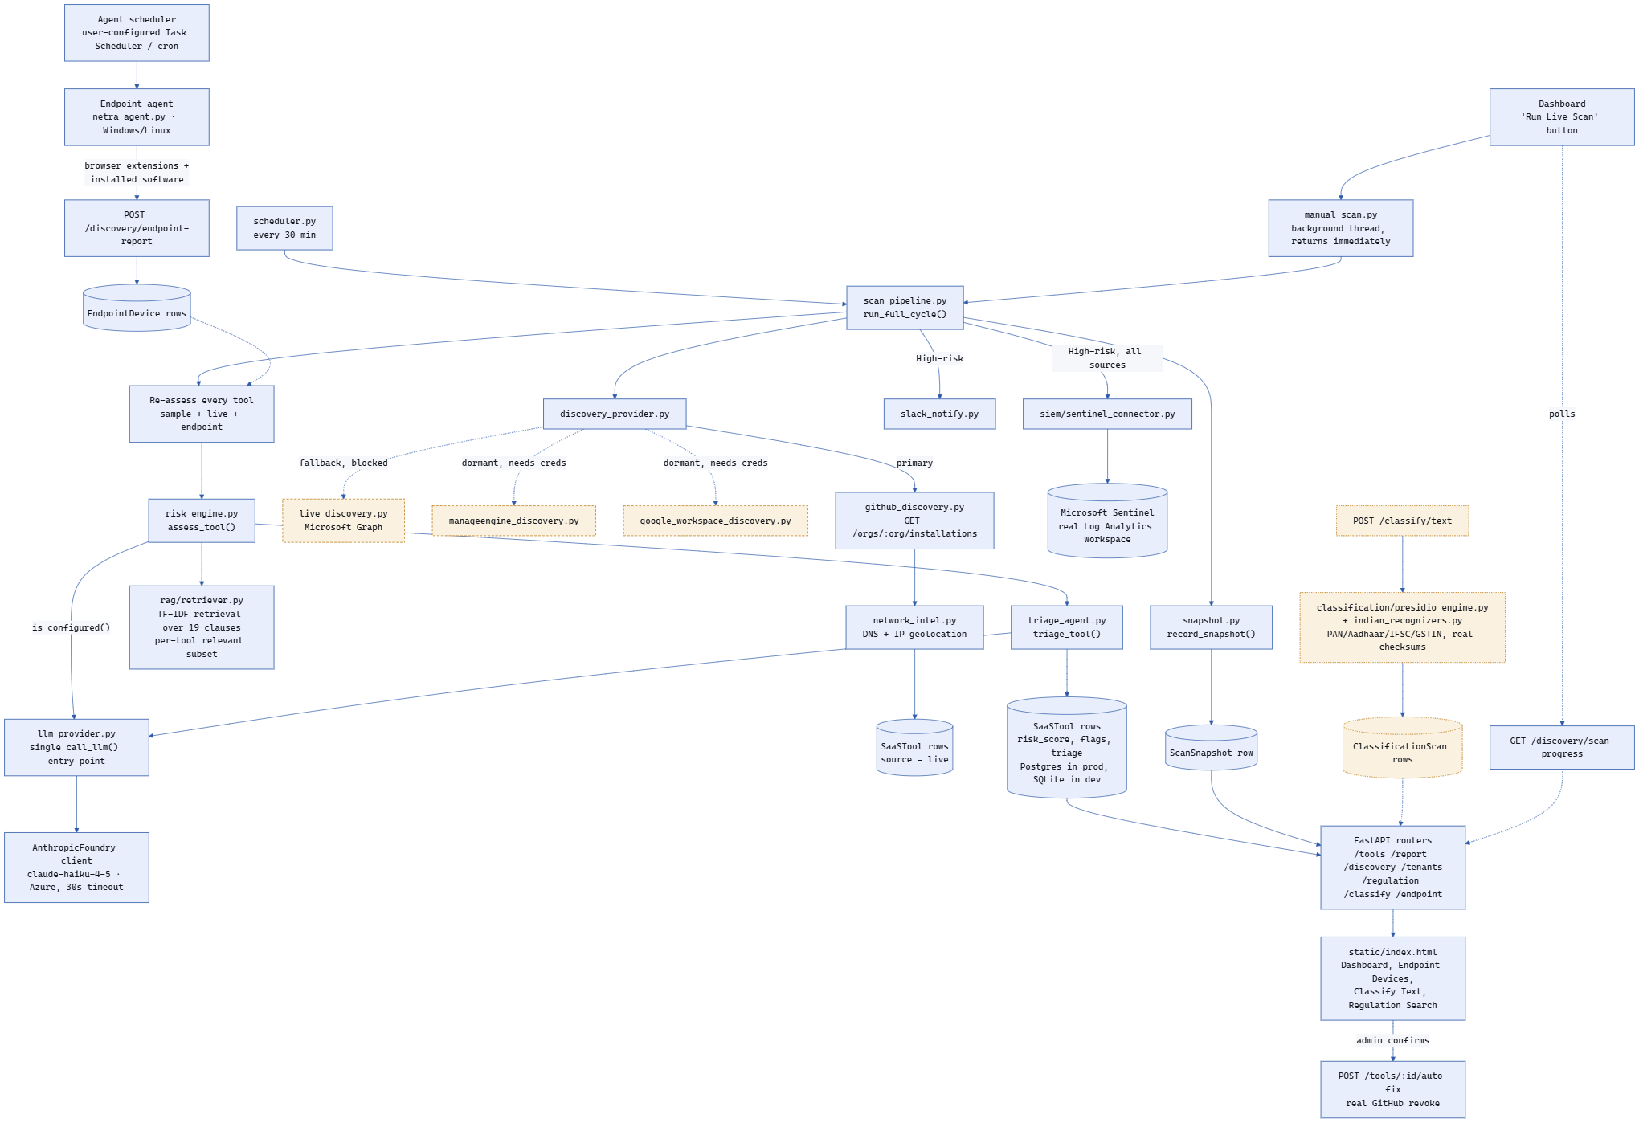
fig. 2 — full component flow

Existing components (built & verified)
COMPONENT | RESPONSIBILITY
scan_pipeline.py | Single orchestration entry point for scheduled + manual runs
github_discovery.py | Real GitHub Apps installation discovery, org-wide, one API call
network_intel.py | Real DNS + IP geolocation for hosting-region resolution, honest substitute for network-tap capture
agent/netra_agent.py + routers/endpoint.py | Windows/Linux endpoint agent (real browser-extension manifests + installed-software inventory) and its ingestion route (POST /discovery/endpoint-report) — verified with 77 real findings from a real machine
risk_engine.py | Scores each tool via Claude Haiku 4.5 on Microsoft Foundry, citing per-tool relevant regulatory clauses
llm_provider.py | Single call_llm() entry point shared by risk_engine.py and triage_agent.py — one place to swap providers later, 30s per-call timeout
rag/retriever.py | Real TF-IDF + cosine-similarity retrieval over 19 DPDP/RBI/CERT-In/SEBI clauses — distinct, differently-ranked results per query, not a static list
triage_agent.py | Recommends auto-fix / manual-review / ignore — never executes directly
snapshot.py / scheduler.py | Readiness-trend history + 30-min background cycle
manual_scan.py | Runs a manually-triggered scan in a background thread so a long batch of real LLM calls can't exceed Railway's HTTP gateway timeout; dashboard polls GET /discovery/scan-progress
slack_notify.py | Real Slack alert on new High-risk findings
siem/sentinel_connector.py | Pushes High-risk findings into a real Microsoft Sentinel / Log Analytics workspace, confirmed queryable via KQL
static/index.html | Dashboard: KPIs, trend, ROI calculator, table, tenant selector, plus Endpoint Devices / Classify Text / Regulation Search views and a Sentinel status pill
classification/presidio_engine.py + indian_recognizers.py | Real Presidio pattern recognizers for PAN/Aadhaar/IFSC/GSTIN with real checksum validation — built & verified, but deliberately not enabled in production (spaCy's model needs a build step Railway isn't configured for); demoed from a local machine via the same Classify Text dashboard view

Still planned / dormant components
COMPONENT | RESPONSIBILITY
Per-employee dashboard view | Select a person, see exactly what's installed on their system — the Endpoint Devices view has the underlying data, but no dedicated per-employee screen exists yet
manageengine_discovery.py | Written and gated off; blocked on Zeeshan's team actually supplying API credentials
google_workspace_discovery.py | Written and gated off; a free-trial spike was considered but not attempted
live_discovery.py | Built, but the M365 Developer Program sandbox rejected eligibility; a real Entra ID tenant path exists but is unexplored

Illustrative example — banking
TRACED THROUGH THE COMPONENTS ABOVE
A loan officer connects an AI notetaker via OAuth → github_discovery.py records it → network_intel.py resolves its real hosting region → risk_engine.py scores it dormant + over-broad-scope, retrieving the most relevant clause via rag/retriever.py → triage_agent.py recommends manual-review → the finding is pushed to Slack and a real Microsoft Sentinel workspace → it shows up on the dashboard as evidence for the next audit.
The same officer's “PDF-to-Excel” browser extension is invisible to every OAuth-side component above — none of them touch the device. The endpoint agent (agent/netra_agent.py) is what surfaces it: reads the extension's own manifest permissions directly off the device and reports into the exact same risk_engine.py → triage_agent.py → Sentinel pipeline, flagged for uploading loan-document content outside India.
NETRA — Team Vajra · LLD, revised after the mentor session with Zeeshan Shaikh and after the endpoint agent, classification, RAG, Sentinel, and async-scan work was actually built and verified against real production data

