Enterprise Cloud Transformation Platform
(ECTP)
____________________________________________________________
Architecture & Future Roadmap

Document ID | ECTP-ARCH-002
Version | 2.0.0
Author | Gopi Krishna Vajrala
Date | February 16, 2026
Classification | Internal - Confidential
Status | Active

Table of Contents
Section 1: Roadmap Overview
Section 2: Phase 1 -- Foundation & Core Platform
Section 3: Phase 2 -- Integration & Migration
Section 4: Phase 3 -- Optimization & Scale
Section 5: Phase 4 -- Advanced Automation
Section 6: Phase 5 -- Innovation & Enhancement
Section 7: Year 2+ Innovation Roadmap (2028+)
Section 8: Architecture Decision Records (ADRs)
Section 9: Roadmap Governance

1. Roadmap Overview
The Enterprise Cloud Transformation Platform (ECTP) roadmap defines a comprehensive 5-phase journey spanning January 2026 through December 2027, with a total investment of $530,000. This roadmap transforms the university's IT operations from manual, on-premises processes to a fully automated, cloud-native platform built on AWS.
Key Insight: The $530K investment is projected to deliver a 3x ROI within 3 years through operational efficiency gains, reduced downtime, and infrastructure cost optimization.

Phase Summary
Phase | Name | Timeline | Budget | Key Focus
1 | Foundation & Core Platform | Jan - Apr 2026 | $115,000 | AWS setup, FastAPI, Terraform, CI/CD
2 | Integration & Migration | May - Sep 2026 | $150,000 | ServiceNow, Ethos, workload migration
3 | Optimization & Scale | Oct 2026 - Jan 2027 | $80,000 | Performance, DR, compliance
4 | Advanced Automation | Feb - Jun 2027 | $100,000 | Self-service, auto-remediation, IaC library
5 | Innovation & Enhancement | Jul - Dec 2027 | $85,000 | AI/ML, multi-region, SOC 2 Type II

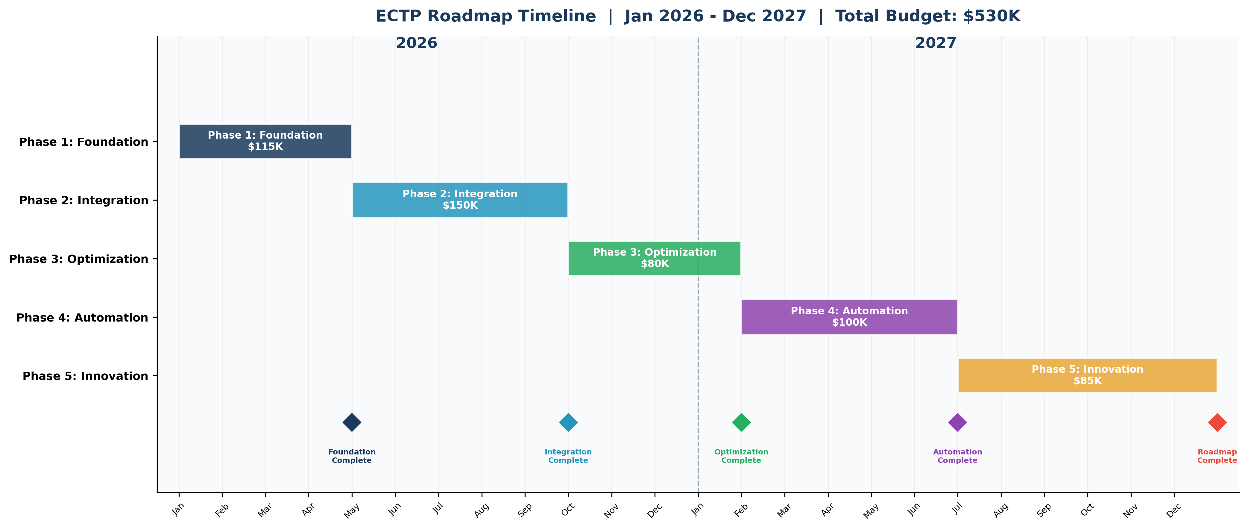

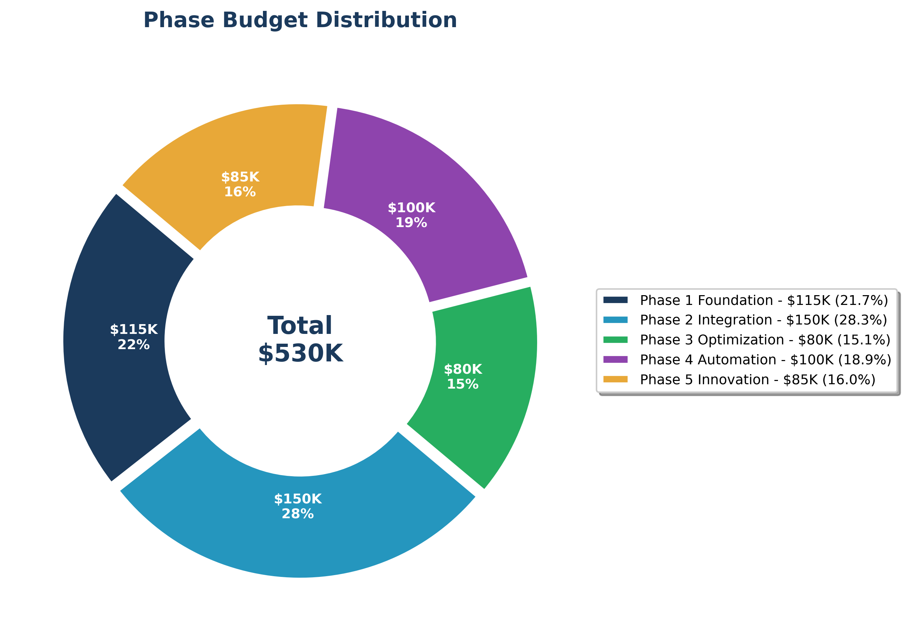

2. Phase 1 -- Foundation & Core Platform
Timeline: Jan - Apr 2026 | Budget: $115,000 | Status: In Progress | Lead: Gopi Krishna Vajrala

Phase 1 establishes the foundational infrastructure and core platform components. This phase focuses on setting up the AWS environment, building the core FastAPI application, implementing Infrastructure as Code with Terraform, and establishing CI/CD pipelines.

Phase 1 Deliverables
ID | Deliverable | Owner | Target Date | Status
1.1 | Architecture design and ADRs | Gopi | Jan 31, 2026 | Complete
1.2 | Core FastAPI platform | Dev Team | Feb 15, 2026 | Complete
1.3 | Health check endpoints | Dev Team | Feb 15, 2026 | Complete
1.4 | Terraform modules (VPC, ECS, RDS) | Cloud Architect | Feb 28, 2026 | In Progress
1.5 | CI/CD pipeline (GitHub Actions) | DevOps | Mar 15, 2026 | Planned
1.6 | Docker multi-stage build & ECR | DevOps | Mar 15, 2026 | Planned
1.7 | ServiceNow ITSM integration | Integration Team | Mar 31, 2026 | Planned
1.8 | Ellucian Ethos API integration | Integration Team | Mar 31, 2026 | Planned
1.9 | Security baseline & scanning | Security Lead | Apr 15, 2026 | Planned
1.10 | Production deployment | Full Team | Apr 30, 2026 | Planned

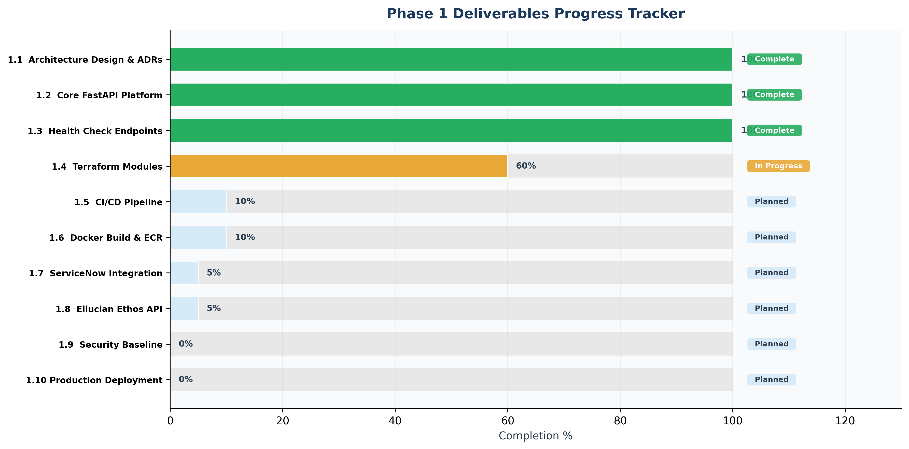

Dependencies
- AWS Account Provisioning: Complete -- all four environments (dev, staging, UAT, prod) provisioned.
- ServiceNow API Access: In Progress -- credentials requested, awaiting approval from ITSM team.
- Ellucian Ethos Credentials: In Progress -- API key request submitted, expected by March 1.
- Security Review Scheduling: Pending -- initial assessment scheduled for March 15.

Risks & Mitigations
Risk | Impact | Probability | Mitigation
ServiceNow API delays | High | Medium | Develop mock API layer; parallel development track
Ellucian credential provisioning | High | Medium | Escalation path defined; interim mock services
Security review bottleneck | Medium | Low | Pre-assessment checklist; early engagement with security team

Success Metrics
- All 4 environments (dev, staging, UAT, prod) deployed and accessible
- Health check endpoints returning HTTP 200 across all environments
- CI/CD pipeline completing full build-test-deploy within 15 minutes
- Terraform plan validates with zero errors on all modules
- Zero critical or high security findings in baseline scan
Key Insight: Phase 1 is currently on track with 3 of 10 deliverables complete and Terraform modules actively in development. The critical path runs through ServiceNow and Ellucian integrations.

3. Phase 2 -- Integration & Migration
Timeline: May - Sep 2026 | Budget: $150,000 | Status: Planned | Lead: Integration Team

Phase 2 focuses on deep integration with enterprise systems and beginning the migration of existing workloads to the cloud platform. This is the largest budget phase reflecting the complexity of integrating ServiceNow, Ellucian Ethos, and migrating production workloads.

Phase 2 Deliverables
ID | Deliverable | Owner | Target Date | Status
2.1 | ServiceNow full ITSM integration | Integration Team | May 31, 2026 | Planned
2.2 | Ellucian Ethos data sync pipeline | Integration Team | Jun 15, 2026 | Planned
2.3 | Workload migration - Batch 1 (2 apps) | Cloud Architect | Jun 30, 2026 | Planned
2.4 | Workload migration - Batch 2 (3 apps) | Cloud Architect | Jul 31, 2026 | Planned
2.5 | API gateway with rate limiting | Dev Team | Jun 30, 2026 | Planned
2.6 | Centralized logging (CloudWatch/ELK) | DevOps | Jul 15, 2026 | Planned
2.7 | Cost management dashboard | Cloud Architect | Aug 15, 2026 | Planned
2.8 | Load testing framework | QA Team | Aug 31, 2026 | Planned
2.9 | Data migration validation suite | Data Team | Sep 15, 2026 | Planned
2.10 | Phase 2 security assessment | Security Lead | Sep 30, 2026 | Planned

Success Metrics
- ServiceNow API response time < 2 seconds for all ITSM operations
- Ellucian Ethos data synchronization completing within 15 minutes
- 2 workloads successfully migrated with zero data loss
- Cost management dashboard achieving 5% budget accuracy
- Load test sustaining 10x normal traffic with p99 latency < 500ms
Key Insight: Phase 2 represents the highest investment ($150K) due to the complexity of enterprise integrations and the risk associated with production workload migrations. Success here unlocks the value for all subsequent phases.

4. Phase 3 -- Optimization & Scale
Timeline: Oct 2026 - Jan 2027 | Budget: $80,000 | Status: Planned | Lead: Cloud Architect

Phase 3 focuses on optimizing the platform for peak performance during critical periods like enrollment, establishing disaster recovery capabilities, and beginning the compliance journey toward SOC 2 Type I certification.

Phase 3 Deliverables
ID | Deliverable | Owner | Target Date | Status
3.1 | Auto-scaling policies (ECS, RDS) | Cloud Architect | Oct 31, 2026 | Planned
3.2 | Performance optimization & caching | Dev Team | Nov 15, 2026 | Planned
3.3 | Disaster recovery (multi-AZ) | Cloud Architect | Nov 30, 2026 | Planned
3.4 | Cost optimization (Reserved/Spot) | Cloud Architect | Dec 15, 2026 | Planned
3.5 | Advanced monitoring & alerting | DevOps | Dec 31, 2026 | Planned
3.6 | SOC 2 Type I preparation | Security Lead | Jan 15, 2027 | Planned
3.7 | Enrollment peak load optimization | Full Team | Jan 15, 2027 | Planned
3.8 | Phase 3 compliance audit | Security Lead | Jan 31, 2027 | Planned

Success Metrics
- 99.9% uptime maintained during enrollment peak periods
- p99 latency < 300ms under peak load conditions
- 25% reduction in infrastructure costs through optimization
- 4-hour Recovery Time Objective (RTO) for disaster recovery
- SOC 2 Type I readiness confirmed by auditor pre-assessment

5. Phase 4 -- Advanced Automation
Timeline: Feb - Jun 2027 | Budget: $100,000 | Status: Planned | Lead: DevOps Lead

Phase 4 elevates the platform through advanced automation capabilities including self-service portals, automated incident remediation, infrastructure drift detection, and a shared Terraform module library for cross-team adoption.

Phase 4 Deliverables
ID | Deliverable | Owner | Target Date | Status
4.1 | Self-service portal for common requests | Dev Team | Feb 28, 2027 | Planned
4.2 | Automated incident remediation (runbooks) | DevOps | Mar 31, 2027 | Planned
4.3 | Infrastructure drift detection & correction | Cloud Architect | Apr 15, 2027 | Planned
4.4 | Shared Terraform module library | Cloud Architect | Apr 30, 2027 | Planned
4.5 | ChatOps integration (Slack/Teams) | Dev Team | May 15, 2027 | Planned
4.6 | Environment provisioning automation | DevOps | May 31, 2027 | Planned
4.7 | Compliance-as-Code framework | Security Lead | Jun 15, 2027 | Planned
4.8 | Phase 4 maturity assessment | Full Team | Jun 30, 2027 | Planned

Success Metrics
- 50% of routine requests fulfilled through self-service portal
- 30% of incidents auto-remediated without human intervention
- Infrastructure drift detected within 1 hour of occurrence
- 3+ teams actively using shared Terraform module library
- New environment provisioning completed in under 1 hour
Key Insight: Phase 4 automation capabilities are projected to reduce operational toil by 40%, freeing engineering time for innovation work in Phase 5.

6. Phase 5 -- Innovation & Enhancement
Timeline: Jul - Dec 2027 | Budget: $85,000 | Status: Planned | Lead: Full Team

Phase 5 represents the innovation horizon, introducing AI/ML capabilities, multi-region architecture, and achieving SOC 2 Type II certification. This phase transforms ECTP from an operational platform into a strategic innovation enabler.

Phase 5 Deliverables
ID | Deliverable | Owner | Target Date | Status
5.1 | AI/ML-powered predictive scaling | Dev Team | Aug 31, 2027 | Planned
5.2 | Multi-region active-passive failover | Cloud Architect | Sep 30, 2027 | Planned
5.3 | SOC 2 Type II certification | Security Lead | Oct 31, 2027 | Planned
5.4 | Event-driven architecture (10K events/min) | Dev Team | Nov 15, 2027 | Planned
5.5 | Advanced analytics & reporting dashboard | Data Team | Nov 30, 2027 | Planned
5.6 | Platform maturity Level 4 assessment | Full Team | Dec 31, 2027 | Planned

Success Metrics
- Less than 2% change failure rate across all deployments
- Multi-region failover completing within 30 minutes
- SOC 2 Type II certification achieved
- Event-driven architecture processing 10,000 events per minute
- Platform maturity assessed at Level 4 (Managed/Optimizing)

Phase Dependency Flow
The following diagram illustrates the dependencies between phases. Each phase builds upon the deliverables and capabilities established in the preceding phase. Critical path dependencies are highlighted to support resource planning and risk management.
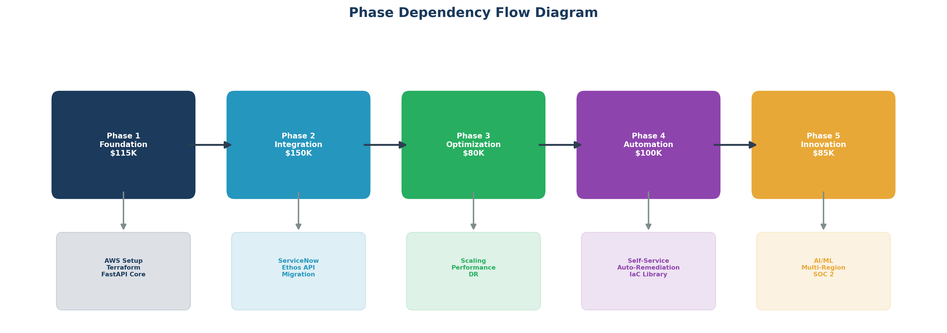

Technology Stack Architecture
The ECTP technology stack follows a layered architecture pattern, providing clear separation of concerns, independent scalability, and well-defined integration points between components.
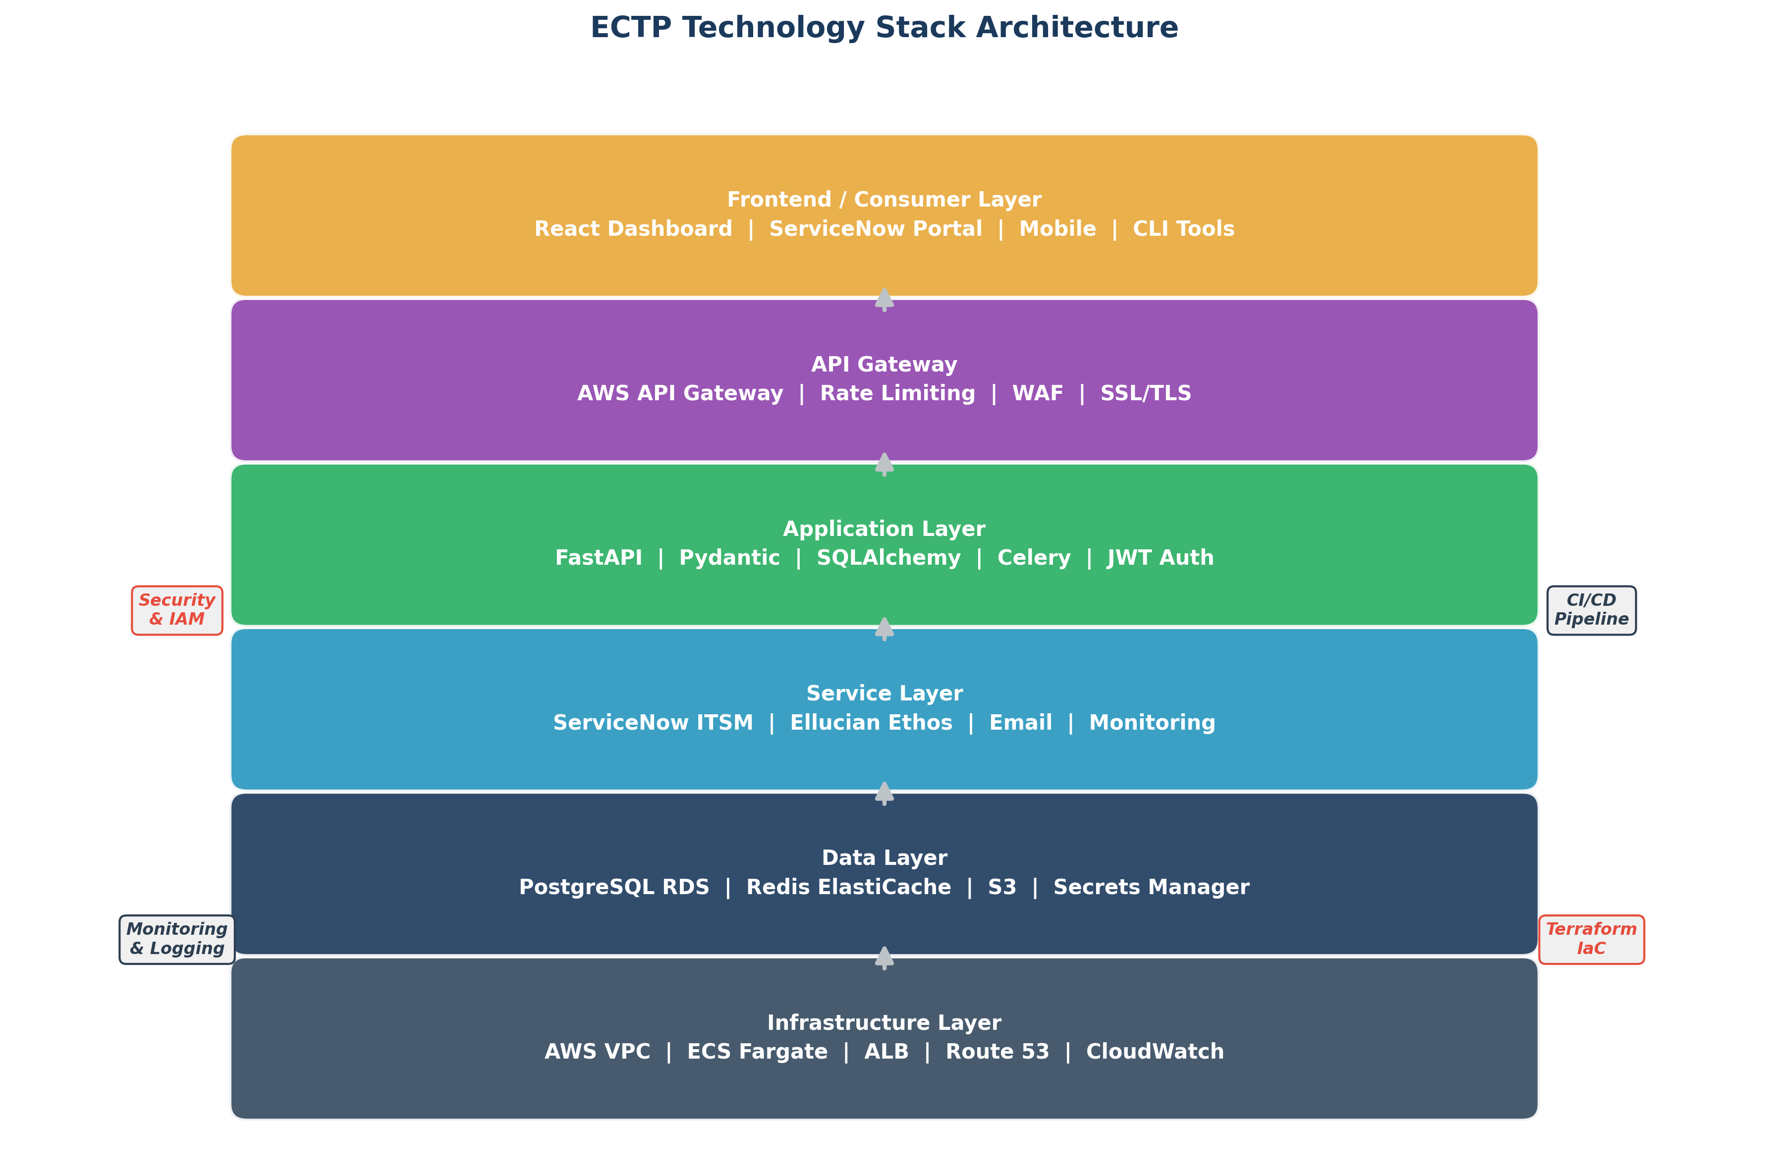

7. Year 2+ Innovation Roadmap (2028+)
Beyond the initial 2-year roadmap, ECTP will evolve into a platform for institutional innovation. The following areas represent strategic investment opportunities identified through stakeholder interviews, industry analysis, and technology trend assessment.
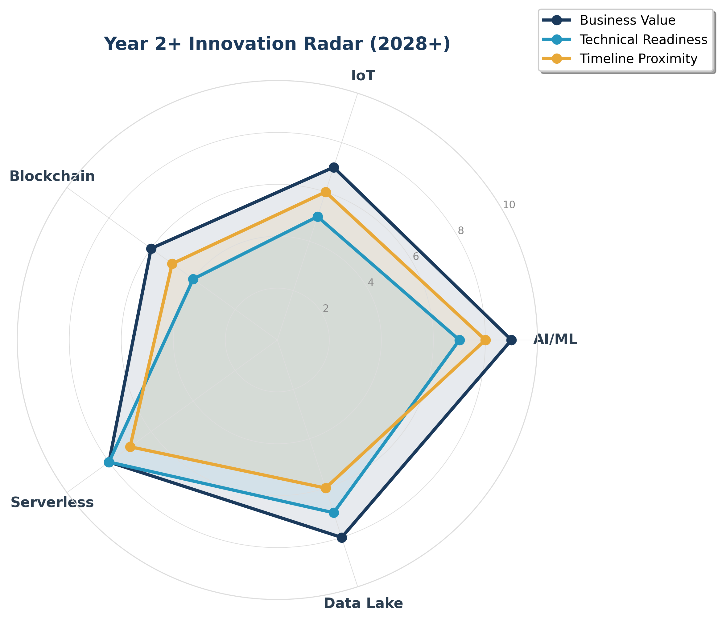

AI/ML Integration
Five strategic AI/ML initiatives planned for 2028:
- Predictive Auto-Scaling (Q1 2028): ML models predict enrollment surges and scale infrastructure proactively.
- Anomaly Detection (Q2 2028): Real-time detection of performance anomalies and security threats.
- Intelligent Incident Routing (Q2 2028): NLP-based ticket classification and automatic routing to appropriate teams.
- ChatBot Ops Assistant (Q3 2028): Conversational AI for infrastructure queries and common operations.
- Capacity Planning AI (Q4 2028): Machine learning models for long-term capacity and cost forecasting.

IoT Integration
Four IoT initiatives for smart campus operations:
- Smart Campus Monitoring (Q1 2028): Environmental sensors for HVAC, lighting, and occupancy optimization.
- Digital Signage Network (Q2 2028): Centralized management of campus-wide digital displays.
- Lab Equipment Monitoring (Q3 2028): IoT sensors for lab equipment status, maintenance, and utilization.
- Asset Tracking (Q4 2028): RFID/BLE-based tracking for IT assets and equipment across campus.

Blockchain Credentials
Four blockchain-based credential initiatives:
- Digital Diploma Verification (Q2 2028): Blockchain-backed verifiable digital diplomas.
- Micro-Credentials (Q3 2028): Stackable, verifiable micro-credentials and digital badges.
- Transcript Portability (Q4 2028): Cross-institution transcript sharing via distributed ledger.
- Alumni Verification (Q1 2029): Instant alumni credential verification for employers.

Additional Strategic Initiatives
- Serverless Evolution: Migration of suitable workloads to AWS Lambda for cost optimization and infinite scalability.
- Data Lake / Lakehouse: Centralized institutional data platform combining structured and unstructured data for advanced analytics.
- Multi-Cloud Strategy: Strategic evaluation of Azure and GCP for specific workloads to avoid vendor lock-in.
- Edge Computing: Campus edge nodes for latency-sensitive applications and local processing.
- Zero Trust Architecture: Full implementation of zero-trust security model with microsegmentation and continuous verification.
Key Insight: Year 2+ initiatives are evaluated using the Innovation Radar framework, scoring each opportunity on Business Value, Technical Readiness, and Timeline Proximity. This ensures data-driven prioritization of innovation investments.

8. Architecture Decision Records (ADRs)
Architecture Decision Records capture the key technical decisions made during the ECTP project, including context, alternatives considered, and rationale for each decision. ADRs provide an auditable trail of architectural choices.

ADR Register
ADR ID | Title | Status | Date | Decision
ADR-001 | Web Framework Selection | Accepted | Jan 15, 2026 | FastAPI for async performance and auto-generated OpenAPI docs
ADR-002 | Primary Database | Accepted | Jan 15, 2026 | PostgreSQL on RDS for reliability, JSONB support, and managed service benefits
ADR-003 | Container Orchestration | Accepted | Jan 18, 2026 | ECS Fargate for serverless containers eliminating node management overhead
ADR-004 | Infrastructure as Code | Accepted | Jan 20, 2026 | Terraform for multi-provider support and mature module ecosystem
ADR-005 | Caching Layer | Accepted | Jan 22, 2026 | Redis on ElastiCache for sub-millisecond latency and pub/sub capabilities
ADR-006 | Data Validation | Accepted | Jan 25, 2026 | Pydantic for runtime validation, serialization, and settings management

ADR Process
The ADR lifecycle follows a structured review and approval process:
- 1. Draft: Author creates ADR with context, alternatives, and recommendation.
- 2. Review (5 business days): Team members review and provide feedback via pull request.
- 3. Discussion: Architecture forum discusses trade-offs and concerns.
- 4. Decision (majority vote): CCoE members vote on the recommendation.
- 5. Record: Final decision is documented with rationale and consequences.
- 6. Communication: Decision is communicated to all stakeholders via email and Confluence.

9. Roadmap Governance
Effective governance ensures the roadmap remains aligned with institutional strategy, adapts to changing requirements, and delivers measurable value. The governance framework covers review cadence, prioritization criteria, and change management.

Review Cadence
Review Type | Frequency | Participants | Purpose
Sprint Review | Bi-weekly | Scrum Team, Product Owner | Demonstrate completed work, gather feedback
Phase Milestone | At phase completion | CCoE, Stakeholders | Validate phase deliverables, approve next phase
Roadmap Adjustment | Quarterly | CCoE, Governance Board | Review priorities, adjust timeline/scope
Innovation Review | Semi-annually | CCoE, Technology Leaders | Evaluate emerging technologies, update Year 2+ roadmap
Strategic Planning | Annually | Steering Committee, CIO | Align roadmap with institutional strategy

Prioritization Framework
Roadmap items are prioritized using a weighted scoring model across six dimensions:
- Business Value (30%): Direct impact on institutional operations, student experience, and revenue.
- Technical Feasibility (20%): Availability of skills, tools, and infrastructure to deliver.
- Cost-Benefit (20%): Expected ROI and payback period for the investment.
- Risk (15%): Technical, operational, and compliance risk assessment.
- Dependencies (10%): Blocking or enabling relationships with other initiatives.
- Strategic Alignment (5%): Fit with university's 5-year technology strategy.

Change Management Process
Changes to the roadmap follow a structured evaluation and approval process:
- 1. ADR Proposal: Requestor submits an ADR or change request with business justification.
- 2. CCoE Evaluation (2 weeks): Cloud Center of Excellence evaluates technical and business impact.
- 3. Governance Board Review: Board reviews CCoE recommendation and votes on inclusion.
- 4. Steering Committee (if >$50K): Changes exceeding $50K require Steering Committee approval.
- 5. Add to Roadmap: Approved changes are integrated into the roadmap with timeline and resources.
- 6. Communicate: All stakeholders are notified of roadmap changes via established channels.
Key Insight: The governance framework balances agility with oversight. Sprint-level reviews enable rapid delivery while quarterly adjustments and annual planning ensure strategic alignment. Changes under $50K can be approved within 2 weeks.

Success Metrics Dashboard -- All Phases
The following dashboard summarizes key performance targets across all five phases, illustrating the progressive improvement trajectory of the ECTP platform.
