FRIENDS
A Cross-Platform Mobile Application

Contact Management | Social Feed | Chat | Friend Tracking

━━━━━━━━━━━━━━━━━━━━━━━━━━━━━━━━━━━━━━━━━━━━━━━━━━━━━━━━━━━━

Author: | Gopi Krishna Vajrala
Date: | February 15, 2026
Version: | 1.0.0
Platform: | Flutter (Android, iOS, Web, Desktop)
License: | MIT

Table of Contents

1. Executive Summary
2. Repository Overview
3. Project 1: CopilotKit + Google ADK Starter
3.1 Architecture
3.2 Tech Stack
3.3 Key Files
3.4 Development Commands
3.5 Environment Variables
3.6 Agent Architecture
4. Project 2: Friends App (Flutter)
4.1 App Architecture
4.2 Tech Stack
4.3 Data Models
4.4 State Management
4.5 UI Screens & Screenshots
4.6 Theme & Styling
4.7 Running the App
5. Common Development Tasks
6. Future Enhancements

1. Executive Summary
This repository contains two interconnected projects demonstrating modern application development across web and mobile platforms:

- CopilotKit + ADK Starter: A Next.js web application powered by Google's Agent Development Kit (ADK) and CopilotKit, providing AI-driven proverb management through a chat interface.
- Friends App: A cross-platform Flutter mobile application for managing friendships, featuring contact management, a social feed, real-time messaging, and friend interaction tracking.

Both projects showcase contemporary frameworks, clean architecture patterns, and Material Design principles. The Friends app in particular demonstrates a production-ready mobile application structure with Provider-based state management, immutable data models, and a polished Material 3 user interface.

2. Repository Overview
The repository is organized into two distinct project areas:
with-adk/
├── CLAUDE.md # Comprehensive project documentation
├── README.md # Quick start guide
├── LICENSE # MIT License
│
├── ── CopilotKit + ADK ──
├── package.json # Node.js dependencies
├── agent/ # Python ADK agent
├── src/ # Next.js frontend
├── scripts/ # Setup & run scripts
│
├── ── Friends App ──
└── friends-app/
├── pubspec.yaml # Flutter config
└── lib/ # Dart source code
├── models/ # Data models (4 files)
├── providers/ # State management (4 files)
└── screens/ # UI screens (8 files)
Metric | ADK Project | Friends App
Language | TypeScript / Python | Dart (Flutter)
Framework | Next.js 15 + FastAPI | Flutter 3 (Material 3)
State Mgmt | CopilotKit useCoAgent | Provider (ChangeNotifier)
UI System | Tailwind CSS 4 | Material Design 3
AI/Model | Google Gemini 2.5 Flash | N/A (in-memory data)
Platforms | Web | Android, iOS, Web, Desktop

3. Project 1: CopilotKit + Google ADK Starter
A full-stack AI agent web application that manages a list of proverbs via an AI-powered chat sidebar. Built with Next.js on the frontend and a Python Google ADK agent on the backend, connected through CopilotKit.

3.1 Architecture
Browser
└─► Next.js 15 (port 3000)
└─► /api/copilotkit (POST)
└─► CopilotKit Runtime + HttpAgent
└─► Python FastAPI (port 8000)
└─► Google ADK Agent (Gemini 2.5 Flash)
- Frontend: Next.js App Router with React 19, CopilotKit UI, Tailwind CSS 4
- Backend: FastAPI server with Google ADK agent wrapped in ag-ui-adk middleware
- Communication: Frontend → /api/copilotkit → CopilotKit Runtime → Python agent
- State Sync: Bidirectional via CopilotKit's useCoAgent hook

3.2 Tech Stack

Frontend
Technology | Version | Purpose
Next.js | 15.3.2 | App Router, Turbopack dev server
React | 19.0.0 | UI component library
CopilotKit | 1.10.4 | AI chat UI (react-core, react-ui, runtime)
@ag-ui/client | 0.0.38 | HTTP agent adapter for ADK
Tailwind CSS | 4 | Utility-first CSS via PostCSS plugin
Zod | 3.24+ | Schema validation for actions
TypeScript | 5 | Type safety

Backend (Python)
Technology | Purpose
FastAPI + Uvicorn | ASGI HTTP server
google-adk | Google Agent Development Kit
google-genai | Generative AI (Gemini models)
ag-ui-adk | AG-UI adapter for ADK agents
Pydantic | State/data model validation
python-dotenv | Environment variable management

3.3 Key Files
File | Purpose
src/app/page.tsx | Main UI: proverbs list, theme color, useCoAgent, CopilotSidebar
src/app/layout.tsx | Root layout with <CopilotKit> provider
src/app/api/copilotkit/route.ts | POST endpoint bridging to Python agent via HttpAgent
agent/agent.py | ProverbsAgent with tools, callbacks, FastAPI server

3.4 Development Commands
Command | Description
npm install | Install all deps (triggers postinstall for Python venv)
npm run dev | Start UI (:3000) + Agent (:8000) concurrently
npm run dev:ui | Next.js dev server with Turbopack only
npm run dev:agent | Python agent server only
npm run dev:debug | Development with LOG_LEVEL=debug
npm run build | Next.js production build
npm run lint | ESLint: next/core-web-vitals + next/typescript

3.5 Environment Variables
Variable | Required | Description
GOOGLE_API_KEY | Yes | Google Makersuite API key for Gemini
PORT | No | Agent server port (default: 8000)
LOG_LEVEL | No | Set to 'debug' for verbose logging

3.6 Agent Architecture
The Python agent (agent/agent.py) components:
- ProverbsState: Pydantic model with proverbs: list[str]
- Tool: set_proverbs(new_proverbs) — replaces the full proverbs list
- Tool: get_weather(location) — returns mock weather data
- Callback: on_before_agent — initializes empty proverbs state
- Callback: before_model_modifier — injects proverbs into system prompt
- Callback: simple_after_model_modifier — ends invocation after text response
- Middleware: ADKAgent wrapper with InMemorySessionService (3600s timeout)

4. Project 2: Friends App (Flutter)
A cross-platform mobile application for managing friendships. The app provides four core features — contact management, a social feed, real-time chat, and friend interaction tracking — all built with Flutter and Material Design 3.

4.1 App Architecture
main.dart (entry point)
└─► MultiProvider (4 providers)
└─► MaterialApp (Material 3, light/dark theme)
└─► HomeScreen (IndexedStack + NavigationBar)
├── Tab 1: FriendsScreen → FriendDetailScreen
├── Tab 2: FeedScreen → CreatePost sheet
├── Tab 3: ConversationsScreen → ChatScreen
└── Tab 4: TrackerScreen → AddEvent sheet

Layer Breakdown
Layer | Directory | Files | Responsibility
Entry Point | lib/ | main.dart | App config, theme, provider setup
Models | lib/models/ | 4 files | Data classes with copyWith()
Providers | lib/providers/ | 4 files | State management (ChangeNotifier)
Screens | lib/screens/ | 8 files | UI widgets and navigation

4.2 Tech Stack
Technology | Version | Purpose
Flutter | 3.x | Cross-platform UI framework
Dart | >=3.0.0 | Programming language
Material 3 | Built-in | Google's latest design system
Provider | 6.1.1 | State management (ChangeNotifier)
intl | 0.19.0 | Date/number formatting
image_picker | 1.0.7 | Photo capture/selection
shared_preferences | 2.2.2 | Local key-value storage
uuid | 4.2.1 | Unique ID generation

4.3 Data Models
All models use immutable fields with copyWith() methods for state updates.

Friend Model
Field | Type | Description
id | String | Unique identifier
name | String | Full name
phone | String | Phone number
email | String | Email address
avatarUrl | String? | Profile image URL (optional)
birthday | DateTime? | Date of birth (optional)
notes | String? | Personal notes
lastInteraction | DateTime | Last interaction timestamp
isFavorite | bool | Favorite flag

Post Model
Field | Type | Description
id | String | Unique identifier
authorId / authorName | String | Author reference and display name
content | String | Post text content
imageUrl | String? | Optional image attachment
createdAt | DateTime | Post timestamp
likes / comments | int | Engagement counts
isLikedByMe | bool | Current user like state

Message & Conversation Models
Field | Type | Description
Message.id | String | Unique message ID
Message.senderId | String | Sender's user ID
Message.receiverId | String | Receiver's user ID
Message.content | String | Message text
Message.timestamp | DateTime | Send time
Message.isRead | bool | Read receipt status
Conversation.friendId | String | Friend this conversation is with
Conversation.messages | List<Message> | All messages in thread

FriendEvent Model
Field | Type | Description
id | String | Unique identifier
friendId / friendName | String | Associated friend
type | EventType | meetup, birthday, call, message, custom
title / description | String | Event details
date | DateTime | Scheduled date
isCompleted | bool | Completion status

4.4 State Management
The app uses the Provider package with ChangeNotifier for reactive state management. Four independent providers each manage their own domain:
Provider | State Type | Key Operations
FriendsProvider | List<Friend> | add, update, remove, search, toggleFavorite
PostsProvider | List<Post> | addPost, toggleLike, removePost
ChatProvider | Map<String, Conversation> | sendMessage, markAsRead, getConversation
EventsProvider | List<FriendEvent> | addEvent, toggleComplete, removeEvent

- Reactive reads: context.watch<T>() for reactive rebuilds when state changes
- One-shot reads: context.read<T>() for one-shot reads (event handlers, callbacks)
- Registration: All 4 providers registered in main.dart via MultiProvider

4.5 UI Screens & Screenshots
The app features 8 screens organized across 4 bottom navigation tabs. Below are live screenshots captured from the running application.

Tab 1: Friends (Contact List)
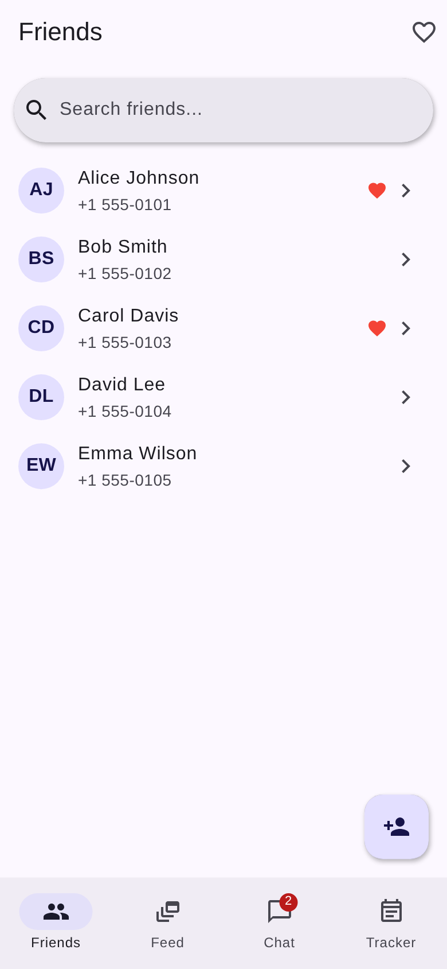
Figure 1: Friends contact list with search, favorites, and avatar initials
- Search bar with real-time filtering by name, email, or phone
- Favorites filter toggle via heart icon in the app bar
- Friend tiles: purple avatar with initials, name, phone, favorite indicator
- Tap to view friend detail; long press to toggle favorite
- Floating Action Button to add new friends
- Bottom navigation with unread message badge on Chat tab

Friend Detail View
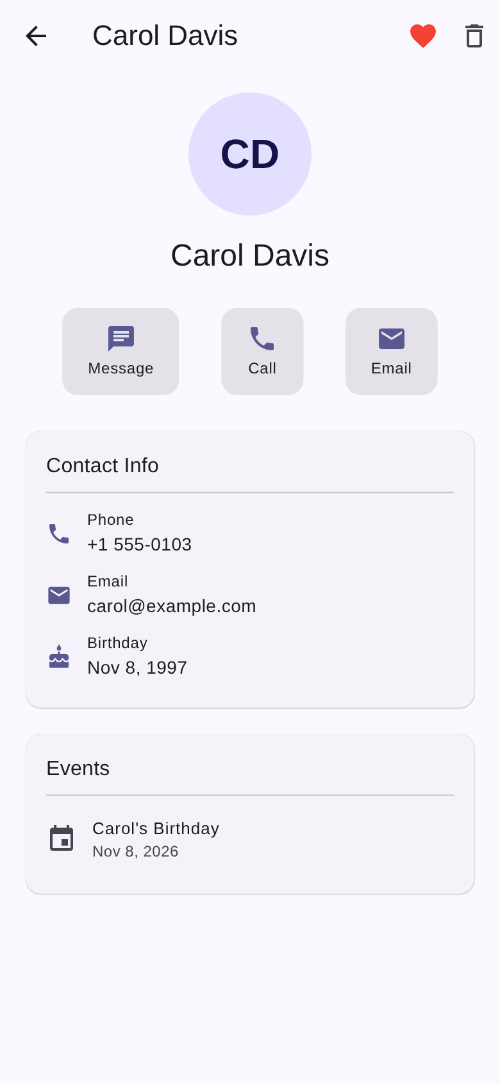
Figure 2: Friend detail with contact info, quick actions, and events
- Large circular avatar displaying friend's initials
- Quick action chips: Message, Call, Email
- Contact Info card: phone, email, birthday (formatted)
- Notes card: personal notes about the friend
- Events card: all tracked events for this friend
- App bar: favorite toggle (red heart), delete with confirmation dialog

Tab 2: Social Feed
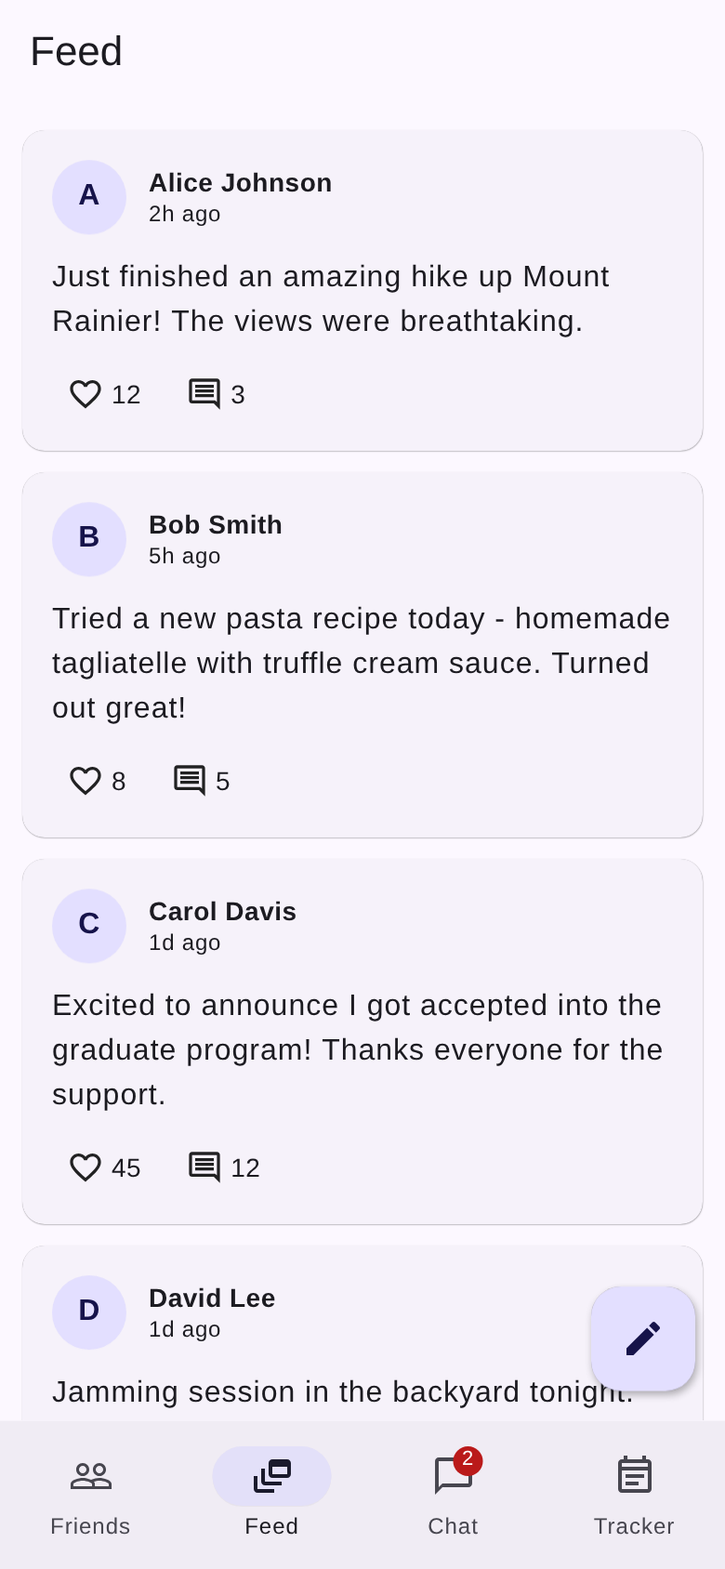
Figure 3: Social feed with post cards, likes, and compose button
- Post cards with author avatar, name, and relative timestamps
- Like button (heart) with count — toggleable, turns red when liked
- Comment count display
- Delete button on own posts
- Compose FAB opens a bottom sheet for new post creation
- Material 3 elevated cards with rounded corners

Tab 3: Chat Conversations
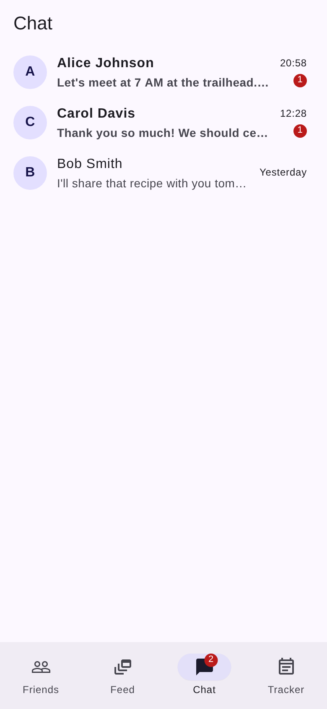
Figure 4: Chat list with unread badges, message previews, and timestamps
- Conversation list sorted by most recent message
- Each row: avatar, bold name (if unread), truncated message preview, timestamp
- Red unread count badges on conversations with new messages
- 'You:' prefix on sent message previews
- Smart timestamps: time for today, 'Yesterday', day name for this week
- Tap opens full chat with message bubbles (sent=purple right, received=grey left)

Tab 4: Friend Tracker
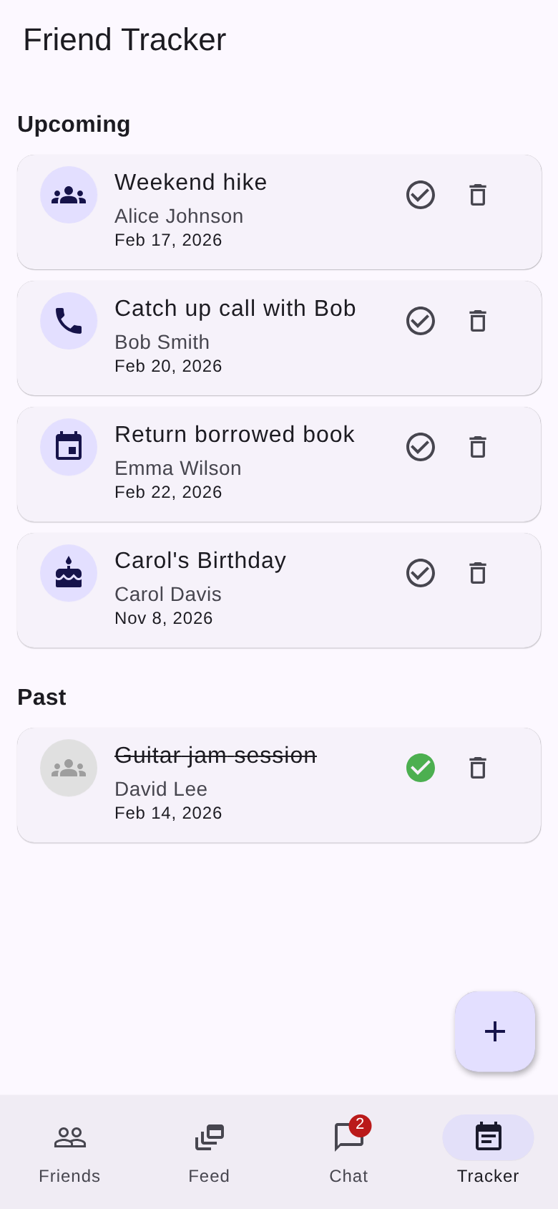
Figure 5: Event tracker with upcoming and past events, completion status
- Upcoming section: events sorted by date with type-specific icons
- Icon mapping: groups (meetup), cake (birthday), phone (call), calendar (custom)
- Each card shows: title, friend name, formatted date
- Action buttons: circle checkmark (toggle complete), trash (delete)
- Past section: completed events with strikethrough text and green checkmark
- Add Event FAB: form with friend picker, title, description, type, date picker

4.6 Theme & Styling
Property | Value
Primary Color | #6C63FF (Purple/Indigo)
Design System | Material 3 (useMaterial3: true)
Theme Mode | System (auto light/dark)
Font Family | Roboto
Color Generation | ColorScheme.fromSeed()

Key Material 3 components used: NavigationBar, SearchBar, Card, ListTile, Badge, CircleAvatar, FilledButton, OutlinedButton, FloatingActionButton, and ModalBottomSheet.

4.7 Running the Friends App

Prerequisites
- Flutter SDK 3.0+ (https://docs.flutter.dev/get-started/install)
- For Android: Android Studio + emulator or USB-connected device
- For web: Chrome browser

Commands
Command | Target Platform
flutter pub get | Install dependencies
flutter run -d chrome | Web (browser)
flutter run -d android | Android device/emulator
flutter run -d ios | iOS simulator (macOS only)
flutter run -d macos | macOS desktop app
flutter run -d windows | Windows desktop app
flutter build apk | Release Android APK
flutter build web | Release web build

5. Common Development Tasks

ADK Project Tasks
- Add agent tool: Define a Python function in agent/agent.py with tool_context: ToolContext parameter, add to tools list in LlmAgent constructor
- Add frontend action: Use useCopilotAction() in page.tsx with name, description, Zod parameters, and handler
- Modify shared state: Update ProverbsState in agent.py and AgentState type in page.tsx
- Change AI model: Update the model parameter in LlmAgent constructor

Friends App Tasks
- Add friend field: Add field to Friend model (constructor + copyWith), update AddFriendScreen form and FriendDetailScreen display
- Add new feature: Create new screen in lib/screens/, add provider if needed, register in MultiProvider in main.dart
- Add event type: Add to EventType enum, update typeLabel getter, add icon in _EventCard._iconForType()
- Change colors: Update seedColor in ColorScheme.fromSeed() in main.dart
- Add persistence: shared_preferences is already included; use in providers to save/load state across restarts

6. Future Enhancements

Friends App
- Firebase or REST API backend for persistent cloud storage
- Firebase Cloud Messaging for push notifications
- Real-time chat with WebSocket or Firebase Realtime Database
- Profile photo upload using the included image_picker dependency
- Local persistence with shared_preferences or SQLite (sqflite)
- Friend groups and group chat functionality
- Birthday reminders with local notifications
- Import contacts from device address book
- Search and discover new friends
- Unit and widget tests with flutter_test

ADK Project
- Multi-agent support with additional CopilotKit service adapters
- Persistent session storage (replace InMemorySessionService)
- Additional agent tools (e.g., web search, database queries)
- Authentication and user management
- Deployment configuration (Vercel, Docker)

━━━━━━━━━━━━━━━━━━━━━━━━━━━━━━━━━━━━━━━━━━━━━━━━━━━━━━━━━━━━

Document prepared by Gopi Krishna Vajrala
Generated on February 15, 2026

