**1) Introduction**

**1.1 What is Solution Design Document?**

The purpose of this document is to provide a description of the changes required to meet the high-level requirements of the process.

This is classified as a "living document", any changes in the process or solution must be appended and signed off by both parties prior to development.

**1.2 System Perspective**

**1.2.1 Assumptions**

|  |  |
| --- | --- |
| **Assumptions ID** | **Assumptions Details** |
| **RPA01-AID1** | Bot has access to google. |
| **RPA01-AID2** | Correct username and password are provided to access Gmail account. |

**1.2.2 Risks**

|  |  |
| --- | --- |
| **Risk ID** | **Risk Details** |
| **RPA01-RID1** | GmailCredentials (User ID/Password) have changed. |
| **RPA01-RID2** | Enough space not available to save files. |
| **RPA01-RID3** | Website not available. |

**2) Process Flow ("As Is")**

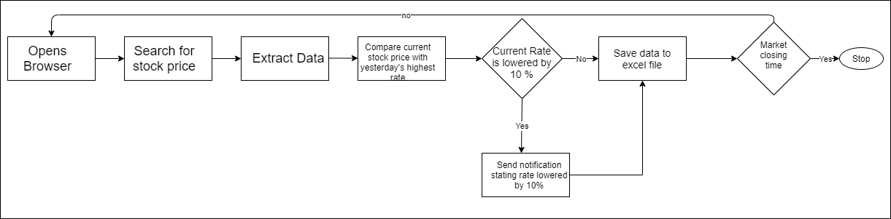

**3) Solution Process ("To Be")**

**3.1 Solution Diagram**

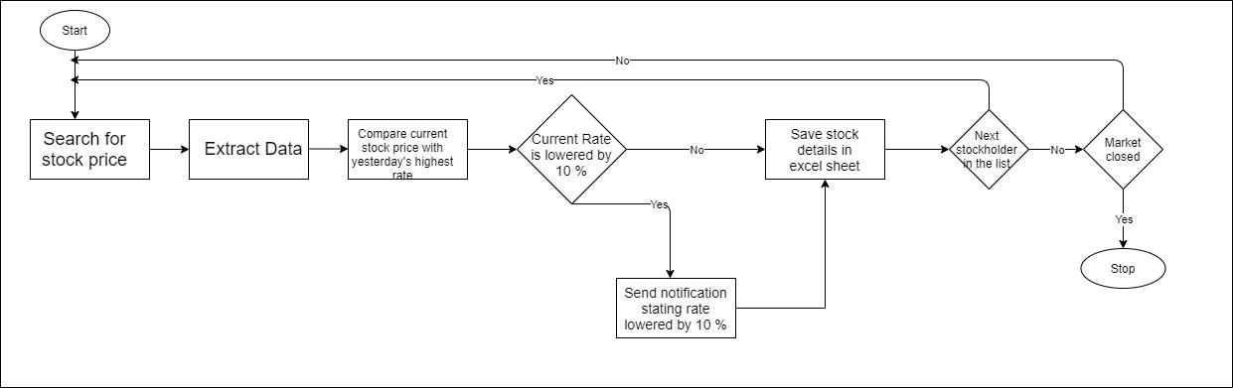

Process Descriptions

* 1.0

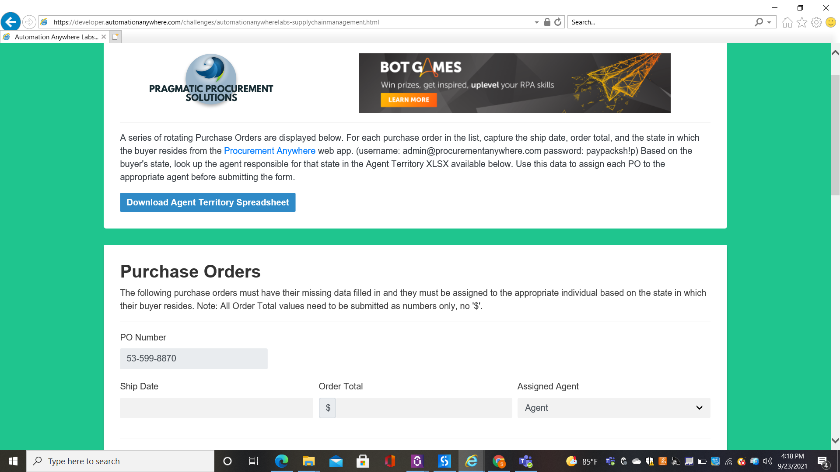

* 2.0 Extracts data.

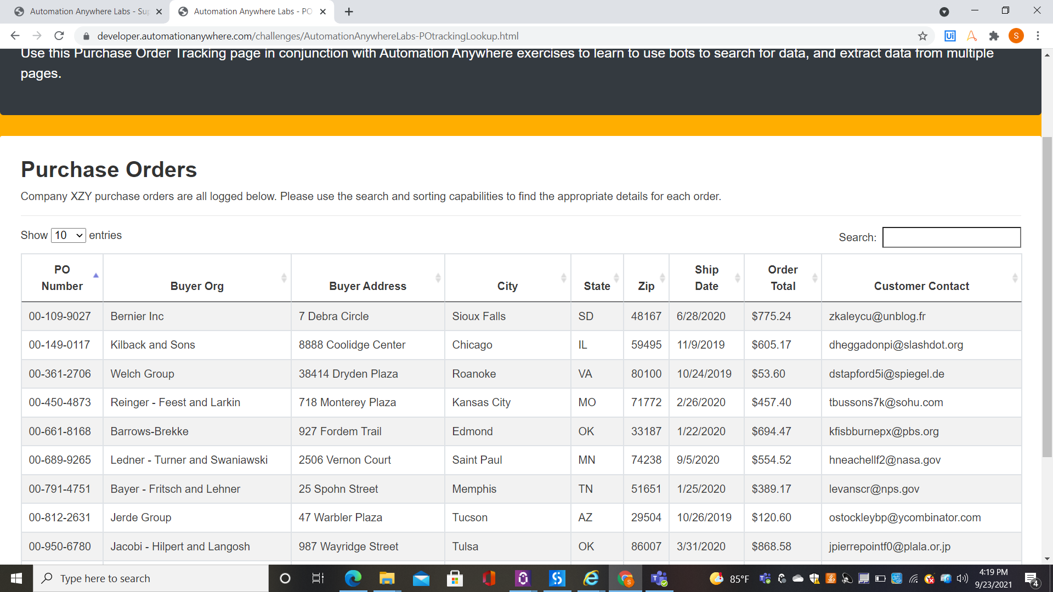

* 3.0 Saves the extracted data into excel sheet.
* 4.0 Compares the current rate with yesterday's highest stock price.
* 5.0 If the current rate is lowered by 10 %, the user will send mail stating stock price dropped by 10 %.

"Hi User,

Path stocks dropped by 10%."

* 5.0 Repeat step from 1.0 to 4.0
* 6.0 Close browser.

**3.2 Application Details**

|  |  |  |
| --- | --- | --- |
| **Application Name** | **Application Type** | **Application URL** |
| Chrome | Application |  |

**4) Solution Organization**

4.1 Modules

|  |  |  |
| --- | --- | --- |
| **Module Name** | **File Name** | **Description** |
| **Main** | Main.xaml | The high-level workflow that extracts stock data, saves it in excel file and sends notification to user. |
| **GetStockHolder'sList** | StockPriceUpdate\ GetStockHolder'sList | Reads Ticker Value from excel file. |
| **GetStockInformation** | StockPriceUpdate\ GetStockInformation | Extracts data from browser and writes it back to excel file. |
| **GetHighestPrice** | StockPriceUpdate\ GetHighestPrice | Calculates yesterday's highest stock price and sends mail to the user. |

**4.2 Steps in Modules**

* Main

1. Init State
2. Load Settings – Read all the data from the config file and store it in config dictionary.
3. Open browser.
4. GetStockHolder'sList - Reads Ticker Value from excel file.
5. Get Transaction State

Get transaction information from the queue, if transaction item is available it will move to process state, otherwise the bot will end the process.

1. Process State

1) Process

* + - 1. Search for the ticker's stock price in browser.
      2. GetStockInformation - Extracts data from browser and writes it back to excel file.
      3. GetHighestPrice - Calculates yesterday's highest stock price and sends mail to the user.

2) SetTransactionStatus

* + - 1. If the transaction item is processed without any exception, its status is updated as Successful.
      2. If a BussinessRuleException is thrown during the process, the transaction item's status is updated as Failed and next transaction item is fetched.
      3. If a system exception occurs during the process, the transaction item's status is updated as Failed and the process moves to init state.

1. End Process State

After processing all transaction items, the bot will end the process.

* GetStockHolder'sList

1. Description:

Reads ticker value from the excel file.

1. Arguments:
2. "in_List" - Excel file path storing the ticker names.
3. "out_StockHolderList" - Data read from the excel file.

* GetStockInformation

1. Description:
2. Extracts data from the browser.
3. Check if the excel file exists or not.
4. If file exists, write the data to the existing file.
5. If file doesn't exist, create a new file and then write extracted data to the file.
6. Arguments:
7. "in_FilePath" - Path of excel file to write extracted data.
8. "out_Ticker" - Ticker name.
9. "out_Name" - Company name.
10. "out_Broker" - Broker name.
11. "out_Price" - Stock price.
12. "out_Closed" - Closing time of stock market.
13. "out_WriteData" - A datatable containing all the extracted data.

* GetHighestPrice

1. Description:
2. Reads yesterday's stock data from the excel file.
3. Calculate the highest stock price, compares it with the current stock price.
4. If stock price is decreased by 10 %, sends mail to user.
5. Arguments:
6. "in_FilePath" - Path of excel file to read the data.
7. "in_UserEmailAddress" - User's email Id.
8. "in_email" - Sender's mail Id.
9. "in_password" - Sender's mail password.
10. "in_Name"- Company name.
11. "in_FilenotFoundTemplate" - Path of mail template if excel file is not found.
12. "in_MailSubject" - Mail Subject.
13. "in_Price" - Stock Price.
14. "in_EmailTemplatePath" - Path of mail template if the stock price is decreased by 10%.

**5) Global Definitions**

**5.1 Global Variables**

|  |  |
| --- | --- |
| **Variables** | **Descriptions** |
|  |  |

**5.2 Packages and Third Party Components**

None

**5.3 Exception Handling**

|  |  |
| --- | --- |
| **Scenario** | **Result** |
| Browser | Throws system exception. |

**6) Appendices**

**6.1 List of Acronyms**

*[ If needed, create a list of acronyms used throughout the BRD document to aid in comprehension.]*

**6.2 Glossary of Terms**

[*If needed, identify and define any terms that may be unfamiliar to readers, including terms that are unique to the organization, the technology to be employed, or the standards in use.]*

|  |  |
| --- | --- |
| **Term** | **description** |
| **Rpa**  **Aid**  **Rid**  **pdd** | Robotic Process Automation  Assumption ID  Risk ID  Process Definition Document |