📊 Movie Analytics Dashboard
Power BI Project Documentation

1. Project Overview
This project analyses movie metadata using Microsoft Excel and Power BI to identify patterns in IMDb ratings, box office revenue, genre performance, and actor popularity.
The objective of this dashboard is to:
- Identify high-performing movies
- Analyse revenue trends over time
- Understand the relationship between IMDb rating and gross collection
- Evaluate the impact of actor popularity on box office performance
This project demonstrates skills in data cleaning, transformation, data modelling, and interactive dashboard creation.

2. Tools Used
- Microsoft Excel – Data cleaning and preprocessing
- Microsoft Power BI Desktop – Data modelling, DAX calculations, and dashboard visualization

3. Dataset
- Source: Movie Metadata Dataset (Sample Dataset)
- Data Contains:
  - Movie Title
  - Title Year
  - Genre
  - IMDb Score
  - Duration
  - Gross Collection
  - Actor Facebook Likes
  - Budget (if applicable)
4. Steps Followed
Step 1: Data Cleaning (Excel)
- Removed blank rows and duplicate records
- Handled missing values
- Converted Gross and Budget columns to numeric format
- Standardized column names
Step 2: Preliminary Analysis (Excel)
- Used Pivot Tables to analyse:
  - Revenue by Genre
  - Average IMDb Score by Year
- Applied basic formulas for aggregation
Step 3: Data Modelling (Power BI)
- Imported cleaned dataset into Power BI
- Created calculated measures using DAX:
  - Total Gross Revenue
  - Average IMDb Score
  - Total Movies
- Created Profit Category column (Hit / Flop classification)
Step 4: Dashboard Development
Built interactive dashboards including:
- KPI Cards (Total Movies, Average IMDb Score, Budget, Gross, Average Duration, Average voted Users, ROI%)
- Pie Chart (Profit vs Loss)
- Line Chart (Average IMDb Score by Year)
- Column Chart (Movie Score Vs Movie Length)
- Scatter Plot (Star Power vs Box office Performance)
- Table (Movie Details – Imdb Score, Budget, Gross, ROI%, Director)
- Clustered Column chart (Total Budget and Gross Collection by Decade)
- Treemap (Top 10 Profitable Directors)
- Table (Top 5 Fan favourite Directors with Images)
- Table(Top 5 Profitable Actors with Images)
- Multirow Card- (Average Imdb_Score, Lead Actor and Movie)
5. Key Insights & Business Findings

📊 Profitability Analysis
- 45.8% of movies in the dataset are profitable, meaning more than half of the films do not generate positive ROI.
- There is no strong relationship between ROI and IMDb score, indicating that highly rated movies are not always financially successful.
- The 2000s decade recorded the highest total gross collection, making it the most commercially successful period in the dataset.
Business Insight:
Box office performance depends on multiple external factors such as marketing, franchise value, timing of release, and audience demand — not just ratings.

🎬 Director Performance
- The most profitable director identified is Steven Spielberg.
- However, top profitable directors do not consistently have the highest IMDb averages, showing that profitability and critical acclaim are different performance indicators.
Top 5 Fan-Favourite Directors (Based on IMDb Performance):
- Clint Eastwood
- David Fincher
- Martin Scorsese
- Steven Spielberg
- Woody Allen
Insight:
Critical appreciation does not always translate into higher financial returns.

⭐ Star Power vs Box Office
- Higher actor popularity (measured by Facebook likes) does not show a strong direct impact on box office revenue.
- The top 5 most profitable actors are:
  - Harrison Ford
  - Tom Hanks
  - Jennifer Lawrence
  - Tom Cruise
  - Bradley Cooper
Surprising Finding:
Even though these actors generate strong box office revenue, social media popularity alone is not a reliable predictor of movie success.

📈 Ratings vs Movie Length
- Movies longer than 150 minutes have the highest average IMDb scores.
- Very long movies tend to receive better ratings, suggesting audiences appreciate in-depth storytelling and larger-scale productions.

🏆 Best Movie Finder Insight
Using dynamic filters (IMDb score and duration), the dashboard identifies:
- Best Movie: The Towering Inferno
- Lead Actor: Martin Short
This highlights how interactive filtering enables users to dynamically identify top-performing movies based on selected criteria.

6.Screenshots

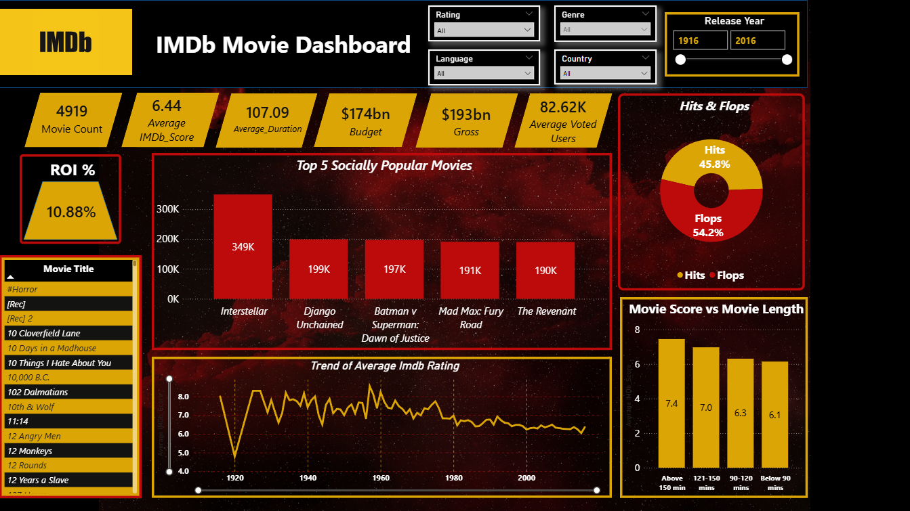

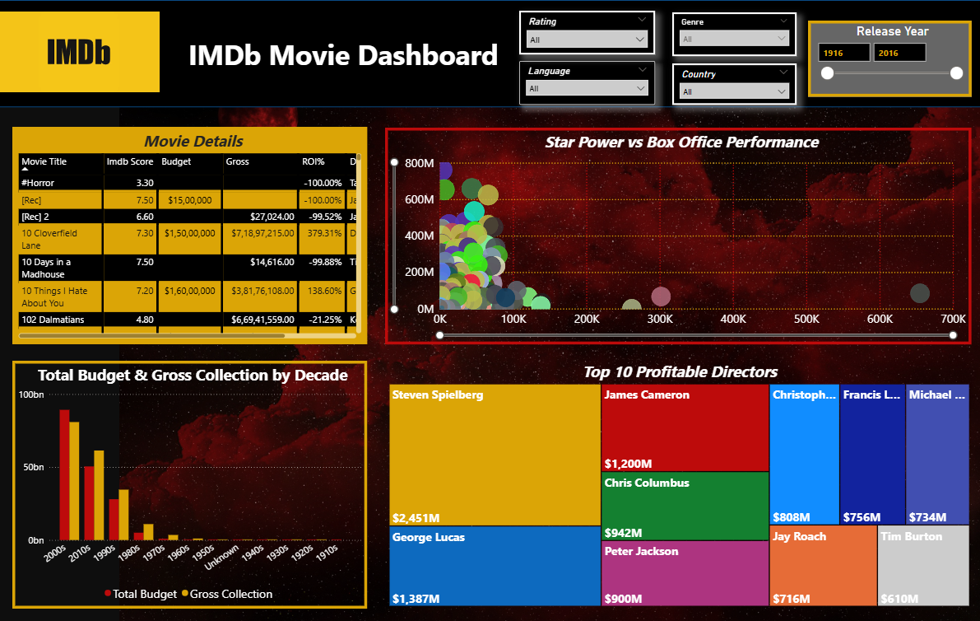

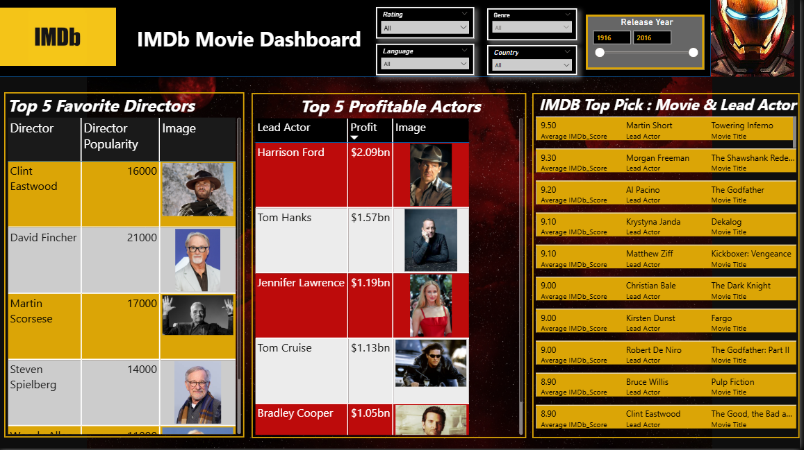

7.Files Included
The following files are included in this project:
- Mini Project_cleaned (Vishnu Anilkumar) - movies_metadata.xlsx
→ Cleaned dataset used for analysis. Includes formatted columns, removed duplicates, handled missing values, and prepared data for Power BI modelling.
- Mini Project - Data Analysis using Excel and Power BI.pbix
→ Power BI dashboard file containing data model, DAX measures, and interactive visualizations.
- Project_Documentation.pdf
→ Detailed documentation explaining project objectives, methodology, insights, and screenshots.
8. How to Use
- Open Mini Project_cleaned (Vishnu Anilkumar) - movies_metadata.xlsx to review the cleaned dataset and Excel-based analysis.
- Open Mini Project - Data Analysis using Excel and Power BI.pbix using Microsoft Power BI Desktop.
- Refresh the data if required.
- Use the slicers to filter by IMDb score, duration, genre, decade, director, or actor.
- Interact with visuals such as:
- KPI cards for performance metrics
- Scatter plot for Star Power vs Box Office
- Treemap for Top Profitable Directors
- Tables for Top Actors and Directors
- The dashboard is fully interactive and allows dynamic filtering for deeper analysis.

