FACTULY RESUME
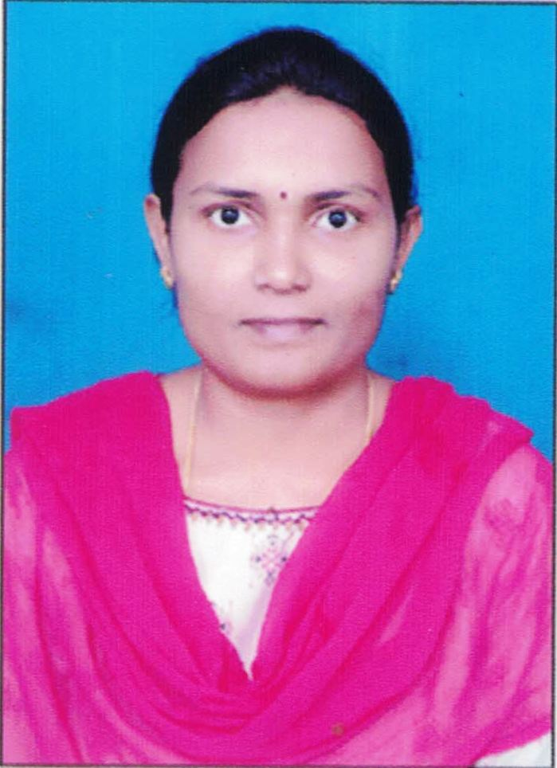
College Name and Code: SRKREC&B9
- Post to which applied :
- Department: Computer Science And Design
- Designation: Assistant Professor
- Name in full (Block letters): ARETI ASWANI PRIYANKA
- Date of Birth of the applicant: 24-08-1991
- Father's/ Husband 's name: A.SRI RAMA MURTHY
- Postal Address: HIG-42,Street No:8,HousingBoardColony,Bhimavaram,534201,W.G.Dist,AP,India
- Telephone No. with STD Code (O) :
- Mobile No: 8985352449
- Email:aswini.areti@gmail.com
- Give the following particulars of Educational Qualifications (Commencing with SSC or equivalent examination). If a qualification has been obtained by private appearance, this should be specifically mentioned.
Name of the Examination/ Degree | Details of School/College | Name of the Board/ University | Year of Award | Class & % of Marks | Subjects taken for specialization
(1) | (2) | (3) | (4) | (5) | (6)
M.Tech | SCET | JNTUK | 2015 | 68% | CSE
B.Tech | GVVIT | JNTUK | 2012 | 64.45% | IT
Intermediate | Aditya Junior College | Board Of Intermediate | 2008 | 65% | M.P.C
SSC | ZP High School | Board Of Secondary Education | 2006 | 75% | SSC

- Project/Thesis:
Ph.D Thesis Title:
M.Tech Thesis Title: Data Confidentiality of Sharing Knowledge Using Client Server Model
UG Project Title:

- Give chronological order details of employment
Name and Address of Institution / Office | Post Held | Scale of Pay | Period |  | Total Period in each cadre | Basic Pay & Gross Pay | Regular / Adhoc. University ratified
Name and Address of Institution / Office | Post Held | Scale of Pay | From | To | Total Period in each cadre | Basic Pay & Gross Pay | Regular / Adhoc. University ratified
1 | 2 | 3 | 4 | 5 | 6 | 7 | 8
Vishnu Institute Of Technology | Asst.Prof | 21,600 | 2016 | 2022 | 7 Years |  | Regular
SRKR Engg College | Asst.Prof | 29,120 | 2023 | Till Date |  |  | Regular

- Whether qualified in NET/SLET/SET/GATE Yes / No: _____NO______
If Yes, Year in which qualified : _____________ (Enclose attested copies of the certificates)

- Details of Research Publications:
S.No. | Title of the Publication with Page Numbers | Journal Name | Month & Year of Publication | ISSN/ISBN Number | Specify....  SCI/UGC/AICTE/  Scopus (UGC Care List Group-II)
1. | Convolutional Neural Networks for the Identification of Skin Disorders | Conference | July 2024 | 9781003529231 | Scopus Indexed
2. | Real-Time IoT-based Vehicle Accident Detection and Emergency Response System using Multi-Sensor Fusion | Conference | July2025 | 979-8-3315-1176-0 | Scopus Indexed
3. | Integrated IoT-Based Smart Home Security System: Real-Time Hazard Detection and Alerts Using Multi-Sensor Fusion | Conference | March 2025 | 979-8-3503-9005-6 | Scopus Indexed
4. | Enhancing Industrial Equipment Longevity with IoT-Enabled Smart Lubrication Systems Using k-Means Clustering | Conference | July 2025 | 2836-1865 | Scopus Indexed

- Details of Ph.D guided if any :
- Details of Memberships in Professional Bodies:
- Details of Awards received, if any:
- Any Other Information:
15.Subjects Taught: OOAD,CN,CG,CLOUD COMPUTING,SPM,DISTRIBUTED SYSTEMS,CO,OS,HCI,DATA VISUALIZATION,MC
16. Total Working Experience: 9.5 Years
17.Workshops/FDP’s Attended:

S No | Name of the workshop/ STTP | Organized by | Period
S No | Name of the workshop/ STTP | Organized by | From | To
1. | Design Thinking and Innovative Product Design | SRKR Engg College | 30/10/2023 | 04/11/2023
2. | CONTEMPORARY ADVANCES IN CONSTRUCTION TECHNOLOGY | Vishnu Institute Of Technology | 20/11/2023 | 25/11/2023

S No | Name of the FDP | Organized by | Period
S No | Name of the FDP | Organized by | From | To
1. | Inculcating Universal Human Values in Technical Education | AICTE at SRKR Engg College | 31/08/2023 | 02/09/2023
2. | Emerging Trends in Nano Technology | VIT | 13/11/2021 | 19/11/2021
3. | Data Analyst | APSSDC | 19/06/2023 | 23/06/2023
4. | RecentTrends In Research Methodology | BIET | 19/05/2020 | 21/05/2020
5. | Recent Advancements in Machine Learning And Artificial Intelligence | GIET | 23/01/2023 | 28/01/2023
6. | Cognitive Computing For Smart Applications | Vishwakarma Inst Of Inf Technology | 18/03/2024 | 22/03/2024
7. | Recent Trends in Artificial Intelligence and Cyber Security | SVECW | 01/11/2022 | 05/11/2022
8. | Cloud Computing and Distributed Systems | NPTEL-AICTE | 02/01/2024 | 31/03/2024
9. | Introduction to Machine Learning | NPTEL-AICTE | 15/07/2023 | 30/09/2023
10. | NLP and ChatGPT APPLICATIONS | EXCELR | 14/08/2023 | 19/08/2023
11. | Cyber Security | CBIT | 25/09/2023 | 14/10/2023
12. | Applications of Business Analytics | Ramaiah Institute of Technology | 09/10/2023 | 13/10/2023
13. | Data Analytics using Power BI and Tableau | Atria Institute of Technology | 11/03/2024 | 15/03/2023
14. | Cloud Infrastructure(AWS) | SRKR | 21/08/2023 | 25/08/2025
15. | OBE&NEP 2020 | SRKR | 10/06/2024 | 14/06/2024

DECLARATION BY THE APPLICANT
I hereby declare that statements made in this application are true to the best of my knowledge. Further, I understand that I am eligible for the Post applied as per the University Guidelines.

Date: 30/07/2025
Place: Bhimavaram

A.Aswani Priyanka
SIGNATURE OF THE APPLICANT

