**Assignment - 1**

**1. Age Distribution**

Plotting the frequency of pupils within designated age ranges (bins) makes it simple to determine which age groups are more prevalent. You can tell if the age distribution is uniform, skewed, or has peaks that represent popular ages among students by looking at the distribution's shape. For instance, it might suggest a typical age for students in this educational setting if many them fall within a particular age range. Demographic analysis can benefit from an understanding of the age distribution, which may also be related to patterns in academic achievement across age groups.

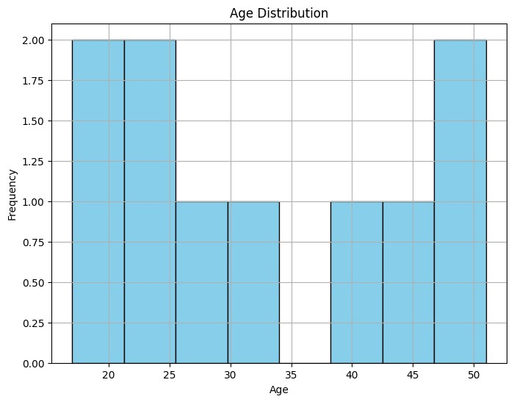

**2.Height vs. Weight**

A single student is represented by each point on the plot, with their weight on the y-axis and their height on the x-axis. You can spot trends by looking at the general pattern of the points, such as if taller pupils typically weigh more. A positive correlation suggests that there is an increasing tendency in the points, implying that weight tends to grow along with height. On the other hand, the absence of any pattern might imply that weight and height are unrelated. Understanding the physical attributes of the student body with the help of this representation will help with future research on fitness and health.

**3.Grip Strength by Frailty:**

The box plot sheds important light on the differences in grip strength between frail and non-frail people. The line inside each box indicates the median score, and each box reflects the interquartile range (IQR) of the grip strength scores. Any points outside of this range are regarded as outliers, and the "whiskers" extend to display the range of scores within 1.5 times the IQR. We can determine whether frail people often have weaker grips than their non-frail counterparts by comparing the two boxes. A possible relationship between frailty and decreased physical strength may be indicated if the median grip strength for the frail group is significantly lower. This is critical information for health assessments and interventions. The visual representation of the distribution of grip strength scores based on this dataset.

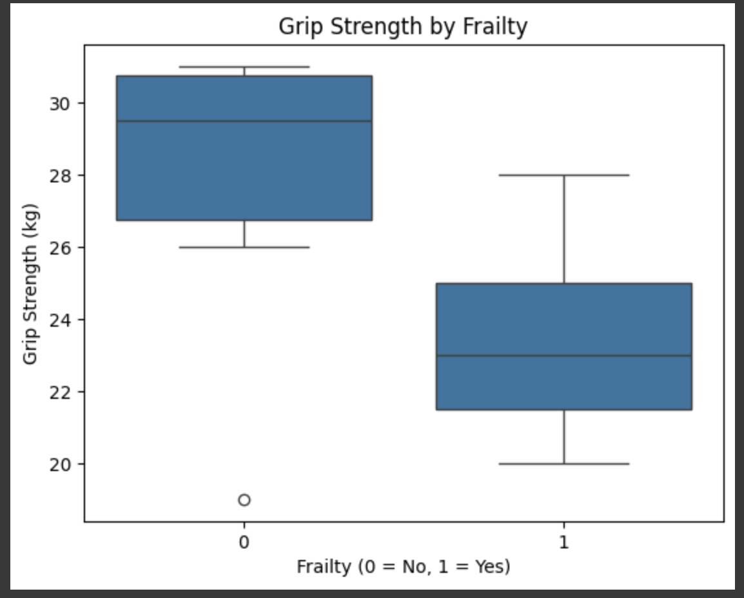

# Correlation Heatmap

The correlation coefficient between two variables is displayed in each heatmap column, with values ranging from -1 to 1. When one variable rises, the other also tends to rise; a high positive correlation is shown by a coefficient close to 1, whereas a significant negative correlation is indicated by a number close to -1 (one variable increases, the other tends to decline). Values close to zero indicate little or no association. Finding important relationships is made simpler by the precise correlation values provided by the annotations in the cells. Students who perform well in reading are likely to do well in writing as well, for example, if the heatmap demonstrates a substantial positive association between writing and reading scores. This graphic helps illustrate the relationships between several qualities.

