**Assignment 1**

# 1. Average Scores by Gender

The bar plot allows for an easy comparison between genders across math, reading, and writing. By visualizing the mean scores, we can quickly identify if one gender tends to outperform the other in specific subjects. For example, if females consistently score higher in reading and writing, this could suggest gender-based trends in language-related subjects, while males might excel in math.

# 2. Distribution of Math Scores by Parental Level of Education

The box plot facilitates the identification of differences in student performance amongst parental educational attainment levels. It offers information on the spread, the median score, and any possible outliers. For instance, if students with parents holding higher degrees (e.g., master’s) tend to have higher median math scores, this could indicate a potential influence of parental education on academic performance in math.

# 3.Distribution of Parental Level of Education

The plot makes it easier to comprehend how students receive parental instruction. The number of students whose parents fit into a particular educational category (such as "bachelor's degree" or "some college") is shown by the height of each bar. A KDE (Kernel Density Estimate) line is added to the distribution to assist smooth it out and make patterns easier to see. The most prevalent parental education levels in the dataset may be seen in this visualization, which may also shed light on possible socioeconomic implications on student achievement. 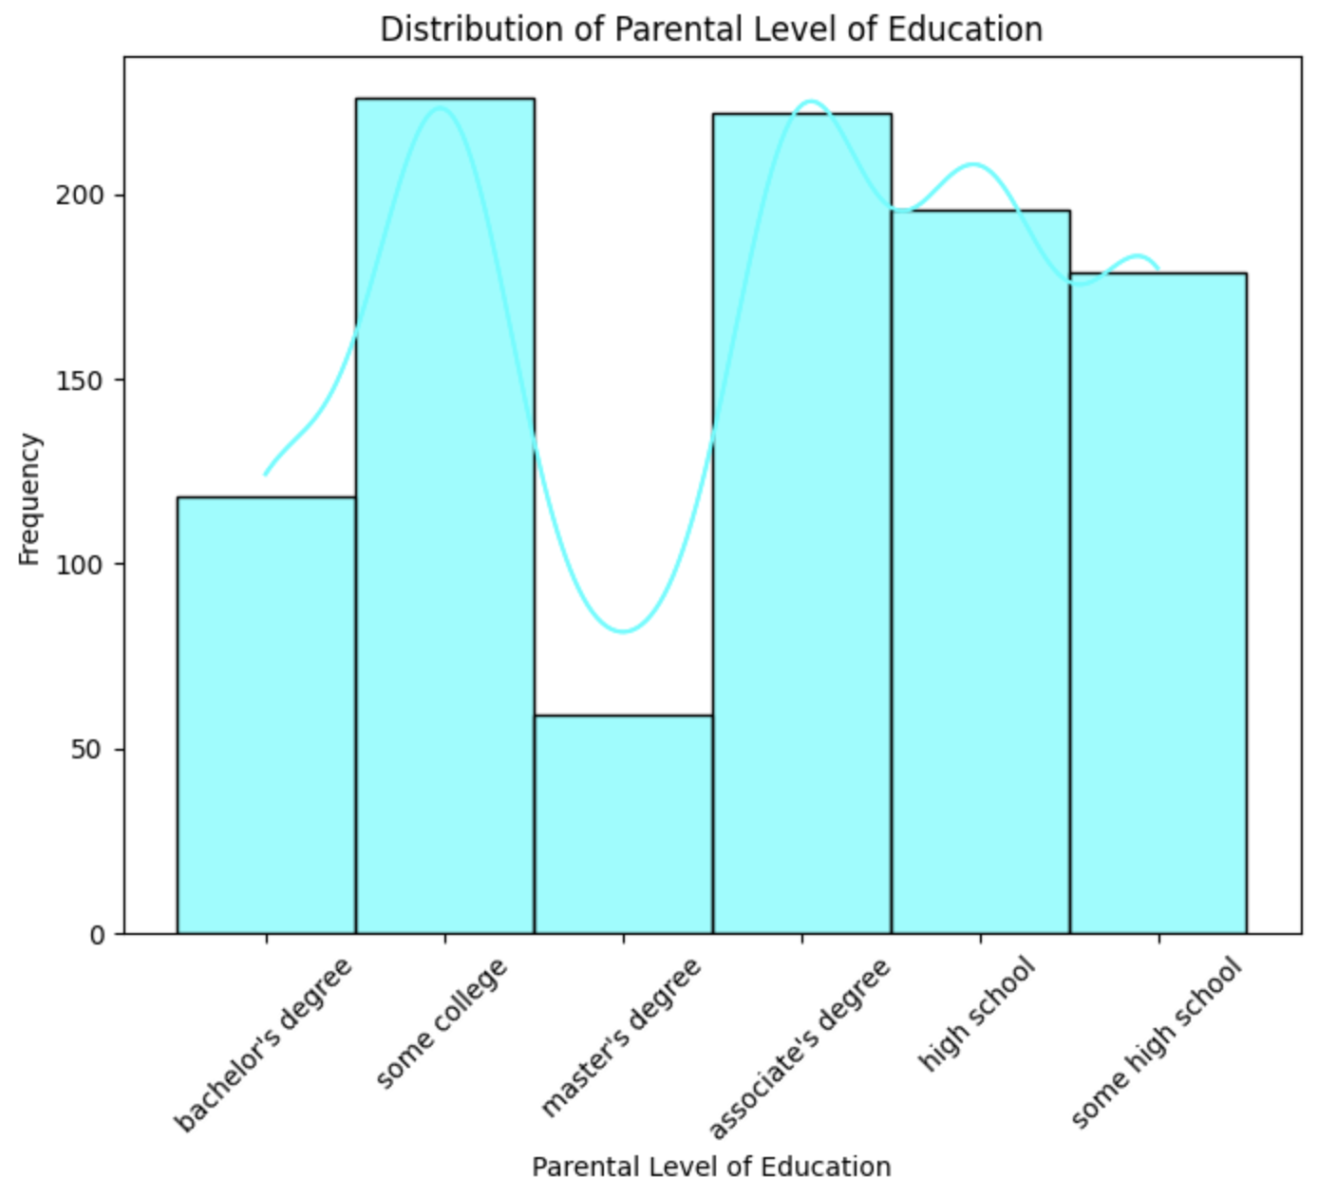

# 4. Total Scores by Lunch Type

The graphic offers information on the distribution of scores within each category in addition to showing the median overall score for each type of lunch. The violin's width represents the density of scores at various levels and the range of scores that many students have overall. Lunch type may be related to academic achievement, for instance, if students who eat normal lunch likely to score higher overall than those who eat free or reduced lunch. This graphic aids in highlighting possible differences in academic performance amongst students according to socioeconomic status. A diagram of a bar chart
