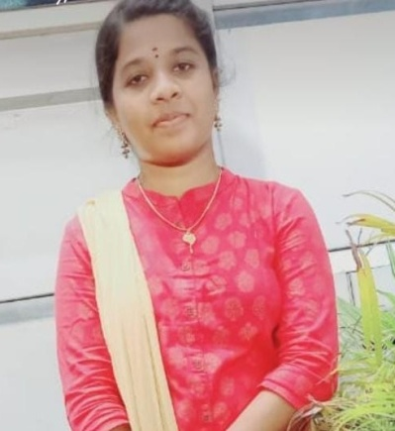 **BIODATA**

**NAME :** V.Akila

**Father’s Name :** R.Veeraiyan

**Email ID :** vakila535@gmail.com

**Mobile Number :** 9363210250

**Date of Birth :** 02.05.2003

**Gender :** female

**Nationality :** Indian

**Religion :** Hindu

**Marital Status :** unmarried

**Address :** 2/411,Mettu Street,

Kokkeri(po),

Vadapathy,

Thanjavur(dt).

**Language Known :** Tamil , English.

**Hobbies :** Reading book , watching movies ,etc...

**Educational Qualification:**

|  |  |  |  |
| --- | --- | --- | --- |
| **Qualification** | **Name of**  **institute** | **Year of passing** | **Marks**  **percentage** |
| 10th |  |  |  |
| 12th |  |  |  |
|  |  |  |  |