MACROECONOMIC OVERVIEW
Investor Friendly Business Environment
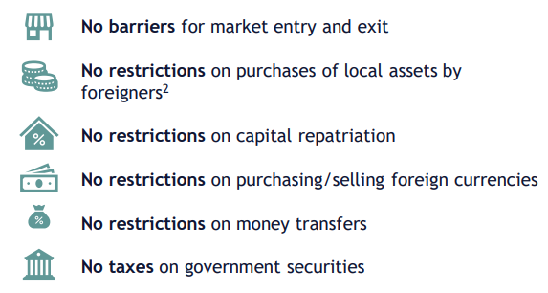

Key Indicators
Exchange rate (Jan 2026) | 1 USD = 2.6968 GEL
Nominal GDP | USD 34.2 bn
GDP per capita (PPP) | USD 28,299
Real GDP growth | 9.70%
Average inflation (2010–2023) | 4.70%
Inflation (2024) | 1.10%
Government debt / GDP | 35.70%
Current account balance / GDP | –5.3%

Georgia’s macroeconomic indicators in 2024 reflect strong growth alongside persistent structural vulnerabilities. Real GDP expanded by 9.7 percent, while inflation declined to 1.1 percent, indicating a favorable cyclical position and effective monetary policy.
However, despite moderate public debt of 35.7 percent of GDP, the economy continues to run a current account deficit of 5.3 percent of GDP, highlighting reliance on imports and external financing. The large gap between nominal GDP per capita and PPP-adjusted income points to solid domestic purchasing power, but also underscores limited productivity and export competitiveness
General Facts
Georgia

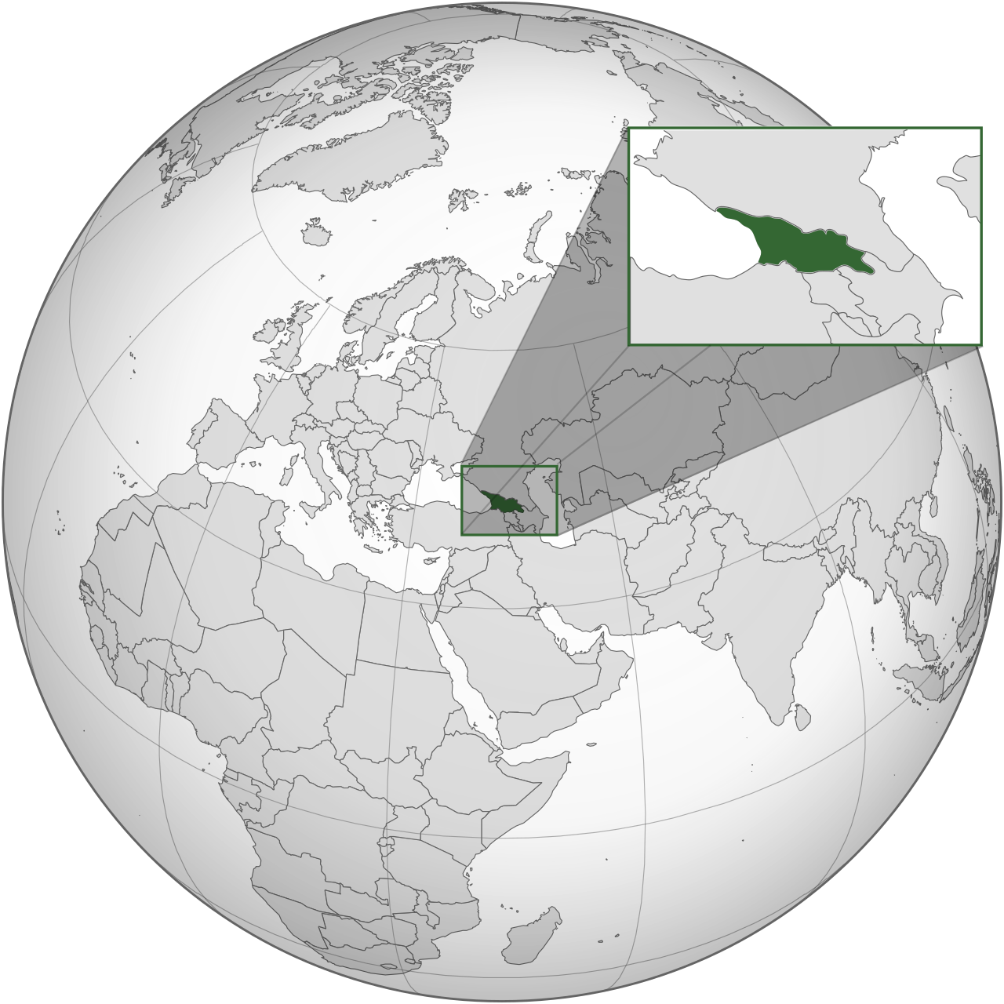

- Area: 69,700 sq. km
- Population (Nov 2025): 3.7 million
- Capital: Tbilisi
- Life expectancy: 73.7 years
- Official language: Georgian
- Currency (code): Lari (GEL)
- Literacy: 100%

- Flag:

Sovereign Credit Ratings
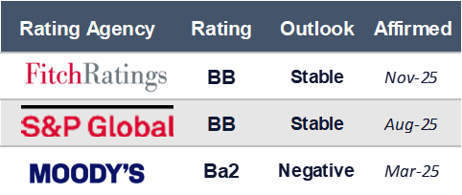



Georgia’s Sovereign Credit Ratings Evolution

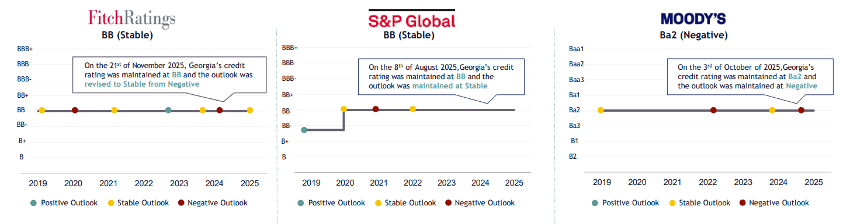

Key Credit Drivers

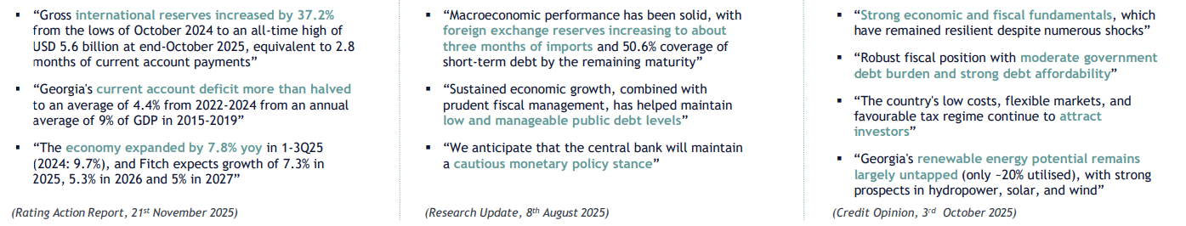

Decomposition of GDP growth

The decomposition of GDP growth highlights Georgia’s structural reliance on domestic consumption and imports, alongside a persistently negative contribution from net exports. As shown in the chart, private consumption has been the dominant driver of growth in recent years, while imports have consistently exerted a negative contribution, reflecting the economy’s high import intensity

Economic Growth and Forecast

Real GDP growth moderated from double-digit levels to more sustainable rates, reflecting the gradual fading of post-pandemic and one-off external factors. According to ministry of finance of Georgia, under the baseline scenario, real growth is projected to decline to around 5 percent by 2026 and remain broadly stable thereafter, indicating convergence toward Georgia’s estimated potential growth rate. At the same time, the optimistic and pessimistic scenarios highlight the economy’s sensitivity to external conditions and geopolitical risks.

Labor Force

FX rates

Inflation

Following heightened volatility during 2020–2022, driven by external shocks and capital flow fluctuations, the Georgian lari stabilized against major currencies in subsequent years. This stabilization was supported by strong inflows and favorable macroeconomic conditions, contributing to lower imported inflation and short-term price stability. However, the exchange-rate dynamic remains closely tied to external financing conditions, indicating continued vulnerability to shifts in global sentiment
After peaking in 2021–2022, driven by global commodity price shocks and supply-chain disruptions, inflation declined sharply and moved close to the National Bank of Georgia’s target of 3 percent. In 2024, inflation remained contained, reflecting the impact of tight monetary policy and easing external price pressures. Forward-looking projections suggest that inflation is expected to remain close to the target over the medium term, indicating improved price stability.
After labor market disruptions during the pandemic period, employment levels recovered steadily from 2022 onward, accompanied by a decline in the unemployment rate. In 2024, labor market conditions remained stable, reflecting cyclical economic recovery rather than structural expansion. The broadly unchanged size of the labor force highlights structural supply constraints.

GDP by Economic Activity
(September 2025, % of total)

The GDP composition highlights Georgia’s continued reliance on services and trade-related activities, with wholesale and retail trade remaining the largest sector. While this structure supports short-term growth through domestic demand, the relatively modest share of manufacturing and tradable sectors points to limited diversification and weak export capacity. As a result, economic performance remains closely tied to consumption dynamics and external conditions rather than productivity-led growth.
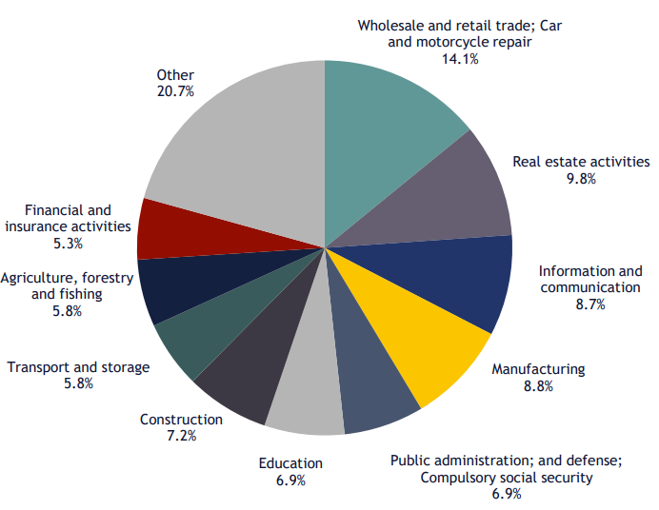

Number Of Employees By Type Of Economic Activity

Employment is concentrated in trade, agriculture, and industry, mirroring the service-oriented structure of the economy. While employment growth is visible across several sectors, it is largely concentrated in lower value-added and demand-driven activities, suggesting that labor absorption has been cyclical rather than structural. This pattern reinforces constraints on productivity growth and limits the economy’s ability to rebalance toward more export-oriented sectors.

Trade dynamics over 2020–2025 show a persistent gap between imports and exports, despite strong post-pandemic recovery. While both exports and imports rebounded sharply in 2021–2022, import growth consistently outpaced export growth, resulting in widening trade volumes rather than external rebalancing. In recent years, trade growth has moderated, but imports continue to expand faster than exports, reinforcing structural external imbalances and dependence on domestic demand and capital inflows rather than export-led growth.

The composition of trade in 2025 highlights Georgia’s strong dependence on machinery and transport equipment, which accounts for the largest share of both imports (37.3%) and exports (43.5%). On the import side, the significant share of capital goods, chemicals, and fuels underscores the economy’s import-intensive growth model, where domestic demand and investment translate directly into higher import volumes. Export structure remains relatively concentrated and dominated by re-exports and selected commodity groups, indicating limited domestic value addition and diversification, which constrains the ability of exports to offset rising import demand.

Financial environment
Monetary Policy Rates and Forecast

Volume on Commercial Banks Loans

Average Annual Interest Rates on Commercial Bank Loans and Deposits

- Lending rates remained elevated over the period, particularly for GEL-denominated loans, while deposit rates adjusted more slowly. The persistent spread between loan and deposit rates indicates tight financing conditions and cautious bank behavior, limiting the pass-through of easing monetary policy to borrowers. As a result, borrowing costs continue to constrain credit-financed investment and consumption.

- Following sharp tightening in 2021–2022, the policy rate entered a gradual easing phase as inflation pressures subsided. Despite this normalization, the level of the policy rate remains restrictive in real terms, signaling a continued focus on price stability. This stance implies sustained restraint on credit growth rather than active monetary support for demand.

- Commercial bank lending expanded steadily across sectors, with the trade sector accounting for the largest share of loan growth. This concentration reflects strong demand-driven activity but also increases exposure to cyclical sectors sensitive to interest rates and consumption dynamics. For firms operating in trade-related industries, financing conditions remain closely tied to banks’ risk appetite and overall credit cycle.

Business environment
analysis of the industry, competitor or other factors. Including past and present and expectation that would be in line with macroeconomic environment forecast

The Georgian automotive industry has shown strong recovery and structural shifts in recent years, aligning with broader macroeconomic stabilization and external trade dynamics. The total automotive fleet grew by 5.4% in the first nine months (9M) of 2025, driven primarily by light vehicles, which remain the largest segment of the market.

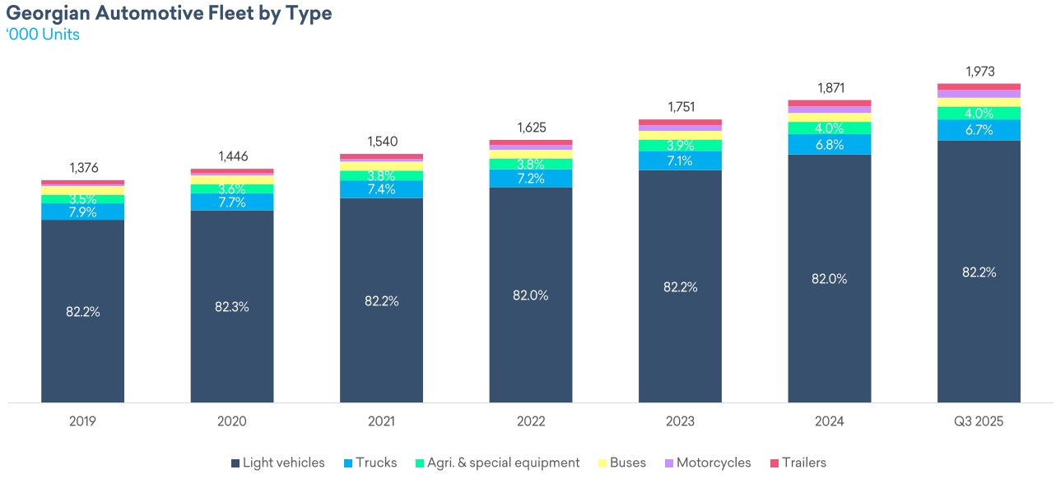

Despite this expansion, the majority of vehicles in operation remain more than 20 years old, suggesting latent replacement demand. However, the average age of newly registered light vehicles has been decreasing, indicating a gradual modernization of the fleet.
- Imported cars: Likely to grow as old domestic vehicles are replaced.
- Automatic vehicles & hybrids: Adoption may increase, as buyers prefer convenience and efficiency.
- Aftermarket & service industry: As more modern vehicles enter, there will be higher demand for parts, servicing, and maintenance geared toward newer technology.

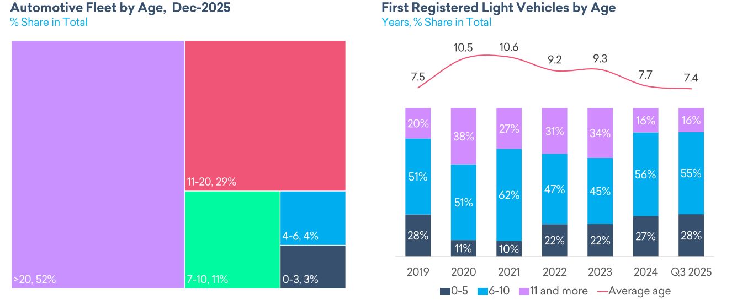

External trade has been another key growth pillar, with imports and re-exports increasing by 5% and 13%, respectively, during the first ten months of 2025. Strong import and re-export growth signals rising domestic demand and increasing integration in global trade, benefiting export-oriented and manufacturing companies.
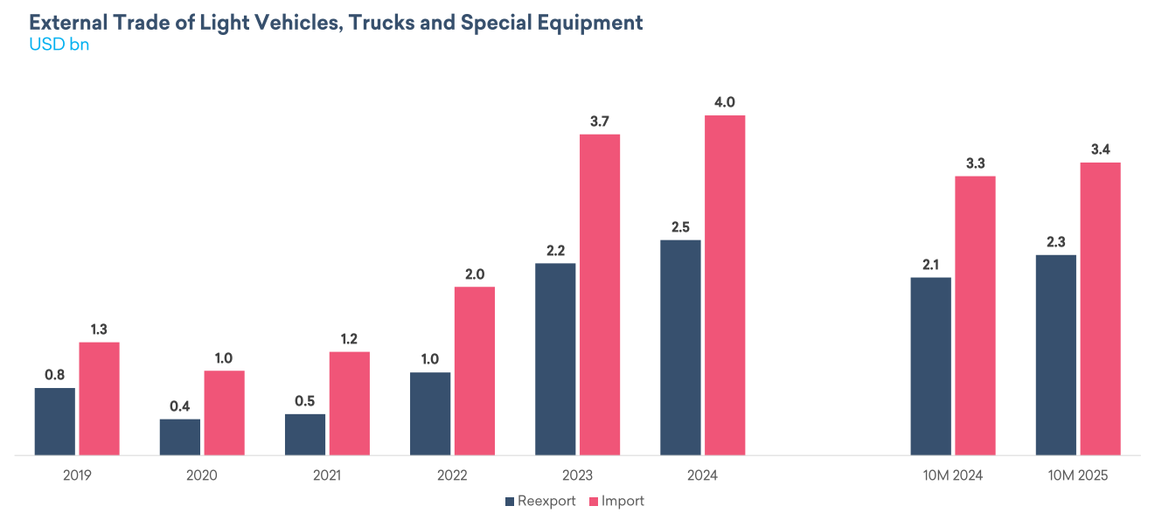

The expected strengthening of Toyota’s vehicle fleet in Georgia supports higher vehicle shipments to the local subsidiary and expands the installed base, which is critical for long-term aftermarket revenues such as spare parts and servicing. While the Georgian market remains immaterial in the context of Toyota Motor Corporation’s global financials, a larger fleet enhances brand dominance, reinforces customer loyalty, and strengthens competitive positioning in a region characterized by an aging vehicle stock.

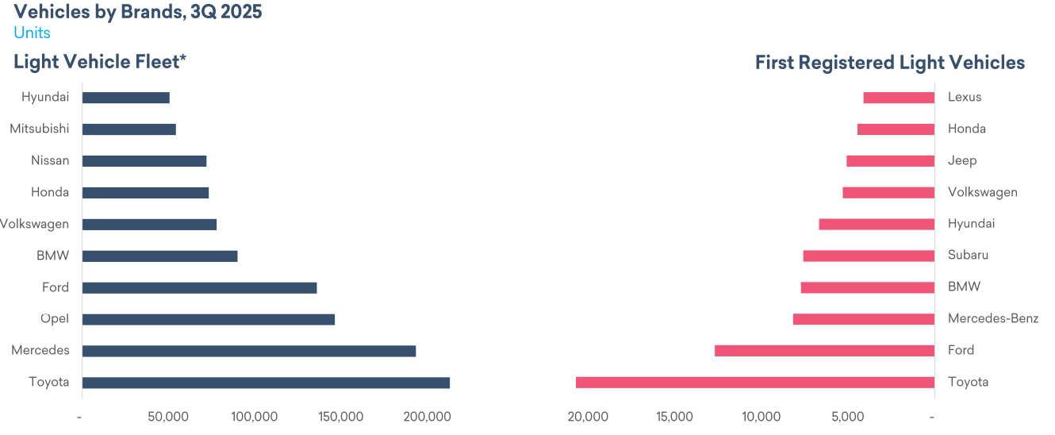

In terms of brand dynamics, Toyota maintains its leadership, though BYD has recently emerged as a notable new entrant in the brand-new car segment.
- As BYD grows, especially in electric vehicles (EVs) or hybrids, Toyota could see some erosion in its market share, particularly among customers looking for innovative or eco-friendly options.
- However, Toyota’s leadership and broad brand recognition still give it a strong base.

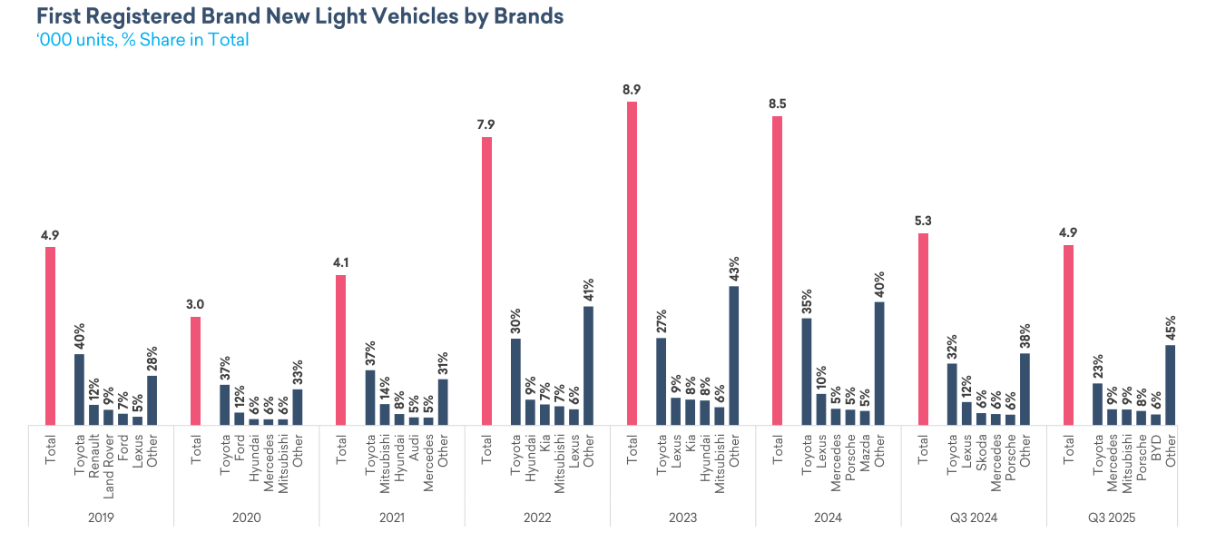

The price of new cars decreased from pandmeic and used cars remain elevated does that meaning many consumers delay upgrading. Instead of buying another used or even a new car, they:
- keep their existing vehicle longer
- spend money on maintenance, repairs, and replacement parts.

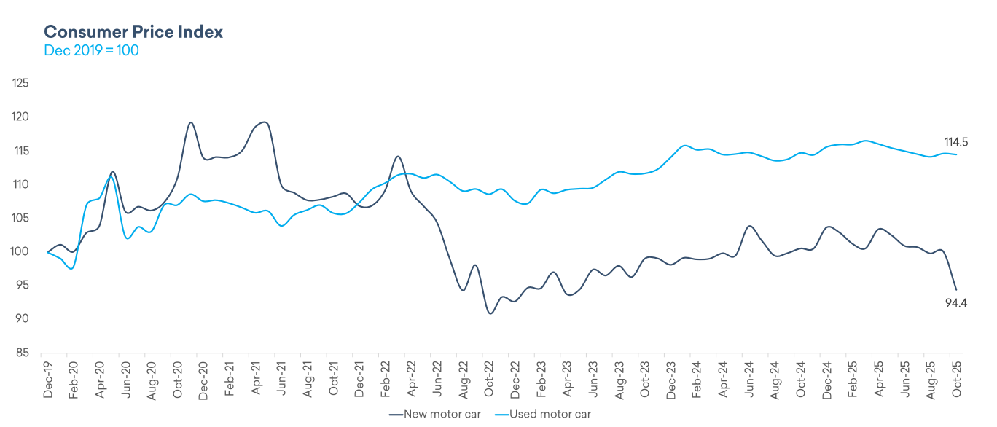

Overall, given the positive trends in trade, technological diversification, and alignment with Georgia’s economic growth trajectory, the industry is expected to maintain steady expansion, even with periodic adjustments in response to global price and logistics fluctuations.

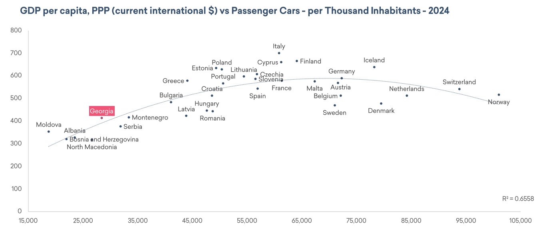

Tax envirounment
and other regulatory aspects that effect to the company

