 | Tegeta Motors is Georgia’s largest automotive distribution and service group, operating primarily in the wholesale and retail trade of motor vehicles and automotive products. The company imports and distributes a wide range of vehicles, spare parts, tires, lubricants, and industrial equipment, serving both individual consumers and corporate clients. In addition to sales, Tegeta provides after-sales services, including maintenance, repair, and technical support, supported by an extensive network of service centers across Georgia ………………………………………………………………………………………………………………………………………………………………  Mariam Jandieri;Nino Dadvani;Valerian Meipariani

MACROECONOMIC OVERVIEW

Investor Friendly Business Environment
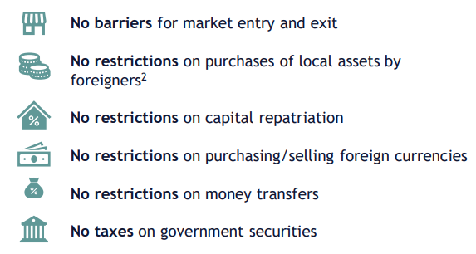

Key Indicators
Exchange rate (Jan 2026) | 1 USD = 2.6968 GEL
Nominal GDP | USD 34.2 bn
GDP per capita (PPP) | USD 28,299
Real GDP growth | 9.70%
Average inflation (2010–2023) | 4.70%
Inflation (2024) | 1.10%
Government debt / GDP | 35.70%
Current account balance / GDP | –5.3%

Georgia’s macroeconomic indicators in 2024 reflect strong growth alongside persistent structural vulnerabilities. Real GDP expanded by 9.7 percent, while inflation declined to 1.1 percent, indicating a favorable cyclical position and effective monetary policy.
However, despite moderate public debt of 35.7 percent of GDP, the economy continues to run a current account deficit of 5.3 percent of GDP, highlighting reliance on imports and external financing. The large gap between nominal GDP per capita and PPP-adjusted income points to solid domestic purchasing power, but also underscores limited productivity and export competitiveness
General Facts
Georgia

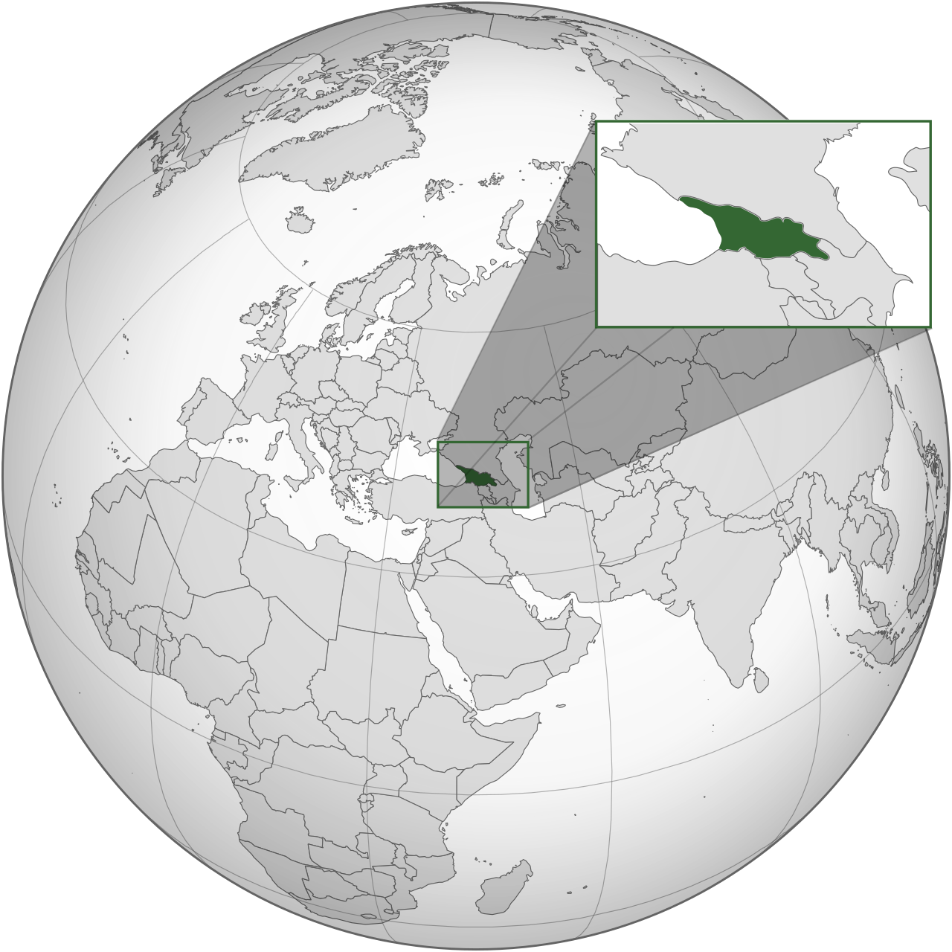

- Area: 69,700 sq. km
- Population (Nov 2025): 3.7 million
- Capital: Tbilisi
- Life expectancy: 73.7 years
- Official language: Georgian
- Currency (code): Lari (GEL)
- Literacy: 100%

- Flag:

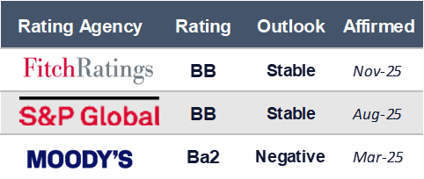
Sovereign Credit Ratings



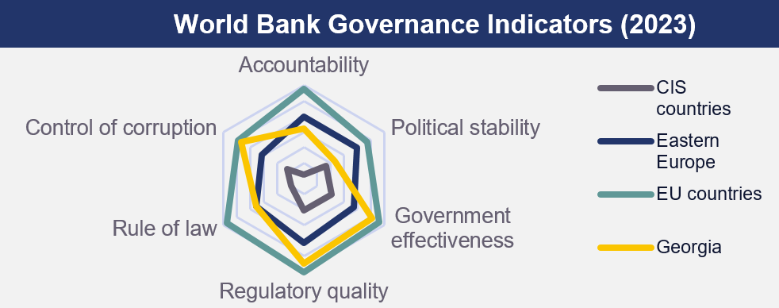

- Regulatory quality is Georgia’s strongest area, outperforming CIS countries and approaching Eastern European levels. This reflects a relatively business-friendly regulatory framework and ease of market entry and operation.
- Government effectiveness is solid but uneven: Georgia performs better than CIS peers, yet remains below EU standards, indicating capacity constraints in public service delivery and policy implementation.
- Control of corruption is a relative strength within the regional context, exceeding CIS averages and comparable to parts of Eastern Europe, which supports investor confidence and reduces informal costs for businesses.
- Rule of law remains a structural weakness, lagging behind Eastern Europe and the EU. This suggests ongoing challenges in contract enforcement, judicial independence, and legal predictability.
- Political stability is the weakest pillar, significantly below EU benchmarks, highlighting elevated political and geopolitical risks that can affect long-term investment planning.

Real GDP growth
Georgia’s economic growth over the past decade has been characterized by strong cyclical fluctuations. Following a period of steady expansion during 2015-2019, economic activity contracted sharply in 2020 due to the COVID-19 shock. This was followed by a rapid rebound in 2021-2022, supported by pent-up domestic demand, external inflows, and accommodative macroeconomic conditions.
Since 2023, growth has moderated from double-digit levels toward more sustainable rates, reflecting the gradual fading of post-crisis drivers and tighter financial conditions. The divergence between baseline, optimistic, and pessimistic scenarios highlights the economy’s sensitivity to external shocks, geopolitical developments, and demand conditions, particularly for sectors closely linked to consumption and trade.
The decomposition of GDP growth shows that Georgia’s economic expansion over the past decade has been predominantly demand-driven, with private consumption acting as the main growth engine. The sharp contraction in 2020 was driven by a collapse in exports and investment, only partially offset by consumption, highlighting the economy’s vulnerability to external shocks.
The post-pandemic recovery in 2021–2022 was led by a strong rebound in consumption and exports, supported by external inflows and normalization of trade flows. However, imports expanded faster than exports, causing net exports to remain negative despite robust headline growth. Overall, the composition of growth suggests limited progress toward export-led expansion, reinforcing reliance on domestic demand and exposing consumption and trade-related sectors to shifts in financing conditions and external demand.

Georgia’s GDP has expanded steadily since 2015, with growth accelerating after 2021 and becoming increasingly services-driven. Wholesale and retail trade (including motor vehicle repair) shows one of the strongest absolute increases, confirming its role as a core pillar of economic activity and domestic demand. Manufacturing and construction also expanded, particularly in the post-pandemic period, reflecting investment recovery and infrastructure activity, but their contribution remains more cyclical.
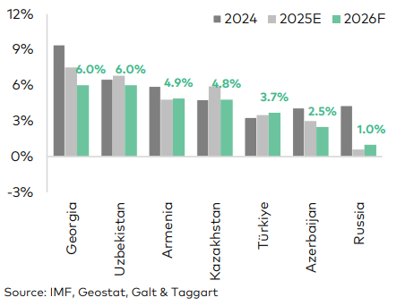
Transportation and storage grew in line with trade and logistics activity, benefiting from higher mobility, regional transit flows, and trade volumes. In contrast, agriculture’s contribution increased more modestly, continuing its long-term decline in relative importance. Overall, the structure of GDP points to an economy increasingly oriented toward trade, logistics, and service sectors, with growth closely linked to consumption, vehicle use, and distribution networks rather than heavy industry.

Compared to regional peers, Georgia is projected to maintain relatively strong economic growth over 2024–2026. While growth is expected to moderate from the post-pandemic peak, Georgia’s performance remains broadly in line with or above countries such as Armenia, Azerbaijan, and Türkiye, and well above Russia. At the same time, convergence toward growth rates similar to Uzbekistan and Kazakhstan indicates a normalization phase, where cyclical drivers fade and structural factors become more important.

BoP
As a % of GDP

Georgia’s balance of payments over 2015-2024 highlights persistent current account deficits, driven mainly by a structural goods trade gap. Imports have consistently exceeded exports, reflecting strong domestic demand and limited local production capacity. This pattern intensified after 2021, when economic recovery and rising consumption led to a renewed widening of the trade deficit.
The deficit has been partly offset by services exports, especially tourism, transport, and related activities, as well as by secondary income (transfers), which provide a stable buffer during periods of external stress. However, primary income remains negative due to profit repatriation and interest payments on external liabilities, limiting the overall improvement in the current account.
On the financing side, the financial account has reliably covered the current account deficit, with foreign direct investment acting as the most stable source of inflows. At the same time, portfolio and other investment flows are volatile, reflecting sensitivity to global financial conditions and interest rate cycles. This increases exposure to external shocks and financing costs, particularly during periods of global tightening.
Overall, the BoP structure suggests that Georgia’s external position remains demand-driven and import-dependent, leaving the economy sensitive to exchange-rate movements and external financing conditions. For sectors heavily reliant on imported goods, logistics, and external funding, these dynamics directly affect cost structures, pricing, and working-capital needs, making exchange-rate stability and access to foreign financing critical for sustainable operations.

Trade Balance
Enhanced customs procedures and trade infrastructure have transformed Georgia into a regional hub for the car trade since 2005. Successful reforms have enabled the economy to become a car-exporting country without its own car production industry. Initially, car re-exports were directed mainly to neighboring Azerbaijan and Armenia, with destination markets diversifying over time. Following steady growth during 2005–13 (with the exception of 2009), car exports declined sharply in 2014–16 due to the introduction of Euro-4 regulations in Azerbaijan combined with a regional economic slowdown.
Although exports recovered from 2017 as regional economies stabilized, the COVID-19 pandemic once again caused a significant contraction in export volumes due to global supply chain disruptions and reduced trade activity. Since 2021, however, car re-exports have rebounded strongly. Moreover, the Russia–Ukraine war has further amplified car export volumes, as shifting trade routes, sanctions, and increased regional demand reinforced Georgia’s role as a key transit and re-export hub.

On the import side, transport equipment imports expanded even more rapidly, deepening the trade deficit in this segment. Imports rose from around USD 0.8 bn in 2015 to over USD 4.6 bn by 2025, driven by domestic demand for vehicles, fleet renewal, infrastructure projects, and re-export activity. This confirms the sector’s import-intensive nature, typical for economies acting as regional trade and distribution hubs.
Inflation

Headline and core inflation remained broadly anchored around the 3% target prior to 2020, indicating effective monetary policy transmission. The sharp inflation surge in 2021–2022 reflected global commodity shocks, supply-chain disruptions, and strong domestic demand, with core inflation rising more gradually, pointing to increasing persistence. Since 2023, both measures have declined and stabilized close to target, signaling normalization of price pressures.
Transport inflation in Georgia is heavily driven by fuel prices, which are almost entirely imported. Global oil price cycles (2016 recovery, 2020 collapse, 2021–22 surge) pass through quickly and with high amplitude. This alone explains why transport inflation overshoots headline inflation in both directions. Because fuel, vehicles, and spare parts are imported, GEL depreciation amplifies price increases, while appreciation causes sharp disinflation. This is why transport inflation spikes during FX stress (2020–21) and drops abruptly when GEL strengthens (2022–23).
This confirms that cost pressures in transport-related sectors are more exposed to external shocks and adjust faster during disinflation phases.
According to the National Bank of Georgia’s forecast, inflation is expected to remain close to the 3% target over 2025–2027, with only temporary deviations. This outlook suggests a stable price environment in the medium term, reducing cost uncertainty for transport-intensive and trade-oriented sectors.
+ევრი4

Population
Georgia’s population has shown a gradual declining trend since 2015, driven mainly by negative natural increase and outward migration pressures. After several years of contraction, temporary population gains in 2023–2024 reflect short-term migration inflows rather than a structural demographic reversal. By end-2025, the population stands at around 3.7 million, broadly stable but below mid-2010s levels.

The age structure remains uneven, with a shrinking 16–30 cohort and a relatively large 30–50 working-age group, while the 70+ population is steadily increasing, indicating gradual population ageing. This suggests medium-term labor supply constraints and rising dependency ratios.
Gender composition has remained remarkably stable, with women accounting for 52% and men 48% over the past decade, indicating no structural gender shifts in the population.
Demographic trends point to tightening labor availability over time, increasing the importance of productivity gains and capital-intensive sectors, while consumption grow mainly because people of working age earn and spend more, not because the population is increasing.

Employment
Total employment has remained broadly stable over the past decade, while the unemployment rate declined sharply, from above 21% in 2015–2017 to around 13% by 2024–2025, reflecting post-pandemic recovery and improved labor absorption rather than strong labor-force expansion.
Sectoral employment dynamics show clear reallocation within the economy:
- Wholesale and retail trade (including vehicle repair) recorded a strong increase in employment, indicating rising domestic demand and expansion of trade-related services.
- Transportation and storage employment also increased, reflecting stronger logistics activity and higher mobility.
- Industry and construction expanded moderately, supporting investment-driven growth.
- In contrast, agriculture experienced a notable decline in employment, continuing the long-term structural shift away from low-productivity sectors.
- Employment in public administration and education remained broadly stable, suggesting limited public-sector-driven job creation.

Employment growth is increasingly concentrated in trade, transport, and industry, pointing to a more urban, services- and logistics-oriented labor market structure rather than broad-based job creation across all sectors.

Salary
Nominal wages in Georgia show a strong upward trend over 2015–2024, with growth accelerating notably after 2020. Salary increases intensified in 2021–2023, reflecting post-pandemic recovery, tight labor market conditions, and elevated inflation pressures that fed into nominal wage adjustments.

Wage growth in the non-public sector consistently outpaced inflation in recent years, indicating improving real income conditions for employed households. The wholesale and retail trade; repair of motor vehicles and motorcycles sector also recorded steady wage increases, though from a lower base, reflecting its labor-intensive nature and sensitivity to domestic demand cycles.
The sharp YoY wage growth in 2022–2023 suggests a combination of inflation pass-through and rising demand for labor in trade-related and service activities. By 2024, wage growth moderated but remained elevated, pointing to normalization rather than reversal.
Rising nominal wages support household consumption and demand in trade- and transport-related sectors, but also increase cost pressures for businesses, especially those reliant on skilled labor and logistics services.

+Real Wage
Public vs nonpublic sector

Financial Sector

The National Bank of Georgia (NBG)
The National Bank of Georgia (NBG) is the country’s independent central bank, mandated by law to ensure price stability and support sustainable economic growth. Institutional independence is a key strength of the NBG framework: the central bank is legally protected from political interference in monetary policy decisions, which enhances policy credibility and anchors inflation expectations.
Georgia operates under a floating exchange rate regime and an independent monetary policy, prioritizing capital mobility. Within the framework of the impossible trinity, this implies that the NBG does not target a fixed exchange rate and instead allows the lari to act as a shock absorber, intervening in the FX market only to smooth excessive volatility and accumulate reserves.
The NBG conducts monetary policy under an inflation-targeting regime, with a medium-term inflation target of 3%. The primary policy instrument is the monetary policy (refinancing) rate, which is set by the Monetary Policy Committee based on inflation forecasts, output dynamics, and external conditions.
Policy transmission operates through several channels:
- Interest rate channel – affecting borrowing costs, credit demand, and investment;
- Exchange rate channel – influencing imported inflation and competitiveness;
- Credit channel – shaping lending conditions and financial intermediation;
- Expectations channel – anchoring inflation expectations through credible communication.

Monetary Policy Rates
Before the pandemic, Georgia already operated with structurally higher policy rates than advanced economies.
When COVID-19 hit, the FED and ECB immediately cut rates to near zero, supported by deep financial markets, reserve-currency status, and strong institutional credibility. By contrast, the NBG’s easing capacity was limited. Aggressive cuts risked capital outflows and exchange-rate depreciation.
The post-pandemic period marked a regime shift. Global supply disruptions, energy and food price shocks, and sharp FX volatility translated rapidly into domestic inflation. In Georgia, this effect was amplified by high import dependence, energy and transport cost pass-through, shallow domestic capital markets.
The NBG responded earlier and more aggressively than both the FED and ECB, pushing the policy rate above 10%. This was not only an anti-inflation measure but a credibility-preserving strategy aimed at anchoring inflation expectations, stabilizing the lari, preventing dollarization pressures.
Meanwhile, the FED and ECB delayed tightening, initially misclassifying inflation as “transitory.”

As inflation declined sharply, NBG entered an easing cycle. However, cuts were gradual and asymmetric relative to advanced economies. Despite inflation falling close to target, the policy rate remained high in real terms due to persistent external uncertainty, geopolitical spillovers, still-elevated risk premia embedded in the economy. In contrast, the ECB and FED eased more slowly from a lower peak, reflecting their concern over wage-price persistence rather than FX stability.
Forecasts suggest Georgia’s policy rate will stabilize around 7%, well above the projected neutral rates of the FED and ECB. Monetary policy is carrying a disproportionate burden because capital markets and FX hedging instruments remain underdeveloped.

Exchange Rates
The exchange rate dynamics reflect two distinct regimes. The first phase is characterized by strong depreciation pressures, driven by a sudden deterioration in external balances and heightened uncertainty. The collapse of foreign-currency earnings, combined with elevated risk aversion, increased demand for FX and reduced supply, forcing the exchange rate to adjust as a shock absorber in a small open economy.
The second phase shows a clear reversal and subsequent stabilization. Improved external inflows strengthened FX supply, while normalization of economic activity reduced precautionary demand for foreign currency. At the same time, tighter monetary conditions and stronger policy credibility helped anchor expectations, limiting volatility. The recent period is best described as a stabilization regime, where the exchange rate is no longer driven by crisis dynamics but by structural inflows and macroeconomic fundamentals rather than short-term shocks.

Reserves
International reserves of the National bank of Georgia have followed a clear upward structural trend, reflecting stronger external buffers and improved resilience to shocks. The accumulation was driven primarily by sustained FX inflows and active reserve management, allowing the central bank to rebuild buffers after periods of stress. The growing reserve stock enhances confidence in the economy’s ability to meet external obligations, smooth exchange-rate volatility, and absorb sudden capital flow reversals.

Georgia’s Sovereign Credit Ratings Evolution
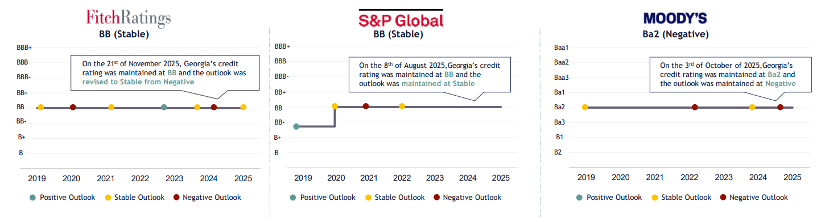
Key Credit Drivers
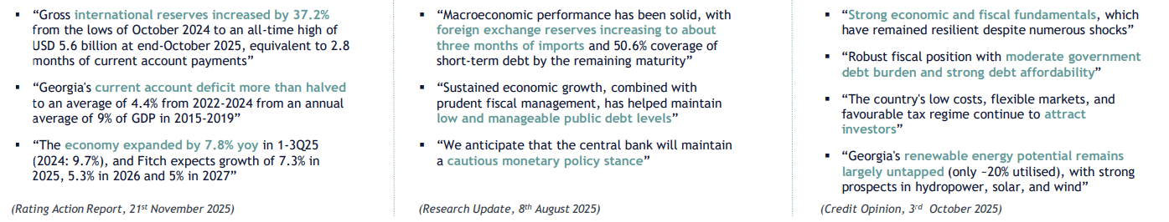

Government Debt
Georgia is an upper-middle-income economy with a relatively small and open economic structure, where public borrowing plays an important role in smoothing shocks and financing development needs. Government financing is sourced through a combination of external borrowing, primarily from multilateral and bilateral creditors and domestic issuance in the local capital market.
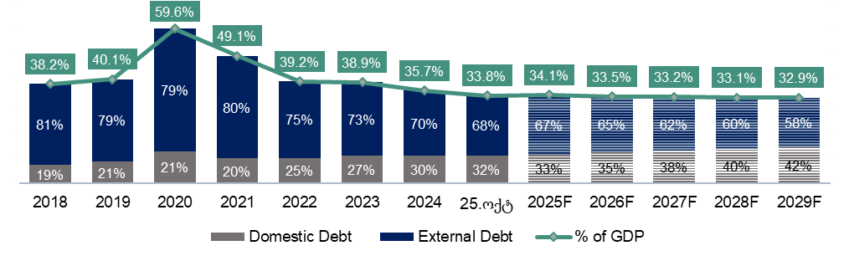
The pandemic-related shock in 2020 led to a sharp increase in public debt ratios across most countries, including Georgia. For Georgia and its regional peers, the debt-to-GDP ratio rose markedly in 2020, reflecting the combined effects of economic contraction, exchange rate depreciation, and crisis-related fiscal support. While comparable countries recorded an average increase of around 10 percentage points, Georgia’s rise was more pronounced. Forward-looking projections in the government’s Debt Management Strategy indicate that the debt-to-GDP ratio is expected to decline further, reaching around 32.9 percent by 2029.
Georgia’s public debt composition has gradually shifted toward a higher share of domestic borrowing, reflecting a strategic effort to reduce foreign-exchange risk and support local capital market development. The expansion of GEL-denominated issuance has helped build a benchmark yield curve and improve market infrastructure, strengthening debt resilience.
While the shift toward greater domestic borrowing reduces foreign-exchange risk and strengthens financial resilience, it also entails higher financing costs. As shown by the weighted average interest rates, domestic debt carries significantly higher yields compared to external concessional borrowing, reflecting tighter local liquidity conditions and underdeveloped capital market depth.

The share of interest payments in total budget expenditures increased from around 4.1% in 2015 to a peak of about 7.1% in 2024, reflecting crisis-related borrowing and tighter global financial conditions.
External borrowing has been largely directed toward infrastructure and capital investment, indirectly supporting trade, transport, and logistics-intensive sectors.

Eurobond
Recently, the Government of Georgia successfully issued USD 500 million Eurobond on the London Stock Exchange at a 5.125% coupon, the lowest among peers with comparable or even one-notch higher credit ratings in recent years. The issuance refinanced the 2021 Eurobonds and served as a key benchmark for assessing sovereign risk and investor confidence. Investor demand reached a record USD 2.8 billion (5.5× oversubscription), with participation from over 100 international investors, leading to a decline in Georgia’s risk premium by more than 50 basis points. Strong demand across regions reflects improved market perception of Georgia’s fiscal and economic framework, while interest in GEL-denominated instruments highlights growing potential for domestic capital market development.

Annual Amounts and Weighted Average Interest Rates on Commercial Banks' Loans
Bank lending expanded steadily over the period, with a particularly strong acceleration after 2021 in both local and foreign currency loans. This reflects post-pandemic recovery, rising investment demand, and improving business confidence, especially in trade, industry, construction, and transport-related activities.

At the same time, interest rates show a clear cyclical pattern. Local-currency loan rates declined gradually from very high levels in the mid-2010s, stabilized before the pandemic, and then adjusted upward again amid tighter monetary conditions and elevated inflation. Despite this, credit volumes continued to grow, indicating that demand for financing outweighed higher borrowing costs, particularly for working capital and expansion.
Foreign-currency loans consistently carried lower interest rates than local-currency loans, reflecting lower global benchmarks. However, the renewed increase in FX lending rates after 2022 highlights the transmission of global monetary tightening and rising external financing costs. This reinforces the trade-off faced by borrowers between cheaper FX funding and higher exchange-rate risk.
Overall, the charts suggest a credit-supportive but risk-sensitive environment: strong loan growth alongside rising rates points to robust sectoral activity, while the currency split underscores the importance of monetary policy, FX stability, and funding structure for business financing decisions.

Sector Overview
Georgia’s transport sector plays a structurally important role in the economy, closely linked to trade and logistics. As mentioned above, from a macroeconomic perspective, transport is critical because exports and imports are central to Georgia’s GDP model. As a small, open economy positioned as a transit corridor between Europe and Asia, Georgia relies heavily on road transport to support:
- Merchandise exports (agricultural products, metals, re-exports)
- Imports of consumer goods, vehicles, fuel, and capital equipment
- Regional transit and re-export activities
Compared to higher-income European countries, Georgia has lower vehicle ownership and significantly older vehicles, underscoring its role as an import-driven transport market rather than a domestic manufacturing hub. Overall, the transport sector underpins trade flows, employment, and fiscal revenues, making it a key enabler of Georgia’s export-import-driven growth strategy.

Trade Feature
External trade plays a critical role in Georgia’s economic structure and GDP dynamics, reflecting the country’s high degree of openness and integration into the global economy. Given Georgia’s relatively small domestic market and limited industrial base, imports are essential for meeting domestic consumption, supplying intermediate goods, and supporting investment activity. At the same time, exports are a key driver of foreign exchange inflows, employment, and sectoral development, particularly in areas such as agriculture, manufacturing, transport services, and re-exports linked to Georgia’s role as a regional transit hub. As a result, changes in export and import performance have a direct impact on economic growth, external balances, and macroeconomic stability, making trade indicators a crucial component of GDP analysis.

Georgia has firmly consolidated its role as a regional hub for automotive trade, despite having no domestic car production. The auto sector is structurally anchored in vehicle imports and re-exports, with new cars primarily imported from Asia (notably Japan) and used cars sourced mainly from the United States, refurbished locally, and re-exported to regional markets. As a result, transport equipment and related parts have become one of the dominant categories in Georgia’s external trade, accounting for a growing share of both imports and exports and positioning the auto industry as a key contributor to foreign trade turnover.

AutoPark
Georgia’s vehicle fleet has expanded rapidly, reaching 1.8 million vehicles in 2024 (approximately 490 vehicles per 1,000 inhabitants), reflecting rising mobility, trade activity, and logistics demand. The fleet is highly aged - over 80% of vehicles are older than 10 years, indicating strong dependence on vehicle imports, spare parts, fuel, and maintenance services. This creates sustained demand for transport-related imports and aftermarket services.

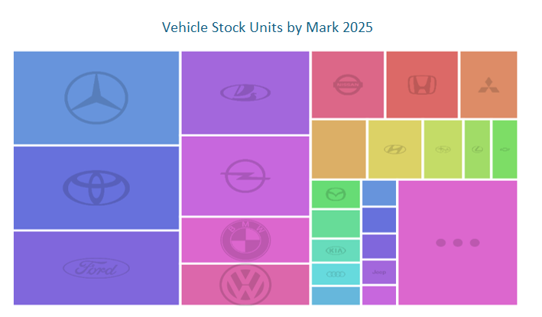

The vehicle stock structure in Georgia is highly diversified, with no single brand dominating the market. European brands (Mercedes-Benz 13%, BMW 5%, Volkswagen 4%, Opel 8%) together account for a significant share, reflecting strong demand for imported used vehicles from the EU. Japanese brands (Toyota 12%, Honda 4%, Nissan 4%, Mitsubishi 3%) also hold a substantial presence, underlining consumer preference for reliability and fuel efficiency.

Driving License Statistic
Strong expansion of the driver base - the total number of driving license holders increased substantially across almost all age groups.
Shift toward younger and prime-age drivers - Compared to 2017, 2024 shows a much larger concentration of license holders in younger age groups (16–30), indicating new market entrants rather than only aging drivers. Persisting male dominance with gradual female growth - While male drivers remain the majority across all ages, female participation increased noticeably, especially in younger cohorts, expanding the potential customer base.

According to TBC Capital annual report Toyota is the largest brand in Georgia (around 35% brand share in recent vehicle market data), followed by Renault and Ford (source provides brand shares, not company shares). These brand shares indicate where dealer networks (including Tegeta for specific brands) capture volume.
Tegeta publicly states it is the largest importer and automotive group in Georgia with extensive nationwide service centers and large employee base implying it is a market leader across dealership, parts distribution and service segments. Public filings and the Group website support Tegeta’s leading role.
The second-hand market in Georgia plays a significant role in the auto-service industry and is widely regarded as part of the shadow economy. A substantial portion of its activities is either poorly documented or not accounted for at all in official statistics. Repair service prices at Eliava and other such marketplaces are relatively low, which drives very high demand. The volume of services provided generates a considerable amount of revenue that remains largely excluded from GDP calculations. As a result, these market represents a strong informal competitor to formal market participants, including Tegeta Motors.

Georgia on Map
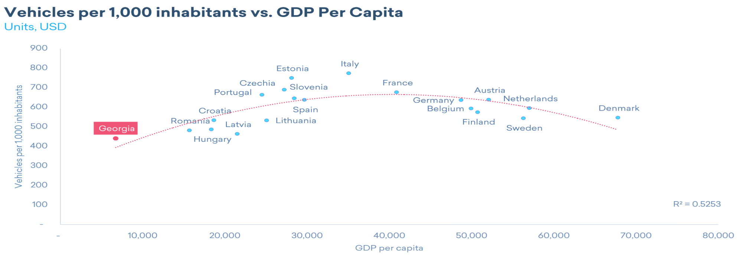
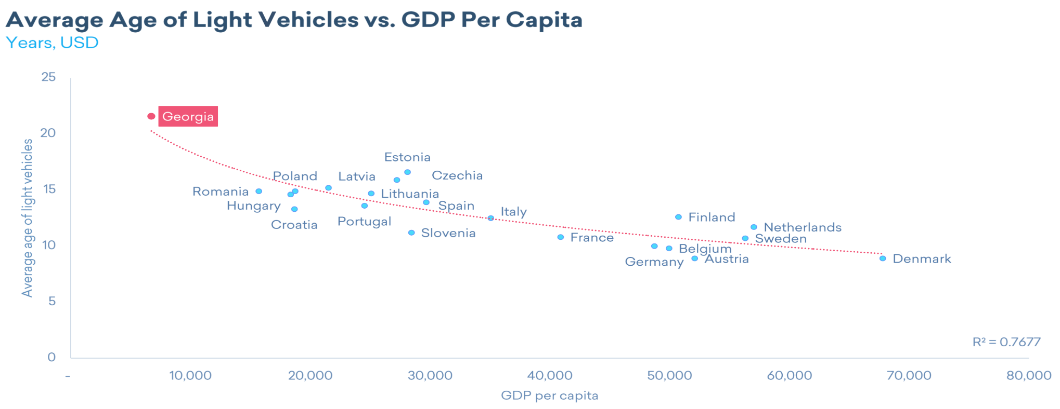

Comparable countries: Albania, Armenia, Azerbaijan, Bosnia and Herzegovina, Bulgaria, Croatia, Czech Republic, Estonia, Hungary, Latvia, Lithuania, Moldova, Montenegro, North Macedonia, Poland, Romania, Serbia, Slovak Republic, Slovenia.

