Power BI – Advanced Reporting Concepts
Task 4 – Work Description
In this task, I worked with several Power BI features to make the report more interactive and easier to explore.
1. Row-Level Security (RLS)
First, I created a security role called “USA Sales”. I used the Sales Territory table and filtered SalesTerritoryCountry to “United States”. I applied the role and checked that it affected the report data. Then I published the report to My workspace and configured the role in Power BI Service.
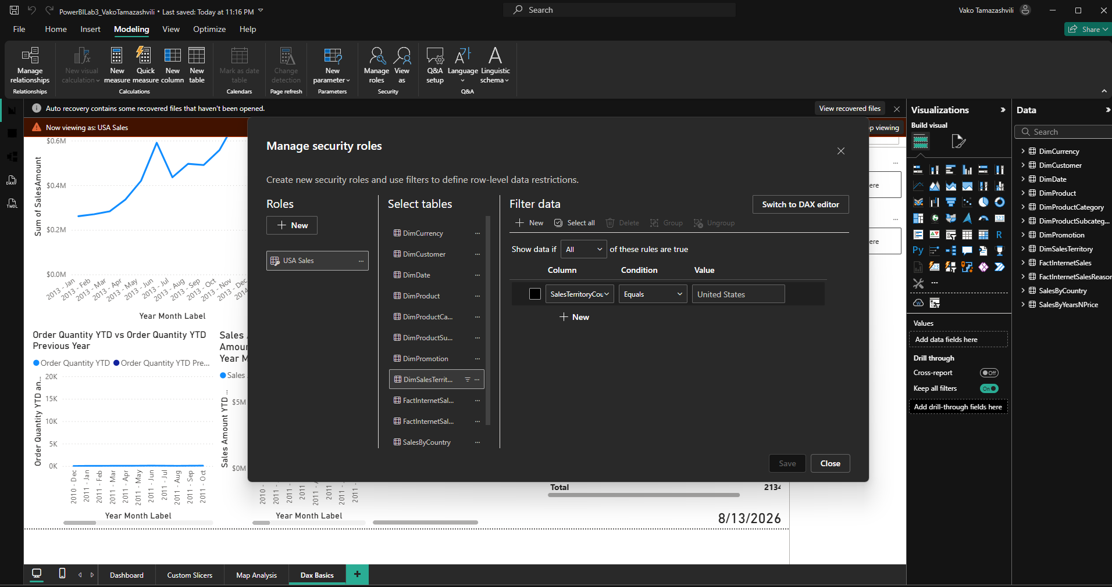
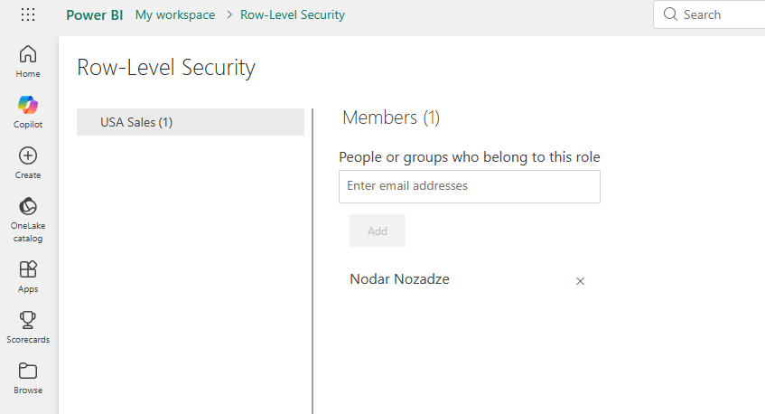
2. Bookmarks and Buttons
I created a bar chart and a map using the same sales data and placed them in the same area. Then I used the Selection pane and Bookmarks to control which visual was visible. Finally, I added buttons and connected them to the bookmarks so I could switch between the two visuals.
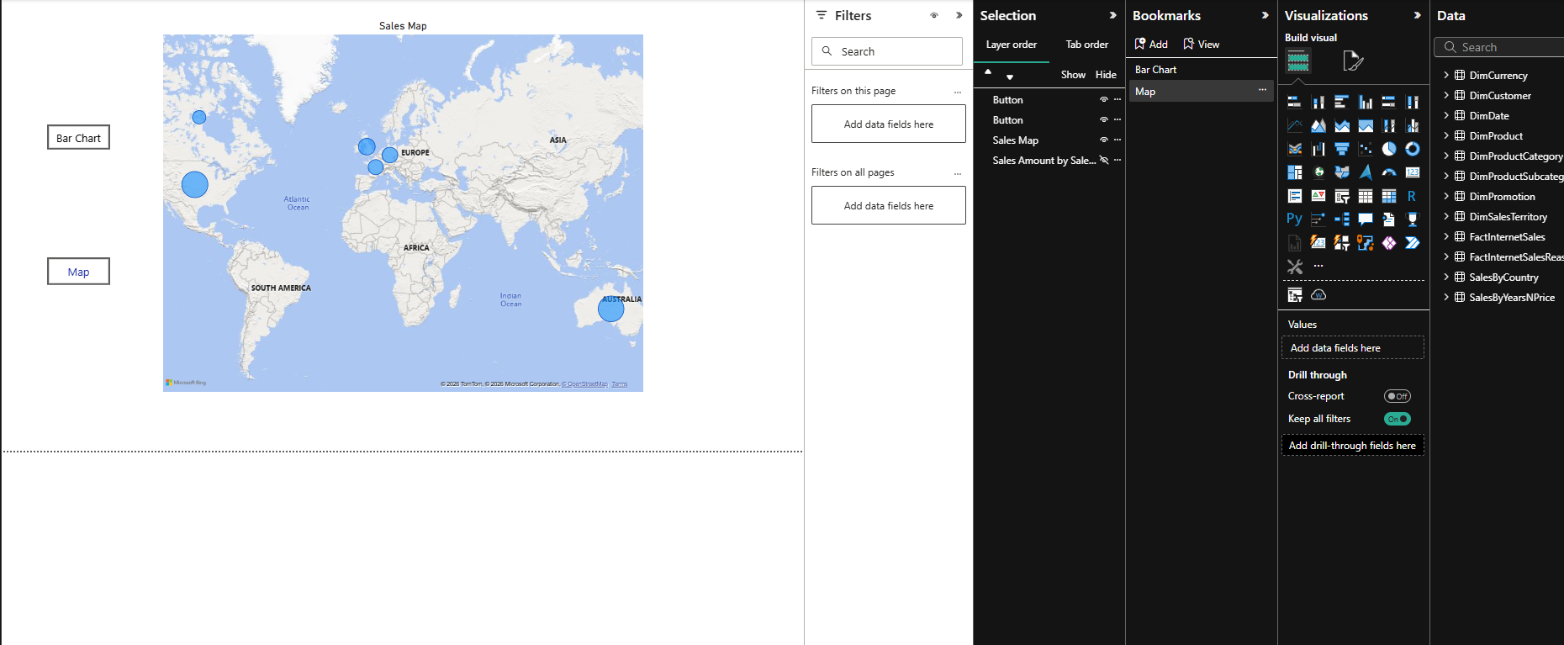
3. MTD, QTD and YTD Switch
I created MTD and QTD measures and used the existing YTD measure. I created a Field Parameter with the three measures and added it to a line chart with Year Month Label. This lets me switch between MTD, QTD and YTD in the same visual. I also marked DimDate as the date table because the time-intelligence calculations were not working correctly before that.
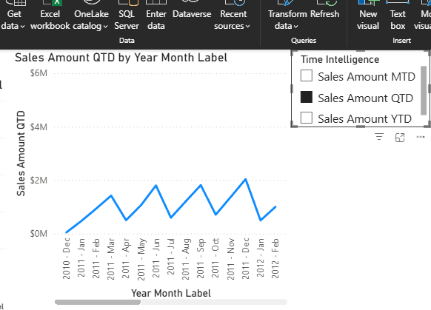
4. Decomposition Tree
I created a decomposition tree using Sales Amount as the main measure. I added SalesTerritoryCountry, EnglishProductCategoryName and Color as the three independent variables. I tested the tree by drilling from Sales Amount to a country, then to a product category and finally to color.

5. Report Page Tooltip
I created a separate tooltip page and changed its page size to Tooltip. I added a Sales Amount card and connected the page to the decomposition tree. Now, when I hover over a node in the tree, the tooltip shows the corresponding Sales Amount.
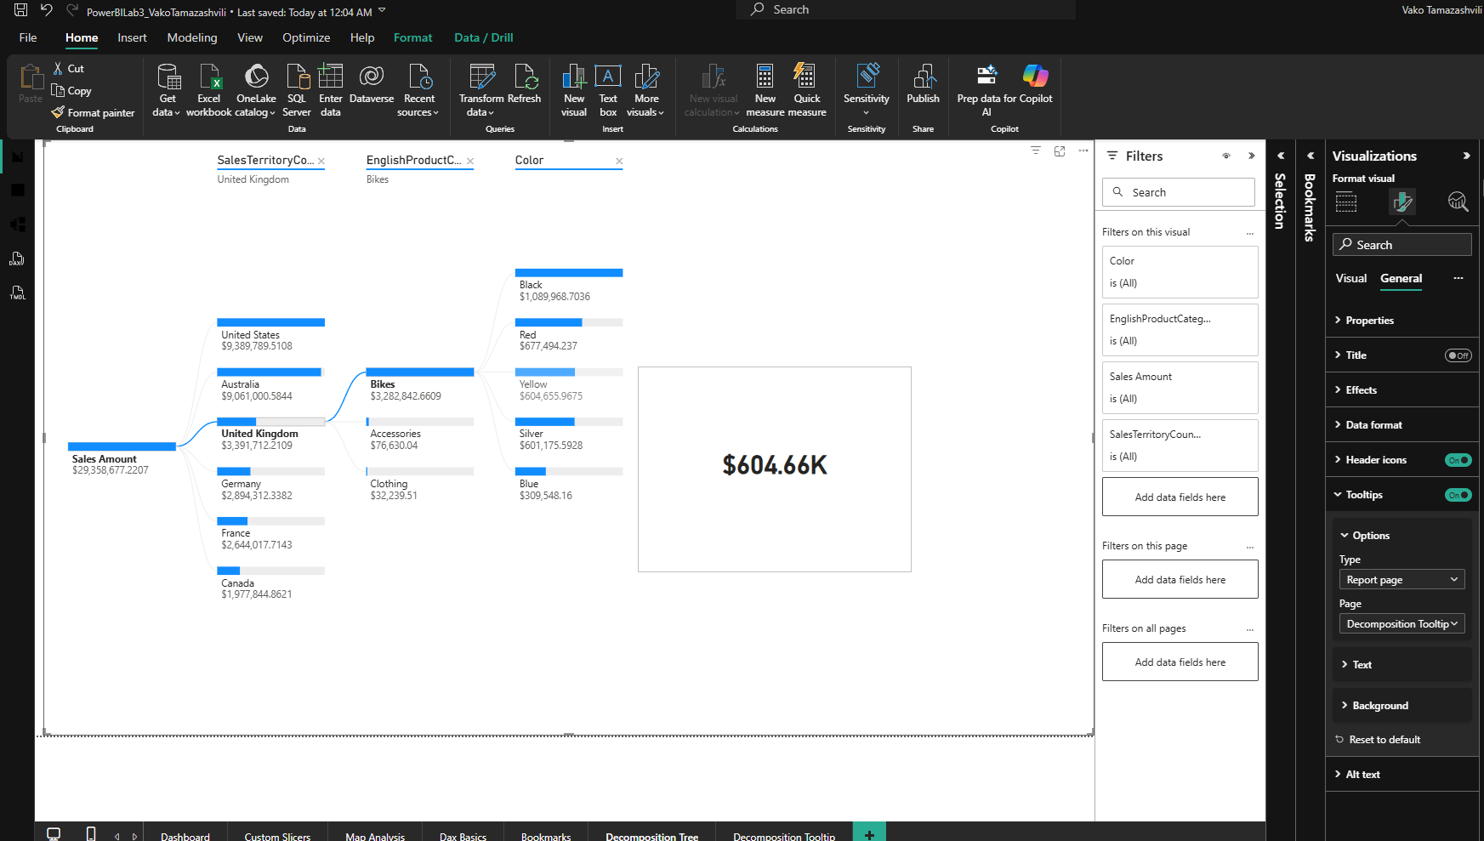
6. Drill-through
As additional task, I created a Sales Details drill-through page using SalesTerritoryCountry as the drill-through field. I added product and sales information to the page and tested it by drilling from a country in the sales chart. The page opened filtered to the selected country.

