1.1
Connected to the postgres database and created a new database named test_db. Verified its creation by querying the pg_database and pg_tablespace system catalogs. The database was successfully created and is currently located in the default PostgreSQL tablespace (pg_default).
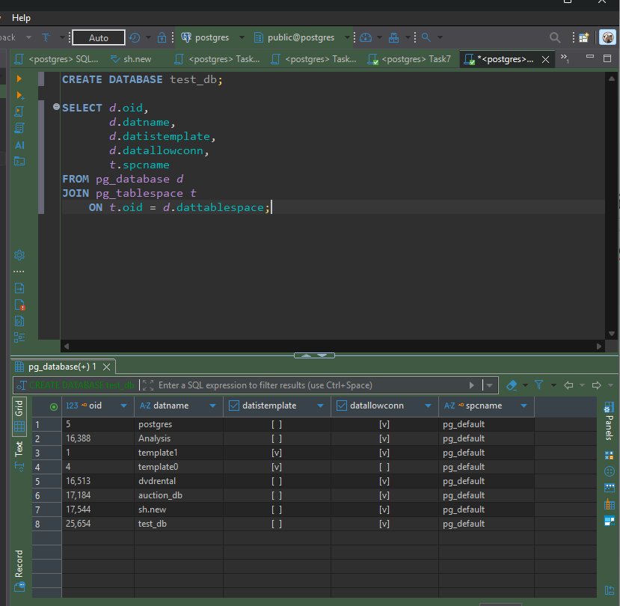
1.2
Created a new tablespace named mytablespace. Verified its existence using the pg_tablespace system catalog. Moved the test_db database to the new tablespace using ALTER DATABASE … SET TABLESPACE. Executed the verification query again and confirmed that the database is now associated with mytablespace.
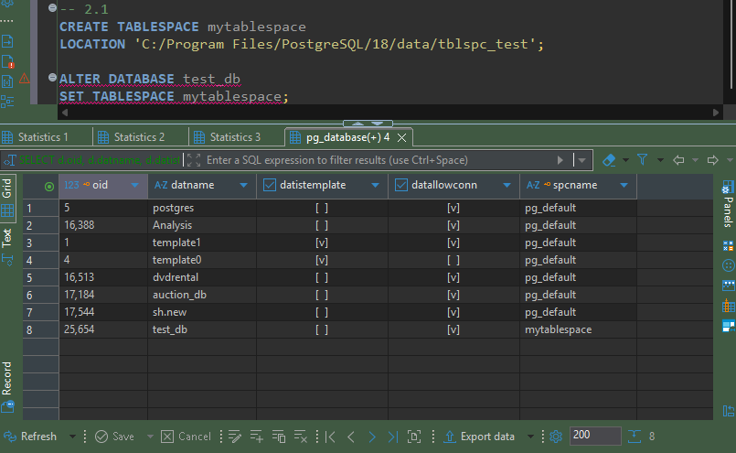
1.3
Connected to the test_db database and created a new schema named labs. Inside the schema, created the person table with two columns: id and name. Verified that the table was successfully created by querying the pg_tables system catalog.
Inserted three records into the person table (Bob, Alice, and Robert). Then checked the current search_path, which was "$user", public. Changed it to labs using the SET search_path command. After updating the search path, verified that the person table could be accessed without specifying the schema name by executing SELECT * FROM person;. This demonstrates that PostgreSQL automatically searches the labs schema for database objects.
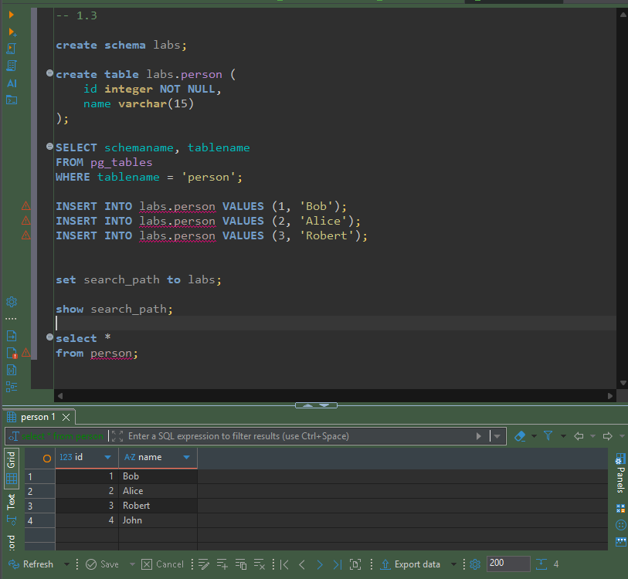
3.1
Updated the record with id = 2 by changing the value from Alice to Alex. PostgreSQL did not modify the existing row directly. Instead, it created a new tuple containing the updated data and marked the old tuple as obsolete. The original row received a non-zero xmax, indicating the transaction that replaced it, while the new row received a new xmin representing the update transaction. The ctid also changed because the updated version was stored as a new physical tuple. This demonstrates PostgreSQL's Multi-Version Concurrency Control (MVCC) mechanism, which preserves previous row versions until they can be safely removed.
Deleted the record with id = 3 (Robert). The row disappeared from normal query results, but the physical tuple remained in the table page. PostgreSQL marked the tuple as deleted by assigning a non-zero xmax, which stores the transaction ID of the delete operation. The xmin remained unchanged because it still represents the transaction that originally inserted the row. This demonstrates that PostgreSQL does not immediately remove deleted rows; instead, they remain in storage until they are cleaned up by the VACUUM process.
Inserted a new record with id = 999 and name = 'Test'. PostgreSQL created a new tuple in the table with a unique physical location (ctid) and assigned a new xmin representing the transaction that performed the insert. The xmax value remained 0, indicating that the row is currently active and has not been updated or deleted. Existing tuples were not modified, illustrating how PostgreSQL stores newly inserted rows independently under the MVCC mechanism.
Deleted the record with id = 999. The row was no longer visible in normal query results, but the physical tuple remained in the table page. PostgreSQL assigned a non-zero xmax, indicating the transaction that deleted the row, while xmin continued to represent the original insert transaction. The deleted tuple remains stored until a VACUUM operation reclaims the space, demonstrating PostgreSQL's MVCC behavior.
During this task, the behavior of PostgreSQL's Multi-Version Concurrency Control (MVCC) was investigated. It was observed that INSERT creates new tuples with a new xmin, UPDATE creates a new tuple version while marking the previous version with xmax, and DELETE marks tuples as deleted without immediately removing them from storage. The physical row versions remain in the table until they are cleaned up by the VACUUM process, allowing PostgreSQL to provide consistent transaction visibility while supporting concurrent access.

3.2
Executed VACUUM on the labs.person table. The dead tuples created by previous UPDATE and DELETE operations were cleaned up and their storage became available for future inserts. The active tuples remained in their original physical locations, and their ctid values did not change. This demonstrates that a regular VACUUM reclaims reusable space without rewriting the table or changing the physical locations of live rows.
Inserted a new record (Sarah) after executing VACUUM. PostgreSQL reused one of the free tuple slots that became available after cleaning up dead tuples. The new row received a new xmin representing the insert transaction and occupied the previously released physical location (ctid = (0,3)). This demonstrates that a regular VACUUM makes freed space available for future inserts without reorganizing the entire table.
Executed VACUUM FULL on the labs.person table. Unlike a regular VACUUM, VACUUM FULL rewrote the entire table, permanently removing dead tuples and compacting the remaining data. The physical locations (ctid) of several rows changed because PostgreSQL created a new compact version of the table. After the operation, all active tuples were stored consecutively with no unused space remaining. This operation also reduces the physical size of the table on disk.
The behavior of both VACUUM and VACUUM FULL was investigated. A regular VACUUM removes dead tuples and makes their storage available for reuse without changing the physical locations of active rows or reducing the table size. In contrast, VACUUM FULL rewrites the entire table, eliminates unused space, compacts the remaining tuples, updates their physical locations when necessary, and reduces the amount of disk space occupied by the table.
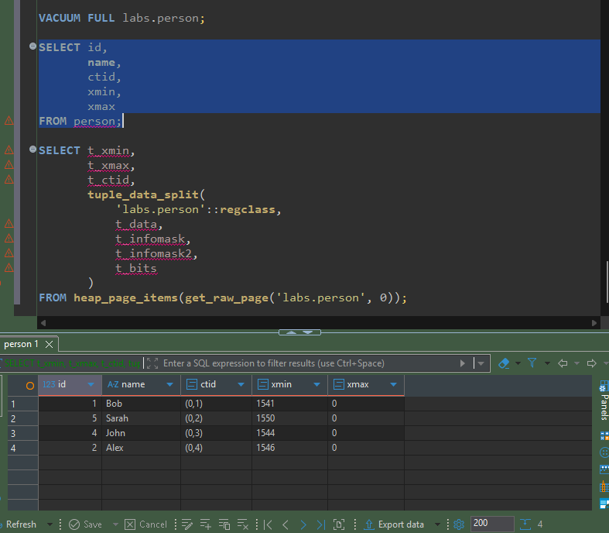
Conclusion
During this laboratory exercise, PostgreSQL database architecture and storage mechanisms were explored. A new database, tablespace, schema, and table were created and verified using PostgreSQL system catalogs. The behavior of Multi-Version Concurrency Control (MVCC) was investigated by observing how INSERT, UPDATE, and DELETE operations affect tuple versions through the xmin, xmax, and ctid system columns. The differences between VACUUM and VACUUM FULL were also examined.
It was observed that PostgreSQL's MVCC architecture enables non-blocking reads, meaning that readers do not block writers and writers do not block readers. Instead of modifying rows directly, PostgreSQL creates new tuple versions, allowing concurrent transactions to access consistent data.
Frequent UPDATE and DELETE operations generate dead tuples, which accumulate over time and can lead to table bloat if they are not cleaned up. Regular VACUUM (or PostgreSQL's autovacuum) is therefore essential to reclaim reusable space and maintain database performance, while VACUUM FULL additionally compacts the table and reduces its physical size.
From a Data Warehouse perspective, this behavior is especially important because large ETL batch loads and update operations can create significant numbers of dead tuples. As a result, an effective vacuum strategy is an important part of maintaining PostgreSQL databases used for DWH workloads.

