Task 1
The UNLOGGED table demonstrated significantly better insert performance than the regular table. Inserting one million rows into the UNLOGGED table took only 0.4 seconds, compared to 1.2 seconds for the regular table. Similarly, inserting the remaining five million rows took 2.2 seconds for the UNLOGGED table versus 6.7 seconds for the regular table.
Task 2
This task demonstrated how PostgreSQL table inheritance works. Child tables inherit the structure of the parent table and are automatically included when querying or updating the parent unless the ONLY keyword is used. Schema changes, such as adding new columns, are propagated to inherited tables, making inheritance useful when related tables share common attributes while maintaining their own additional columns.
Screenshots:
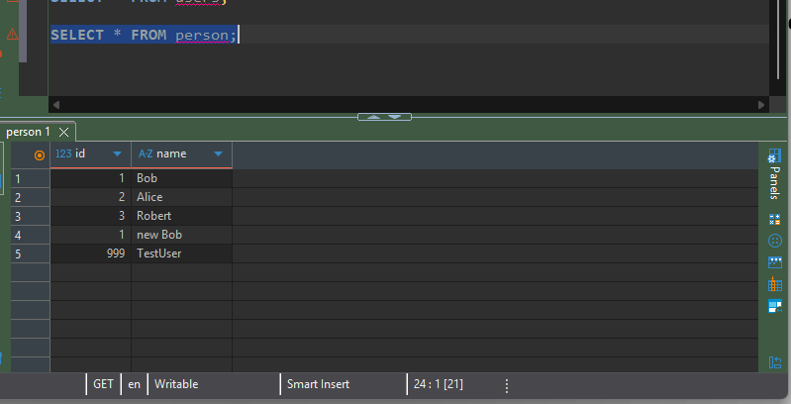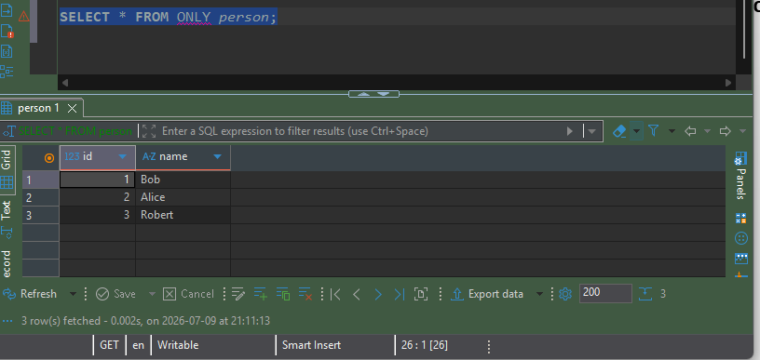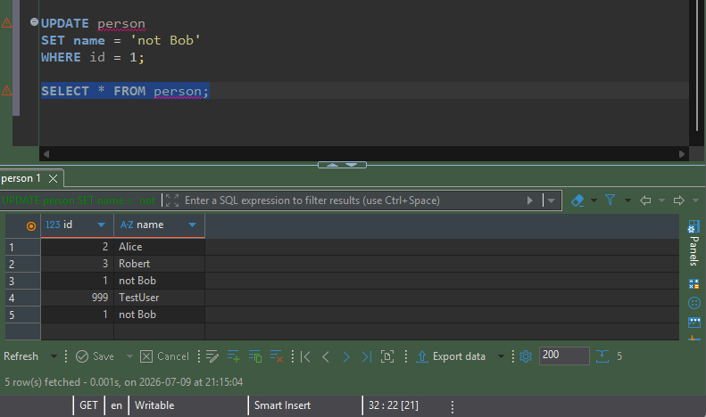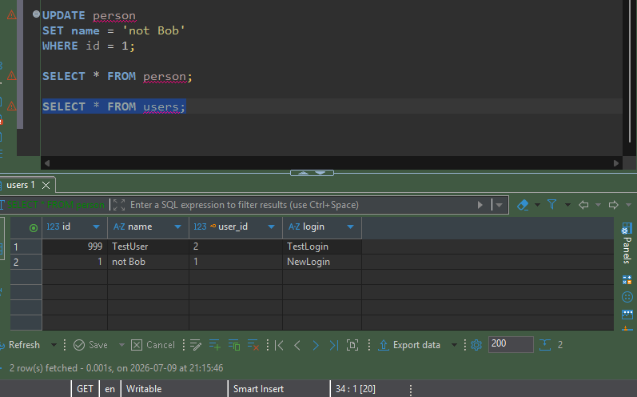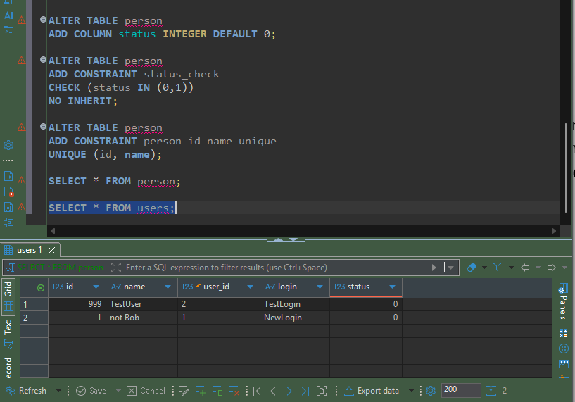

Task 3
The purpose of this task was to compare the performance of B-Tree and BRIN indexes on a large table containing timestamp data. The comparison included table size, index creation time, index size, and query performance.
The generated table occupied 666 MB of storage. After creating a B-Tree index on the load_date column, the index size was 338 MB, which is approximately half the size of the table itself. Building the index required 5.637 seconds.
The BRIN index produced significantly different results. It was created in only 0.66 seconds and occupied just 40 KB, making it dramatically smaller and much faster to build than the B-Tree index.
Running the query with EXPLAIN ANALYZE demonstrated how PostgreSQL changes its execution plan depending on the available index. Without an index, PostgreSQL performs a sequential scan of the table. After creating the B-Tree index, the optimizer can use the index to locate matching rows more efficiently. When using the BRIN index, PostgreSQL uses summarized page information to reduce the amount of data scanned, which is highly efficient for large tables where data is naturally ordered by timestamp.
Screenshots :
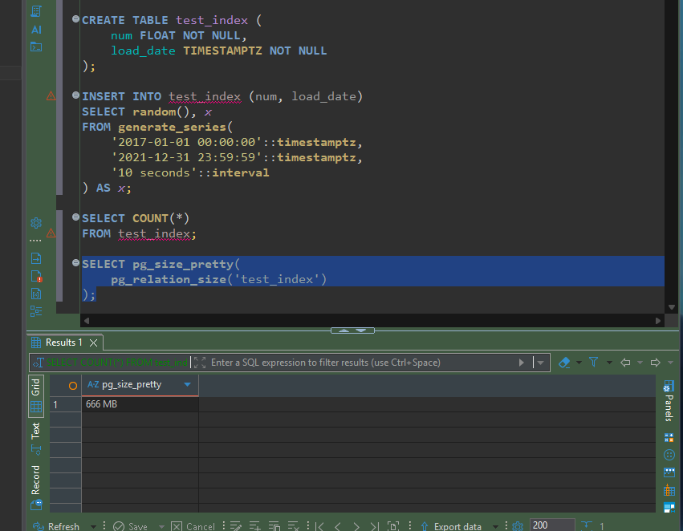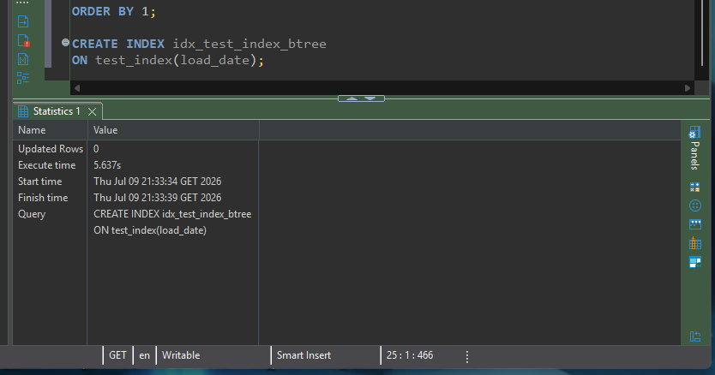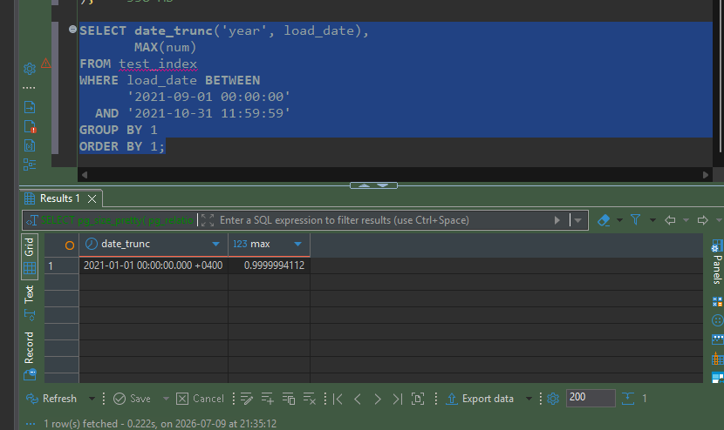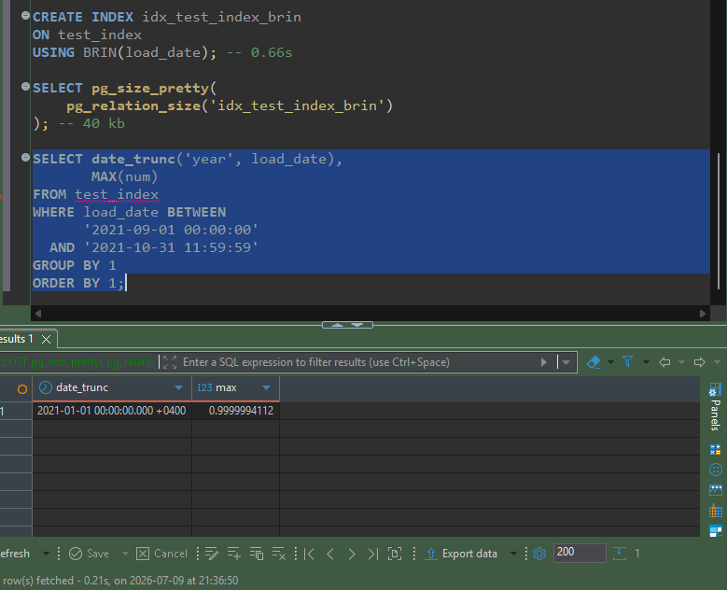
Task 4 Gin vs Gist
The purpose of this task was to compare GiST and GIN indexes for text searching using the pg_trgm extension. The comparison focused on index creation time, index size, and query performance when searching text with the LIKE operator.
The experiment showed a significant performance difference between the two index types.
The GiST index required 4 minutes and 27 seconds to build and occupied 1768 MB of storage. Executing the text search query using the GiST index took approximately 1.2 seconds.
The GIN index produced much better results in this environment. It was created in only 1 minute and 1 second, occupied 600 MB, and reduced the query execution time to approximately 0.02 seconds.
Using EXPLAIN ANALYZE demonstrated that PostgreSQL changed its execution plan after the indexes were created. Instead of performing a sequential scan, the optimizer used the available trigram index to locate matching rows much more efficiently.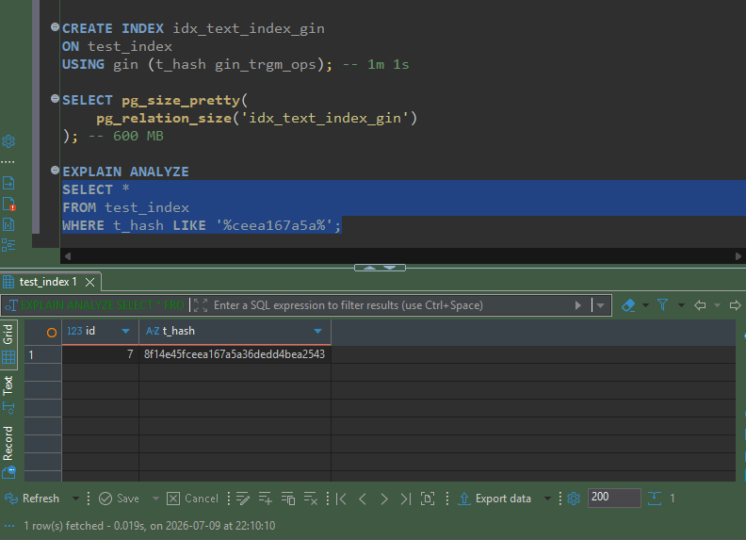
Task 5
The purpose of this task was to use PostgreSQL's Foreign Data Wrapper (FDW) functionality to access a CSV file as if it were a regular database table. The task also demonstrated the difference between querying a foreign table directly and querying a materialized view created from that table.
The foreign table allowed PostgreSQL to read data directly from the CSV file without importing it into the database. Selecting data from the foreign table returned the contents of the CSV file, and the row count matched the file.
After deleting several rows from the CSV file, the row count returned by the foreign table immediately reflected the changes. This demonstrated that a foreign table always reads the current contents of the external file.
A materialized view was then created from the foreign table. Unlike the foreign table, the materialized view stored a snapshot of the data at the time it was created. After deleting rows from the CSV file, the row count in the materialized view remained unchanged until the view was refreshed.

