Task 4
1.1
Since there is no index on load_date, PostgreSQL performs a Sequential Scan, reading every row of the table and applying the WHERE filter. The matching rows are then sorted by num because of the ORDER BY 1 clause. EXPLAIN displays only the estimated execution plan, while EXPLAIN ANALYZE executes the query and reports actual execution statistics. EXPLAIN (ANALYZE, BUFFERS) additionally shows memory and disk buffer usage, making it possible to determine whether data was read from cache or disk. The sort operation uses an External Merge Sort, indicating the result set exceeded the available memory and temporary disk space was used, which increases execution time.
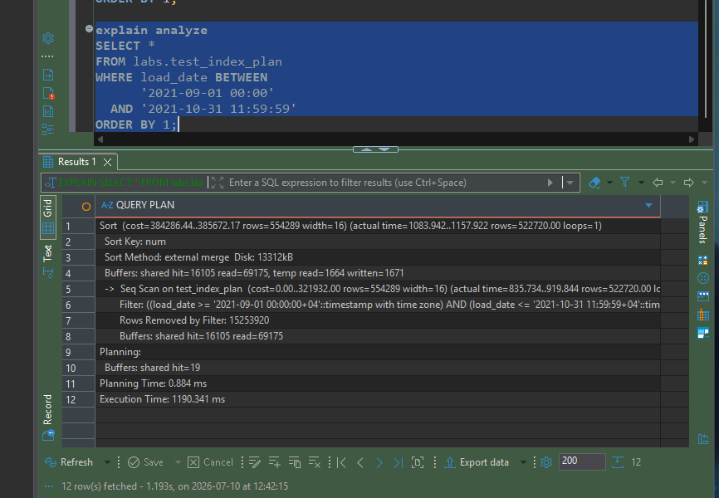
1.2
After creating a B-tree index on load_date, PostgreSQL changed the execution plan from a Sequential Scan to an Index Scan. Instead of scanning the entire table, it uses the index to locate only the rows within the specified date range. This significantly reduces disk I/O and execution time (from about 1190 ms to about 226–305 ms). The query still performs a sort because the results are ordered by num, while the index is built on load_date. An Index Only Scan is not used because the query selects all columns (SELECT *), but the index contains only load_date. It could be enabled by selecting only indexed columns or by creating a covering index using INCLUDE (num).

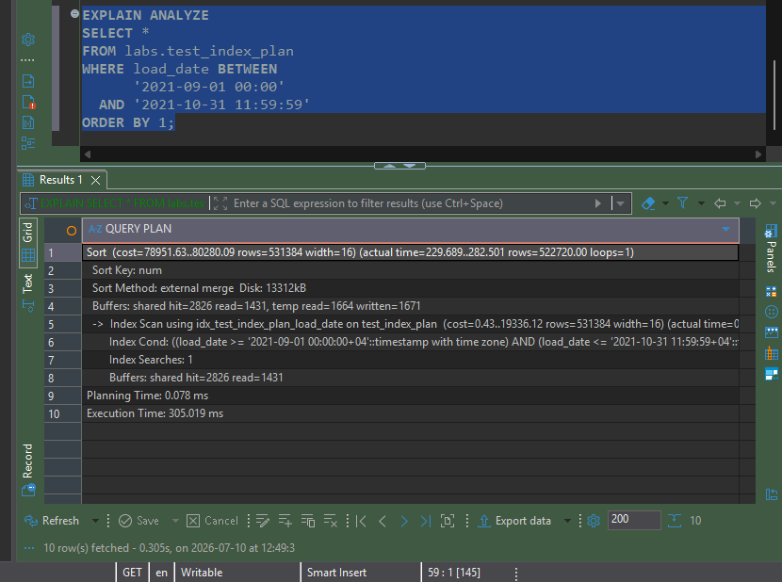

Index only scan
To enable an Index Only Scan, the query must request only columns that are stored in the index. In this example, selecting only load_date allows PostgreSQL to satisfy the query directly from the B-tree index. Since the execution plan shows Heap Fetches: 0, PostgreSQL did not need to access the table, making the query significantly faster than an ordinary Index Scan.
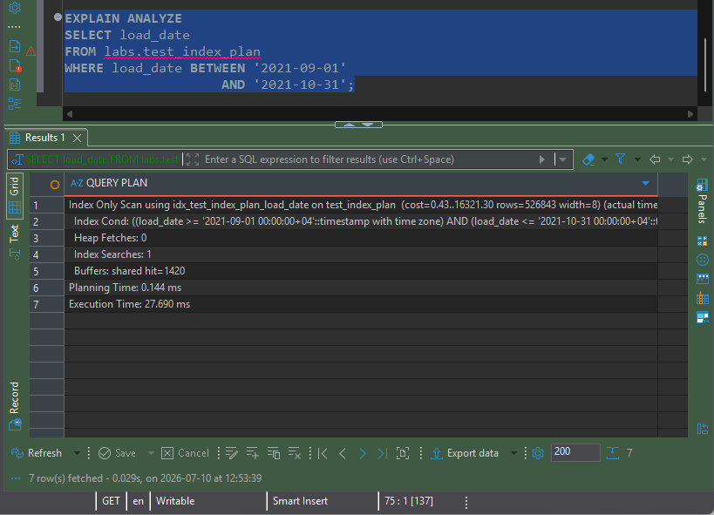

BRIN index
The BRIN index reduced query execution time compared to a Sequential Scan by scanning only the relevant page ranges instead of the entire table. However, it was slightly slower than the B-tree index because it requires row rechecks. BRIN indexes are best suited for very large tables with naturally ordered data, where they provide good performance while using much less storage than B-tree indexes.
Conclusion
I would choose a B-tree index for frequent lookups where exact row access is required, such as equality searches or selective range queries. I would choose a BRIN index for very large tables where the indexed column is naturally ordered, such as timestamps or sequential IDs. BRIN indexes are much smaller and cheaper to maintain because they store summaries of page ranges instead of an entry for every row. They are ideal for data warehouse and ETL workloads where data is appended in order, although they are less precise and require a recheck of matching rows.
2.1 Bulk Insert
A bulk INSERT INTO ... SELECT copies data from one table to another using a single SQL statement. This is much more efficient than executing many individual INSERT statements because PostgreSQL parses and plans the query only once and performs the operation in a single transaction. Although the target table has a B-tree index, PostgreSQL updates the index automatically as rows are inserted.

Using a single INSERT statement with multiple VALUES clauses is more efficient than executing many separate INSERT statements. PostgreSQL parses and plans the statement only once, reducing execution overhead and improving performance.
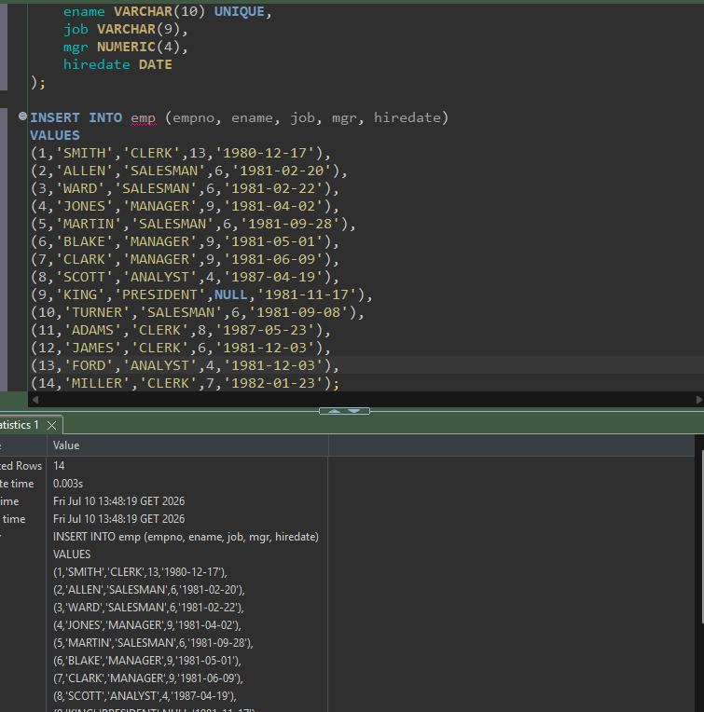

The COPY command is PostgreSQL's most efficient method for bulk data import and export. COPY TO exports table data or query results directly to a CSV file, while COPY FROM loads data from a CSV file into a table. Compared to individual INSERT statements, COPY is significantly faster because it processes data in bulk with minimal parsing and transaction overhead. In this task, the exported data was successfully imported into test_copy, and the row count matched the source table, confirming a successful data transfer.

2.3 Upsert
An UPSERT combines an INSERT and an UPDATE in a single statement. PostgreSQL uses the ON CONFLICT clause to detect conflicts on a unique constraint or primary key. If no conflict exists, the row is inserted. If a conflict occurs, the existing row is updated using the values from the EXCLUDED pseudo-table. This approach is efficient because it eliminates the need to check whether a row already exists before deciding to insert or update.
