Task 5
  - Task 1: Nested loop join
PostgreSQL selected the Nested Loop Join because the join condition uses the inequality operator (a.id1 > b.id1). Hash Join is designed for equality conditions, and Merge Join is generally applicable to sorted equality joins, so Nested Loop is the appropriate method. PostgreSQL performs a sequential scan of test_joins_a as the outer table and sequentially scans test_joins_b, materializing it in memory so it does not need to be read repeatedly. The join evaluates approximately 100 million comparisons (10,000 × 10,000), returning 49,995,000 matching rows and rejecting 50,005,000 rows. This large number of comparisons explains the relatively high execution time.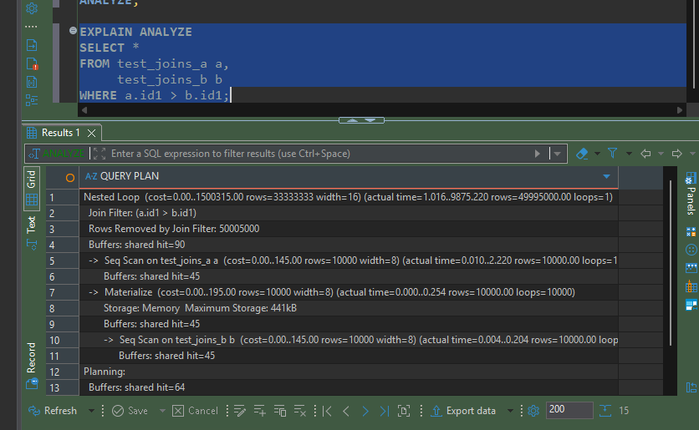

PostgreSQL selected the Nested Loop Join because a CROSS JOIN generates a Cartesian product and has no join condition. Each row from test_joins_a is combined with every row from test_joins_b, resulting in 100,000,000 output rows. PostgreSQL performs sequential scans on both tables and materializes the inner table in memory to avoid repeated disk reads. Since every possible row combination must be produced, Nested Loop is the appropriate and only practical join method for this query.
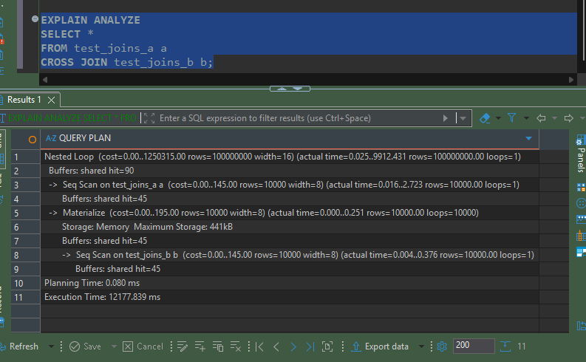

  - Hash Join
PostgreSQL selected Hash Join because the join condition uses the equality operator (a.id1 = b.id1). The planner first performs a sequential scan of test_joins_b and builds an in-memory hash table on the id1 column. It then sequentially scans test_joins_a and probes the hash table for matching values. Since the hash table fits entirely in memory (1 batch, 519 KB), no disk I/O is required during the join. This approach avoids the quadratic comparisons of Nested Loop Join and reduces execution time from approximately 10 seconds to about 4 milliseconds.
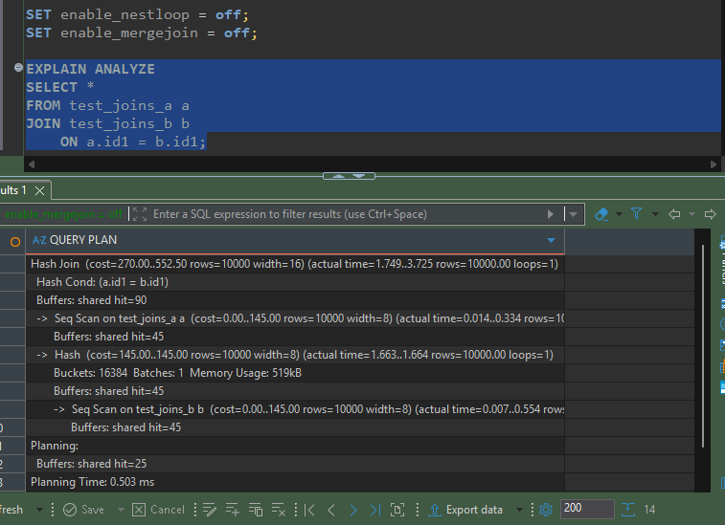
PostgreSQL selected a Hash Semi Join because the query uses the EXISTS predicate. Unlike a regular join, a Semi Join only checks whether a matching row exists in the second table and stops searching after the first match is found. PostgreSQL first builds an in-memory hash table from test_joins_b and then scans test_joins_a, performing one hash lookup per row. Since all values from test_joins_a exist in test_joins_b, all 10,000 rows are returned. Using a Semi Join avoids producing duplicate matches and is more efficient for EXISTS queries.
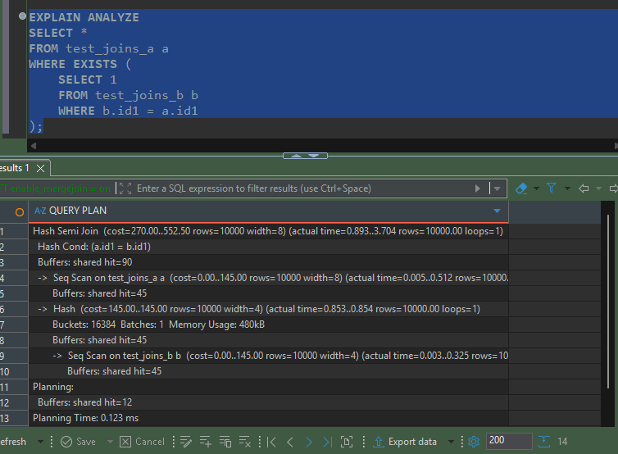
After disabling enable_hashjoin, PostgreSQL could no longer use a Hash Join and selected a Merge Join instead. Merge Join requires both input tables to be sorted by the join key, so PostgreSQL performed sequential scans followed by in-memory quicksort operations on both tables. After sorting, the tables were merged by comparing the sorted values of id1. Although Merge Join is efficient for equality joins, the additional sorting phase made it slower than Hash Join.
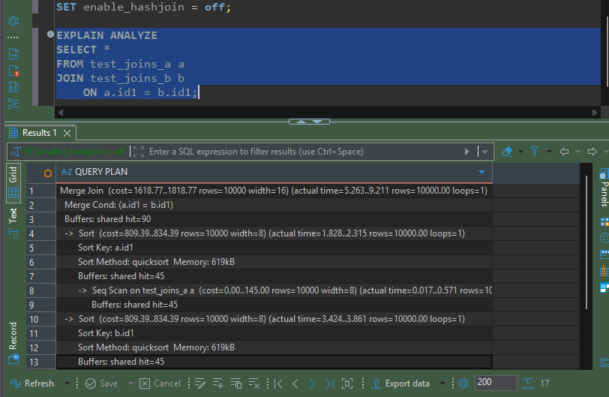
  - Merge join
PostgreSQL selected Merge Join because the join condition is an equality comparison (a.id1 = b.id1) and Hash Join was disabled. The planner performed sequential scans on both tables, sorted them by the join key (id1) using in-memory quicksort, and then merged the sorted datasets. Merge Join efficiently processes sorted inputs by scanning each table only once after sorting.

After setting enable_mergejoin = off, PostgreSQL selected Hash Join because Merge Join was no longer available. The planner built an in-memory hash table from test_joins_b and then scanned test_joins_a, probing the hash table for matching values. Unlike Merge Join, Hash Join does not require sorting the input tables, making it more efficient for this dataset.
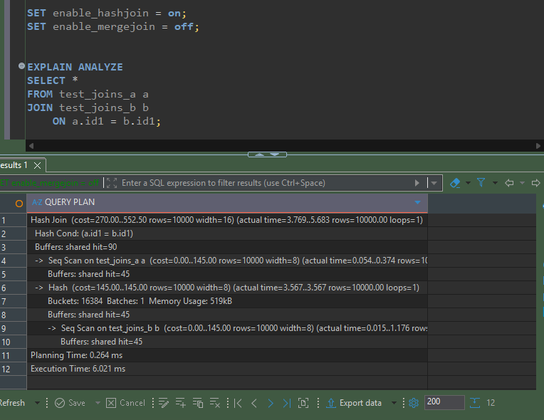

2.1 Changing Join order
PostgreSQL did not simply execute the joins in the order written in the SQL statement. The optimizer chose a more efficient plan by first joining test_joins_b and test_joins_c using a Hash Right Join (which is logically equivalent to the requested LEFT JOIN), and then joining the intermediate result with test_joins_a using a Hash Join. The planner reordered the joins because it estimated this execution strategy to have the lowest cost while preserving the query semantics.
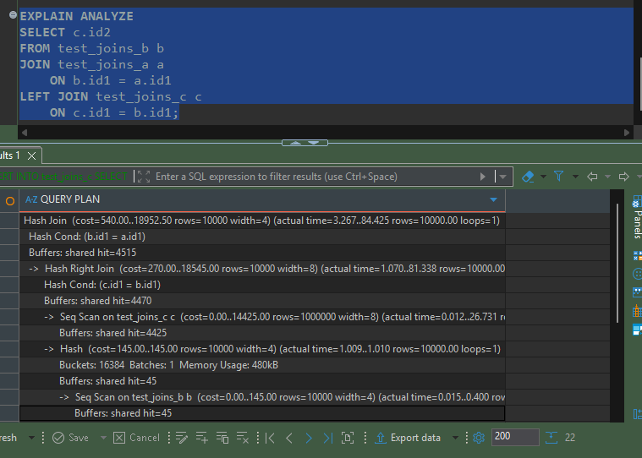

By default (join_collapse_limit = 8), PostgreSQL is free to reorder joins to find the lowest-cost execution plan. In the initial plan, it first joined test_joins_b with test_joins_c and then joined the result with test_joins_a. After setting join_collapse_limit = 1, PostgreSQL preserved the join order written in the SQL statement. It first executed the join between test_joins_b and test_joins_a, and only then performed the LEFT JOIN with test_joins_c. The execution plan changed accordingly, demonstrating that join_collapse_limit controls whether the optimizer may reorder joins.
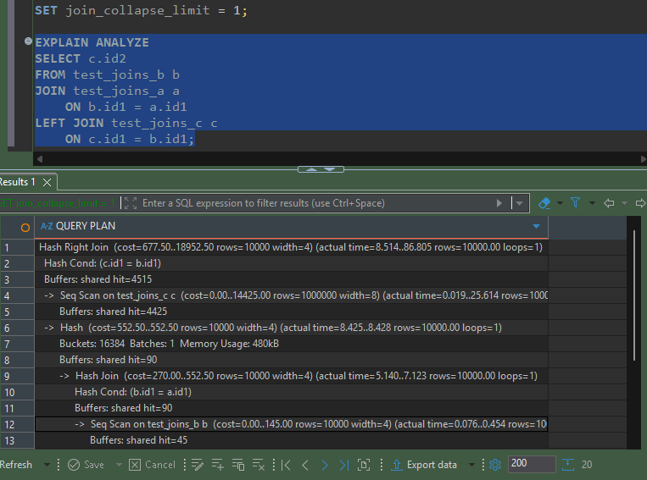

2.2 Lateral Join
The query uses a LATERAL JOIN so that the subquery can reference the max_order_cost value from each row of the stores table. PostgreSQL executes the subquery once for every store, which is implemented as a Nested Loop in the execution plan. For each store, the database scans the orders table, filters orders with order_cost < max_order_cost, sorts them by order_cost in descending order using the Top-N HeapSort optimization, and returns only the first 10 rows. The final result is then sorted by store_id and order_cost.
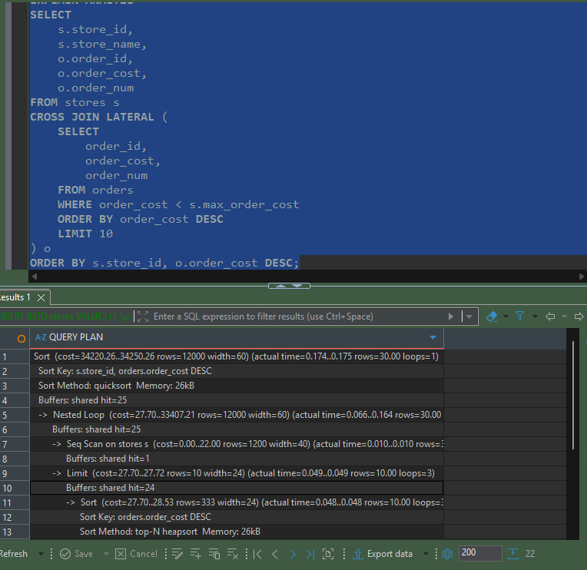

3.1 Recursive CTE
A recursive CTE was used to traverse the employee hierarchy. The anchor member selects the root of the hierarchy (KING), whose mgr value is NULL, and assigns management level 1. The recursive member repeatedly joins the emp table with the previously generated hierarchy, finding employees whose mgr matches the current employee's empno. On each iteration, the management level is increased by one and the manager's name is propagated. The recursion stops automatically when no additional child employees are found.
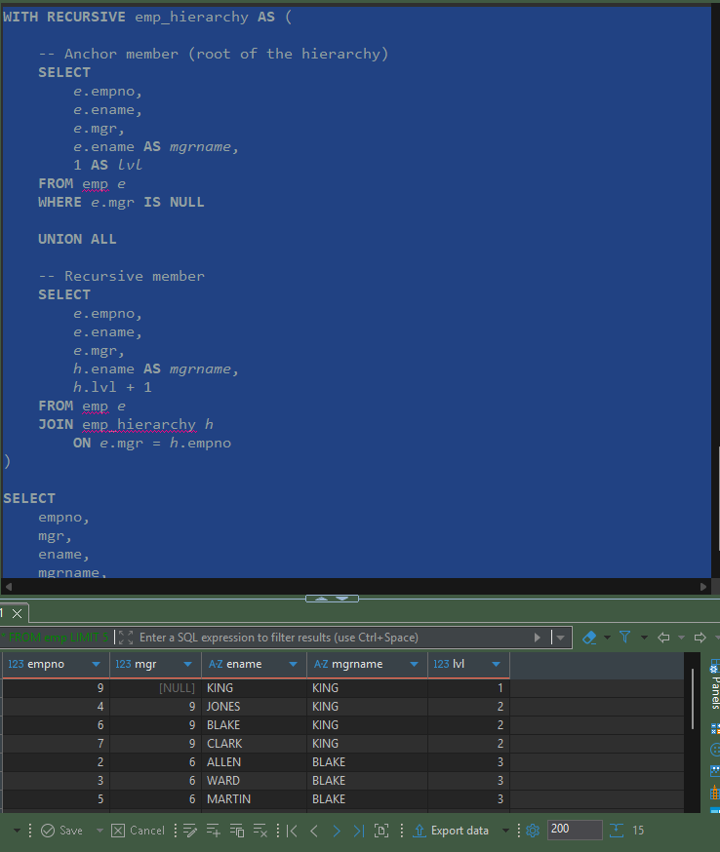

3.2 Changing DATA CTE
A data-modifying CTE was used to perform multiple operations in a single SQL statement. The first CTE updates all orders with order_cost between 100 and 1000 and returns the modified rows using the RETURNING clause. These rows are inserted into order_log with action type 'U'. The next CTE deletes all orders with order_cost < 50, again using RETURNING to capture the deleted rows. Finally, the deleted rows are inserted into order_log with action type 'D'. This demonstrates how PostgreSQL allows UPDATE, DELETE, and INSERT operations to be chained together within one CTE.
