AWS Cloud for Data Engineering
IAM S3 — Implementation Report

Prepared by: Vako Tamazashvili
AWS account: 260586643565 | Region: eu-central-1 (Frankfurt)

20 August 2026

1. Assignment Requirements and Scope
This report consolidates the work completed for the EPAM "AWS Cloud for Data Engineering — IAM S3" task. The source assignment requires use of Frankfurt (eu-central-1), the mandatory resource tag owner=student, AWS CLI version 2, creation/use of the students-role profile, S3 uploads, Glue Crawler/Data Catalog discovery, an Athena query that is more substantial than a simple SELECT, table properties, query results, and consolidation of screens, queries, and intermediate results into a Word-based report.
The report is based on the supplied assignment document: AWS_task1_IAM_S3.docx.
Requirement | Implementation | Evidence
Frankfurt region / eu-central-1 | All CLI and AWS service operations were performed in eu-central-1. | CLI and AWS Console screenshots
Mandatory tag owner=student | S3 bucket was tagged owner=student; crawler was also created with owner=student. | S3 tagging and crawler screenshots
students-role | Configured AWS CLI profile students-role and verified with STS. | STS get-caller-identity screenshot
Create recognizable S3 bucket | Created vako-260586643565-dwh. | S3 CLI evidence
Upload BL_DM tables | Uploaded four CSV dimensions under dwh_database/bl_dm/<table>/. | Upload and S3 listing screenshots
Glue Crawler / Data Catalog | Created vako-bl-dm-crawler using dilab-glue-role and database vako_bl_dm. | Crawler configuration and READY screenshots
Athena query | Executed an aggregate product analysis query against vako_bl_dm.dim_products_scd. | Completed Athena query screenshot
Table properties | Displayed dim_products_scd table properties including Glue Catalog metadata and S3 location. | Table properties screenshot

2. AWS Account Connection and CLI Configuration
The AWS CLI was installed as AWS CLI v2. The SSO configuration was created with the User profile, and a separate students-role profile was added for the required permissions. The students-role profile was verified through AWS STS before working with S3 and Glue.

2.1 CLI profile configuration
The Windows AWS configuration contained the user-role SSO session and a students-role profile with region eu-central-1. No access keys or secrets are included in this report.
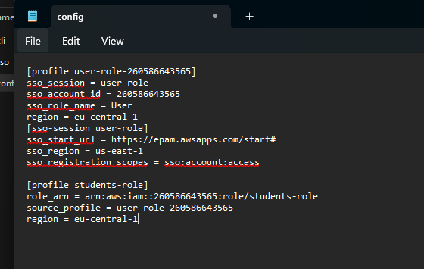

2.2 Verify the assumed role
The following command was used to verify the active AWS identity:
aws sts get-caller-identity --profile students-role
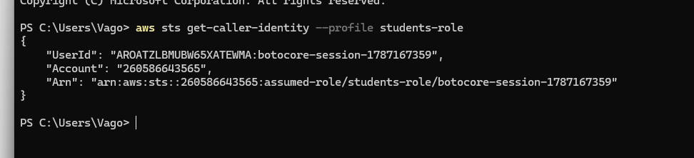
.

3. S3 Bucket and BL_DM Data Upload
A recognizable bucket named vako-260586643565-dwh was used. The BL_DM CSV files were organized under the required hierarchy:
s3://vako-260586643565-dwh/dwh_database/bl_dm/<table>/

3.1 Local source files
Four dimension files were prepared on the Windows desktop: dim_employee, dim_products_scd, dim_store, and dim_time_day.
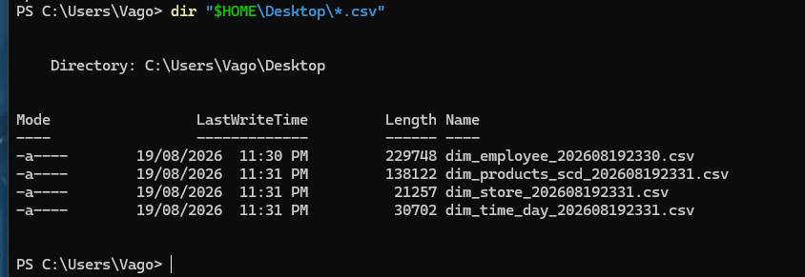

3.2 Upload to S3
The four CSV files were copied with the students-role profile into separate table folders in the bl_dm S3 prefix.
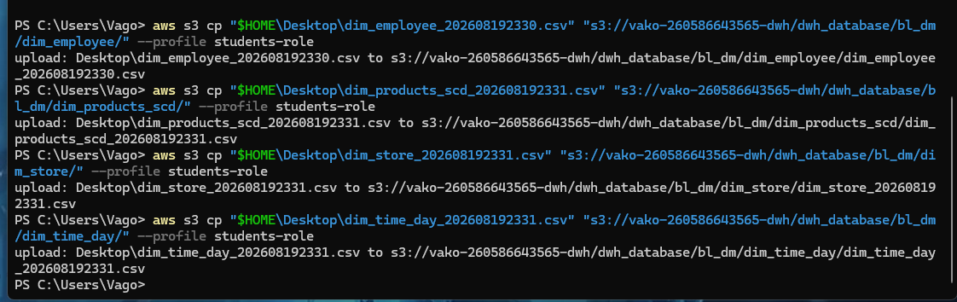

3.3 Resource tagging
The bucket was tagged with the mandatory assignment tag owner=student and then verified.
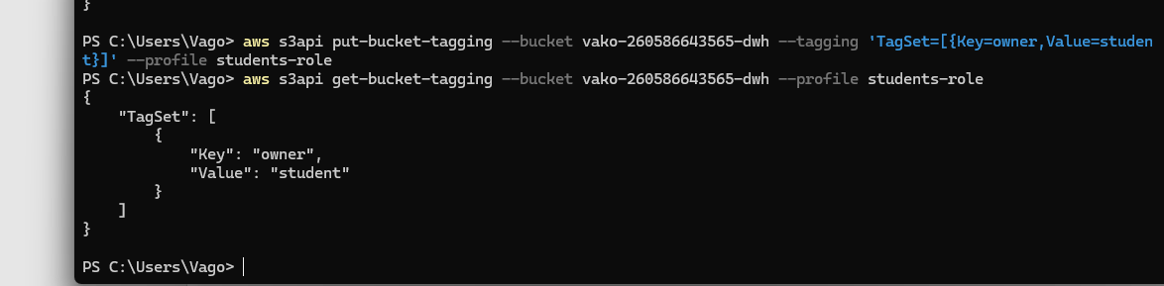

3.4 Verify the S3 hierarchy
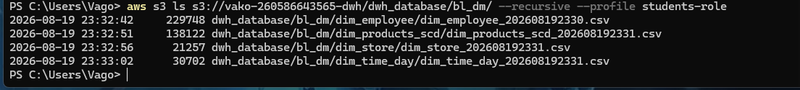

4. AWS Glue Crawler and Data Catalog
The Glue Data Catalog was populated by a dedicated crawler. The crawler source was the complete bl_dm prefix, so the crawler could discover each table folder. The target database was vako_bl_dm.

4.1 Crawler configuration
Crawler name: vako-bl-dm-crawler. S3 source: s3://vako-260586643565-dwh/dwh_database/bl_dm/. The crawler was configured for on-demand execution and the mandatory owner=student tag.
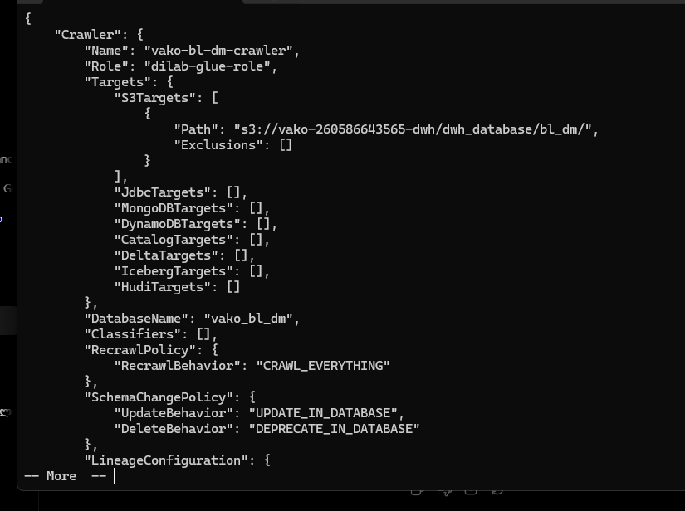

4.2 IAM role used by the crawler
The initial console-generated AWSGlueServiceRole-vako did not become available in IAM. An existing Glue service role, dilab-glue-role, was therefore used. Its trust policy allows glue.amazonaws.com to assume the role, and its permissions included AmazonS3FullAccess and AWSGlueServiceRole.

4.3 Crawler execution
The crawler was started from the AWS CLI and progressed from RUNNING to READY. READY confirms that the crawl completed.
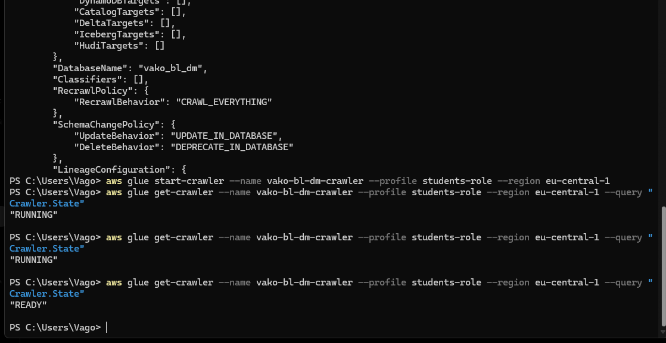

4.4 Data Catalog tables discovered
The Glue Data Catalog was queried directly to verify the discovered table names.
aws glue get-tables --database-name vako_bl_dm --profile students-role --region eu-central-1 --query "TableList[].Name"
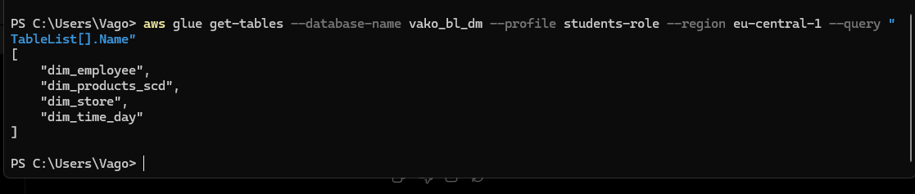

5. Athena Querying
Athena was opened in the Frankfurt region and configured to use AwsDataCatalog with the vako_bl_dm database. The four Glue tables were visible in the query editor.
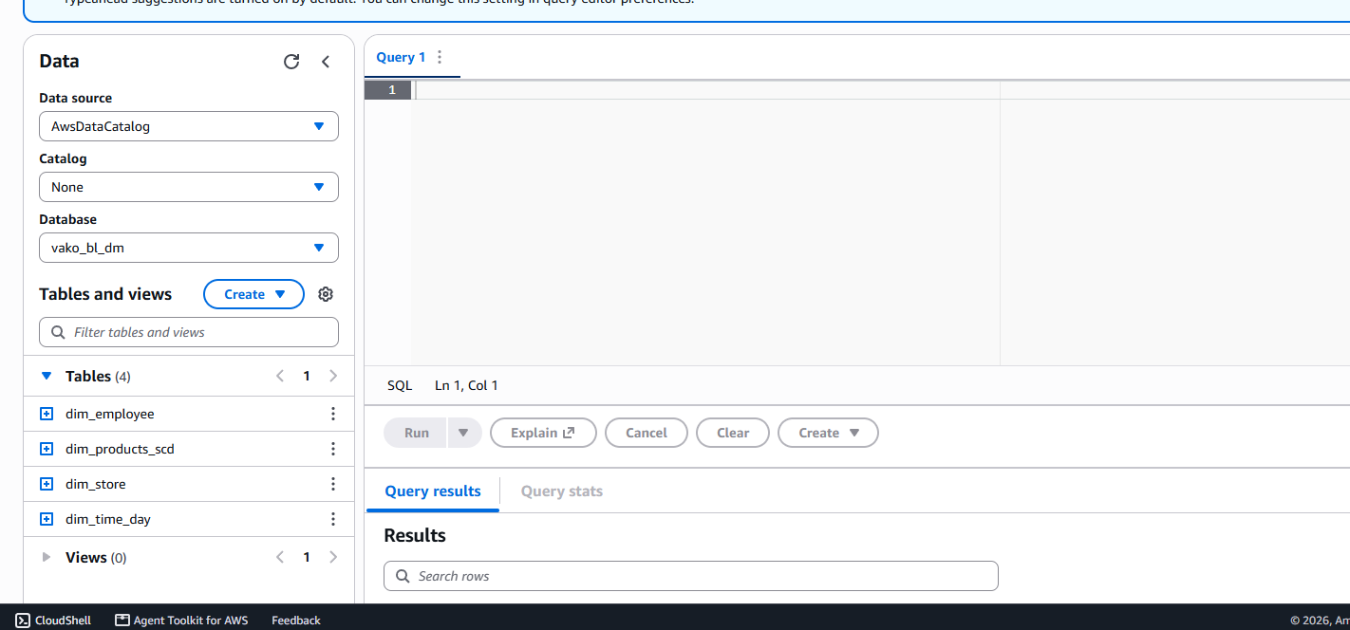

5.1 Table schemas inspected before querying
The table columns were inspected before constructing the query so that the SQL used the actual Data Catalog schema.

5.2 Final Athena query
SELECT
p.category,
p.brand,
COUNT(DISTINCT p.product_surr_id) AS product_count,
AVG(p.unit_price) AS average_unit_price
FROM vako_bl_dm.dim_products_scd p
WHERE p.unit_price IS NOT NULL
GROUP BY
p.category,
p.brand
HAVING COUNT(DISTINCT p.product_surr_id) > 1
ORDER BY
product_count DESC,
average_unit_price DESC
LIMIT 50;
This query is substantially more than a simple SELECT: it uses WHERE, COUNT(DISTINCT), AVG, GROUP BY, HAVING, ORDER BY, and LIMIT. It returned four grouped results and scanned 134.88 KB.
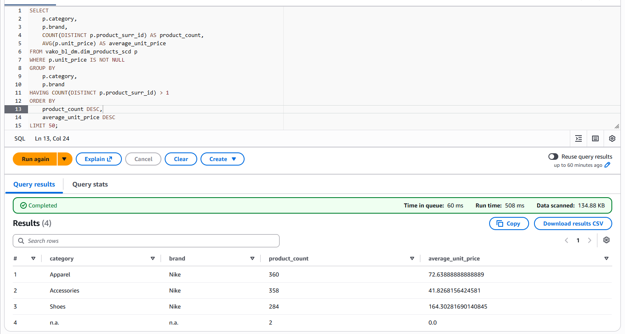

5.3 Table properties
The properties of dim_products_scd were displayed to document the Glue Data Catalog metadata and the underlying S3 location.
