Power BI Final Project
Nike Direct — Online Sales Analysis
Final Project Documentation

1. Business Background

1.1 Company and Field of Activity
For this project, I created a fictional business model for Nike Direct, an online retail business focused on selling Nike products directly to customers. The report is based on online sales data and focuses on product performance, customer behavior, sales performance, and operational aspects of online orders.

1.2 Business Process
The business process exposed in the report is the online sales process. Each transaction contains information about the order date, customer, product, quantity, price, cost, discount, payment method, shipping type, and coupon usage. I organized this information into a Power BI model so that the business can analyze transactions by date, customer, geography, product, category, and subcategory.

1.3 Purpose of the Report
The purpose of the report is to provide a clear and interactive view of online sales performance. It helps users understand revenue, profit, profitability, orders, units sold, customer activity, product performance, payment methods, shipping types, discounts, and promotional activity.

1.4 End Users
The main end users are sales managers, business managers, product managers, and other employees who need to monitor online sales performance and investigate changes in results.

1.5 Business Questions
- How much revenue and profit are generated by online sales?
- How does sales performance change over time?
- Which countries and product categories generate the most sales?
- Which products and subcategories are the strongest performers?
- How many customers and orders are involved in the online business?
- What is the average order value?
- How are sales distributed by customer gender and city?
- Which payment and shipping methods are associated with the most sales?
- How much discount is being given and how does it relate to sales?
- Which coupon codes are associated with the highest sales?

2. Data Source and Power BI Model

2.1 Data Source
I used the provided Excel-based DWH source containing approximately 500,000 online sales records. The source was loaded into Power BI Desktop and used as the basis for the report.

2.2 Data Preparation
I prepared the source data in Power Query and structured the report around a fact table and dimension tables. The main tables used in the report are FactOnlineSales, DimProduct, DimCustomer, and DimDate.

2.3 Data Model
I created a star-schema-style model where FactOnlineSales is the central fact table and DimProduct, DimCustomer, and DimDate provide descriptive and filtering information. The relationships are active one-to-many relationships from the dimensions to the fact table.
I also marked DimDate as the date table and sorted Month Name by MonthNumber so that months appear in chronological order in report visuals.

3. DAX Calculations

3.1 Calculated Columns
I created two calculated columns in FactOnlineSales:
- Profit = SalesAmount - CostAmount
- Net Sales = SalesAmount - DiscountAmount

3.2 Measures
The main measures created for the report are:
- Total Sales
- Total Cost
- Total Profit
- Profit Margin %
- Total Orders
- Units Sold
- Sales Title
- Unique Customers
- Average Order Value
- Total Discounts
- Discount Rate %
The Sales Title measure was used for a dynamic visualization title. The title changes according to the selected customer country.

4. Report Structure and Visualizations

Page 1 — Executive Overview
This page provides the main business overview with KPI cards for Total Sales, Total Orders, Total Profit, Units Sold, and Profit Margin. It also includes a monthly sales trend, sales by country, sales by category, and profit by category. Slicers make the page interactive.

Page 2 — Product & Customer Analysis
This page focuses on customers and products. It includes Unique Customers and Average Order Value KPIs, sales by subcategory, Top 10 Products by Sales, Sales by Gender, Top Cities by Sales, and a product profitability table. Data bars were applied to Total Profit.

Page 3 — Sales & Operations
This page focuses on operational and promotional aspects of online sales. It includes Total Sales, Total Cost, Total Profit, and Discount Rate KPIs, together with Sales by Payment Method, Sales by Shipping Type, Sales vs Discounts by Month, and Sales by Coupon Code.

5. Interactivity

5.1 Slicers
I added slicers using dimension fields such as Year, Quarter, Customer Country, and Category. The slicers filter the report visuals through the relationships in the data model.

5.2 Navigation Buttons
I added page-navigation buttons to the three visible report pages so the user can move between Executive Overview, Product & Customer Analysis, and Sales & Operations.
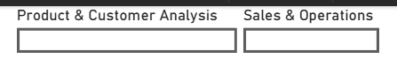

5.3 Drillthrough
I created a hidden Product Details page with DimProduct[ProductName] as the drillthrough field. From the Top 10 Products by Sales visual, the user can right-click a product and drill through to a detailed view containing product information, Total Sales, Total Profit, Units Sold, and Sales & Profit by Year.
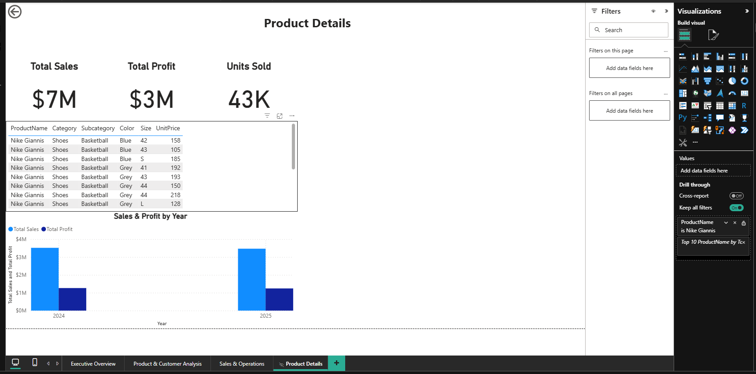

5.4 Conditional Formatting
I applied data bars to the Total Profit column in the product profitability table. This makes differences in product profitability easier to identify visually.
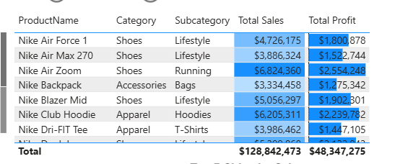

6. Publishing to Power BI Service
After completing the Power BI report, I published the PBIX file to Power BI Service and opened the published report in the browser. I also captured a screenshot of the published report for inclusion in this Word document.
