Nike

1.1 Business Background
Nike is a global sportswear retailer selling footwear, apparel and accessories through two independent operational systems:
• Online Store (e-commerce)
• Physical Point of Sale (POS) stores.
The business generates a large volume of transactional data including customers, products, stores, employees, dates, payments and sales. To support business analysis, these operational datasets are integrated into a centralized Data Warehouse. The warehouse enables consistent reporting, historical analysis and decision-making across all sales channels.

1.2 Problems Because of Poor Data Management
Without a centralized Data Warehouse, online and in-store data remain isolated, making reporting inconsistent and time-consuming. Product and customer information may differ between systems, creating duplicate or inconsistent records. Managers cannot easily analyze total sales, customer purchasing behavior, regional performance, employee productivity or product profitability. Manual reporting also increases the risk of errors and delays.

1.3 Benefits From Implementing a Data Warehouse
A Data Warehouse integrates data from both source systems into a single repository for analysis. It enables:
• Analysis of online vs. store sales.
• Product performance by category and subcategory.
• Customer purchasing behavior by country and city.
• Revenue, cost and discount analysis.
• Employee and store performance.
• Historical trend analysis by Year, Quarter, Month and Day.
• Faster and more reliable business reporting.

1.4 Datasets Description
Source System 1 – Nike Online Sales
Contains denormalized online order information including:
• Customer (ID, name, gender, birth date, email, country, city)
• Product (ID, code, name, brand, category, subcategory, color, size)
• Date (OrderDate, Year, Quarter, Month, Day)
• Sales measures (Quantity, Unit Price, Unit Cost, Sales Amount, Cost Amount, Discount Amount)
• Payment Method, Shipping Type, Coupon Code and Sales Channel.
Source System 2 – Nike Store Sales (POS)
Contains denormalized in-store sales including:
• Customer information
• Store (ID, name, address, country, city)
• Employee (ID, name, position)
• Product information
• Date hierarchy
• Sales measures
• Register Number, Shift, Payment Method and Sales Channel.
Hierarchy Descriptions
Date Hierarchy:
Year
└── Quarter
└── Month
└── Day
Product Hierarchy:
Category
└── Subcategory
└── Product
Geography Hierarchy:
Country
└── City
└── Store / Customer

1.5 Grain / Dimension / Fact
Grain:
One record represents one completed sales transaction (one purchased product in one transaction).
Fact:
FCT_SALES_DD
Measures:
• Quantity
• Unit Price
• Unit Cost
• Sales Amount
• Cost Amount
• Discount Amount
Dimensions:
• DIM_CUSTOMERS
• DIM_PRODUCTS_SCD
• DIM_STORES
• DIM_EMPLOYEES
• DIM_TIME_DAY

2. Business layer 3nf

2.1 Business Layer Overview
The Business Layer integrates data from the Online Sales and Store Sales operational systems into a single normalized model. The model follows Third Normal Form (3NF) principles to eliminate redundancy, improve data integrity, and provide a consistent foundation for ETL processing and the dimensional model. Common business entities are represented only once regardless of the source system.
2.2 Why Product Was Selected as SCD Type 2
Among all business entities, the Product entity was selected to implement Slowly Changing Dimension Type 2 (SCD2) because product information is subject to business changes over time while historical sales transactions must remain unchanged. In real-world retail environments, product attributes such as category, subcategory, color, size, unit price, or production cost may be updated as products evolve or are reclassified.
If these changes were applied by simply updating the existing record, historical sales would incorrectly reflect the new product information instead of the values that were valid at the time of purchase. This would reduce the accuracy of historical reporting and business analysis.
To preserve complete historical information, the Product entity uses the SCD Type 2 approach. Whenever one of the tracked attributes changes, the current record is closed by updating the END_DT value and setting IS_ACTIVE to FALSE. A new record with a new surrogate key is then inserted containing the updated product information, a new START_DT, and IS_ACTIVE = TRUE.
This implementation guarantees that every sales transaction remains linked to the correct historical version of the product, ensuring accurate reporting, auditing, and trend analysis.
2.3 Source Triplet
The Business Layer integrates information from two independent operational source systems: Nike Online Sales and Nike Store Sales. Since both systems may contain records describing the same business entities, it is important to preserve information about the origin of every record.
To achieve this, every business entity contains a Source Triplet, which consists of the following attributes:
- SOURCE_SYSTEM – identifies the operational source system (for example, Online or Store).
- SOURCE_ENTITY – identifies the original source table or dataset from which the record was extracted.
- <ENTITY>_SRC_ID– stores the original identifier assigned by the source system.
The Source Triplet provides complete data lineage by allowing every record in the Business Layer to be traced back to its original source. This information is particularly valuable during ETL processing, data quality validation, auditing, and troubleshooting because it allows developers to identify where each record originated.
The Source Triplet also simplifies the integration of multiple source systems into a single normalized model while preserving the identity of the original operational data.
2.4 Surrogate Keys and Natural Keys
Every business entity in the Business Layer is uniquely identified using key attributes that support both operational integration and analytical processing.
A Natural Key (NK) is a business identifier that already exists in the operational source system. Examples include CUSTOMER_ID, PRODUCT_CODE, STORE_ID, and EMPLOYEE_ID. These identifiers uniquely identify business records within the source systems but may change over time or may not be globally unique when integrating data from multiple source systems.
A Surrogate Key (SK) is a system-generated identifier used internally by the Data Warehouse. Unlike natural keys, surrogate keys have no business meaning and remain stable throughout the lifetime of a record.
Using surrogate keys provides several advantages:
- They establish stable relationships between Business Layer entities.
- They simplify the implementation of Slowly Changing Dimensions (SCD).
- They improve ETL performance by replacing complex business identifiers with compact numeric keys.
- They prevent conflicts when integrating records from multiple source systems that may use the same natural key values.
Natural keys are retained to preserve the business identity of each record and to support traceability to the source systems, while surrogate keys are used to maintain efficient and consistent relationships within the Data Warehouse.
2.5 Design process
The Business Layer was designed according to the principles of the Third Normal Form (3NF) to eliminate data redundancy, maintain data integrity, and provide a scalable foundation for the ETL process. The model integrates data from two independent source systems, Nike Online Sales and Nike Store Sales, into a single normalized business model. This approach ensures that common business entities are represented only once, regardless of the source system.
The design process consisted of the following steps:
Step 1 – Analyze Source systems
The first step was to analyze the structure of both source datasets. Although the datasets represented different sales channels, they contained many common business entities, including customers, products, stores, employees, geographical information, and sales transactions. During this analysis, duplicate entities across the two datasets were identified.
Step 2 – Identify Business Entities
Based on the source analysis, the following business entities were identified:
- Customer
- Product
- Store
- Employee
- Geography
- Date
- Sales
Instead of creating separate tables for each source system (for example, Online Customer and Store Customer), a single table was created for each entity. This follows the assignment requirement of representing identical business entities only once in the Business Layer.
Step 3 – Normalize the Data Model
The model was normalized to Third Normal Form (3NF). Each table stores information about only one business entity, and non-key attributes depend only on the primary key. This minimizes redundancy and prevents update, insertion, and deletion anomalies.
Relationships between entities were established using foreign keys. For example:
- One customer can generate many sales.
- One product can appear in many sales.
- One store employs many employees.
- One employee can process multiple sales.
- One date can correspond to many sales transactions.
Step 3.1 – Resolve Data Redundancy
During the design process, duplicate business entities across the Online Sales and Store Sales datasets were consolidated into single Business Layer entities. This eliminated redundant storage of customer, product, store, employee, date, and geographical information while preserving the origin of each record through the Source Triplet.
Step 4 – Introduce Surrogate and Natural Keys
Each table contains:
- Surrogate Key (SK): an internally generated unique identifier used for relationships between tables.
- Natural Key (NK): the business identifier received from the source system.
Surrogate keys are used to establish stable relationships between business entities and to simplify ETL processing, while natural keys preserve the original business identity of each record and support traceability to the operational source systems.
Step 5 – Add Source Triplet
To support data lineage and traceability, every business entity includes a Source Triplet consisting of:
• SOURCE_SYSTEM – identifies the operational source system (e.g., Online or Store).
• SOURCE_ENTITY – identifies the original source entity or dataset.
• <ENTITY>_SRC_ID – stores the original business identifier from the source system.
Step 6 – Implementing Slowly Changing Dimension (SCD Type 2)
The Product entity was selected as the Slowly Changing Dimension Type 2 (SCD2).
Product attributes such as:
- Category
- Subcategory
- Color
- Size
- Unit Price
may change over time. Instead of updating existing records, a new version of the product is inserted whenever one of these attributes changes.
To support SCD Type 2, the Product table includes the following metadata columns:
- START_DT
- END_DT
- IS_ACTIVE
This approach preserves historical product information and guarantees that historical sales remain associated with the correct version of each product. A new product version is created only when tracked business attributes change; otherwise, the existing active record remains unchanged.
Step 7 – Add Metadata Columns
To support auditing and ETL processes, technical metadata columns were added where appropriate
• INSERT_DT – records when a row was initially loaded into the Business Layer.
• UPDATE_DT – records the latest modification timestamp for applicable entities.
• START_DT – indicates the beginning of the validity period for SCD Type 2 records.
• END_DT – indicates the end of the validity period for SCD Type 2 records.
• IS_ACTIVE – identifies the currently active version of an SCD Type 2 record.
These attributes simplify incremental loading, historical tracking, and data quality validation.
Step 8 – Prepare the Model for ETL and Dimensional Modeling
The completed 3NF model serves as the Business Layer of the data warehouse architecture. It provides a normalized and consistent data structure that will be populated through ETL processes. The completed Business Layer serves as the trusted integration layer between the operational source systems and the dimensional model. During the ETL process, data is first loaded into the Business Layer, validated and standardized, and then transformed into the Star Schema used for analytical reporting.
2.6 Business Entities
Entity | Purpose | Notes
CE_CUSTOMERS | Stores customer master data integrated from both source systems. | NK, Source Triplet
CE_PRODUCTS_SCD | Stores historical product information using SCD Type 2. | SCD Type 2
CE_STORES | Stores store information and references geographical data. | NK, Source Triplet
CE_EMPLOYEES | Employee information | FK Store
CE_DATES | Calendar | Year/Quarter/Month/Day
CE_GEOGRAPHIES | Country/City | Reusable
CE_SALES | Sales transactions | FKs to all entities
2.7 Business rationale
The relationships between business entities were defined according to the business rules identified during source system analysis.
- CE_CUSTOMERS → CE_SALES: One customer can generate many sales transactions.
- CE_PRODUCTS_SCD → CE_SALES: One version of a product can appear in many sales transactions.
- CE_STORES → CE_SALES: One store processes many sales transactions.
- CE_EMPLOYEES → CE_STORES: Each employee belongs to one store.
- CE_EMPLOYEES → CE_SALES: One employee can process many sales transactions.
- CE_DATES → CE_SALES: One calendar date can correspond to many sales transactions.
- CE_GEOGRAPHIES → CE_SALES: One geographical location may be associated with many sales transactions.

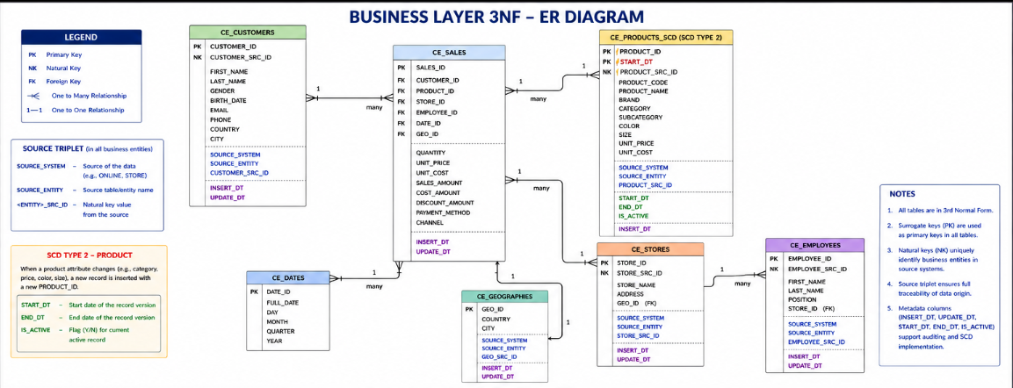

3. business layer dimensional model
3.1 Introduction
The Dimensional Model was designed based on the Business Layer (3NF) to support analytical reporting and business intelligence. While the Business Layer focuses on data integration, normalization, and data consistency, the Dimensional Model is optimized for fast and efficient analytical queries. It follows the Star Schema approach, consisting of one central fact table (FCT_SALES_DD) surrounded by multiple dimension tables. This design minimizes the number of joins, improves query performance, and simplifies reporting in Business Intelligence tools such as Power BI.
The Dimensional Model was derived from the normalized Business Layer by transforming business entities into analytical dimensions while denormalizing descriptive attributes where appropriate. For example, geographical information was incorporated into the DIM_STORES dimension to simplify reporting and reduce query complexity. In addition, the DIM_PRODUCTS_SCD dimension implements Slowly Changing Dimension Type 2 (SCD Type 2) to preserve historical product information and ensure accurate historical analysis.
The resulting Star Schema provides a scalable and efficient structure for analyzing sales performance, customer behavior, product trends, employee performance, and store activity across both Online Sales and Store Sales source systems.
3.2 Star Schema Design
The Dimensional Model was designed using the Star Schema approach to support analytical reporting and business intelligence. The model consists of one central fact table, FCT_SALES_DD, surrounded by five dimension tables: DIM_CUSTOMERS, DIM_PRODUCTS_SCD, DIM_STORES, DIM_EMPLOYEES, and DIM_TIME_DAY. The fact table stores quantitative business measures, while the dimension tables provide descriptive business attributes used for filtering, grouping, and analytical reporting.
Compared to the normalized Business Layer (3NF), the Dimensional Model intentionally denormalizes selected descriptive attributes to reduce the number of joins and improve query performance. For example, geographical information such as Country and City was incorporated into the DIM_STORES dimension instead of being maintained as a separate Geography dimension. This approach simplifies analytical queries, improves reporting efficiency, and follows dimensional modeling best practices.
The DIM_PRODUCTS_SCD dimension implements Slowly Changing Dimension Type 2 (SCD Type 2) to preserve historical changes to product attributes. As a result, historical sales remain associated with the correct version of each product, ensuring accurate trend analysis and historical reporting.
3.3 Fact Table Grain
The grain of the fact table defines the level of detail represented by each record. In this dimensional model, each row in FCT_SALES_DD represents a single sales transaction, where one product is sold to one customer, in one store, by one employee, on a specific day. This level of granularity ensures that every transaction is recorded consistently and supports accurate calculation of business measures such as Quantity, Sales Amount, Cost Amount, and Discount Amount.
Clearly defining the grain establishes a consistent level of detail throughout the dimensional model, enabling reliable aggregation, filtering, and analytical reporting.
3.5 Fact Table Measures
Metric | Description | Formula
QUANTITY | Number of products sold in a sales transaction | -
UNIT_PRICE | Selling price per unit | -
UNIT_COST | Cost per unit | -
SALES_AMOUNT | Total revenue generated from the sale | Quantity x unit_price
COST_AMOUNT | Total cost associated with the sale | Quantity x unit_cost
DISCOUNT_AMOUNT | Total discount applied to the transaction | -
PROFIT_AMOUNT | Profit earned from the transaction | Sales_amount – cost_amount

Attribute | Description
PAYMENT_METHOD | Payment method used for the transaction (e.g., Card, Cash).
CHANNEL | Sales channel through which the transaction was completed (Online or Store).
3.6 Calculated Metric
To provide additional analytical value, the PROFIT_AMOUNT measure was added to the FCT_SALES_DD fact table as a calculated measure. It is derived using the following formula:
PROFIT_AMOUNT = SALES_AMOUNT − COST_AMOUNT
This measure represents the profit generated by each sales transaction and enables business users to analyze product profitability, compare financial performance across different products, stores, employees, and sales channels, and support data-driven business decision-making.

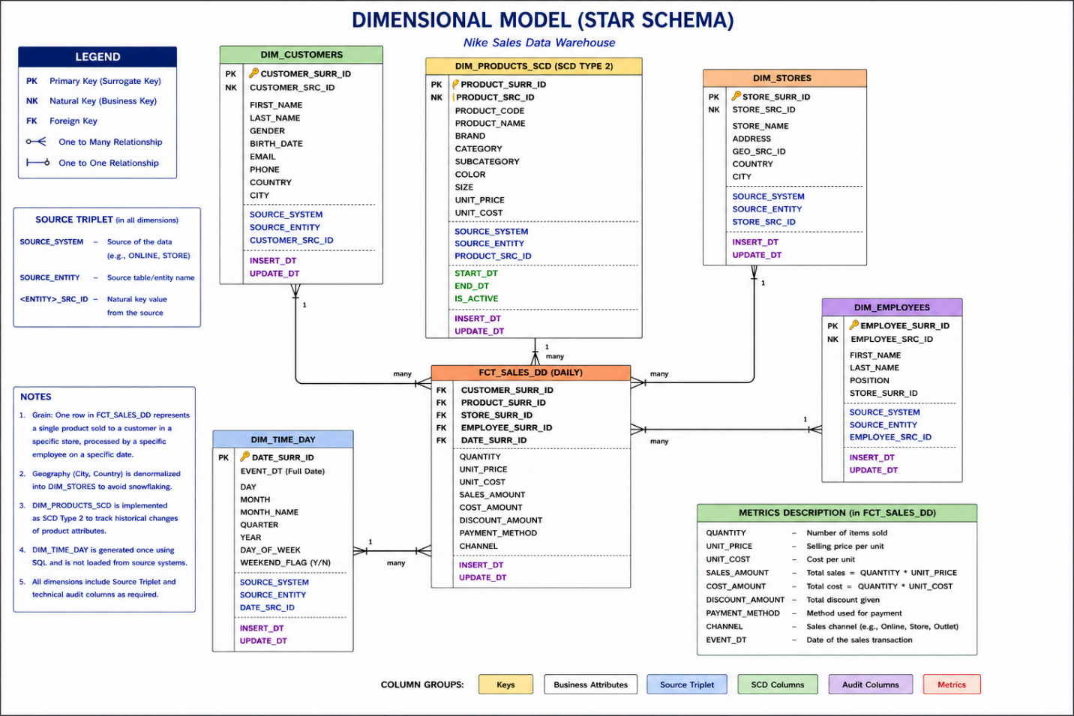

4. logical scheme

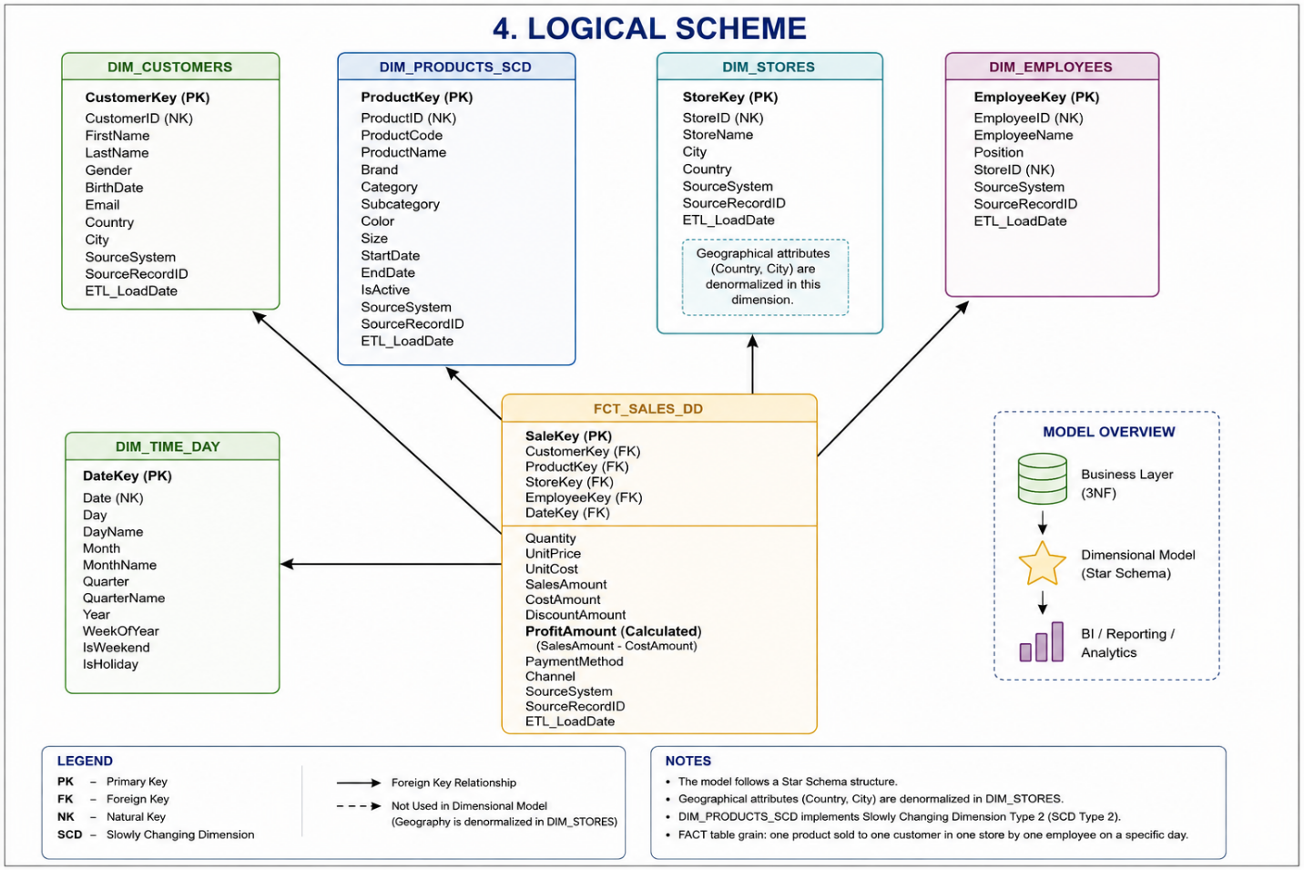

5. data flow

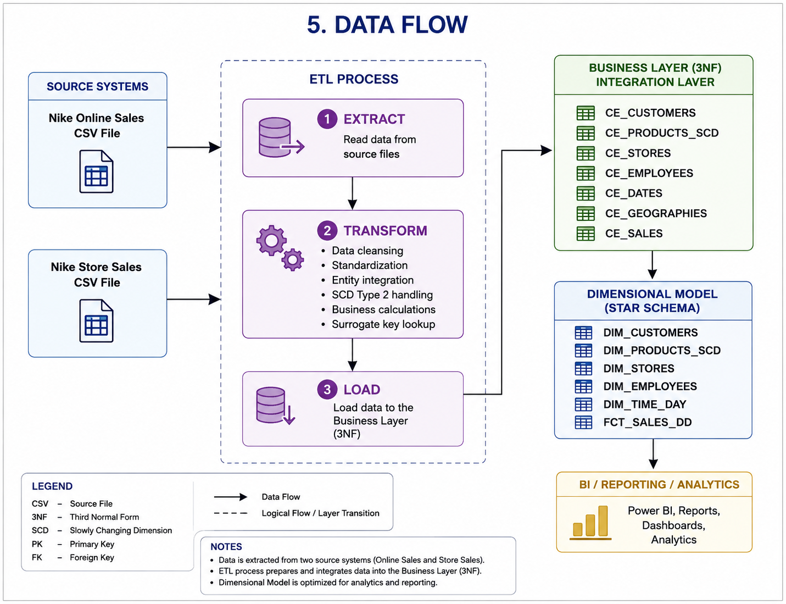

6. fact table partitioning strategy
The FCT_SALES_DD fact table is designed to be partitioned by the EVENT_DT (transaction date) using monthly partitions. Since the source datasets contain sales transactions covering the period from 2024 to 2025, partitioning the fact table by month improves query performance by limiting the amount of data scanned during analytical queries.
This partitioning strategy provides several benefits:
- Improved query performance for time-based analytical reports.
- Reduced scan time by accessing only the required monthly partitions.
- Faster and more efficient ETL loading of new transactional data.
- Simplified maintenance and index management.
- Independent archival of historical partitions without affecting recent data.
Monthly partitioning provides an effective balance between query performance, storage management, and scalability, making it suitable for analytical workloads in the Nike Sales Data Warehouse.

