Task 8
In this task, I implemented the ETL process for loading data from the 3NF layer into the dimensional model (DM). Separate procedures were created for each dimension and the fact table. During the implementation I also added ETL logging, exception handling, rerunnable loading logic, and SCD Type 2 support for the product dimension. Finally, I tested the procedures to verify that they work correctly and produce consistent results.

A separate logging procedure (log_etl) was created to record ETL execution details. Each loading procedure writes the procedure name, execution time, number of processed rows, and a status message into the logging table. This makes it easy to verify that procedures executed successfully and supports rerunnable ETL processes.
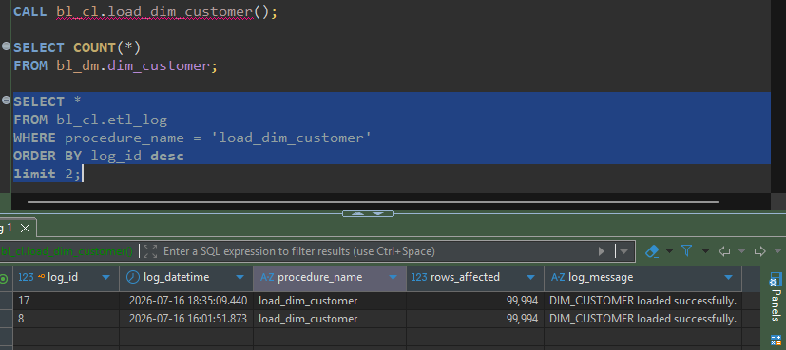

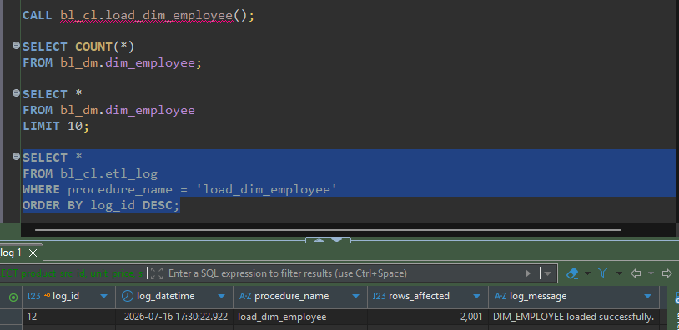

3.1 Rerunnable ETL procedures
To verify that the ETL procedures are rerunnable, one of the loading procedures was executed multiple times using the same source data. After each execution, the ETL log was checked to confirm that the procedure completed successfully. Running the procedure again did not create duplicate business data, which confirms that the ETL process is rerunnable and produces consistent results.
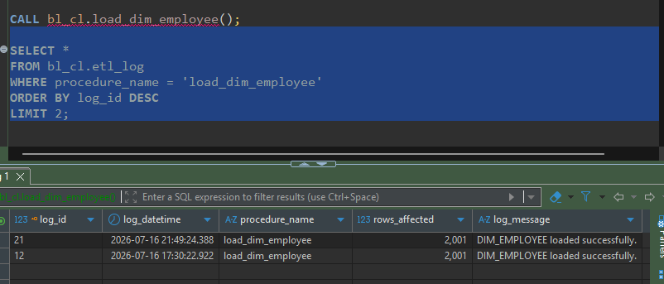

Although the number of affected rows is not zero, the target data remains unchanged after repeated execution. The logged value represents the number of processed records rather than only newly inserted records. Existing records are validated during each execution, therefore rerunning the procedure does not create duplicate data and the results remain consistent.
3.2 SCD 2 validation
To verify that the SCD Type 2 implementation works correctly, a product from the source data was modified. The change was propagated through the ETL process, and the results were verified in both the 3NF and DM layers. First of all, I opened the original CSV file and selected several product records for testing.
I chose one of the products and verified in the 3NF layer to ensure that the source data was correctly loaded before I made any changes.
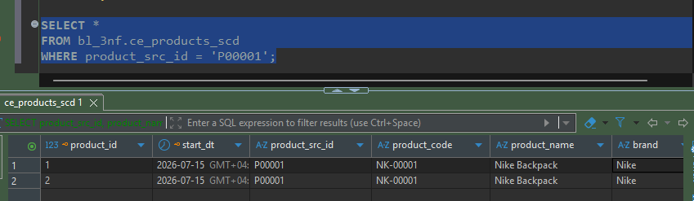
I did the same verification in the dimensional model.
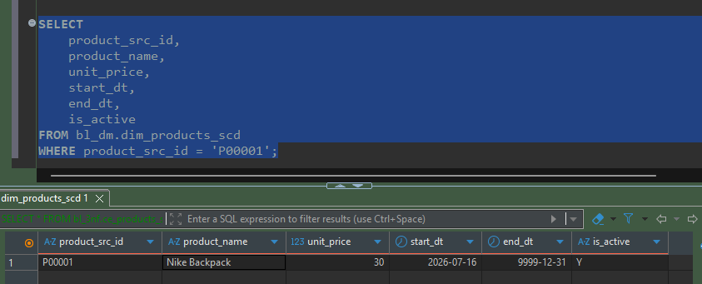
I created an additional copy of the original CSV file and simply changed the unit price of product P00169 from 54 to 60.
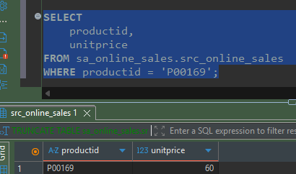
After importing the modified source file and running the ETL procedure, the updated product appeared in the 3NF layer with the new unit price.
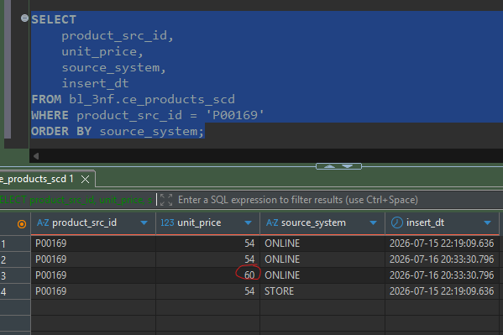
After that, I reloaded the product dimension. The previous product version was marked as inactive, while a new active version with the updated unit price was inserted. This confirms that the SCD Type 2 logic works correctly.
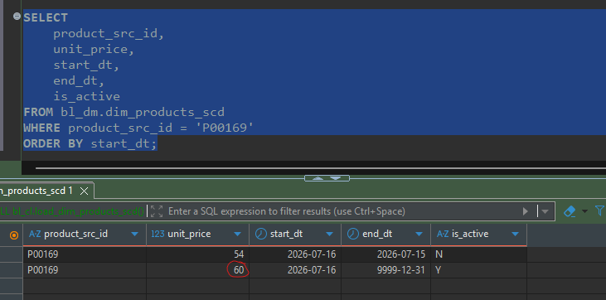
3. PL/pgSQL Features Used
The assignment required the use of several PL/pgSQL features such as Composite Types, Cursor FOR loops, Dynamic SQL (EXECUTE), Cursor Variables (REFCURSOR), and UPSERT (MERGE). While some of these features could have been integrated into the ETL procedures, I decided to keep the loading procedures as simple and readable as possible. Instead, the additional features were demonstrated in a separate validation procedure where they fit naturally without making the ETL logic unnecessarily complex.
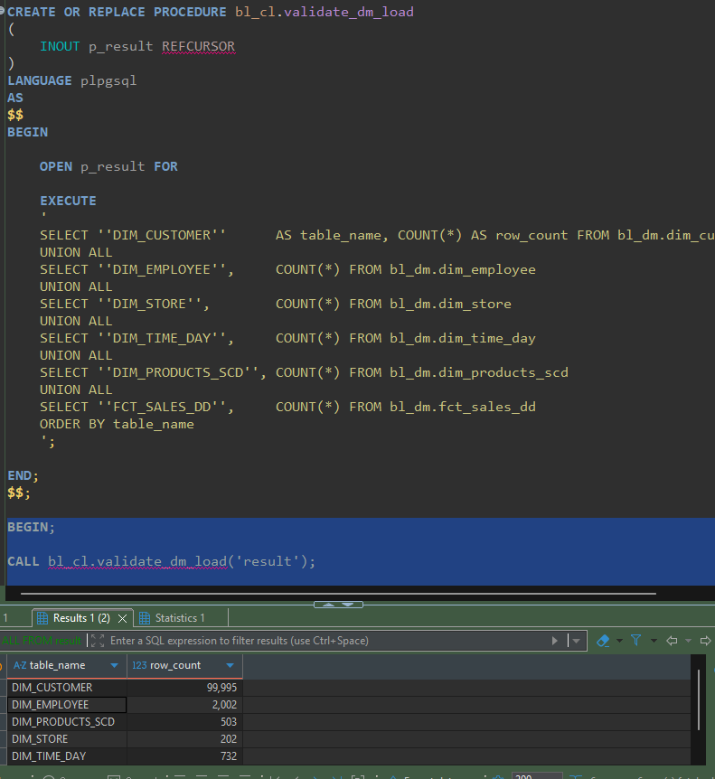
The validate_dm_load() procedure executes a dynamic query using EXECUTE and returns the results through a REFCURSOR. The output displays the number of loaded records in each dimensional table and the fact table, making it easy to verify that the ETL process completed successfully.

