Task 2
Introduction
In this lab, I enhanced the Power BI report that I created during the previous lab work. I reviewed the data model, built an interactive dashboard, added different slicer types, standard and custom visuals, configured a mobile layout, published the report to Power BI Service, configured scheduled data refresh through Personal Gateway, and created a filtered report URL.
- Building the Dashboard
I started by opening the Power BI report created in Lab Work 01 and verified the relationships in the data model. I ensured that OrderDate was used as the active relationship between FactInternetSales and DimDate, because it is the main date used for analysis.
- Creating Slicers
I added three different slicer types to improve the user experience:
- A List slicer using the Full Name field from the DimCustomer table.
- A Dropdown slicer using the same field.
- A Date slicer using the Order Date.
I also enabled the Search option on the customer slicers so users could quickly find customers.
- Creating Standard Visuals
I designed the dashboard using several standard Power BI visuals:
- Card – Total Sales
- Line Chart – Sales Trend
- Clustered Column Chart – Sales by Product Category
- Donut Chart – Sales by Country
- Table – Top 10 Customers
These visuals provide a clear overview of sales performance and allow users to analyze the data from different perspectives.
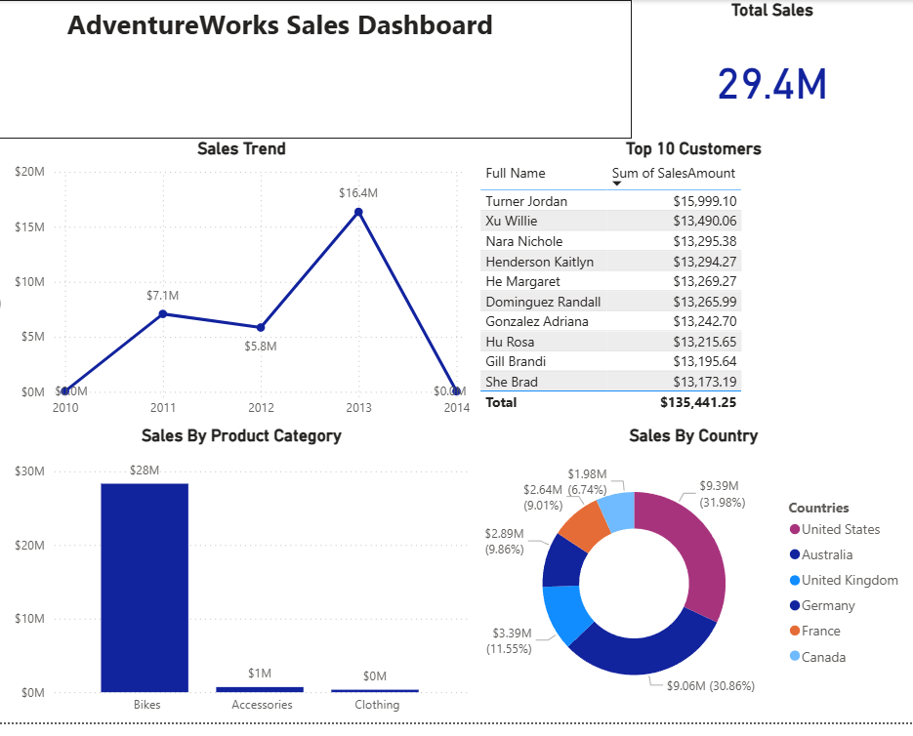
- Adding Custom Visuals
I imported custom visuals from AppSource and added them to a separate report page.
The custom visuals I selected were:
- Hierarchy Slicer
- Word Cloud
I chose the Hierarchy Slicer because it allows users to navigate product categories and subcategories more efficiently than a standard slicer.
I chose the Word Cloud because it provides a quick visual summary of the most frequently occurring product names, making the report more engaging and easier to interpret.
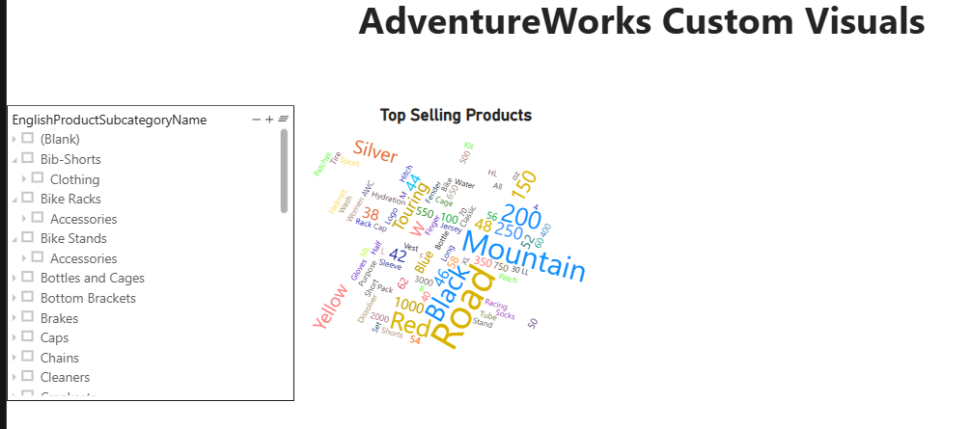
- Disabling Visual Interaction
I disabled the interaction between list slicer and Donut chart using the Edit Interactions feature.
This allowed me to prevent a selected slicer from affecting a specific visual while keeping interactions enabled for the remaining visuals. This demonstrates how Power BI can control report behavior for different analytical scenarios.
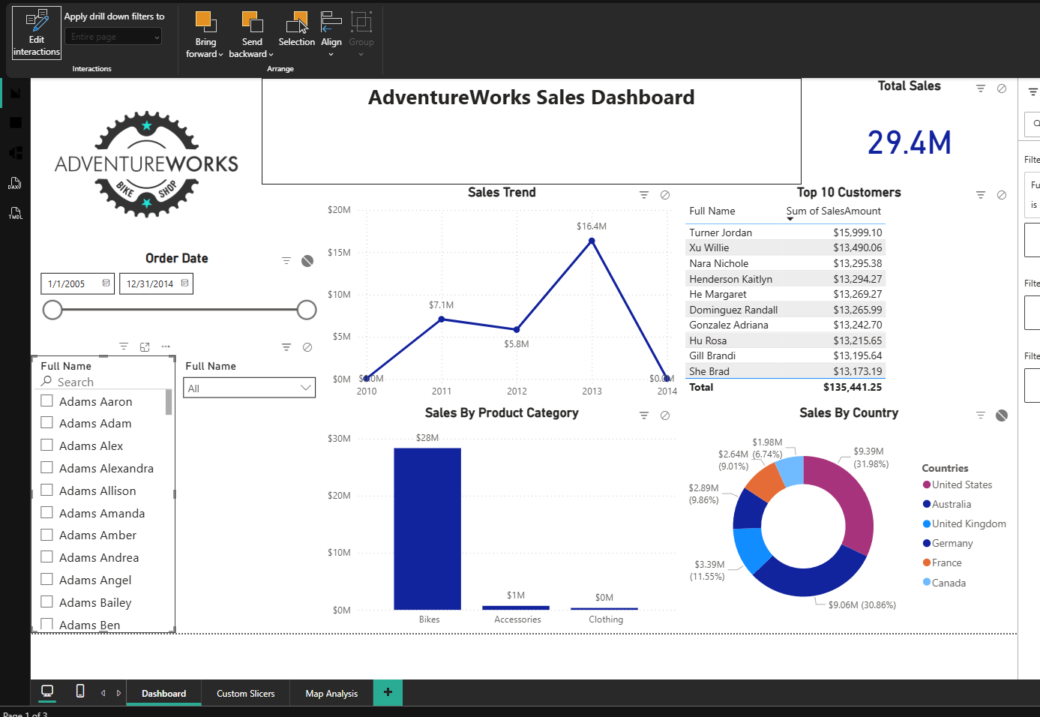
- Dashboard Design
I designed the dashboard using a blue color palette that matches the AdventureWorks logo.
I added a report title and company logo to the header to create a professional appearance. The colors of the charts were selected to remain consistent with the overall dashboard theme.
- Map visual
I added a Map visual to display sales by country.
The map provides a geographical view of sales distribution, allowing users to compare sales performance across different countries more easily.
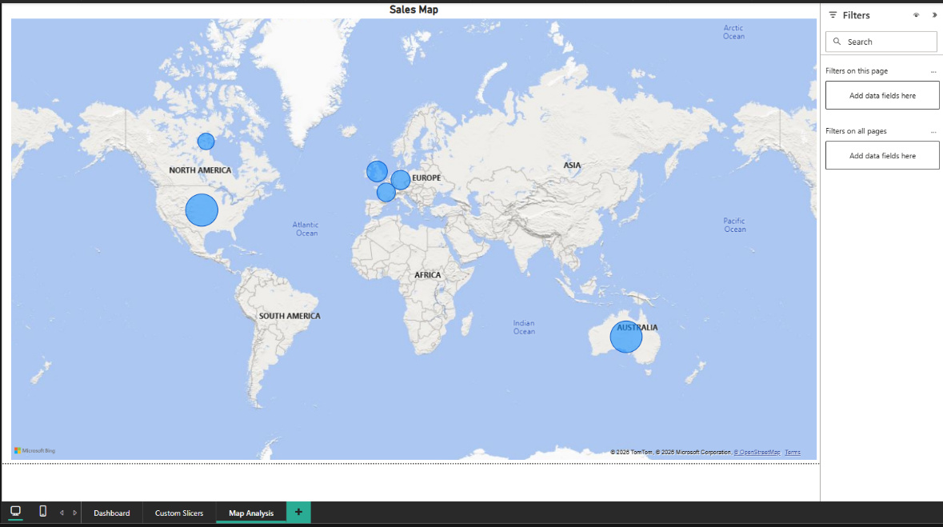
- Mobile Layout
I configured the mobile layout for all report pages.
I arranged the visuals to ensure that the report remains readable and user-friendly on mobile devices.
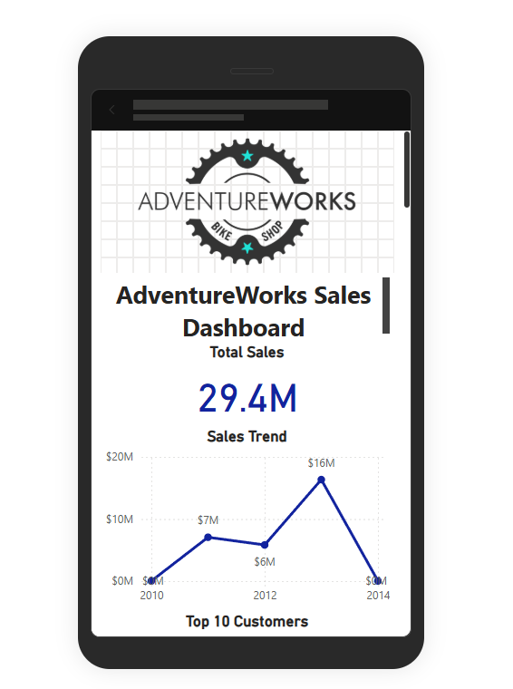

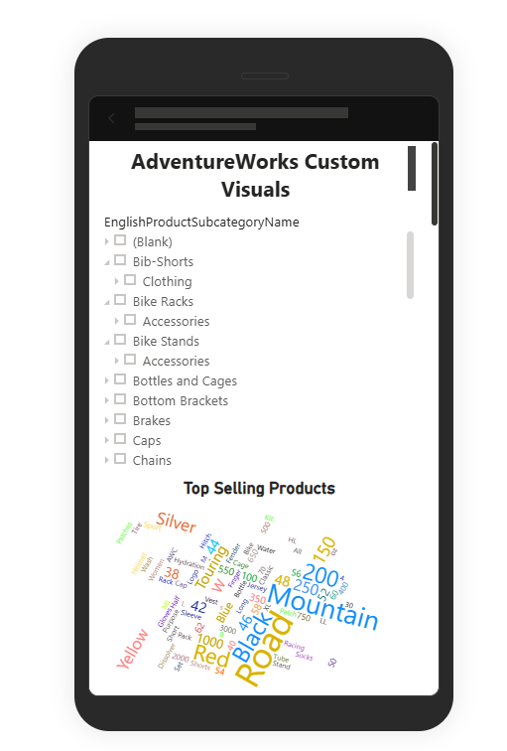
- Publishing the report
I published the report to Power BI Service using my workspace.
After publishing, I verified that the report was available online and functioning correctly.
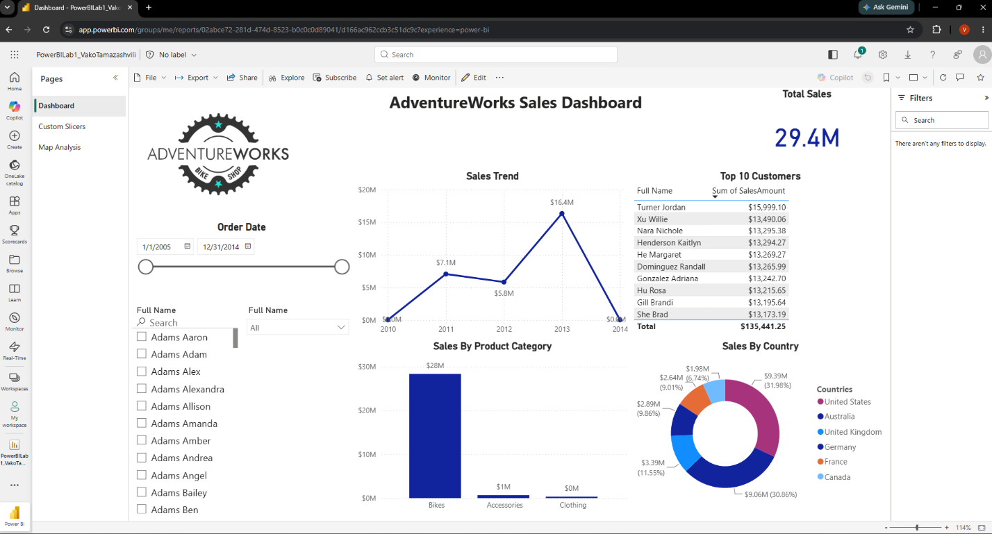

- Personal Gateway and Scheduled Refresh
I installed On-premises Data Gateway (Personal Mode) and configured a daily scheduled refresh for the semantic model.
This allows the published report to refresh automatically from the SQL Server data source. I Chose to refresh it once a day, with Time set on 9:00 AM.
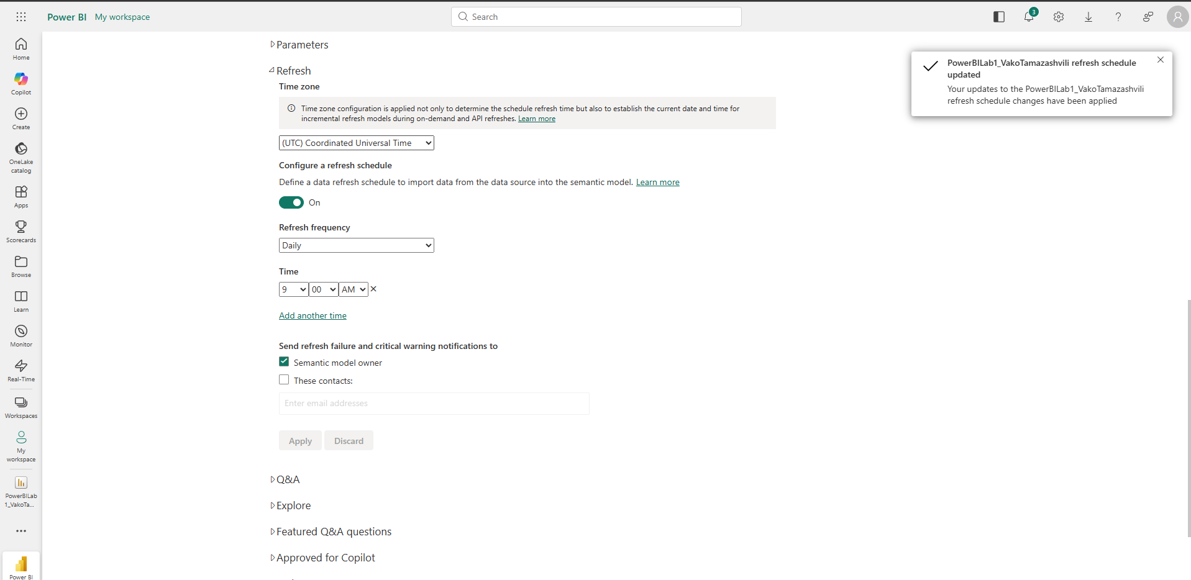
- Filtered report URL
I created a report URL that includes a built-in filter so the report opens with a predefined country filter applied, as required by the assignment.
https://app.powerbi.com/groups/me/reports/02abce72-281d-474d-8523-b0c0c0d89041/d166ac962ccb3c51dc9c?experience=power-bi&filter=DimSalesTerritory/SalesTerritoryCountry%20eq%20'Germany'
- Conclusion
During this lab, I successfully developed an interactive Power BI dashboard using AdventureWorks data. I implemented multiple slicer types, standard and custom visuals, a map visualization, mobile layouts, and Power BI Service features such as publishing and scheduled refresh. The final report provides an interactive and user-friendly dashboard for analyzing sales data.

