Task 6
1.1
I created one parent table (sales_info) and five child tables using PostgreSQL table inheritance. Each child table stores data for a single year (2020–2024) based on the eventdate column. This setup allows the data to be separated into yearly partitions while keeping a single parent table for querying. I also used CREATE TABLE IF NOT EXISTS so the script can be executed multiple times without recreating existing tables or losing data.
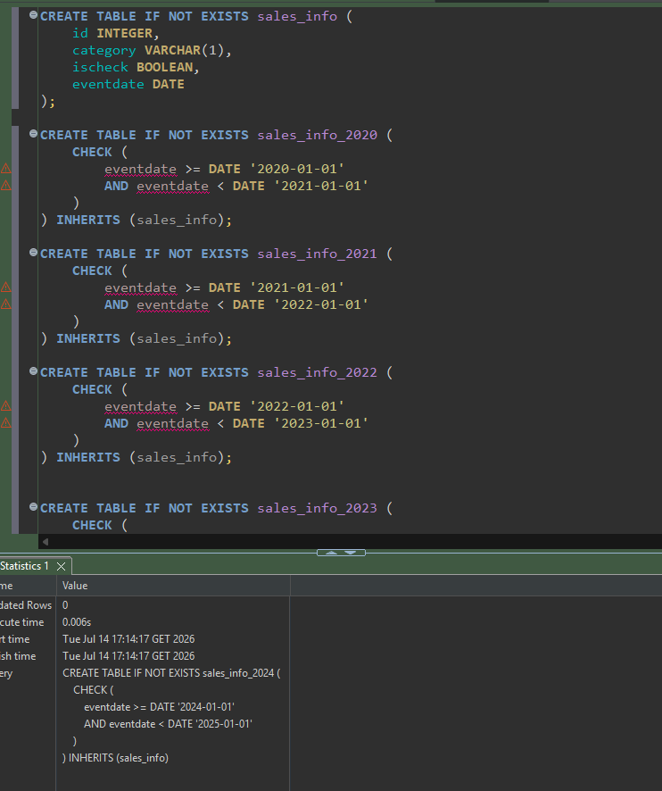

1.2
I created a trigger function that automatically routes each new row to the correct child table based on its eventdate. If the date doesn't fall into any of the defined yearly partitions, the function raises an exception to prevent invalid data from being inserted.
1.3
I created a trigger on the parent table that executes the partition function before each insert. The trigger automatically sends every new row to the correct yearly partition. I used DROP TRIGGER IF EXISTS so the script can be run multiple times without errors while preserving the data. PostgreSQL doesn’t support CREATE TRIGGER IF NOT EXISTS.
1.4
I generated random test data and inserted it into the parent table. The trigger automatically redirected each row to the appropriate yearly partition based on the eventdate. After the insert, I verified that the rows were distributed across the child tables and that the total number of rows matched the expected count.
1.5
I attempted to update the eventdate of existing rows to move them into another yearly partition. PostgreSQL returned a CHECK constraint violation because the rows remained in their original child table. Inheritance partitioning only routes rows during INSERT operations and does not automatically move rows between partitions when the partition key is updated.
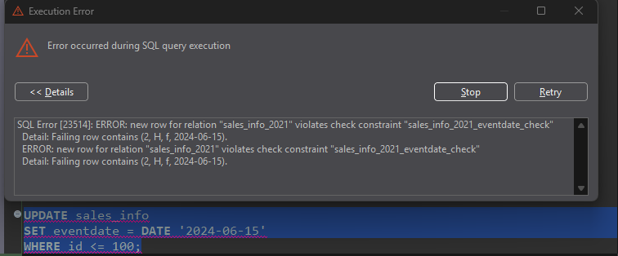
1.6
For SELECT *, both tables had to read all 10 million rows because there was no filter to limit the search. The partitioned table used an Append node to scan each partition separately, while the regular table scanned one large table. In my case, the partitioned table finished faster (about 739 ms vs 1401 ms), which shows that even when reading all data, scanning several smaller partitions can sometimes be more efficient than scanning one very large table.
When filtering by a date range, the partitioned table performed much better. PostgreSQL only needed to read the partition that contained data for 2022, while the regular table had to scan all 10 million rows and filter out most of them. Because of that, the partitioned table finished much faster (around 224 ms vs 595 ms). This is where partitioning really starts to show its benefit.
For the exact date search, both tables performed almost the same. PostgreSQL used parallel workers for both queries, which helped speed up the scan. Since there were no indexes and both queries relied on parallel sequential scans, there was no difference between the partitioned and regular table in this case (193 ms vs 193 ms).
For COUNT(*), the regular table actually performed better. Since the query has to count every row, PostgreSQL still needs to scan all partitions, so partitioning doesn't provide any benefit here. In fact, scanning multiple partitions and combining the results adds a bit of extra work, which is why sales_info_simple finished faster in my test (about 216 ms vs 361 ms). This shows that partitioning is mainly useful when queries filter on the partition key, not when they need to read the entire dataset.
When counting rows within a specific date range, the partitioned table performed noticeably better. Since the query filtered by the partition key (eventdate), PostgreSQL only needed to process the relevant partition instead of scanning the entire dataset. The regular table had to read all rows before applying the filter, so it took almost twice as long (142 ms vs 258 ms). This is a good example of where partitioning provides a real performance benefit.
1.7
I removed the oldest partition (sales_info_2020) and created a new partition (sales_info_3000). After updating the trigger function, new rows with dates in 3000 were automatically inserted into the new partition. This shows that with inheritance partitioning, adding or removing partitions also requires updating the trigger logic manually.
2.1
I created a new table using PostgreSQL's declarative partitioning. Unlike the previous task, the table is partitioned directly by eventdate, so PostgreSQL handles routing rows to the correct partition automatically without using inheritance or triggers.
2.2
I created a two-level partitioning structure. The first level splits the data by year using eventdate, and each yearly partition is further divided by category. Categories A-E and F-J have their own partitions, while the default partition stores any remaining values. Compared to inheritance partitioning, the structure is much cleaner because PostgreSQL manages the routing automatically.
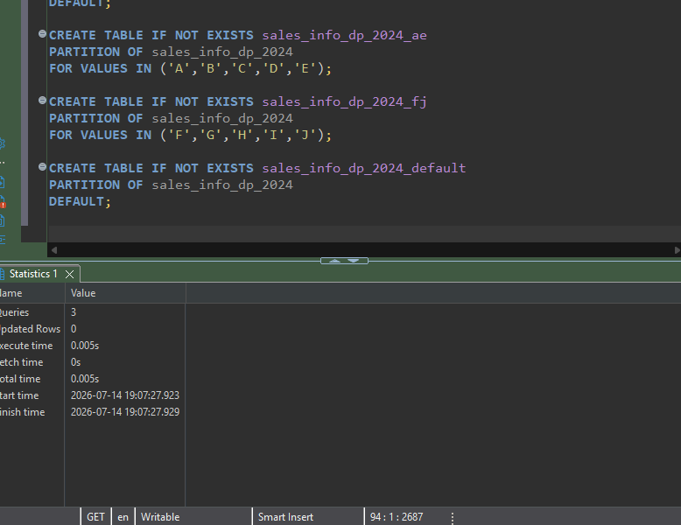
2.3
I inserted the test data directly into the parent table. Unlike inheritance partitioning, I didn't need a trigger because PostgreSQL automatically placed each row into the correct range and list partition. This makes declarative partitioning much simpler to use and maintain.
2.4
I updated the category for some rows, and PostgreSQL automatically moved them to the correct list partition. Unlike inheritance partitioning, I didn't have to handle this myself. The database takes care of moving rows when the partition key changes, which makes declarative partitioning much easier to maintain.
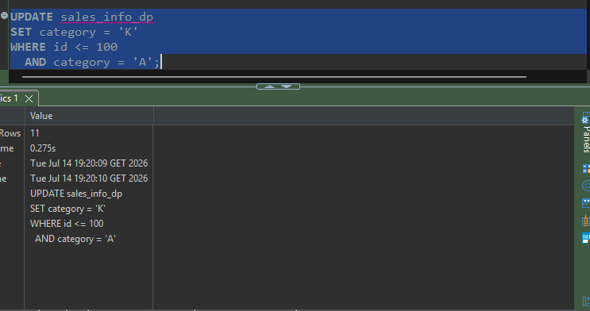

2.5
For SELECT *, both tables performed almost the same because the query had to read all rows. The partitioned table scanned every partition and combined the results, while the regular table scanned one large table. Since there was no filter, partitioning didn't provide any real advantage in this case.
When filtering by a date range, the declaratively partitioned table performed much better. PostgreSQL pruned all partitions outside of 2022 and only scanned the three partitions for that year. The regular table had to scan all 10 million rows and then filter out most of them. As a result, the partitioned table finished much faster (210 ms vs 657 ms), showing one of the biggest advantages of declarative partitioning.
For the exact date search, the declaratively partitioned table was noticeably faster. PostgreSQL only scanned the partitions for the year 2023 and ignored the rest, while the regular table still had to scan the entire dataset. Even though both queries used parallel workers, partition pruning gave the partitioned table a clear advantage (91 ms vs 193 ms).
Even though the query didn't filter by eventdate, declarative partitioning still helped because PostgreSQL only scanned the A-E list partitions and skipped the F-J and DEFAULT partitions. The regular table had to scan all 10 million rows and filter out most of them. As a result, the partitioned table completed the query much faster (308 ms vs 604 ms).
When filtering for multiple categories (A, B, and C), PostgreSQL was able to prune the F-J and DEFAULT partitions and only scan the A-E partitions for each year. The regular table still had to scan all 10 million rows and filter out most of them. Because of that, the partitioned table finished almost twice as fast, same result as last. (590 ms vs 1144 ms).
For COUNT(*), the regular table was faster. Since the query counts every row, PostgreSQL still has to read all partitions in the partitioned table, so partitioning doesn't provide any benefit here. The extra work of scanning multiple partitions and combining the results makes it a bit slower than scanning one regular table (374 ms vs 218 ms).
When counting rows within a specific date range, the partitioned table was faster because PostgreSQL only scanned the partitions for 2022. The regular table had to read all 10 million rows and then apply the filter. As a result, the partitioned table completed the query noticeably faster (156 ms vs 239 ms), showing how effective declarative partitioning is when queries use the partitioning column.
2.6
I split the A-E partition into two smaller partitions (A-C and D-E), then restored the original structure by merging them back into a single A-E partition. Since PostgreSQL doesn't merge partitions automatically, I temporarily stored the data, recreated the original partition, and inserted the rows back through the parent table so PostgreSQL could route them correctly.
3.1
Even after increasing max_parallel_workers_per_gather to 4, PostgreSQL didn't use parallel workers for these SELECT * queries. The planner decided that a regular sequential scan was more efficient than parallel execution. This shows that the setting only defines the maximum number of workers available—PostgreSQL still chooses the execution plan based on its cost estimates.
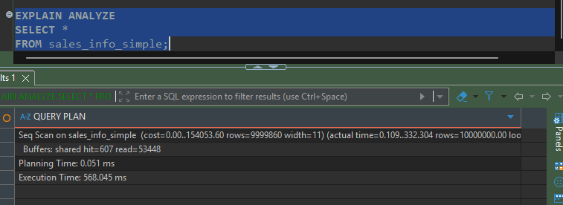
Adding ORDER BY eventdate made the query much more expensive because PostgreSQL had to sort the entire dataset. The regular table performed the best because PostgreSQL used 4 parallel workers with a Gather Merge plan, allowing the sorting work to be shared across multiple processes. The partitioned tables did not use parallel sorting, so they took considerably longer to finish. (3331ms vs 4199ms vs 2049ms)
After increasing max_parallel_workers_per_gather to 4, PostgreSQL used more parallel workers for the COUNT(*) queries. The regular table benefited the most because it used all 4 workers and finished the fastest (150 ms). The partitioned tables also used parallel aggregation, but only with 3 workers, so they took a bit longer. This shows that increasing the parallel worker limit can improve performance, but PostgreSQL still decides how many workers to use for each query.
When counting rows for a specific date range, both partitioned tables outperformed the regular table. Even though sales_info_simple used the maximum of 4 parallel workers, it still had to scan all 10 million rows. The partitioned tables only processed the relevant 2022 data, so they finished faster. In this test, the inheritance-partitioned table was the fastest (116 ms), followed by the declaratively partitioned table (138 ms), while the regular table was the slowest (194 ms). This shows that filtering on the partition key can have a bigger impact than simply increasing the number of parallel workers.
For the GROUP BY category query, all three tables used parallel aggregation with a Gather Merge plan. Since the query had to process every row, partitioning didn't provide any advantage. The regular table performed the best because PostgreSQL used all 4 parallel workers, while the partitioned tables used 3, allowing the regular table to finish faster (311 ms vs 367 ms and 409 ms).
For the join query, PostgreSQL combined partition pruning with parallel execution. It first filtered both tables by the specified date, reducing the amount of data that needed to be joined. Then it performed the join in parallel and aggregated the result. Because only a small portion of the data was processed, the query finished quickly (around 98 ms), showing how filtering on the partition key can significantly improve join performance.
3.3
After creating the index on eventdate, PostgreSQL stopped using sequential scans and switched to a bitmap index scan. This significantly reduced the amount of data it had to read and improved the execution time from about 91 ms to 17 ms.
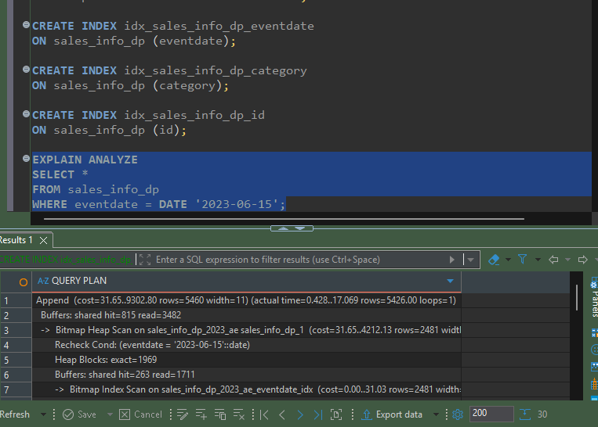
The category index allowed PostgreSQL to find matching rows much faster using bitmap index scans instead of scanning entire partitions. As a result, the query execution time dropped from about 308 ms to 134 ms.
Adding indexes did not improve the join query in this case. PostgreSQL chose a different execution plan with fewer parallel workers, and the query took slightly longer (124 ms vs 98 ms). This shows that indexes don't always make a query faster—the optimizer decides whether using an index is actually beneficial based on the estimated cost.

