Task 3
  - Creating the year month label
First, I opened the Power BI report from the previous lab and went to the DimDate table. I created a new calculated column called Year Month Label using the FORMAT function. I used this column because I wanted to display the dates on my chart as a simple month-year label instead of using the default date hierarchy.
After creating the column, I added a line chart using Year Month Label on the X-axis and Sales Amount on the Y-axis. I also added a filter for CalendarYear and set it to show 2013 and later, as required. At first, the months appeared in alphabetical order, so I created a separate sorting column and used it to sort Year Month Label chronologically. This made the chart display the months in the correct historical order, starting from January 2013.
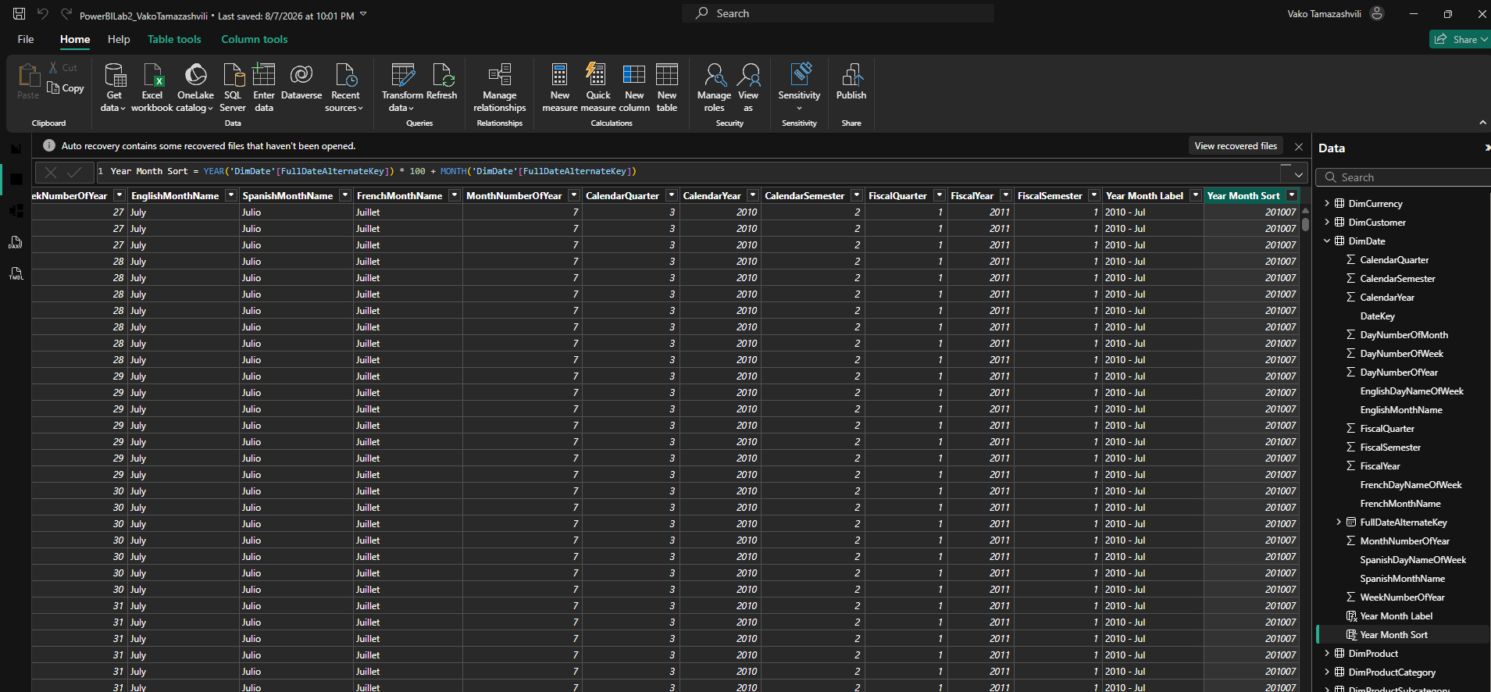
And I created a visual for this as well.
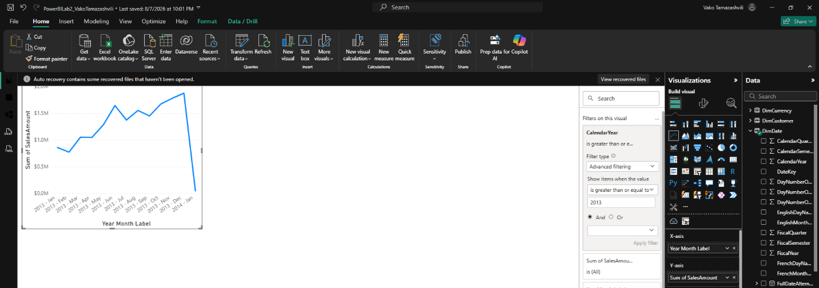
1.2 Today date measure
Next, I created a Today Date measure using the TODAY() function. I added it to a Card visual and changed the date format to a shorter format. I then placed the card in the bottom-right corner of the report as a footer.
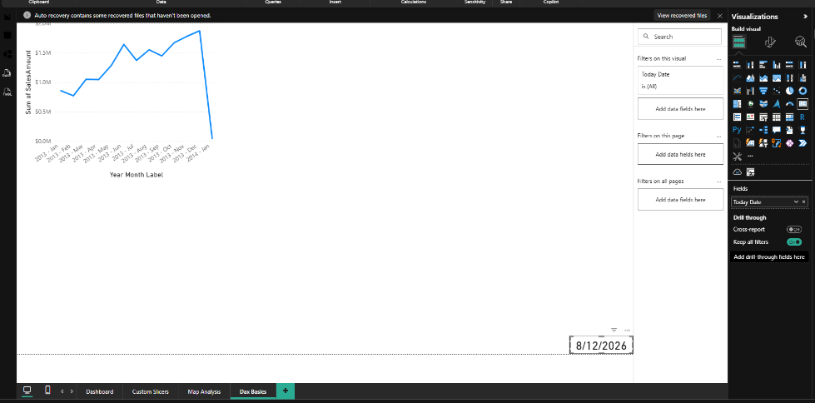
  - Order quantity
Next, I created an Order Quantity measure using the OrderQuantity column from FactInternetSales. I added it to a table together with the date and then created an Order Quantity YTD measure using CALCULATE and DATESYTD to calculate the cumulative quantity throughout each year.
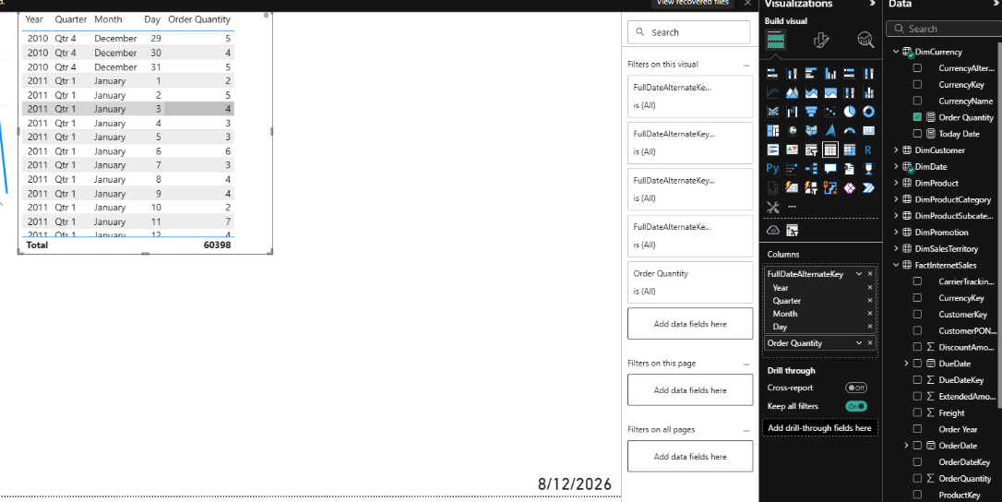
1.3 Order Quantity YTD vs Previous Year
I then created a measure for Order Quantity YTD Previous Year and added it together with Order Quantity YTD to one line chart. This allowed me to compare the current year's cumulative Order Quantity with the previous year's cumulative results.

  - Sales amount
Next, I created Sales Amount, Sales Amount YTD, and Sales Amount YTD Previous Year measures. I then created another line chart with both YTD measures to compare the current and previous year's Sales Amount.
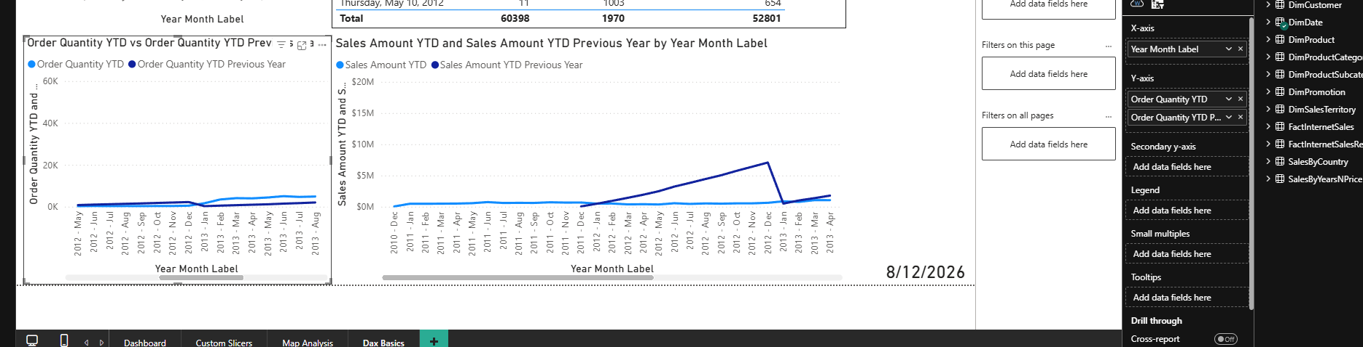
1.5 Current User and Current Date
I created a Current User measure using USERNAME() and used it with my existing Today Date measure. I displayed both on Cards at the top of the report using the required “Welcome” and “Current Date is” labels.
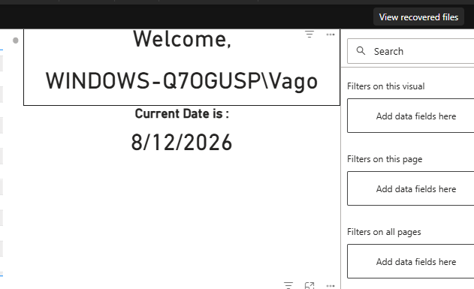
  - Order quantity %
I created an Order Quantity % measure and then added a table with Year Month Label, Product Name, Color, Order Quantity, and the percentage of total Order Quantity. I also formatted the percentage as a percentage value with two decimal places.
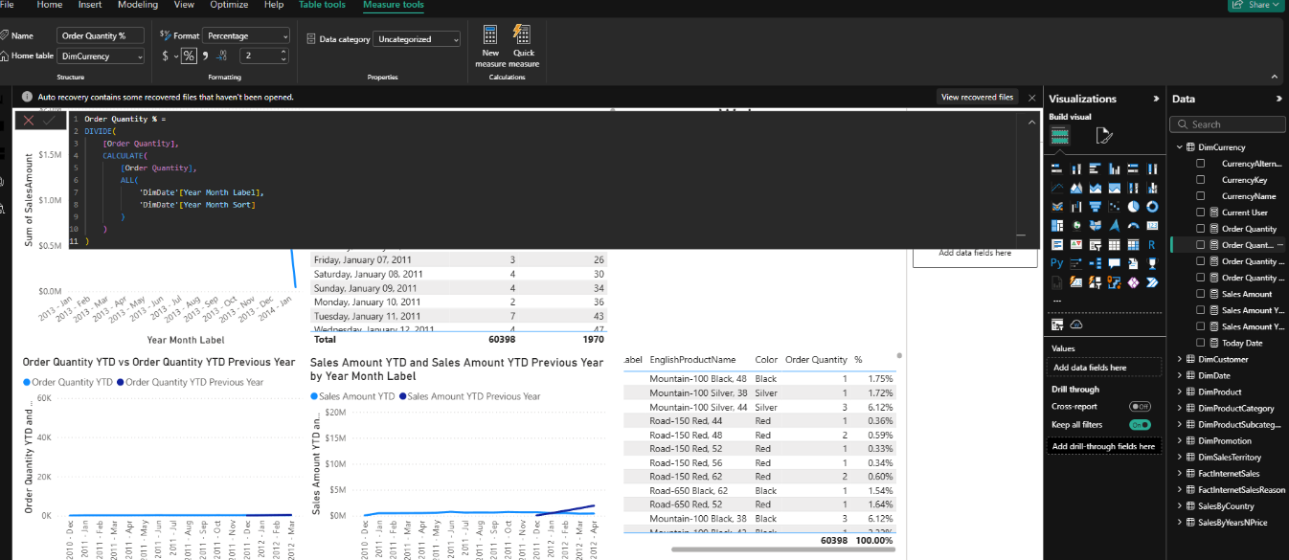
  - Sale amount for Maximum OrderDate
I created a measure that always calculates the Sales Amount for the latest available OrderDate. I displayed the result in a Card, which showed $2.64K for the maximum date in the data. I chose this method because I wanted the result to update automatically if new data is added, instead of using a fixed date.
  - Country with Highest sales
I created a DAX measure to find the country with the highest Sales Amount across all years and displayed the result in a Card. The result was the United States. I chose this method because it compares the sales of all countries and returns only the country with the highest total, making the result simple and easy to understand.
  - Product Category Ranking
Finally, I created a Product Category Rank measure using RANKX to rank the product categories by Sales Amount. I displayed the categories, Sales Amount, and their ranks in a table. I chose this method because RANKX makes it easy to compare all product categories and assign a clear rank based on their total sales.
